Tips for Searching on the USSGL Web Site:

Doing a search on the USSGL Web site is easy!
- Simply type one or more search terms (the words or phrase that best describe the information you want to find) into the “Search by Topic/Account Number” box.
- Select the fiscal year for the information you are requesting. You must select a fiscal year to execute your search.
- Select the appropriate data topics in which you would like to search. You can choose from the following data topics: USSGL Interactive Database, Account Definition, Transaction Description, Attributes and Crosswalks. You must select the data topics to execute your search.

In response to your search the USSGL Web site will produce a results page: a list of web pages related to your search terms, with the most relevant link appearing first, then next and so on.

Here are some basic tips to help you maximize the effectiveness of your search:

- Choose the right search term is the key to finding the information you need.
- Start with the obvious – if you’re looking for general information on Fund Balance With Treasury, try Fund Balance With Treasury.
- But it’s advisable to use multiple search terms; if you’re recording Fund Balance With Treasury while under a continuing resolution, try Fund Balance With Treasury Continuing Resolution rather than Fund Balance With Treasury or Continuing Resolution by themselves.

- Searches on the USSGL Web site are not case sensitive. All letters, regardless of how you type them, will be understood as lower case.

- By default, the USSGL Web site search results will only return results that include all of your search terms. There is no need to include “and” between terms.

Key Terms used on the USSGL Web Site

USSGL Interactive Database
The USSGL Interactive Database includes USSGL information (Chart of Accounts, Account Definitions, Transactions, etc.) that is incorporated in the current USSFL TFM supplement. The database provides interactive functions not provided in the USSGL TFM Supplement document. For example, when searching on an USSGL account, a user will be able to link to transactions, attributes and accounts associated with that USSGL account.

return to top

Account Definition
The account definition includes the USSGL account number, account title, normal balance of the account (debit or credit) and the account definition.

return to top

Transaction Description
Transactions illustrate both proprietary and budgetary entries for each accounting event. Please note that there are valid accounting events/postings not yet documented.

return to top

Attributes
The attribute section provides USSGL attribute tables for the FMS-administered FACTS I and FACTS II “trial-balance” reporting systems. To meet external reporting requirements, agencies need data at a level below the 4-digit USSGL account. Attributes are used to capture this data. Attributes are like adjectives that further describe a USSGL account in order to meet a specific reporting requirement.

return to top

Crosswalks
The crosswalk section includes crosswalks for the two most current fiscal years. These crosswalks map USSGL accounts to external reports in accordance with current reporting guidance from the Office of Management and Budget, Federal Accounting Standards Advisory Board and the Financial Management Service.

return to top

- USSGL Search is located in the bottom center of the page.
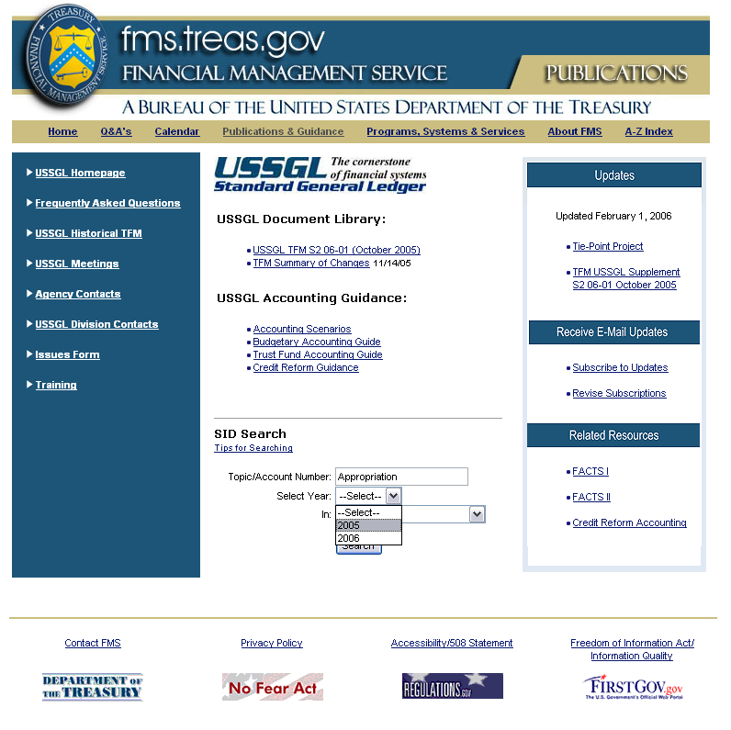

- Enter Topic/Account Number

- Select Year from pull down menu

NOTE: Select Year: is required
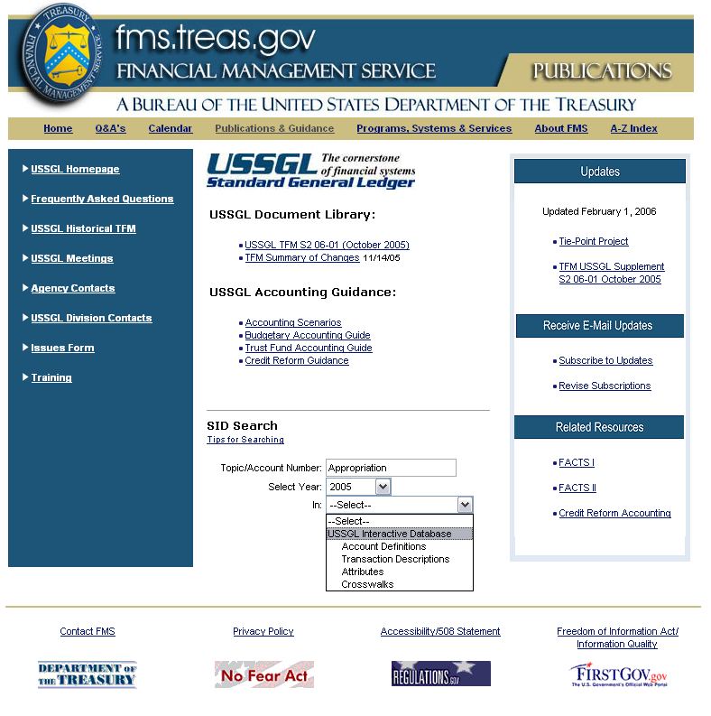

- Select from the pull down menu; which section of the database you would like to search (refer to Tips for Searching at the beginning of document).

NOTE: In: is required
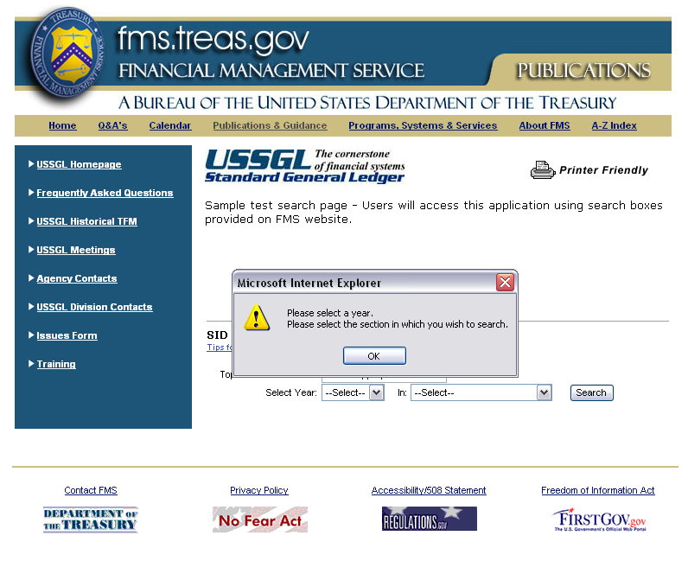

- If year and/or section is not entered an alert will be displayed.

- After all information is entered, click Search.
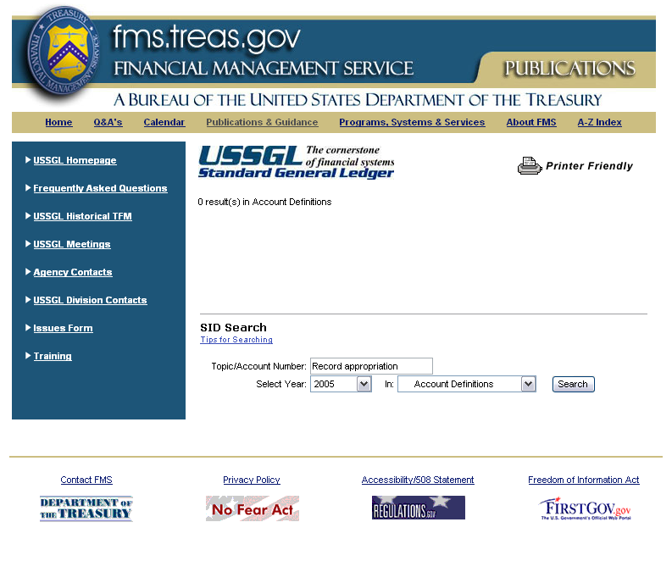
Figure A

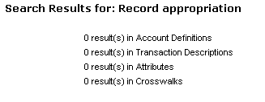
Figure B

- If no results are found when searching by section, 0 results will be displayed – Figure A.

- If no results are found, when searching the entire database,0 results will be displayed in each section – Figure B.
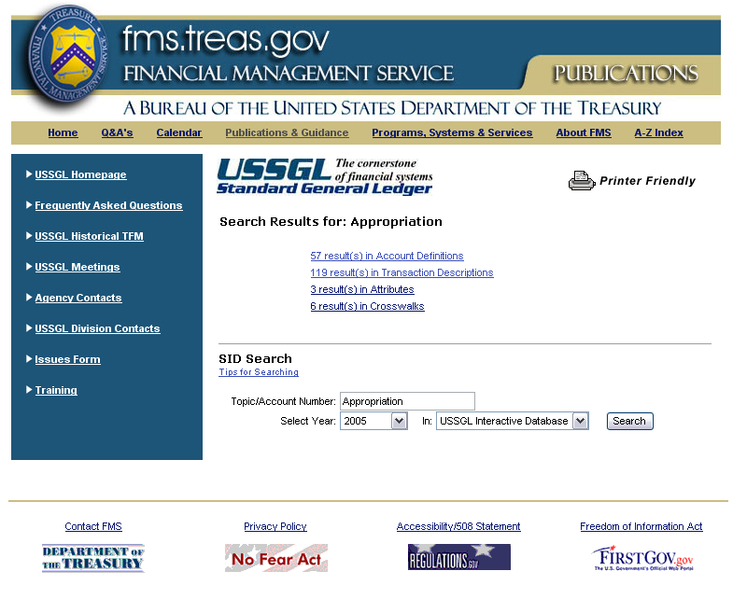

- If there are results, the number of results found will be displayed by category. This is only true when the entire USSGL Interactive Database is searched.

- If the database was searched by Account Definitions, then only results for Account Definitions will be displayed. This is true for Transaction Descriptions, Attributes, and Crosswalks.

- Click on applicable link to display results.

Account Definitions

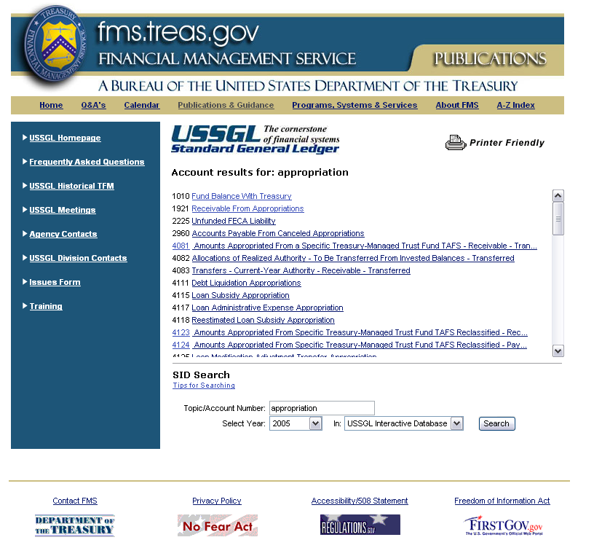

- A list of results is displayed. Use the scroll bar to see all results
- Results are displayed by account number and title
- Click on account title link to display information

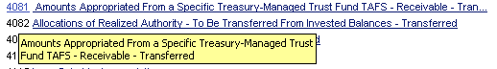
Figure A

NOTE: Place the cursor over the account numbers that are displayed as links to display complete transaction description – Figure A.
Account Definitions cont’d

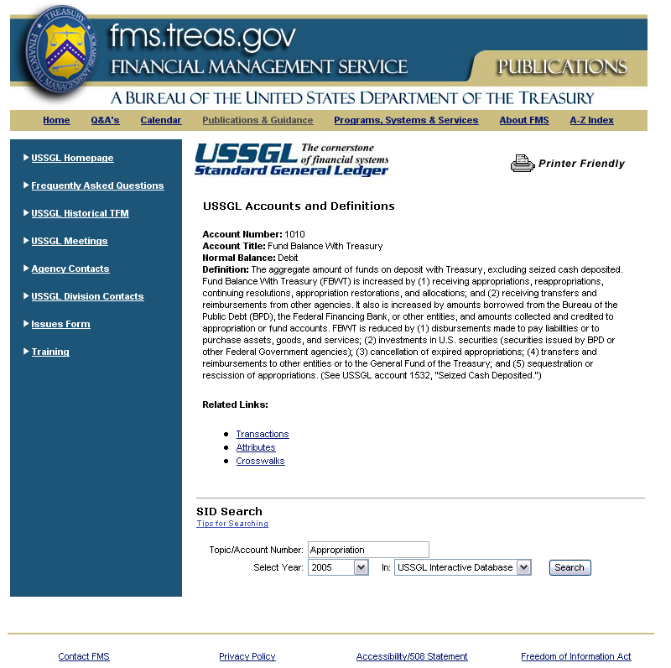

- Review information

- If there is additional information under another section pertaining to the selected account, it will be displayed at the bottom of the page under Related Links. Click on the link to display the information.
Transaction Descriptions for Account 1010

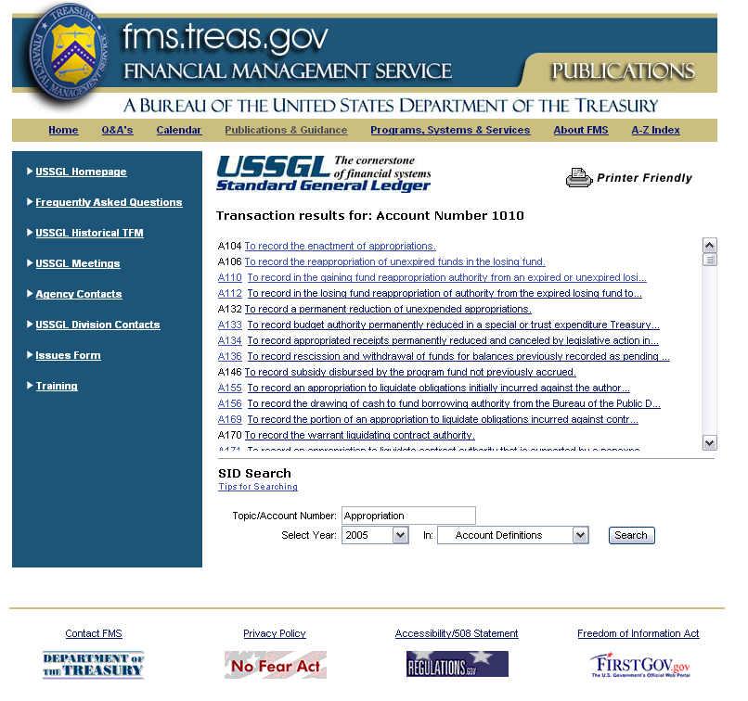

- A list of transaction descriptions associated with account 1010 is displayed.

- Click the transaction description to display account transaction information.

NOTE: Place the cursor over the transaction codes that are displayed as links to display complete transaction description – Figure A.
Transaction Descriptions

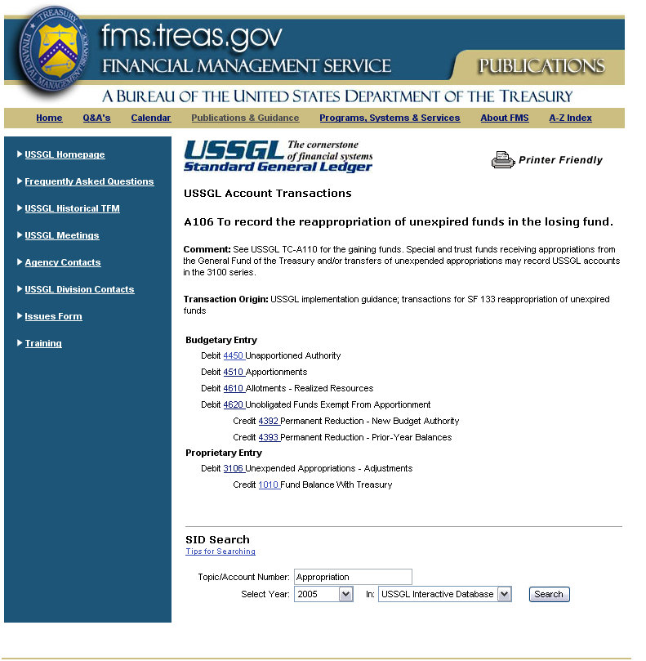

- Review information

- Click on account number to view account definition.
Transaction Descriptions cont’d

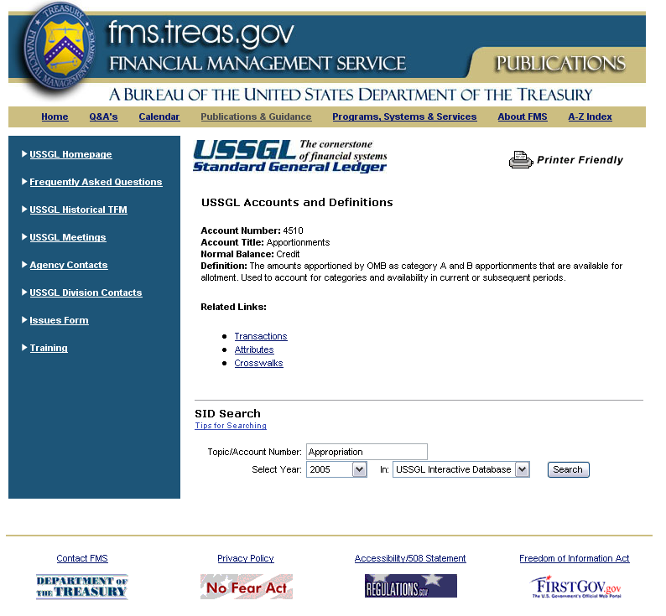

- View account definition
Attributes

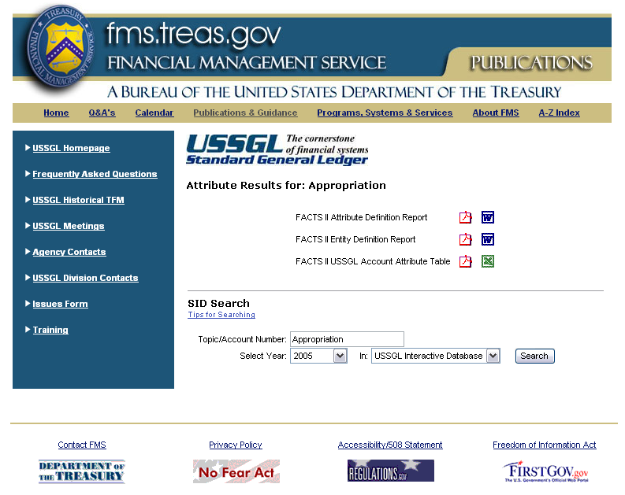

- Results for Attributes will be displayed with the option to view it in PDF, Word, or Excel formats.

- Click icon to view report.

NOTE: To search within a specific attribute report, user must use feature built in the software application (ex. Word, Excel, or PDF).
Attributes cont’d

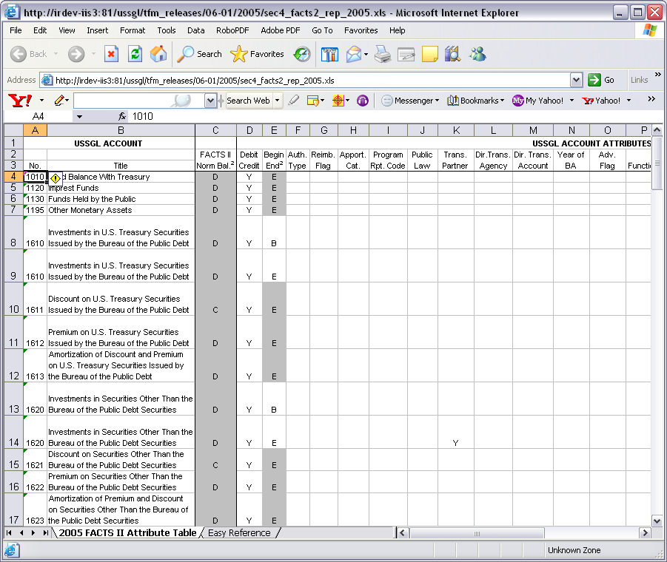

- Report will open.

- View report

- Click the close (X) button to close the window and return to search page.
Crosswalks

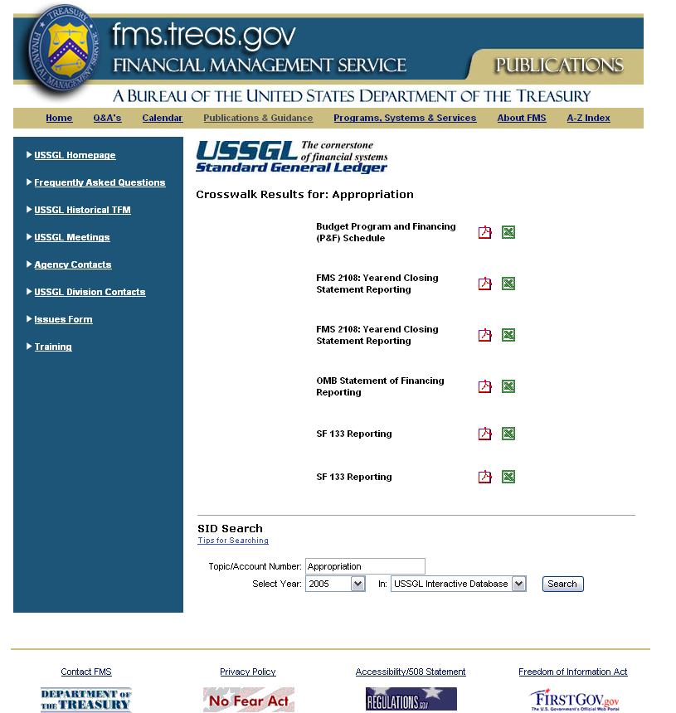

- Results for Crosswalks will be displayed with the option to view it in PDF or Excel formats.

- Click icon to view report.

NOTE: To search within a specific attribute report, user must use feature built in the software application (ex. Word, Excel, or PDF).
Crosswalks cont’d

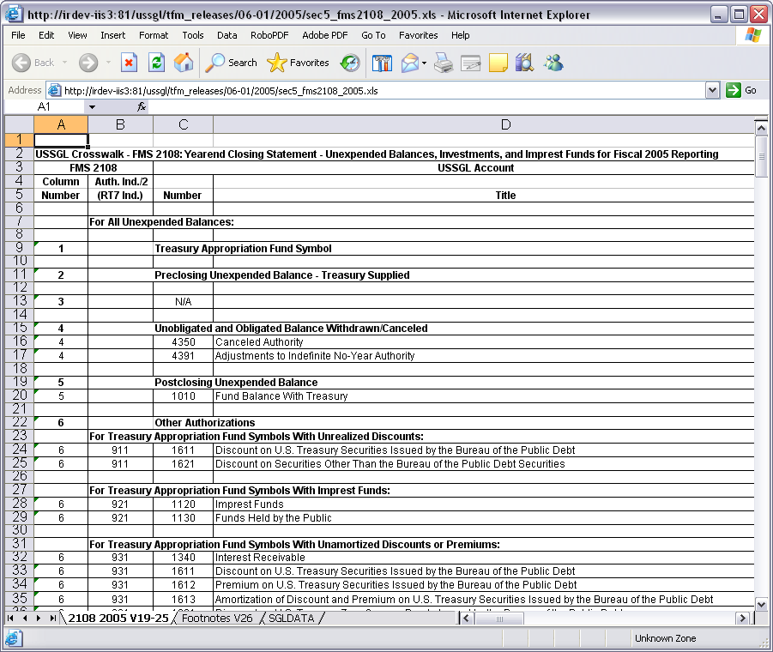

- Report will open.

- View report

- Click the close (X) button to close the window and return to search page.

