bluebunch wheatgrass
Pseudoroegneria spicata (Pursh) A. Love
Plant Symbol = PSSP6

Contributed by: USDA NRCS Idaho State Office

Alternate Names

Agropyron spicatum, Elytrigia spicata

Uses
Grazing/rangeland/wildlife: Bluebunch wheatgrass can be used for native hay production and will make nutritious feed, but is better suited to pasture and rangeland use. Bluebunch wheatgrass is palatable to all classes of livestock and wildlife. It is a preferred feed for cattle and horses year long, but is considered coarse in summer. It is a preferred feed for sheep, elk, deer, and antelope in spring. It is considered a desired feed for elk in summer. It is a desirable feed for sheep in summer, desirable feed for sheep, elk, deer, and antelope in fall and desirable feed for sheep, elk and deer in winter. In spring, the protein levels can be as high as 20 percent and decreases to about 4 percent protein as it matures and cures out. Digestible carbohydrates remain about 45 percent throughout the active growth period.

Erosion control/reclamation: Bluebunch wheatgrass is very drought resistant, stands are persistent and it is adapted to stabilization of disturbed soils. It is very compatible with slower developing native species, such as thickspike wheatgrass (Pseudoroegneria lanceolata), western wheatgrass (Pascopyrum smithii), and needlegrass species (Achnatherum spp., Stipa spp., and Ptilagrostis spp.). It does not compete well with aggressive introduced grasses. Its drought tolerance, combined with extensive root systems and good seedling vigor, make this species ideal for reclamation in areas receiving 10 to 20 inches annual precipitation. 'Secar' competes well in areas as low as 8 inches annual rainfall. This grass can be used in urban areas where irrigation water is limited and to stabilize ditchbanks, dikes, and roadsides as a component of a mix.
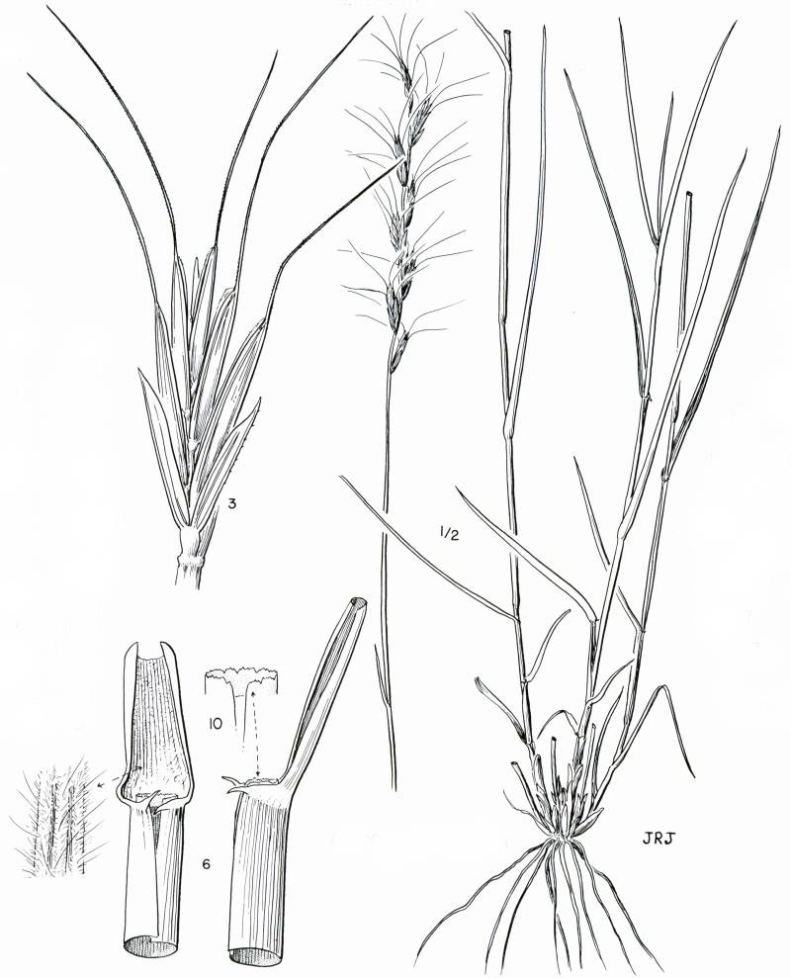
Jeanne R. Janish
© The New York Botanical Garden
Cronquist et al. (1977)

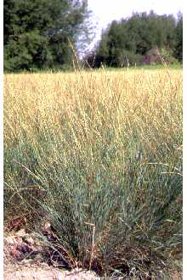
Loren St. John
USDA NRCS Aberdeen PMC
@ PLANTS

Status
Please consult the PLANTS Web site and your State Department of Natural Resources for this plant’s current status, such as, state noxious status and wetland indicator values.

Description
General: Grass Family (Poaceae). Bluebunch wheatgrass is a perennial, native bunchgrass. Bluebunch wheatgrass is highly variable and grows to 1.5 to 4 feet tall and seed spikes are 3 to 8 inches long. The auricles are pointed and semi-clasping to nearly lacking. Leaves are lax, cauline, flat to in-rolled, 4-6 mm wide, and green to blue in color. Sheath is generally glabrous. Reproductive stems are erect, slender, and sometimes wiry with a wavy rachis. The lemmas have a divergent awn to awn tipped except on the beardless type where awn is lacking.

Distribution
Bluebunch wheatgrass is common to the northern Great Plains and the Intermountain regions of the western United States. It is a long-lived cool season native grass with an extensive root system with strong tillers. Bluebunch wheatgrass spreads by seed, except in high rainfall zones where some short rhizomes may occur. For current distribution, please consult the Plant Profile page for this species on the PLANTS Web site.

Establishment
Adaptation: Bluebunch wheatgrass does best on medium to coarse textured soils and can be found on heavy to medium to coarse textured soils over 10 inches deep including fairly sandy sites. It can be seeded on clayey sites. It can be found on thin, rocky sites and on very steep slopes. It will tolerate weakly saline conditions. It cannot grow on very acidic sites. It is cold tolerant, is moderately shade tolerant, and very tolerant of fire. It is intolerant of high water tables, poor drainage and periods of extended inundation.

On native sites, bluebunch wheatgrass is most abundant in the 8 to 20 inch annual precipitation zones. Seeded varieties do best with 12 to 20 inches of precipitation (exception 'Secar' 8 to 18 inches) and will tolerate up to 35 inches on very well drained soils with southerly aspects. The elevation range is from 500 feet above sea level to 10,000 feet. It is a major component of many native plant communities and generally occupies 20 to 60 percent of the overall composition by weight.

Species often associated with bluebunch wheatgrass include the following: the big sagebrush complex, juniper, ponderosa pine, needlegrasses, bluegrass complex, bottlebrush squirreltail, prairie junegrass, thickspike wheatgrass, Idaho fescue, arrowleaf balsamroot, and tapertip hawksbeard.

Planting: This species should be seeded with a drill at a depth of 1/2 inch or less on medium textured soils, 1/4 inch on fine textured soils and 3/4 inch or less on coarse textured soils. Single species seeding rates recommended for this grass are 6 to 8 pounds Pure Live Seed (PLS) per acre or 19 to 25 PLS seeds per square foot. If used as a component of a mix, adjust to percent of mix desired. For mined lands and other harsh critical areas, the seeding rate should be increased to 40 to 50 PLS seeds per square foot. Seedlings are weaker than crested wheatgrass and a clean, firm, weed free seedbed is required for establishment (cheatgrass competition can cause stand failure).

The best seeding results are obtained from seeding in very early spring on heavy to medium textured soils and in late fall on medium to light textured soils. Late summer (August - mid September) seeding is not recommended unless irrigation is available. Dormant fall seedings will pre-chill seed and reduce seed dormancy.

Bluebunch wheatgrass establishes fairly quickly for a native grass and stands should be given 2-3 years to ensure establishment. It is compatible with other species and should be used in seeding mixtures. It should not be seeded with strongly competitive introduced species.

Bluebunch wheatgrass makes good spring growth, fair summer growth, and good fall growth if moisture is available. Seedling vigor is fair to good, but less than crested wheatgrass.

Stands may require weed control measures during establishment. Application of 2,4-D should not be made until plants have reached the four to six leaf stage. Mow weeds at or prior to their bloom stage. Grasshoppers and other insects may also damage new stands and pesticides may be needed.

Management
Bluebunch wheatgrass has good palatability to livestock and wildlife. Established stands cannot withstand heavy continuous grazing.

Stands of bluebunch wheatgrass should not be grazed until they have firmly established (usually two growing seasons) and have headed out. Six inches of new growth should be attained in spring before grazing is allowed in established stands. The growing point of bluebunch wheatgrass is fairly high and thus stands can easily be overgrazed. It is recommended that this grass be grazed under a deferred, rotational grazing system to ensure plants remain healthy. Spring grazing should occur no more than one out of three years and no more than 40 percent utilization should occur during rapid growth. Heavy early spring grazing is especially damaging and grazing should be delayed until at least mid boot stage. No more than 60 percent utilization should occur after seed ripens.

Once established, bluebunch wheatgrass is competitive with weedy species, but can be crowded out by some aggressive introduced species.

Environmental Concerns: Bluebunch wheatgrass is long-lived, spreads primarily via seed distribution, but can spread vegetatively in precipitation zones above 18 inches annual rainfall. It is not considered a "weedy" or invasive species, but can spread into adjoining vegetative communities under ideal climatic and environmental conditions. Most seedings do not spread from original plantings. It is a cross-pollinating species and is known to cross with other ecotypes of bluebunch wheatgrass, quackgrass, thickspike wheatgrass and bottlebrush squirreltail. These natural crosses broaden the gene pool and do not generally dominate a site or crowd out the native ecotypes and in many cases is sterile.

Seed Production
Seed production of bluebunch wheatgrass has been very successful under cultivated conditions. Row spacing of 24 to 36 inches are recommended under irrigation and 36 inches under dryland conditions. Seeding rates of 4 to 6 PLS per acre are recommended. Cultivation will be needed to maintain rows and weed free conditions.
Seed fields are productive for three to four years. Average production of 100 to 250 pounds per acre can be expected under dryland conditions. Average production of 300 to 500 pounds per acre can be expected under irrigated conditions. Swathing, followed by combining of the cured rows, best completes harvesting. The seed heads readily shatter and require close scrutiny of maturing stands. If direct combined, harvest at 30 percent moisture and dry seed down to 12 percent moisture if stored in bins or 15 percent moisture if stored in sacks. Removal of awn may be required during processing. Seed is generally harvested in mid July to mid August.

Cultivars, Improved and Selected Materials (and area of origin)
Contact your local Natural Resources Conservation Service (formerly Soil Conservation Service) office for more information. Look in the phone book under ”United States Government.” The Natural Resources Conservation Service will be listed under the subheading “Department of Agriculture.” Foundation and registered seed is available through the appropriate state Crop Improvement Association or commercial sources to grow certified seed.

'Goldar' (P. spicata spp. spicata) bluebunch wheatgrass was developed from seed originating near Asotin, Washington by the Aberdeen Plant Materials Center and released by Idaho-Utah AES, ARS and the PMC in 1989. 'Goldar' is noted for rapid establishment, high forage production and the ability to survive and thrive under dry conditions at or above 12 inches rainfall. It is intended for use on rangeland for re-establishment of native plant communities, vegetative firebreaks, critical area stabilization and reclamation purposes. Certified seed is available and Aberdeen PMC maintains breeder seed.

'Secar' is a cultivar of Snake River wheatgrass (Elymus wawawaiensis J. Carlson) and was originally identified as a variety of bluebunch wheatgrass. The original collection site is along the Snake River gorge near Lewiston, Idaho. The Idaho-Oregon-Montana-Wyoming AES, Washington Agriculture Research Center, and Pullman Plant Materials Center released ‘Secar’ in 1980. It is one of the most drought tolerant native perennial grasses presently available and can survive down to 8 inches rainfall. It is a bunchgrass with fair to good seedling vigor and establishes well under droughty conditions. 'Secar' is intended for use on rangeland for re-establishment of native plant communities. Certified seed is available and Pullman PMC maintains breeder seed.

'Whitmar' (P. spicata spp. inermis) beardless wheatgrass is the awnless form of bluebunch wheatgrass and was developed by Pullman PMC from seed native to the Palouse grasslands near Colton, Washington. Idaho-Oregon-Washington AES and Aberdeen-Corvallis-Pullman PMCs released ‘Whitmar’ in 1946. It performs best above 12 inches rainfall in high winter-low summer precipitation areas. 'Whitmar' was selected for forage quality, seedling vigor, and good seed production. Intended for use on rangeland for re-establishment of native plant communities and for reclamation. Certified seed is available and Pullman PMC maintains breeder seed.

References
Alderson, J. & W.C. Sharp 1994. Grass varieties in the United States. Agriculture Handbook No. 170. USDA, SCS, Washington, D.C.

Carlson, J.R. & M.E. Barkworth 1997. Elymus wawawaiensis: a species hitherto confused with Pseudoroegneria spicata (Triticeae, Poaceae). Phytologia 83:312-330.

Cronquist, A., A. H. Holmgren, N. H. Holmgren, J. L. Reveal, & P. K. Holmgren 1977. Intermountain flora. Vol. 6. The New York Botanical Garden. Columbia University Press, New York, New York.

Hitchcock, A. S. 1950. Manual of the grasses of the United States. USDA, Washington, DC.

Powell, A.M. 1994. Grasses of the Trans-Pecos and adjacent areas. University of Texas Press, Austin, Texas.

USDA, Forest Service 1996. Fire effects information system. Version: 000413. <http://www.fs.fed.us/database/feis/>. Rocky Mountain Research Station, Fire Sciences Laboratory, Missoula, Montana.

USDA, NRCS 2006. The PLANTS database. Version: 060808. <http://plants.usda.gov>. National Plant Data Center, Baton Rouge, Louisiana.

Prepared By and Species Coordinator
Daniel G. Ogle
USDA, NRCS, Idaho State Office, Boise, Idaho

Edited 05dec00 jsp; 13feb03 ahv; 060808 jsp

For more information about this and other plants, please contact your local NRCS field office or Conservation District, and visit the PLANTS Web site<http://plants.usda.gov> or the Plant Materials Program Web site <http://Plant-Materials.nrcs.usda.gov>

The U.S. Department of Agriculture (USDA) prohibits discrimination in all its programs and activities on the basis of race, color, national origin, sex, religion, age, disability, political beliefs, sexual orientation, and marital or family status. (Not all prohibited bases apply to all programs.) Persons with disabilities who require alternative means for communication of program information (Braille, large print, audiotape, etc.) should contact USDA's TARGET Center at 202-720-2600 (voice and TDD).
To file a complaint of discrimination write USDA, Director, Office of Civil Rights, Room 326-W, Whitten Building, 14th and Independence Avenue, SW, Washington, DC 20250-9410 or call 202-720-5964 (voice or TDD). USDA is an equal opportunity provider and employer.
Read about Civil Rights at the Natural Resources Convervation Service.

