PUBLIC NOTICE
News media information 202 / 418-0500
Fax-On-Demand 202 / 418-2830
Internet: http://www.fcc.gov
ftp.fcc.gov
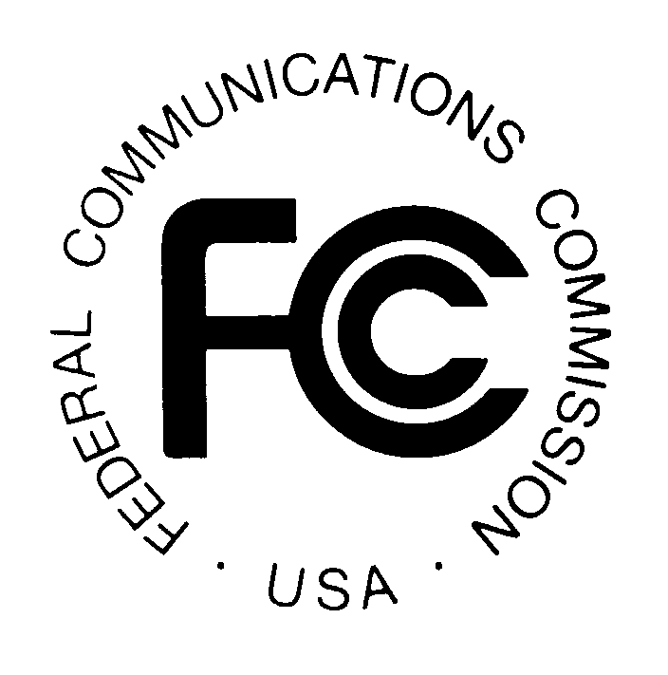

Federal Communications Commission
445 12th St., S.W.
Washington, D.C. 20554

DA 00-2290
Released: October 6, 2000

NETWORK SERVICES DIVISION, COMMON CARRIER BUREAU, INCREASES CONVENIENCE AND LOWERS COST FOR PART 68 APPLICATIONS

The Commission will henceforth accept applications for Part 68 Certification for multiple factories on a single Form 730, even if the factories are located in different countries. Form 484 certificates granted for such applications will show "MUL" in the country code. Because equipment manufactured in multiple locations may be manufactured by more than one entity, such certificates will show "Manufactured in Multiple Locations" in place of the manufacturer's name. A single "registrant" entity will continue to be identified on each certificate. Applicants are not required to submit "MUL" applications and may continue to submit one application per manufacturing location if they desire. Applicants are still required to display the country of origin on the outside surface of the product, 19 U.S.C. Section 3109.

All terminal equipment sold in the United States and connected to the public switched telephone network (PSTN) must be certified under Part 68 of the Commission’s rules. The Part 68 certification process requires an applicant to show that the device for which it assumes responsibility complies with specifications designed to prevent harm to the PSTN. Upon a finding that the applicant has met this requirement, which involves a review of test data, the Commission issues a certification number, thereby permitting sale and connection of the device.

The Network Services Division, Common Carrier Bureau administers the Part 68 program. Prior to this Notice, we required a Form 730 application for each location that manufactured an applicant's product. We now revise our procedures to allow applicants to designate multiple manufacturing locations for the same product in a single application. We anticipate that the change will increase administrative convenience both for us and for applicants, as well as reduce processing fees whenever applicants opt for this approach.

This document will be available for public inspection and copying during regular business hours at the FCC Reference Center, located at the Portals II building, 445 12th Street, SW, Room CY-A257, Washington, DC 20554. It may also be purchased from the Commission's copy contractor, International Transcription Service, Inc. (ITS), located at 1231 20TH Street, NW, Washington, DC 20036; phone (202) 857-3800; fax (202) 857-3805; TTY (202) 293-8810.

For further information, contact Jamal Mazrui at phone (202) 418-0069, email jmazrui@fcc.gov, or Bill Howden at phone (202) 418-2343, email whowden@fcc.gov of the Network Services Division, Common Carrier Bureau. The TTY number is (202) 418-0484.

-FCC-

