Cheatgrass
Bromus tectorum L.
Plant Symbol = BRTE

Contributed By: USDA, NRCS, National Plant Data Center & University of California, Department of Botany; partial funding from the US Geological Survey and the US National Biological Information Infrastructure
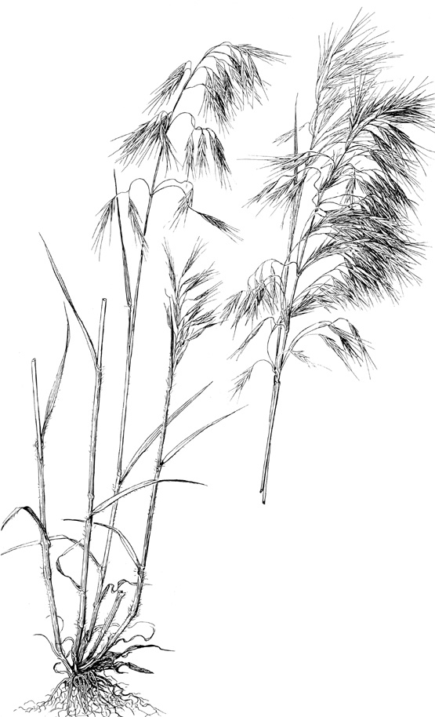
Hitchcock (1950)

Caution: This plant is highly invasive.

Alternate Names
Downy brome, downy brome-grass, downy chess, early chess, slender chess, drooping chess, junegrass, and bronco-grass

Uses
Noxiousness: Downy brome or cheatgrass is native to the Mediterranean region. In Europe, its habitat was the decaying straw of thatched roofs. ‘Tectum’ is Latin for roof, hence the name Bromus tectorum, ‘brome of the roofs’. Introduced into the United States in packing materials and perhaps as a contaminant of crop seeds, downy brome was first found in the United States near Denver, Colorado, in the late 1800s (Whitson et al. 1991). In the late 1800’s and early 1900’s, it spread explosively in the ready-made seed-beds prepared by the trampling hooves of overstocked range livestock. Disturbance associated with homesteading and cultivation of winter wheat accelerated its spread and establishment. By the 1930’s, cheatgrass had become the dominant grass over whole counties in the Pacific Northwest and the Intermountain area, and the “worst” western weedy range grass.

Downy brome has developed into a severe weed in several agricultural systems throughout North America, particularly pastureland, western rangeland, and winter wheat fields. It is now estimated to infest over 41 million hectares (101 million acres) in the western states (Mack 1981). Winter wheat growers in the western United States proclaim it as their worst weed problem. In the Palouse wheat country in the Pacific Northwest, at high density, it will reduce wheat yields by an average of 27% (FICMNEW, 1997). It can reduce seed yield of winter rye as much as 33%, detrimental effects being greatest when it emerges within six weeks of the grain crop. In winter wheat and alfalfa fields, it is especially troublesome, because of its ability to reproduce prior to crop harvesting (Peepers 1984). It is an aggressive invader of sagebrush, pinyon-juniper, and other shrub communities, where it can completely out-compete native grasses and shrubs. Approximately five million hectares of overgrazed rangeland in Idaho and Utah are covered by almost pure stands of cheatgrass (FICMNEW 1997). Recent serious problems with downy brome have been reported in the New England nursery trade and in orchards (Morrow & Stahlman 1984).

Dense stands of cheatgrass on rangeland are highly flammable in late spring and summer after maturation, which usually occurs before native species enter summer and autumn dormancy. Consequently, its presence, in altering the timing and occurrence of range fires, negatively impacts other species. Although it provides forage early in the season, the plants soon mature and turn brown, leaving few competing species for late season forage. Moreover, in drought situations the presence of Bromus tectorum causes rapid depletion of soil moisture, thus serving to retard or prevent the establishment of perennial grasses (Welsh 1981).

Mature plants are unpalatable, the characteristic drooping seed heads becoming brittle as the plant dries, shattering upon disturbance and disseminating the sharp-tipped lemmas with their barbed awns. These can work their way into eyes, nostrils, mouths, and intestines of grazers. Put succinctly by Aldo Leopold (1949), he writes “to appreciate the predicament of a cow trying to eat mature cheat, try walking through it in low shoes. All field workers in cheat country wear high boots.” Leopold was perhaps one of the first authors to bring to the general public an awareness of the impact of downy brome in the west. In his essay “Cheat Takes Over,” he addresses the ecological implications of its establishment with clarity and humor. His list of negative impacts and noxious characteristics are:
- replacement of rich and useful native bunchgrasses and wheat-grasses with the inferior cheat;
- prickly awns that, when mature, cause cheat-sores in the mouths of cows and sheep;
- extreme flammability of cheat-covered lands that results in burn-back of winter forage such as sagebrush, bitterbrush, and native perennial grasses, and destruction of winter cover for wildlife;
- degradation of hay following invasion of alfalfa fields; and
- blockading of newly-hatched ducklings from making the vital trek from upland nest to lowland water.

Vectors: Overgrazing of western rangeland since the introduction of cattle has resulted in trampling of bunchgrasses and destruction of the cryptogam layer, with concomitant increase in evaporation of soil moisture and reduction of bunchgrass populations. Such disturbance favors the invasion of Bromus tectorum, whose seedlings become established during fall and late winter before the principal germination and growth period of native taxa. Homesteading and cultivation of winter wheat, beginning with the railroad boom of the 1880s, disturbed the land even further, and accelerated the introduction and establishment of cheatgrass.

Cultivation of land for winter wheat prepares a seedbed. Changes in tillage practices that are currently being implemented for the control of soil erosion coupled with the lack of selective herbicides for the control of downy brome have aided its increase and spread.

The barbed awns of the florets penetrate or adhere readily to fur or clothing. When vehicles are driven across cheatgrass-infested land, seeds become lodged in tire treads, in cracks and crevices, and in mud of tires and bumpers, to be dislodged perhaps hundreds of miles distant. Since its introduction, downy brome has been spread far and wide by livestock, by trains and other vehicles, and by wildlife and range stock. Seeds, maturing before harvest of alfalfa and winter wheat, contaminate hay and grain.

Status
Please consult the PLANTS Web site and your State Department of Natural Resources for this plant’s current status, such as, state noxious status and wetland indicator values.

Description
General: Grass Family (Poaceae). Downy brome is a small annual or winter annual, softly short-hairy throughout, generally 1-6 dm tall. Stems are solitary or in a few-stemmed tuft. Ligules are short (usually 1-2 mm long), membranous, and fringed at the top; auricles are lacking. Leaf blades are up to 2 dm long, flat, relatively narrow (usually 2-5 mm wide), and generally long-ciliate near the base. The roots are fibrous; the plants do not root at the nodes. The inflorescence is a soft and drooping, much-branched, open panicle, usually becoming a dull red-purple color as it matures. Spikelets are about 1.5-2.0 cm long with 3-6 florets. The glumes are shorter than the florets, the first 1-veined and the second 3-veined. Lemmas are glabrous to densely hairy, more-or-less rounded on the back, and with nearly straight awns that are 7-18 mm long. Flowering is from May to July. Reproduction is by seed. Germination occurs in fall to spring, depending on the climate and rainfall (Hickman 1993; Gleason & Cronquist 1991; Cronquist et al. 1977; Muenscher 1955; Uva et al. 1997).
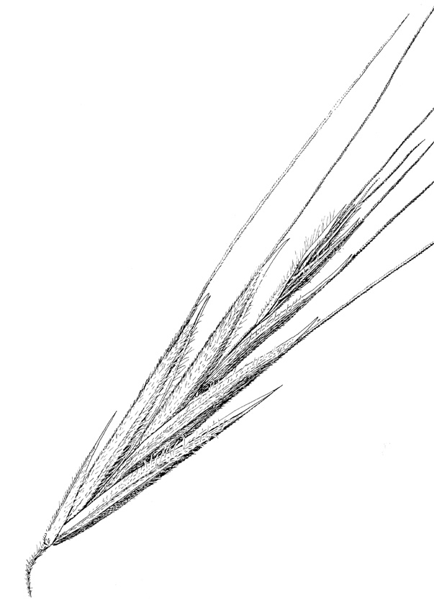
Hitchcock (1950)

Distribution
Bromus tectorum is one of the most widespread introduced annual grasses in the United States, occurring in all 50 states as well as in most of the Canadian provinces and in parts of Mexico. It is most common where annual rainfall ranges from 15-55 cm and autumn rainfall ranges from 5-12 cm (Peepers 1984). It is a weed of roadsides, fields, pastures, and waste places, usually occurring on dry, often alkaline, sandy or gravelly soils. Downy brome is especially common in the western states, particularly in the Columbia Basin and in the Great Basin (Morrow & Stahlman 1984). Uncommon or sporadic in the southeastern part of the United States, it is abundant over large areas of the sagebrush zone, where whole landscapes are turned first purplish by the developing inflorescences, then straw-brown as the plants mature and die. For current distribution, please consult the Plant Profile page for this species on the PLANTS Web site.

Control
Please contact your local agricultural extension specialist or county weed specialist to learn what works best in your area and how to use it safely. Always read label and safety instructions for each control method. Trade names and control measures appear in this document only to provide specific information. USDA, NRCS does not guarantee or warranty the products and control methods named, and other products may be equally effective.

Environmental and Mechanical: Environmental practices, which minimize the further spread of downy brome, are suggested by knowledge of the circumstances, which have accompanied its spread. Vehicles, clothing, camp gear, and pets should be cleaned of adhering seed after driving, camping, and walking in cheatgrass-infested areas. Excessive roadside and rangeland disturbance should be avoided. In cultivated fields, mowing before seeds are formed and clean cultivation assist in control. Infested meadows and pastures can be harrowed while seedlings are small (Muenscher 1955). In cropland, the best control is often achieved by planting continuous spring crops for two or more years; however, this practice may not be economically feasible (Kennedy et al. 1989).

Biological: Crown rot, with is adapted to dry soils, may be a potential biological control for downy brome in the arid environment of the western U.S. (Grey et al. 1995). Soil bacteria have been isolated which produce a toxin that is specific for downy brome and related species. Studies have shown that these bacteria can be used to suppress the growth of downy brome, thus resulting in substantial increases in winter wheat yields (Kennedy et al. 1989).

Applications of a strain (D7) of Rhizobacterium have been shown to selectively suppress downy brome in winter wheat test plots by means of a phytotoxin produced by the bacteria (Tranel et al. 1993), apparently by inhibition of root elongation.

Chemical: Only non-selective herbicides are presently available for control of downy brome. Since non-selective herbicides can kill all vegetation they contact, not just the problem weed, care must be taken that they do not contact desirable plants.

The chemical fluazifop has been shown to prevent seed formation in downy brome, most successfully when applied early in the reproductive phase (Richardson et al. 1987. Metribuzin or Metribuzin plus terbutryn, fall-applied, have succeeded in reducing downy brome infestations and increasing wheat yields. The combination results in better control . Sulfonylurea herbicides have been shown to increase winter wheat yields when used for cheatgrass control.

Three other herbicides that have been recommended for cheatgrass management are glyphosate, bromacil, and tebuthiuron. Formulations containing glyphosate are marketed as JURY, RATTLER, ROUNDUP, and RODEO. Those containing bromacil are sold as HYVAR X and HYVAR X-L. Tebuthiuron is sold as SPIKE 80W.

Glyphosate controls cheatgrass by inhibition of biosynthesis of amino acids. It is applied to above ground parts, since the active ingredient is adsorbed and made inactive by soil particles. Following absorption, glyphosate is translocated to underground structures and should thus be applied during active growth. Growth is inhibited soon after application, and foliar chlorosis and necrosis are seen within 10-20 days. Contact with formulations of glyphosate should be avoided. Ingestion requires emergency medical attention.

Bromacil inhibits photosynthesis. It is readily absorbed through the root system and is then translocated to foliage. It is applied as a spray just before or during the period of active growth, preferably when rain can be expected for soil activation. Application near desirable plants or grazing of cattle in treated areas should be avoided. After the herbicide has been carried into the root zone by rain, leaf chlorosis and defoliation occur within a week. Contact with bromacil may irritate eyes, nose, throat, and skin. In case of contact, flush eyes copiously with water and wash skin with soap and water. Get medical attention if irritation persists.

Tebuthiuron is a pre- and post-emergence herbicide used for total control of vegetation. A small amount of the herbicide in contact with roots of desirable plants may kill them. It produces browning of vegetation within one week, which suggests that it acts through photosynthesis inhibition. It is absorbed principally through the roots, and is readily translocated. For best results it should be applied before spring growth begins. At least one inch of rainfall is needed to activate the herbicide and place it in the seed germination zone, so it should be applied before the predominant portion of annual rainfall occurs. It may not be fully effective on clay soils or those high in organic matter. Tebuthiuron should not contact skin, clothing, or eyes (causes eye irritation). If it gets on skin or in eyes, wash with plenty of water; if swallowed, or if breathing difficulty develops from inhalation, get emergency medical attention.

References
Abrams, L. 1923. An illustrated flora of the Pacific States. Vol. 1. Stanford University Press, Stanford, California.

Albee, B.J., L.M. Shultz, & S. Goodrich 1988. Atlas of the vascular plants of Utah. Utah Museum of Natural History Occasional Publication No. 7.

Blackshaw, R. E. 1991. Control of downy brome (Bromus tectorum) in conservation fallow systems. 1991 Weed Tech. 5:557-562.

__________1993. Downy brome (Bromus tectorum) interference in winter rye (Secale cereale). Weed Science 41:557-562.

Cronquist, A., A. H. Holmgren, N. H. Holmgren, J. L. Reveal, & P. K. Holmgren 1977. Intermountain flora. Vol. 6. Columbia University Press, New York, New York.

FICMNEW (Federal Interagency Committee for the Management of Noxious and Exotic Weeds) 1997. Invasive plants – changing the landscape of America. Washington, D.C.

Gleason, H. A., & A. Cronquist 1991. Manual of vascular plants of northeastern United States and adjacent Canada. The New York Botanical Garden, Bronx, New York.

Gray, W. E., P.C. Quinby Jr., D.E. Mathre, & J. A. Youngll 1995. Weed Tech 9:362-365.

Hickman, J.C. (ed.) 1993. The Jepson manual. Higher plants of California. University of California Press, Berkeley, California.

Hitchcock, A. S. 1950. Manual of the grasses of the United States. USDA, Washington, DC.

Kennedy, A. C., F. L. Young, & L. F. Elliot 1989. Proceedings Western Society Weed Science 42:86.

Leopold, A. 1949. A Sand County Almanac, and sketches here and there. Oxford Univ.
Press, New York, New York.

Mack, R. 1981. Invasion of Bromus tectorum L. into western North America; an ecological chronical. Agro-ecosystems 7:145-165.

______, 1984. Invaders at home on the range. Natural History 93(2):40-47.

Morrow, L. A. & P. W. Stahlman 1984. The history and distribution of downy brome (Bromus
tectorum) in North America. North America Weed Science 32: supplement.

Muenscher, W.C. 1955. Weeds. The Macmillan Co., New York, New York.

Peeper, T. F. 1984. Chemical and biological control of downy brome. North American Weed Science 32.

Richardson, J. M., D. R. Gealy, & L. A. Morrow 1987. Weed Science 35: 277-281.

USDA, NRCS 2000. The PLANTS database. Version: 000412. <http://plants.usda.gov>. National Plant Data Center, Baton Rouge, Louisiana.

Uva, R.H., J.C. Neal, & J.M. DiTomaso 1997. Weeds of the northeast. Cornell University Press, Ithaca, New York. 397 pp.

Welsh, S. L., et al. 1987. A Utah flora. Great Basin Naturalist Memoirs No. 9. Brigham Young University, Provo, Utah.

Whitson, T.D. (ed.) 1991. Weeds of the west. Western Society of Weed Science, University of Wyoming, Laramie, Wyoming.

Prepared By

Elizabeth Neese
University of California, Botany Department, Berkeley, California

Species Coordinator

Mark Skinner
USDA, NRCS, National Plant Data Center, Baton Rouge, Louisiana

Edited 05dec00 jsp; 10feb03 ahv; 25may06jsp

For more information about this and other plants, please contact your local NRCS field office or Conservation District, and visit the PLANTS Web site<http://plants.usda.gov> or the Plant Materials Program Web site <http://Plant-Materials.nrcs.usda.gov>

The U.S. Department of Agriculture (USDA) prohibits discrimination in all its programs and activities on the basis of race, color, national origin, sex, religion, age, disability, political beliefs, sexual orientation, and marital or family status. (Not all prohibited bases apply to all programs.) Persons with disabilities who require alternative means for communication of program information (Braille, large print, audiotape, etc.) should contact USDA's TARGET Center at 202-720-2600 (voice and TDD).
To file a complaint of discrimination write USDA, Director, Office of Civil Rights, Room 326-W, Whitten Building, 14th and Independence Avenue, SW, Washington, DC 20250-9410 or call 202-720-5964 (voice or TDD). USDA is an equal opportunity provider and employer.
Read about Civil Rights at the Natural Resources Convervation Service.

