A Message from the Commissioner
______________________________________________________

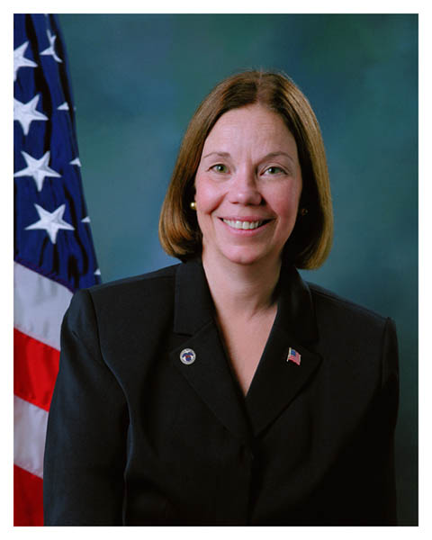
I am pleased to present the Social Security Administration’s Fiscal Year 2005 Annual Performance Plan (APP), and Revised Final Plan for FY 2004. This APP reflects my priorities of service, stewardship, solvency, and staff as set forth in SSA’s Strategic Plan. We developed an APP that is intimately interconnected with our long-range Agency Strategic Plan and the President’s FY 2005 budget for SSA. This document describes specific levels of performance the Agency is committed to achieve, and satisfies the statutory requirements of the Government Performance and Results Act.

Today, Social Security faces great challenges: giving the American people the service they expect and deserve, particularly as the number of beneficiaries increases with the aging of the baby boomers; providing program integrity through sound fiscal stewardship; ensuring the program’s financial solvency for future generations; and maintaining quality staff to continue our operations.

Despite these significant challenges, I remain confident that we will meet our goals. We can, and will, continue to improve. This APP includes performance indicators that are outcome-oriented. We also pay particular attention to program areas that we determined require immediate improvement.

I believe that this APP underscores our Agency’s commitment to find the best ways to be more responsive to claimants and beneficiaries who depend on us for excellent service and the nation’s taxpayers who fund our programs and expect sound fiscal stewardship.

Jo Anne B. Barnhart
Commissioner

