

PKI Credentialing System

AIMS-Enterprise Card Issuance and

Troubleshooting Manual

Date: May 04, 2004

Version: 1.1

www.activcard.com

Editing History:

Ver. | Date | Description
1.0 | December 15, 2003 | Document created
1.1 | January 12, 2004 | BLM Screen Shots added
2.0 | May 4, 2004 | Corrections and Major Revisions

Table of Contents

1 Introduction 5
2 General Pre-conditions for Smart Card Use 5
2.1 End User Workstation 5
2.2 Issuing Station 5
2.3 Smart Card Pin Requirements 5
3 End User Windows Login using Smart Card 6
3.1 Pre-conditions 6
3.2 Windows Login 6
3.3 Post-conditions 6
4 Face-to-Face Issuance of Initial Permanent Card 7
4.1 Pre-conditions 7
4.2 Issuance Operator Login (Local Issuance) 7
4.3 Enrollment 8
4.4 Post-conditions 11
5 Change Initial PIN 12
5.1 Pre-conditions 12
5.2 Change PIN on First Use 12
5.3 Post-conditions 12
6 Logout of another Operator 13
6.1 Pre-conditions 13
6.2 Operator Logout 13
6.3 Post-conditions 13
7 Validated Issuance of Initial Permanent Card 14
7.1 Pre-conditions 14
7.2 Operator Login 14
7.3 Validated Issuance Request Submission 14
7.4 Validated Issuance Request Approval 14
7.5 Execute the Validated Issuance Request 15
7.6 Post-conditions 15
8 Troubleshooting/Help Desk Operations 16
8.1 General Pre-conditions 16
8.2 Offline PIN Unlock Use Case 16
8.2.1 Pre-conditions 16
8.2.2 Unlock Challenge Generation 16
8.2.3 Unlock Response Generation 17
8.2.4 Unlock Response Injection 18
8.2.5 Post-conditions 18
8.3 Online PIN Unlock 18
8.3.1 Pre-conditions 18
8.3.2 Unlock Request Generation 18
8.3.3 Unlock Request Processing 19
8.3.4 Post-conditions 21

9 PKI Credential Management 22
9.1 PKI Credential Management: Hold 22
9.1.1 Pre-conditions 22
9.1.2 Hold Credential(s) 22
9.1.3 Post-conditions 23
9.2 PKI Credential Management: Resume 23
9.2.1 Pre-conditions 23
9.2.2 Resume Credential(s) 23
9.2.3 Post-conditions 23
9.3 PKI Credential Management: Revoke 23
9.3.1 Pre-conditions 23
9.3.2 Revoke Credential(s) 23
9.3.3 Post-conditions 24
9.4 PKI Credential Management: Terminate 24
9.4.1 Pre-conditions 24
9.4.2 Terminate Credential(s) 25
9.4.3 Post-conditions 25
9.5 PKI Credential Management: Recycle 26
9.5.1 Pre-conditions 26
9.5.2 Recycle Card 26
9.5.3 Post-conditions 26

- Introduction
This document is the operational manual for the Bureau of Land Management (BLM) to outline the steps required for Face-to-Face Issuance of Initial Permanent Card, Changing the smart card PIN at the Issuance Operator’s Workstation, and Change/Unlock PIN function.

Additional information about the use of the BLM PKI Credentialing System may be found at the following Website: http://web.wo.blm.gov/e-gov/index.htm
- General Pre-conditions for Smart Card Use
  - End User Workstation
- ActivCard Gold Middleware installed. This is a BLM National CM approved software package which should be installed via SMS or from the BLM Ent Distributed File System (DFS) share.
- A single Smart Card Reader installed. Administrative users should have two Smart Card Readers installed to facilitate administrative work requiring an alternate set of credentials.
  - Issuing Station
- ActivCard Gold Middleware installed. This is a BLM National CM approved software package which should be installed via SMS or from the BLM Ent Distributed File System (DFS) share.
- Two Smart Card Readers installed.
- Before issuance can occur, several other preconditions must be satisfied. These pre-conditions are outlined in the section entitled Face-to-Face Issuance of Initial Permanent Card which follows below.
  - Smart Card Pin Requirements
- PIN must be a minimum of 5 alpha/numeric characters
- PIN does not expire
- PIN is locked after 5 unsuccessful access attempts
- End User is warned after 4 unsuccessful access attempts
- Setting a new PIN resets the unsuccessful attempt counter

- End User Windows Login using Smart Card
  - Pre-conditions
- End User has ActivCard Gold and a smart card reader installed on their workstation
- End User has successfully changed the initial PIN at the Issuance Operator’s workstation
- Windows GINA is used
  - Windows Login
- End User’s workstation is at Windows Log On Screen or locked
- End User inserts card into reader
- Windows GINA switches from Username/Password screen to PIN screen
- End User enters PIN correctly
- End User is authenticated to the network using the VeriSign Authentication certificate
  - Post-conditions
- End User has access to workstation and network resources
- Face-to-Face Issuance of Initial Permanent Card
  - Pre-conditions
- Issuance Operator has been issued a valid smart card with valid VeriSign certificates and has been assigned the Issuance Operator role in AIMS-Enterprise. This step is completed by the AIMS Enterprise Administrative Operator. This role is filled by the Bureau Information Technology Security Manager (BITSM) or their designated representative.
- Issuance is performed via Face-to-Face Issuance per BLM Security Policy with the End User present. These policies are mandated by the Federal Bridge approved Certificate Policy and Certificate Practice Statements (CP/CPS).
- All CP/CPS required AD data fields are completed and correct. These include: First Name, Middle Initial, Last Name, E-mail address and User Principal Name (UPN). The UPN must consist of user logon @ corp.blm.gov (i.e. blmuser@corp.blm.gov). A National Help Desk Request may be submitted for assistance in the population of these fields.
- Change PIN on first use flag set in Card Profile.
- Issuance Operator has rights to issue card locally.
- Issuance Station has registry entry for certificate propagation turned off: Modify the following registry key to reflect the new value.
HKEY_LOCAL_MACHINE\SOFTWARE\Microsoft\Windows NT \CurrentVersion\Winlogon\Notify\ScCertProp

Enabled: 0

- Issuance Station has two smart card readers and ActivCard Gold installed.
- Issuance Operator has registered Certificates on Issuance Station.
  - Log into the Domain using the SmartCard
  - Launch ActivCard Gold Utilities
  - Go to TOOLS menu
  - Click on Register Certificates
  - Close ActivCard Gold.
- The user exists in Active Directory (AD).
  - Issuance Operator Login (Local Issuance)
- Issuance Operator uses their smart card to perform Windows login into the Domain.
- Issuance Operator launches Internet Explorer.
- Issuance Operator navigates to the URL for the AIMS-Enterprise Operator Portal. Notice that this URL uses Secure HTTP.
https://eauth.corp.blm.gov/aims/enterprise/operator

  - Enrollment
- Select Card Issuance tab in the Operator Portal.
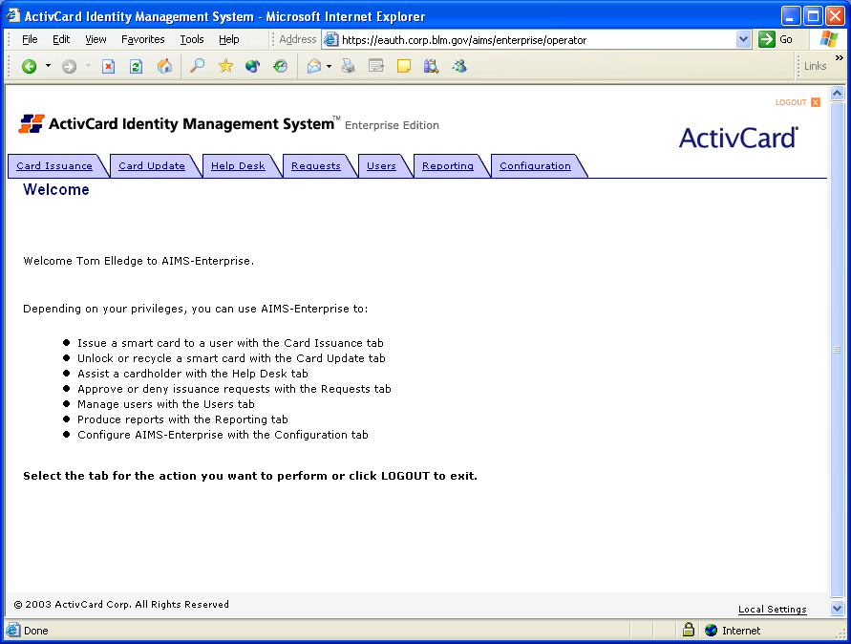

- Perform a User Lookup from the corporate directory.
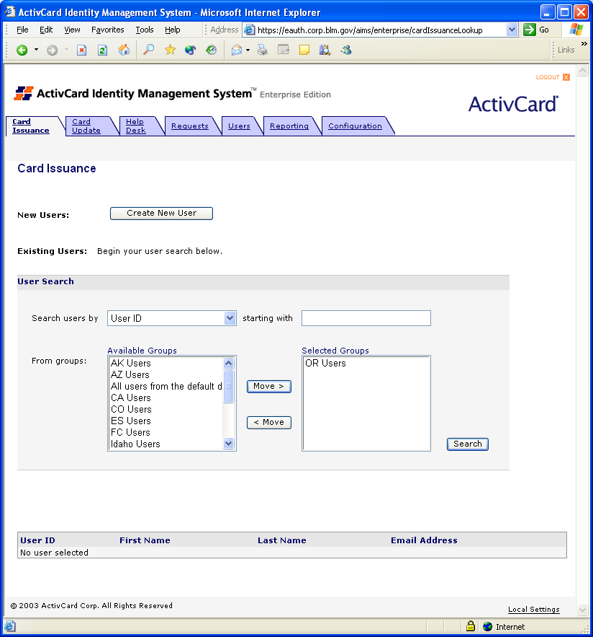
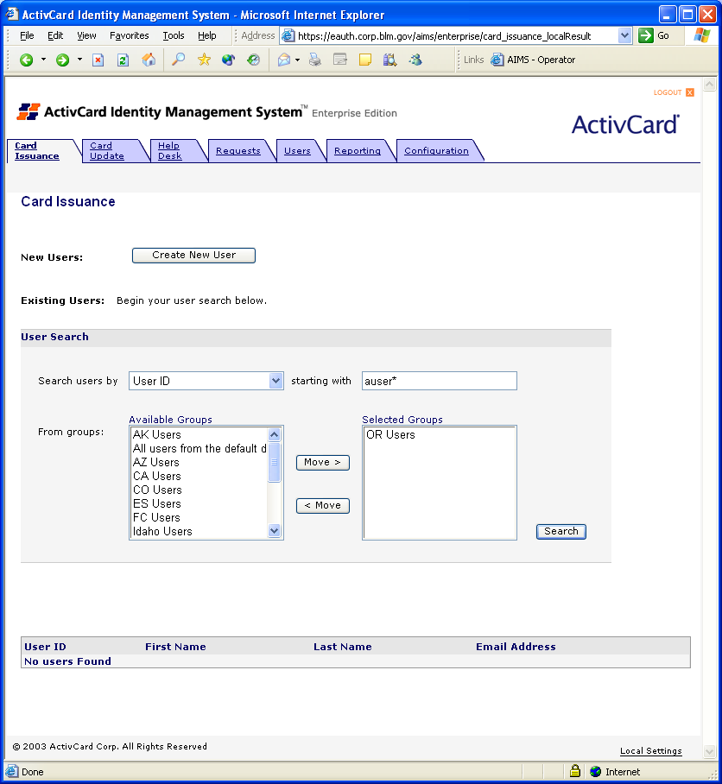
- Select the appropriate User.
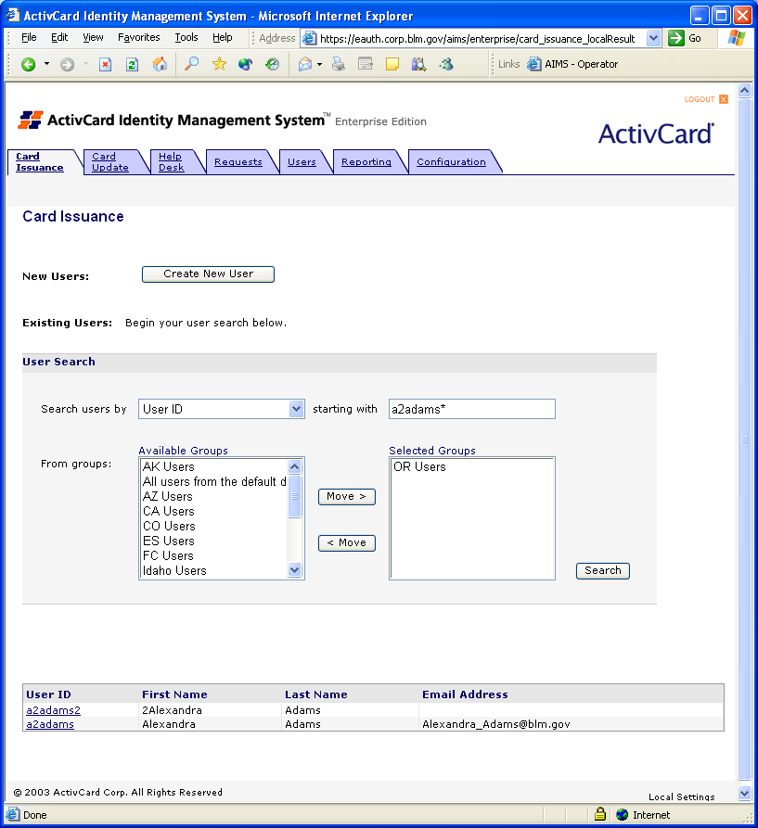
Note: If only one user is found – this screen is skipped and the screen in the next step will be displayed.
- Insert the user card into the card reader.
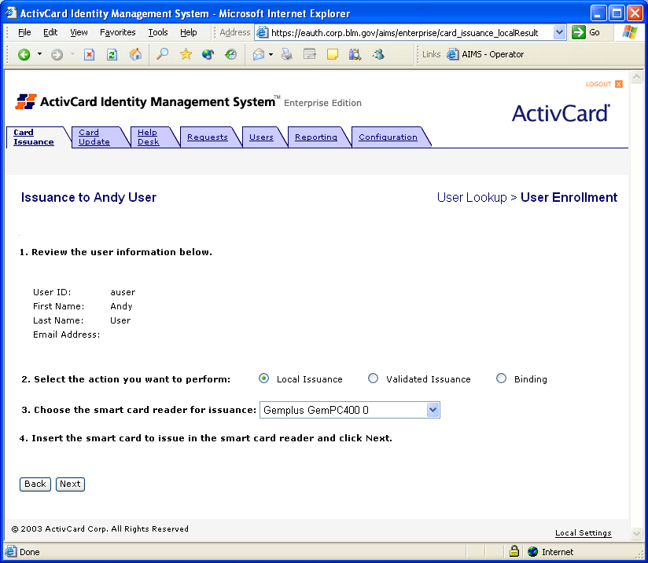
- Select the BLM Standard Card Policy.
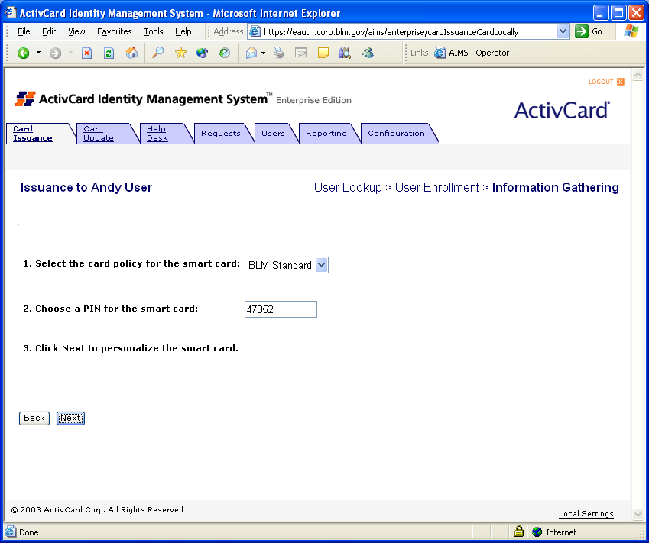
- AIMS-Enterprise randomly computes and displays an initial PIN. The Issuance Operator should not change the initial PIN. The screen on the following page will be displayed.
Q: What happens while the Operator waits?
A: AIMS-Enterprise personalizes the chip according to the card policy and binds the card to the End User.
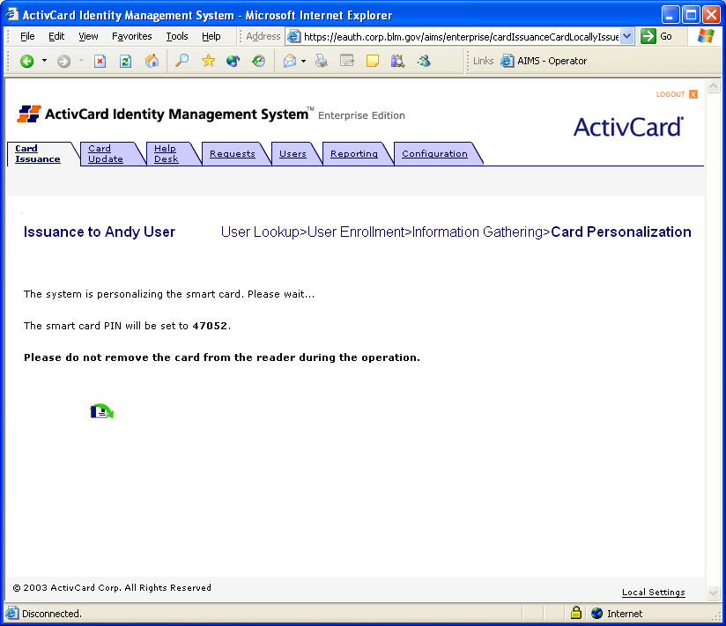
  - Post-conditions
- Card has been successfully issued using the BLM Standard Card Profile
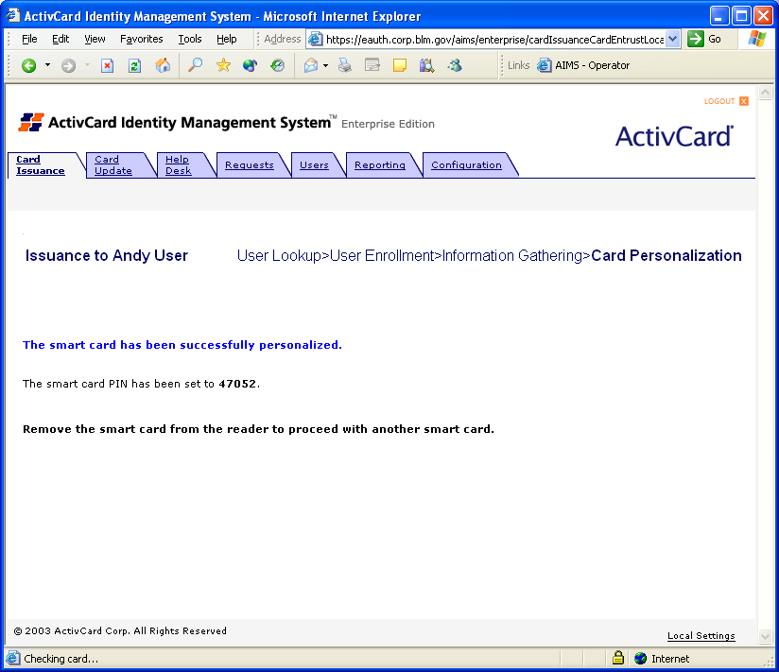

- End User remains with the Issuance Operator if available.
- Change Initial PIN
Note – Not all offices will have the end-user available during the issuance process. The following steps REQUIRE that a designated representative check the identification of the end user prior to transfer of the card.

  - Pre-conditions
- Card Issuance was successful
- End User is in presence of the Issuance Operator or their designated representative
- Representative/Issuance Operator does not witness PIN change
- End User has a workstation available with a User Account logged in
  - Change PIN on First Use
- Representative/Issuance Operator inserts smart card into reader and launches ActivCard Gold Utilities from the System Tray. Be sure to select the correct card reader.
- Representative/Issuance Operator or End User then enters the initial PIN. The system will then prompt for a PIN change.
Note: The Representative/Issuance Operator should not watch the process performed in the next two steps. This will ensure that the new PIN is only known to the End User.
- An ActivCard Gold dialog box will appear prompting End User to enter the initial PIN, a new PIN, and to confirm the new PIN.
- End User enters PIN and confirms.
- End User or Representative/Issuance Operator closes ActivCard Gold Utilities.
  - Post-conditions
- End User has successfully changed the initial PIN and has a PIN known only to him/her

- Logout of another Operator
NOTE: This is for the Administrative Operator only and is not available to Issuance Operators. These steps are only required if an Issuance Operator has incorrectly exited from the system and the account can no longer reconnect.
  - Pre-conditions
- Issuance Operator has been issued a valid smart card with valid VeriSign certificates and has been assigned the Issuance Operator role in AIMS-Enterprise
- Issuance Operator “A” has accidentally clicked on the “x” in the upper right corner of Internet Explorer
- Issuance Operator “A” is attempting to reconnect from another workstation and the session timeout has not expired
- Operator “B” is already authenticated to AIMS-Enterprise
  - Operator Logout
- Issuance Operator “B” selects the Configuration tab
- Use the Operators page and select Issuance Operator “A”
- The Operator Logout page will appear with Issuance Operator “A” displayed. Click on the Log Out button
  - Post-conditions
- Issuance Operator “A” will be logged out

- Validated Issuance of Initial Permanent Card
NOTE: This option is available but is not currently in use for BLM Issuance Operators
  - Pre-conditions
- Issuance Operator has been issued a valid smart card, has valid VeriSign certificates, and has been assigned the Issuance Operator role in AIMS-Enterprise
- Issuance is performed Face-to-Face at a Satellite Office per the BLM Security Policy with the End User present
- User exists in corporate directory
- Change PIN on first use flag set in Card Profile
- Issuance Operator has rights to only submit card issuance requests pending Security Manager approval
- Issuance Station has two smart card readers and ActivCard Gold installed
  - Operator Login
- Validated Issuance Operator uses their smart card to perform Windows logon into the Domain
- Validated Issuance Operator launches Internet Explorer
- Validated Issuance Operator uses the URL for the AIMS-Enterprise Operator Portal
  - Validated Issuance Request Submission
- Select Card Issuance tab in the Operator Portal
- Validated Issuance Operator performs a User Lookup from the corporate directory
- Validated Issuance Operator selects the appropriate User
- On the Issuance to John Doe screen the Operator will click on the Validated Issuance radio button
- Click Next to submit the Validated Issuance request for approval
  - Validated Issuance Request Approval
- The Security Manager selects the Requests tab in the Operator Portal
NOTE: The Security Manager has the option of selecting three types of searches: Overview to view all pending requests, User Search, and Request Search to view pending request by type. It is recommended that either User Search or Validated Issuance Request Search be used.
- The Security Manager selects Request Search, Validated Issuance from the pull down menu, and Awaiting Approval from the Status pull down menu
- Click Approve button on the Request Approval screen. AIMS-Enterprise will display a message stating that request status has been changed to Approved.
  - Execute the Validated Issuance Request
- Select Card Issuance tab in the Operator Portal
- Validated Issuance Operator performs a User Lookup from the corporate directory
- Validated Issuance Operator selects the appropriate User
- Validated Issuance Operator inserts user card into the card reader
- Validated Issuance Operator selects the BLM Standard Card Policy
- AIMS-Enterprise randomly computes the initial PIN
- Validated Operator does not change the initial PIN
Q: What happens while the Operator waits?
A: AIMS-Enterprise personalizes the chip according to the card policy and binds the card to the End User
  - Post-conditions
- Card has been successfully issued using the BLM Standard Card Profile
- End User remains with the Validated Issuance Operator and performs the steps defined in Section 3 – Change Initial PIN

- Troubleshooting/Help Desk Operations
Note: The term “Help Desk” refers to a function and not to an individual. The Help Desk functions are normally performed by the Issuance Operators. A National Issuance Operator may in the future be added.
  - General Pre-conditions
- Issuance Operator has been issued a valid smart card, has valid VeriSign certificates, and has been assigned the Issuance Operator role in AIMS-Enterprise
- Issuance Operator is authenticated to AIMS-Enterprise
- User exists in corporate directory
- User has been issued a valid smart card with valid VeriSign certificates
  - Offline PIN Unlock Use Case
NOTE: The PIN of a card is stored on the card. 5 failed attempts to enter the PIN will lock the card. This count is for the life of the PIN. The count may be reset by changing the PIN on the card.
    - Pre-conditions
- Card Holder exists in the corporate directory
- Card Holder has been issued a valid card
- Card Holder has ActivCard Gold Middleware and a smart card reader installed on his/her workstation
- Card Holder has exceeded the maximum incorrect PIN entries and locks card
- Card Holder can log into their workstation using their domain user account and password.
Note: When username/password is disabled, this option will no longer be available.
    - Unlock Challenge Generation
- Card Holder launches ActivCard Gold Utilities
- Card Holder selects the Unlock Card function
- ActivCard Gold Utilities computes and displays the unlock challenge

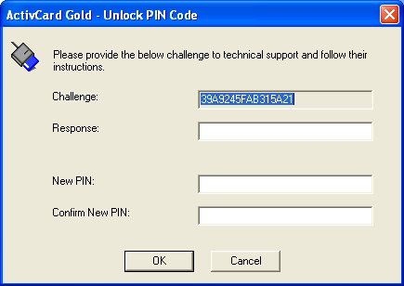
    - Unlock Response Generation
- Card Holder contacts Issuance Operator or their Designated Representative
- Issuance Operator/Representative validates the identity of Card Holder
- Issuance Operator searches for the Card Holder in the corporate directory
- AIMS-Enterprise displays the Card Holder’s card status as Active
- Issuance Operator selects the Get Unlock Code operation

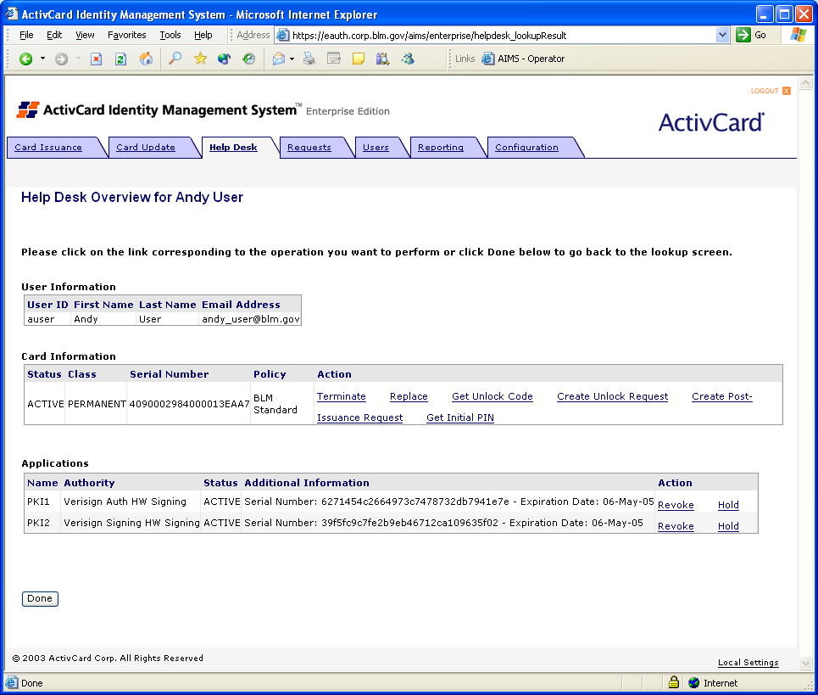

- Card Holder relays the Unlock Challenge to the Issuance Operator
- AIMS-Enterprise computes and displays the Unlock Response

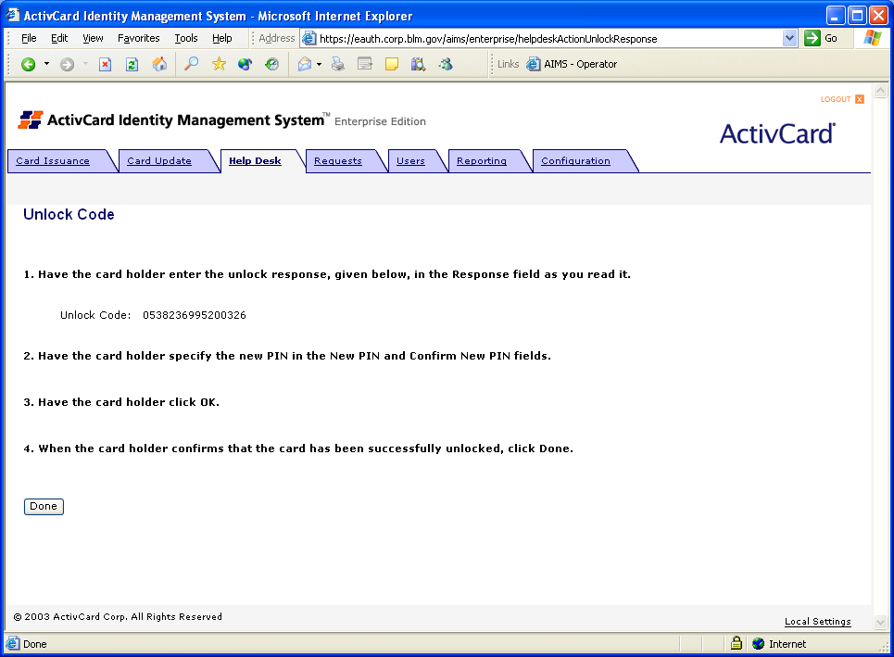

- Issuance Operator relays the Unlock Response to the Card Holder

    - Unlock Response Injection

- Card Holder enters the Unlock Response in ActivCard Gold Utilities
- Card Holder enters a new PIN in ActivCard Gold Utilities
- ActivCard Gold Utilities unlocks card and sets new PIN
    - Post-conditions
- Card is unlocked
- New PIN protects the card
  - Online PIN Unlock
NOTE: This procedure has a 10 minute timeout from request to completion.
    - Pre-conditions
- Card Holder exists in the corporate directory
- Card Holder has been issued a valid card
- Card Holder has ActivCard Gold and a smart card reader installed on his/her workstation
- Card Holder has exceeded the maximum incorrect PIN entries and locks card
- Law Enforcement or trusted Security Manager Agent validates Card Holder identity to Issuance Operator
    - Unlock Request Generation

- Card Holder contacts Issuance Operator\Representative
- Issuance Operator validates identity of Card Holder with a Law Enforcement or trusted Security Manager agent
- Issuance Operator searches for the Card Holder in the corporate directory
- AIMS-Enterprise displays the Card Holder’s card status as Active
- Issuance Operator selects the Unlock Request operation
- AIMS-Enterprise generates a random activation PIN

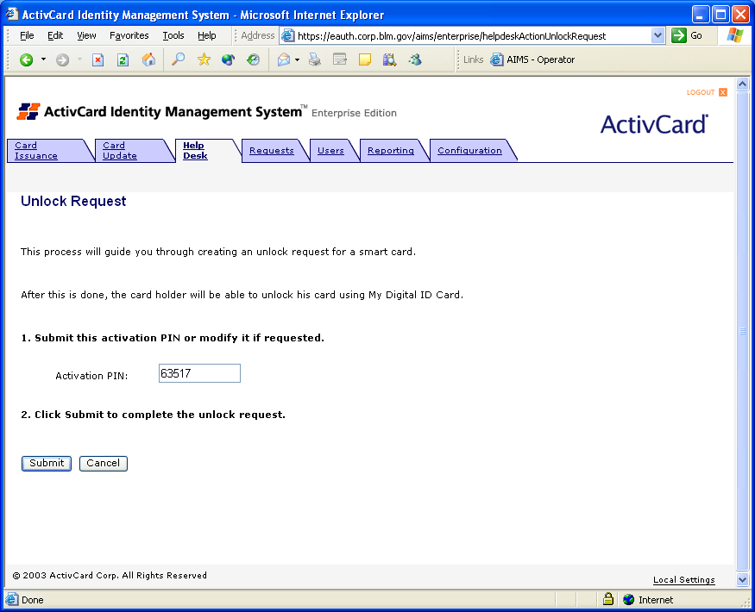

- Issuance Operator updates the activation PIN if necessary
- Issuance Operator submits the request

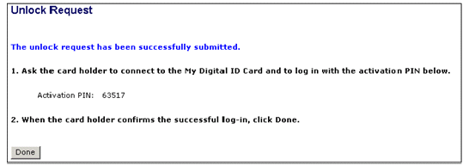

- Issuance Operator provides the Card Holder the Activation PIN
    - Unlock Request Processing

- Card Holder logs onto his/her workstation using domain username/password. This may be accomplished at a designated representative workstation with 2 card readers.

Note: This option will not be available when username/password is disabled.

- Card Holder inserts card into reader

- Card Holder enters the Activation PIN to authenticate to SmartCard Management System (SCMS) – This is by default the AIMS user portal https://eauth.corp.blm.gov/aims/enterprise/user

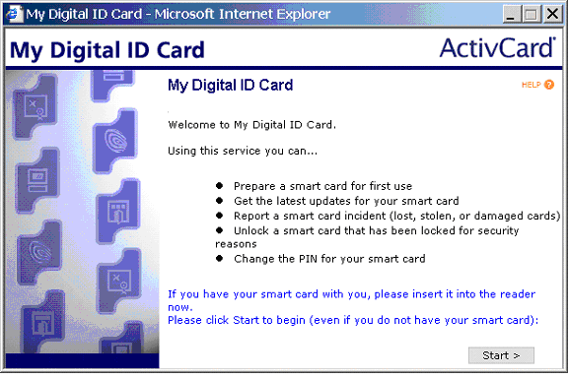

- AIMS-Enterprise automatically detects and executes the pending Unlock Request

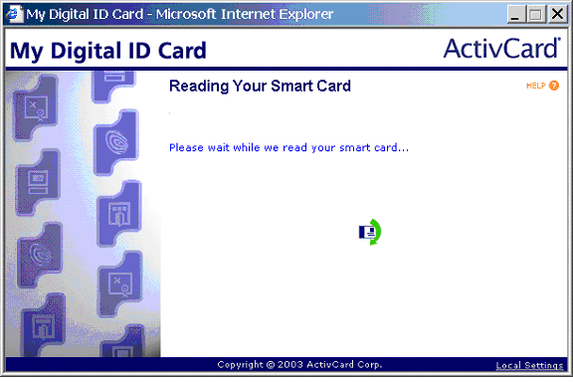

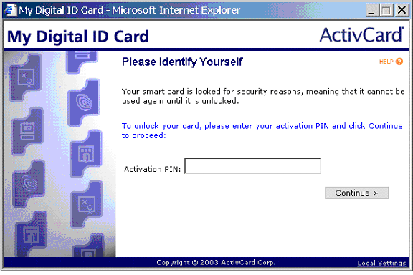

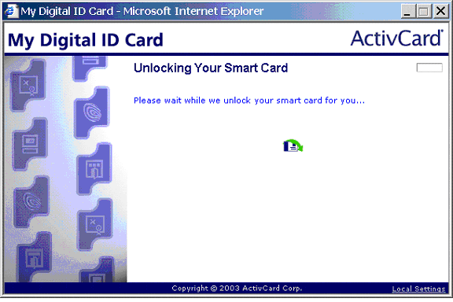
- Card Holder enters new PIN

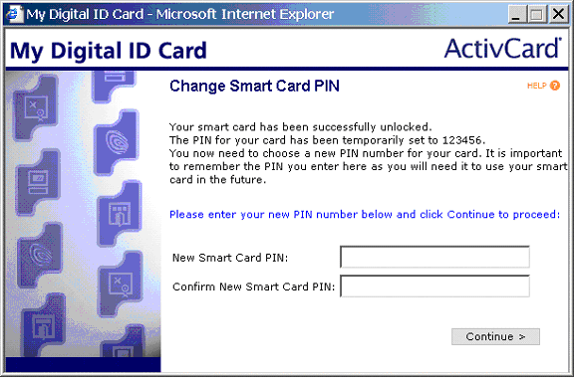
- AIMS-Enterprise injects the new PIN into the card

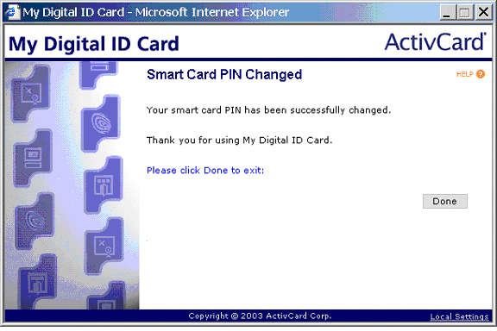

- Card Holder clicks on the Done button to complete the process
    - Post-conditions
- Card is unlocked
- New PIN protects the card
- PKI Credential Management
  - PKI Credential Management: Hold
This process should be followed when a permanent card has been misplaced or the individual is a seasonal employee who is expected to return next season or for an individual who is on extended leave such as a long term illness.
    - Pre-conditions
- Card assigned to Card Holder by AIMS-Enterprise
- Valid AIMS-Enterprise issued PKI credential(s) stored on card
- Credential status is Active
- Law Enforcement or trusted Security Manager agent validates Card Holder identity to Issuance Operator
    - Hold Credential(s)
- Issuance Operator is contacted to Hold credentials for a Card Holder
- Issuance Operator verifies the identity of the requestor by a Law Enforcement or trusted Security Manager agent validates Card Holder identity to Issuance Operator (outside scope of AIMS-Enterprise)
- Issuance Operator searches for Card Holder in corporate directory
- AIMS-Enterprise displays the credential status as Active

- Issuance Operator selects the Hold operation
- AIMS-Enterprise suspends the credential(s)
    - Post-conditions
- AIMS-Enterprise has placed a request with the Certificate Authority (CA) to suspend the PKI credential(s) of the Card Holder
- AIMS-Enterprise has changed the credential status from Active to Hold

  - PKI Credential Management: Resume
This process should be followed when a permanent card has been located after being lost or anytime a card has been placed in a Hold status and needs to be reactivated for use.
    - Pre-conditions
- Card assigned to Card Holder by AIMS-Enterprise
- Valid AIMS-Enterprise issued PKI credential(s) stored on card
- Credential status is Hold
- Law Enforcement or trusted Security Manager agent validates Card Holder identity to Issuance Operator
    - Resume Credential(s)
- Issuance Operator is contacted to Resume credentials for a Card Holder
- Issuance Operator verifies the identity of the requestor by a Law Enforcement or trusted Security Manager agent validates Card Holder identity to Issuance Operator (outside scope of AIMS-Enterprise)
- Issuance Operator searches for Card Holder in corporate directory
- AIMS-Enterprise displays the credential status as Hold
- Issuance Operator selects the Resume operation
- AIMS-Enterprise changes the credential status to Active
    - Post-conditions
- AIMS-Enterprise has placed a request with the Certificate Authority (CA) to remove the suspension of the PKI credential(s) of the Card Holder
- AIMS-Enterprise has changed the credential status from Hold to Active

  - PKI Credential Management: Revoke
This process should be followed to revoke individual credentials on a card.
    - Pre-conditions
- Card assigned to Card Holder by AIMS-Enterprise
- Valid AIMS-Enterprise issued PKI credential(s) stored on card
- Credential status is Active
- Law Enforcement or trusted Security Manager agent validates Card Holder identity to Issuance Operator
    - Revoke Credential(s)
- Issuance Operator is contacted to Revoke credentials for a Card Holder
- Issuance Operator verifies the identity of the requestor by a Law Enforcement or trusted Security Manager agent validates Card Holder identity to Issuance Operator (outside scope of AIMS-Enterprise)
- Issuance Operator searches for Card Holder in corporate directory
- AIMS-Enterprise displays the credential status as Active

- Issuance Operator selects the Revoke operation for the credential to revoke

NOTE – individual credentials maybe revoked or the entire card may be terminated.

- AIMS-Enterprise revokes the credential
    - Post-conditions
- AIMS-Enterprise has placed a request with the Certificate Authority (CA) to revoke the PKI credentials of the Card Holder
- AIMS-Enterprise has changed the credential status from Active to Revoked

  - PKI Credential Management: Terminate
This process should be followed the terminate a card. A card must be terminated when an employee no longer requires logical access to Active Directory or Network Resources such as when they leave government service.
NOTE: The End User must not be removed from Active Directory before the credentials on their Smart Card are terminated.
    - Pre-conditions
- The End User must exist in Active Directory.
- Card assigned to Card Holder by AIMS-Enterprise
- Valid AIMS-Enterprise issued PKI credential(s) stored on card
- Credential status is Active
- Law Enforcement or trusted Security Manager agent validates Card Holder identity to Issuance Operator
    - Terminate Credential(s)
- Issuance Operator is contacted to Terminate credentials for a Card Holder
- Issuance Operator verifies the identity of the requestor by a Law Enforcement or trusted Security Manager agent validates Card Holder identity to Issuance Operator (outside scope of AIMS-Enterprise)
- Issuance Operator searches for Card Holder in corporate directory
- AIMS-Enterprise displays the credential status as Active

- Issuance Operator selects the Terminate operation for the credential to revoke

NOTE – this action revokes all credentials on the entire card.

- AIMS-Enterprise terminates the card
    - Post-conditions
- AIMS-Enterprise has placed a request with the Certificate Authority (CA) to revoke the PKI credentials of the Card Holder
- AIMS-Enterprise has terminated the card

  - PKI Credential Management: Recycle
Once a smart card has been terminated it may be recycled to allow it to be used solely for physical access. Before commencing upon this process, the card must be run through a printing station and the existing identification oblitherated by a black covering. Once this is done and the card has been recycled, it may be used for purely physical access.
A Issuance Operator may also be requred to Recycle a card if the issuance process fails. Before attempting to reissue the card, a Recycle process should be exectued.
    - Pre-conditions
- Credential status is Terminated
    - Recycle Card
- Issuance Operator is contacted to Recycle a Card
- Issuance Operator verifies the identity of the requestor by a Law Enforcement or trusted Security Manager agent validates Card Holder identity to Issuance Operator (outside scope of AIMS-Enterprise)
- Issuance Operator selects Card Update in AIMS-Enterprise

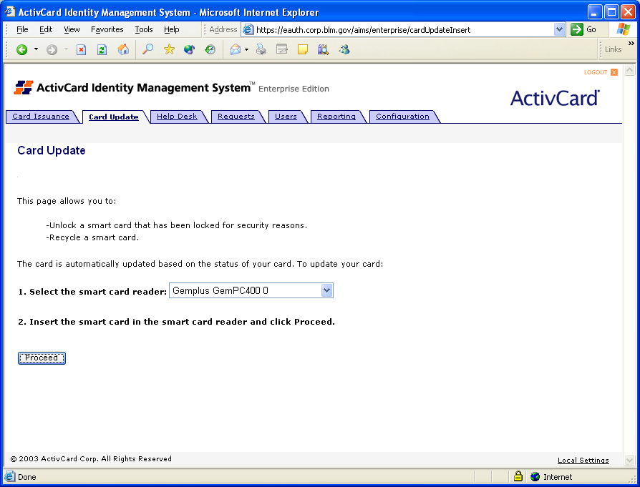

- Insert the Card into the reader and ensure that the correct reader is selected and click on the Proceed button
- AIMS-Enterprise displays the status of the card as Terminated
- Issuance Operator clicks on the Recycle button
- AIMS-Enterprise recycles the card
    - Post-conditions
- AIMS-Enterprise has recycled the card

