
U.S. Department of Justice
Drug Enforcement Administration
Timothy J. Landrum
Special Agent in Charge
Los Angeles Field Division
www.dea.gov

Fact Sheet

High Intensity Drug Trafficking Area
Southern California Drug Task Force

The High Intensity Drug Trafficking Areas program (HIDTA) was authorized by the Anti-Drug Abuse Act of 1988 and is administered by the Office of National Drug Control Policy. Since the original designation of five HIDTAs in 1990, the program has expanded to 31 areas of the country, including five partnerships along the southwest border. The DEA plays a very active role, and now has 282 special agent positions dedicated to the program.
The HIDTA's mission is to reduce drug trafficking in the most critical areas of the country, thereby reducing its impact in other areas. This is accomplished by institutionalizing teamwork among local, state, and federal efforts; synchronizing investments in strategy-based systems; and focusing on outcomes.
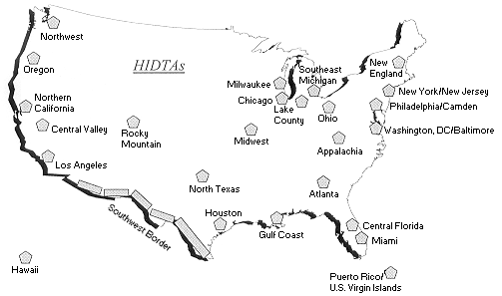
- The DEA led Southern California Drug Task Force (SCDTF/HIDTA) is an integral part of the DEA’s enforcement strategy.

- The SCDTF/HIDTA enforcement efforts focus on international and national/regional priority targets with emphasis on organizations trafficking heroin, cocaine, methamphetamine, PCP, and precursor chemicals.

- Currently, the SCDTF/HIDTA is composed of personnel from 18 federal, state, and local law enforcement agencies.

- Local police agencies contributing personnel to the Task Force receive priority investigative support from the Task Force for local impact drug investigations.

-30-

