
Indiana Farm Service Agency
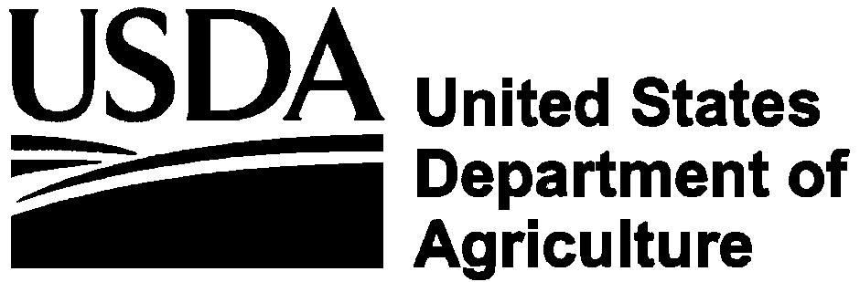 |  | Indiana FY 2005 Accomplishments |  | December 2005
Fiscal Year 2005

The Farm Service Agency (FSA) supports American farmers through a variety of Credit and Commodity Programs designed to stabilize and enhance our rural landscape. FSA is at the forefront of providing services that farmers have come to trust in order to compliment their operations in times of plenty and brace their operations during times of economic insecurity.

Making Credit Available to Indiana Farmers

$74.4 Million Available to Indiana Farmers - FSA county offices approved 473 loans totaling $74,479,000 to producers, including:

$29 Million in Farm Operating Loan - FSA processed 300 loans, totaling $29,090,000 in Direct and Guaranteed Farm Operating Loans to help Indiana farmers plant crops, purchase livestock, or reorganize their operation.

$45 Million in Farm Ownership Loans - FSA processed 173 loans, making $45,383,000 in credit available to Indiana farmers through the Direct and Guaranteed Farm Ownership Loan programs. The loan funds were used to purchase real estate and construct buildings.

Of these Direct and Guaranteed loans - $20.6 Million in Special Qualified Loans. FSA processed 20 loans, making $2,241,000 to qualified producers under the Socially Disadvantaged Loan Program, and $18,473,000 to 134 qualified beginning farmers.

Emergency Loans – Farmers can also qualify for Emergency Loan funds. These loans are used to purchase feed, pay production costs, and restore or replace essential property destroyed by weather-related disasters

$66,000 for Youth Loans - Under the Youth Loan program, 25 youths received $66,850 to establish and operate income- producing projects. Money was used to purchase supplies, animals, and equipment, and pay operating expenses.

Price Support and Farm Programs

$363 Million in Marketing Assistance Loans: Marketing assistance loans provide producers interim financing at harvest time to meet cash flow needs without having to sell their commodities when prices are typically at harvest-time lows. In Fiscal year 2005, Indiana made 7,136 commodity loans for $363,899,054.

$16 Million in Market Gains for Indiana for FY 2005: Marketing assistance loans provide producers interim financing at harvest time. A producer receives a marketing loan gain if the loan is repaid at less than the loan principal. Indiana producers received $16,419,917 in market gains for fiscal year 2005.

$2 Million in Farm Stored Facility Loans: Loans are made to producers to build or upgrade farm storage and handling facilities. In FY 2005, Indiana disbursed 40 loans totaling $2,011,757.

$255 Thousand in Milk Income Loss Contract (MILC) Payments: MILC is a safety net for dairy farmers established under the 2002 farm bill. FSA provided $255,101 in payments to eligible dairy farms when the Boston Class I milk price was below $16.94 per hundredweight (cwt.). This program benefited all dairy operations, regardless of size. Eligible milk production for payment purposes cannot exceed 2.4 million pounds per operation.

$315 Million in Direct and Counter-Cyclical Payments The 2002 Farm Bill replaced production flexibility contract (PFC) payments with direct payments, and added new counter-cyclical payments. Both payments are established from historical acreage bases and payment yields and not on current production. These payments are issued to producers with a history of growing corn, oats, barley, wheat, soybeans and other oilseeds. 116,005 farms enrolled in DCP during FY 2005 received a total of $315,582,521 in payments.

$272.5 Million in Loan Deficiency Payments: LDP’s help bridge the difference between low market prices and established target prices set by the government. The target price is the lowest price farmers should expect to receive for their commodities.

$43.7 Million in Conservation Reserve Program Payments The Conservation Reserve Program is USDA’s largest environmental improvement program on private lands. Indiana farmers received $24,629,148 in annual rental payments for removing highly erodible land and environmentally sensitive cropland from production. Newly enrolled program participants received $10,342,438 in CRP cost-share payments. Cost sharing is provided to cover part of the cost to establish conservation measures on the land. This may include re-establishing native or perennial grasses, planting trees or fencing animals out of streams. Incentive payments totaling $8,763,557 were paid out under CRP. Incentive payments are offered in some cases to encourage participation and to protect highly sensitive land surrounding waterways.

$120,262 in Emergency Conservation Program Funds: Farmers whose cropland was severely damaged by storms received $120,262 in assistance. Cost sharing is used to repair the land and return it to productive agricultural use.

$133,515 in Lamb Meat Adjustment Assistance Payments - Shepherds received $133,515 under a program designed to help them raise a higher quality meat product for market.

$176,915 in Noninsured Assistance Program
Producers of noninsured crops in Indiana received $176,915 in benefits. These benefits are paid to provide financial assistance to producers of non-insurable crops when low yields, loss of inventory, or prevented planting occurs as result of natural disasters or when the catastrophic level of crop insurance is not available.

$50,841 in Grassland Reserve Payments: which help landowners restore and protect grassland, rangeland, pastureland, and certain other lands and provides assistance for rehabilitating grasslands.

$60,911 in the Wetland Reserve Program: This program offers landowners an opportunity to establish long-term conservation and wildlife practices and protection. The program is designed to achieve the greatest wetland functions and values, along with optimum wildlife habitat on every acre enrolled.

$8.3 Million in Tobacco Transition Payment
Program (TTPP):
The tobacco marketing quota and price support loan programs ended with the 2004 crop. Payments will be made under TTPP that are intended to help tobacco producers make the transition from a federal regulated program which provided the safety net of price support loans, to an environment in which there will be no planting restrictions, no marketing cards, and no safety net of price support. Sign-up for TPP began on March 14 and ended on June 17, 2005

Indiana Ag Highlights
2004 Production & Livestock Ranking

Number of Farms | 59,300
Land in Farms | 15 Million
Cropland Area | 12.9 Million
Popcorn | 2nd in Nation
Soybeans | 3rd
Corn | 5th
Tomatoes Processing | 2nd
Winter Wheat | 16th
Ducks | 1st in Nation
Milk Cows | 14th
Beef Cows | 33rd
All Hogs | 5th

The U.S. Department of Agriculture (USDA) prohibits discrimination in all its programs and activities on the basis of race, color, national origin, gender, religion, age, disability, political beliefs, sexual orientation, and marital or family status. (Not all prohibited bases apply to all programs.) Persons with disabilities who require alternative means for communication of program information (Braille, large print, audiotape, etc.) should contact USDA’s TARGET Center at 202-720-2600 (voice and TDD).
To file a complaint of discrimination, write USDA, Director, Office of Civil Rights, Room 326-W, Whitten Building, 1400 Independence Avenue, SW, Washington, D.C., 20250-9410, or call (202) 720-5964 (voice or TDD).
USDA is an equal opportunity provider and employer.

