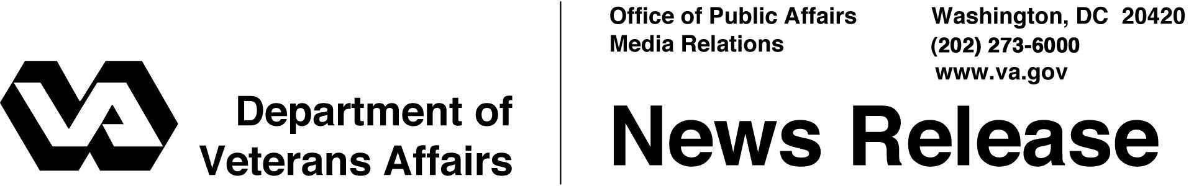

FOR IMMEDIATE RELEASE
September 29, 2004

Veterans head to Salt Lake City for 2004 Creative Arts Festival
WASHINGTON – Nearly 100 veterans from across the country who are medal winners in national music, dance, drama or art contests are preparing to attend the 16th annual National Veterans Creative Arts Festival in Salt Lake City from October 9-16, 2004.
The festival is the culmination of a year-long fine arts talent competition with 3,000 participants nationwide that was open to all veterans receiving care at Department of Veterans Affairs (VA) medical facilities.
"The National Veterans Creative Arts Festival helps demonstrate that real healing goes well beyond a person’s physical needs," said Secretary of Veterans Affairs Anthony J. Principi. "For many veterans, the festival has been more than a one-week event. It is a stepping-stone to further artistic success."
These talented veterans will come to Salt Lake City for a week of rehearsals and workshops concluding on Friday, Oct. 15, with a visual art exhibit at the Edgar J. Thompson Music Hall, and a gala variety stage show at Kingsbury Hall, both on the University of Utah campus.
The artists will exhibit their work from 6:00 p.m. to 7:15 p.m. in Gardner Hall. At 7:30 p.m., the music, drama and dance performers will showcase their talent in the stage show, backed by a professional orchestra. Renowned actress of Hollywood’s golden era, Jane Powell, will be the mistress of ceremonies for the show.
Deputy Secretary Gordon Mansfield will be in attendance during the week to visit with veterans and attend rehearsals for the Festival stage show. Actress Bo Derek, National Honorary Chairperson of VA’s National Rehabilitation Special Events, will attend the Festival again this year to meet with veterans and attend the art exhibit, stage show and closing ceremonies.

Creative Arts 2/2/2/2

The festival is presented by VA, the American Legion Auxiliary and Help Hospitalized Veterans. It is hosted this year by the George E. Wahlen VA Medical Center in Salt Lake City.
For further information about the festival, contact Kim Byers, public affairs coordinator, at (734) 761-7824, or log on to the festival’s website: www.creativeartsfestival.org. During the festival, call (801) 883-3414.

# # #

People wishing to receive e-mail from VA with the latest news releases and updated fact sheets can subscribe at the following Internet address:
http://www.va.gov/opa/pressrel/opalist_listserv.cfm

