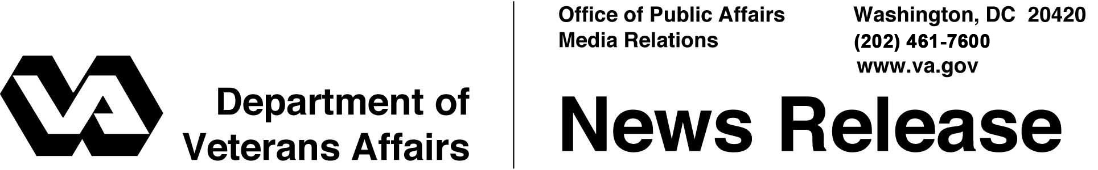

FOR IMMEDIATE RELEASE
June 17, 2008

Statement by the Department Of Veterans Affairs
On Smoking Cessation Research Program

WASHINGTON -- Reports in the news media today that the Department of Veterans Affairs (VA) is testing drugs on war veterans are inaccurate and misleading. VA conducts extensive and often groundbreaking, evidence-based research nationwide to discover better health care methods for our veterans. In our PTSD and smoking cessation study, our research is to learn if it is easier to stop smoking when smoking cessation treatment is combined with PTSD therapy, or whether the two therapies are more effective if they are provided separately. In either case, patients are receiving treatment recommended by their own doctors using counseling with or without FDA approved medication that includes Varenicline (Chantix). Participation in this program is voluntary, and all participants are closely monitored clinically by mental health professionals who provide smoking cessation methods patients agree to use.
More than six million prescriptions were written for Varenicline in the United States in 2007; it is an FDA-approved, widely used medication for smoking cessation. In November, 2007, FDA issued an “early communication” to health care providers indicating concerns had arisen about the medication having a possible side effect involving mental health; VA immediately passed along that concern to practitioners at all of our medical centers. On February 1, FDA issued a “Public Health Advisory,” to providers, providing more information on potential side effects of which clinicians and patients should be aware. VA distributed this alert to pharmacists in its system on that same day, and to researchers on February 5. FDA has never asked that Varenicline be removed from the market, and it continues to be FDA approved as a safe and efficacious medication.
- More -

Chantix 2/2/2/2

It is important to note that neither FDA nor the manufacturer has ever recalled Varenicline, and VA has never been asked to do so.
Had a recall been requested, VA would immediately have notified patients and stopped refilling prescriptions, standard procedure when such recalls occur. VA’s letter to patients in the study using Varenicline was carefully written by a team of psychiatrists and psychologists, and clearly and specifically requested patients to come in and discuss possible side effects of which they should be aware; these professionals felt that the issue of suicide should be discussed in a clinical setting, not in a mailing to a group of patients.
The implication that a modest payment for volunteers in medical research programs is somehow wrong is a distortion. Such payments are a widely used practice, both in VA and in the private sector, to help volunteers pay for expenses. The characterization of the purpose of these payments was entirely incorrect.
Treating PTSD is very important to VA and to veterans, and smoking can kill. This research program, like all VA research, is approved by independent institutional review boards to ensure the safety of all participants. The progress of the study is regularly scrutinized by a VA Data Safety Monitoring Board that closely tracks any and all reported side effects related to the study to ensure safety.
VA's use of Varenicline is consistent with guidelines on smoking cessation the U.S. Surgeon General's office has established. VA is committed to the ethical treatment of all who participate in our research studies, to the principle of informed consent, and to treating veterans participating in our research programs with the highest quality and most advanced health care available. The VA cares about every veteran who suffers from PTSD, and that concern reinforces our obligation to quality research and providing the best treatments possible.
# # #

