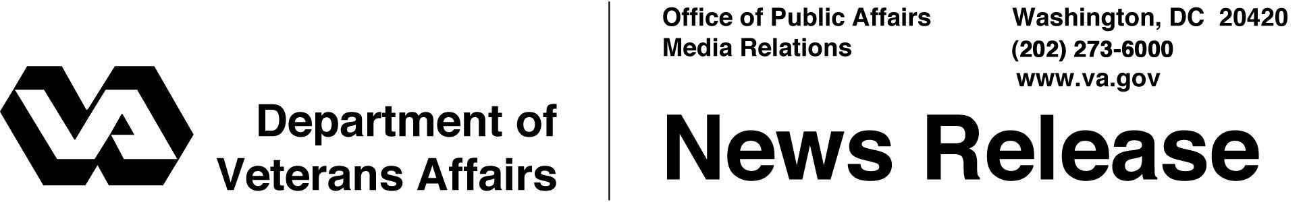

FOR IMMEDIATE RELEASE
September 9, 2005

VA Secretary Gives Katrina Report to Congress
WASHINGTON – During Hurricane Katrina, the employees of the Department of Veterans Affairs (VA) have been "heroic patriots in a tragedy of unprecedented proportions," the Honorable R. James Nicholson, Secretary of Veterans Affairs told members of four congressional committees Thursday.
"What they have been through defies description," he said. "Even as they endured personal tragedy, their commitment to their patients and to the mission of VA has been unflagging."
Nicholson made his remarks Thursday to members of the House and Senate committees for appropriations and veterans affairs, following a two-day visit to the stricken area. The Secretary told lawmakers about VA health care professionals sleeping only two or three hours a day, and others giving themselves intravenous fluids to preserve water for the patients.
Among the lessons VA has drawn from the tragedy are the importance of realistic emergency drills; the need to ensure that families of health care workers are safe during natural disasters; and the rewards of empowering employees to "do the right thing," free of bureaucratic oversight during emergencies.
"We will need additional funding for clean up, repairing facilities, providing temporary facilities and staffing," Nicholson said. "In the intermediate and longer term, there will be rebuilding – and rebuilding to withstand forces never before encountered."
Information for veterans, the families of patients in the affected area and VA employees is available by calling 1-800-507-4571 and on the Internet at http://www.va.gov/opa/katrina.

