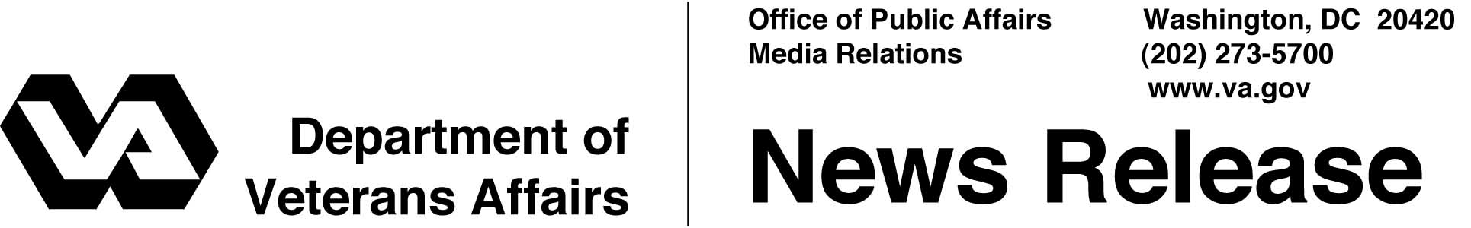

FOR IMMEDIATE RELEASE
April 4, 2002

New Mastectomy Compensation Regulation Issued

WASHINGTON -- The Department of Veterans Affairs (VA) has issued a final regulation that awards special monthly compensation to women veterans with service-related loss of one or both breasts.

Such anatomic losses may include simple, modified or radical mastectomies. The regulation is based on provisions of the Veterans Benefits and Health Care Improvement Act of 2000.
Federal law provides a special monthly benefit of $80 for certain service-related disabilities suffered by veterans.
This special benefit is paid in addition to VA's regular disability compensation. To qualify, recipients must have their conditions officially recognized by VA as being "service-connected."
In addition to loss of breasts, this special benefit is paid for a variety of other anatomical losses and for certain conditions affecting speech, hearing and sight.
VA estimates it will receive about 600 cases over five years, at an estimated cost of $2.9 million.
The new regulation became effective March 18.
# # #

