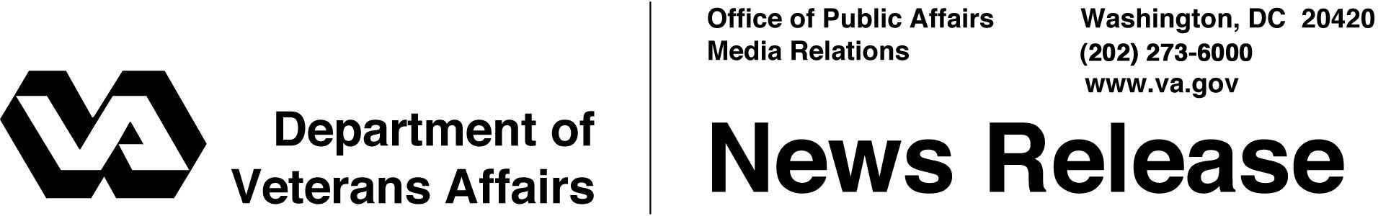

FOR IMMEDIATE RELEASE
November 23, 2005

VA's Online RX Refill Service the Right Prescription for Vets
Secretary Nicholson: Service is "Fast, Easy and Secure"
WASHINGTON – Tens of thousands of veterans are now receiving their prescription drug refills from the Department of Veterans Affairs (VA) with greater convenience, speed and security, thanks to a new service available to veterans over the Internet.
More than 70,000 prescriptions have been refilled using the latest service added to VA's "MyHealtheVet," the personal online health record system designed for veterans in the VA health care system. The prescription refill service began on Aug. 31.
"VA's MyHealtheVet prescription refill service is proving to be extremely successful in providing America's veterans with fast, easy and secure access to their important medications," said the Honorable R. James Nicholson, Secretary of Veterans Affairs. "Given the overwhelmingly positive response VA has received to this initiative from our veterans, we anticipate that thousands more veterans will choose to take advantage of this convenient service."
The secure online prescription refill service has quickly emerged as one of the more popular features in the MyHealtheVet system, which connects with VA's widely respected electronic records system.
When a veteran orders a prescription refill, the request is routed to VA's computer system to be filled by one of the department's outpatient mail pharmacies. The refill is then sent directly to the veteran, eliminating the need for a trip to the pharmacy and a wait in line.
- More -
MyHealtheVet 2/2/2/2

On Veterans Day, Nov. 11, 2005, MyHealtheVet marked its second anniversary by adding three new health records that veterans can keep in a secure electronic environment and make available to VA health professionals nationwide – blood oxygen levels taken from a pulse oximeter, daily food intake in the Food Journal, and physical activity and exercise in the Activity Journal.
By last month, more than 100,000 veterans had signed up to use MyHealtheVet, which is located on VA's Web site at www.myhealth.va.gov.
Among the services available to veterans, their families and VA care providers through the online personal record are the ability to track health conditions – entering readings such as blood pressure and cholesterol levels – and to record medications, allergies, military health history, medical events and tests.
Veterans can also include personal information, such as emergency contacts, names of medical providers and health insurance information. They can access health information on the Internet from VA, MedlinePlus from the National Library of Medicine, and Healthwise, a commercial health education library.
Future expansion of MyHealtheVet will allow VA patients to view appointments and co-payment balances, access portions of their medical records, and give access to their records to doctors, family members and others.
# # #
People wishing to receive e-mail from VA with the latest news releases and updated fact sheets can subscribe at the following Internet address:
http://www.va.gov/opa/pressrel/opalist_listserv.cfm

