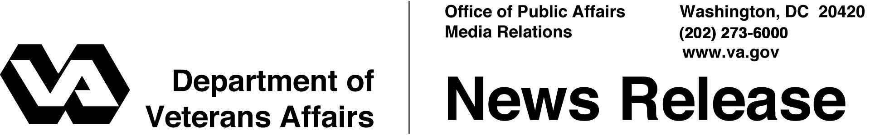

FOR IMMEDIATE RELEASE
June 1, 2007

Great Lakes National Cemetery Officially Dedicated
Michigan Veterans Attend Ceremony for New National Shrine
WASHINGTON – Secretary of Veterans Affairs Jim Nicholson will officiate at ceremonies June 3 dedicating the Great Lake National Cemetery in Holly, Mich.
“This will be a great day for Michigan’s veterans, as we dedicate this magnificent facility to honor their service to our nation,” Nicholson said. “Veterans have earned the right to be buried, if they choose, with their comrades in a national shrine.”
The Secretary will be joined at the dedication by William F. Tuerk, Under Secretary for Memorial Affairs with the Department of Veterans Affairs (VA), and local officials.
Burials actually began at the 544-acre site in Oakland County on Oct. 17, 2005, and more than 2,500 interments have already taken place. Nearly 487,000 veterans and their families live within the service radius of the national cemetery, which is 45 miles northwest of Detroit.
Phase 1 construction of the cemetery, which is nearly complete, includes a public information center, an administration and maintenance complex, two committal shelters and an entrance area. The developed area has capacity for 6,500 full-casket gravesites, 1,450 in-ground cremation gravesites and 1,768 columbaria niches for cremation remains.
Veterans with a discharge other than dishonorable, their spouses and eligible dependent children can be buried in a national cemetery. Other burial benefits available for all eligible veterans, regardless of whether they are buried in a national cemetery or a private cemetery, include a burial flag, a Presidential Memorial Certificate and a government headstone or marker.

- More -
Great Lakes National Cemetery 2/2/2/2

In the midst of the largest cemetery expansion since the Civil War, VA operates 125 national cemeteries in 39 states and Puerto Rico, and 33 soldiers' lots and monument sites. More than three million Americans, including veterans of every war and conflict, are buried in VA’s national cemeteries on more than 17,000 acres of land.
Information on VA burial benefits can be obtained from national cemetery offices, from the Internet at http://www.cem.va.gov or by calling VA toll-free at 1-800-827-1000.
Information about the Great Lakes National Cemetery can be obtained from the cemetery office at (248) 328-0386.

# # #

