USDA Foreign Agricultural Service
GAIN Report

Global Agriculture Information Network
Template Version 2.09

Voluntary Report - public distribution
Date: 7/24/2006
GAIN Report Number: CH6057
CH6057
China, Peoples Republic of
Poultry and Products
Summary of Avian Influenza Outbreaks in China During 2006
2006

Approved by:
Casey Bean
U.S. Embassy
Prepared by:
Zhang Jianping, Wu Yuhong

Report Highlights:
On July 20, 2006, the Ministry of Agriculture (MOA) notified the U.S. Embassy and the World Organization for Animal Health (OIE) of the most recent outbreak of highly pathogenic avian influenza (HPAI) – H5N1 strain in Yinglanganawati District of Akesu City, Xinjiang Uygur Autonomous Region. This brings to 14 the total number of Chinese reported HPAI cases during calendar year 2006. Chinese authorities confirmed the HPAI H5N1 strain virus in all of these cases. This report includes a translation of MOA's notification.

Includes PSD Changes: No
Includes Trade Matrix: No
Unscheduled Report
Beijing [CH1]
[CH]

Xinjiang - - The most Recent Reported Avian Influenza Outbreak

On July 20, 2006, the Ministry of Agriculture (MOA) notified the U.S. Embassy and the World Organization for Animal Health (OIE) of an outbreak of highly pathogenic avian influenza (HPAI) – H5N1 strain in Yinglanganawati District of Akesu City, Xinjiang Uygur Autonomous Region. A total of 3,045 chickens were infected, and all died. A total of 356,976 chickens were also destroyed. This is China’s 14th reported HPAI case during calendar year 2006.
Xinjiang has reported two outbreaks this calendar year. Though the region is not a main poultry-producing province in China. The annual slaughter is only about 74 million birds accounting for less than 1 percent of the total slaughter in China.

A Summary of China’s Avian Influenza Outbreaks During 2006

Thus far in 2006, Chinese authorities reported a total of 14 outbreaks of HPAI in 8 provinces. Unlike during the HPAI situation in 2005, thus far this year, the situation had less of an impact on poultry and human health; additionally, because the outbreaks have not occurred in important poultry producing provinces, consumption of poultry has not significantly decreased. For more information on China’s poultry and products situation, please refer to our 2006 Poultry and Products Semi-Annual Report.

The following is FAS Beijing’s translation of MOA’s notification to FAS Beijing Office.

Translation of MOA’s notification

Notification of Avian Influenza Outbreak in China

On July 19, 2006, The Ministry of Agriculture received a report from the National Avian Influenza Reference Lab confirming that an outbreak of highly pathogenic avian influenza (HPAI), H5N1 strain, occurred in Akesu City, Xinjiang Uygur Autonomous Region. The details are as follows.

- Outbreak location: Ying Lan Gan A Wa Ti Living Quarters, Lan Gan Administration Office, Akesu City, Xinjiang

- Date of confirmation: July 19, 2006

- Infected species: 3,045 chicken birds were infected, 3,045 died and 356,976 chicken birds were culled.

- Diagnose Lab: The National AI Reference Laboratory at Harbin Veterinary Research Institute under China Academy of Agricultural Sciences
Methods: Virus isolating through RT-PCR; Intravenous inoculation: IVPI.

- Control measures: MOA and the Government of Xinjiang Uygur Autonomous Region have been handling the disease according to the relevant requirements of the AI Urgent Action Plan. The main measures include identifying the outbreak point, infected area and exposed areas, isolating and disinfecting the infected point and area, culling and destroying the infected poultry and disinfecting all of the culled, and urgent vaccination to all susceptible poultry within a radius of 5 kilometers.

The Chinese Chief Veterinary Officer, Dr. JIA Youling, has reported this FMD outbreak to the World Organization for Animal Health (OIE).

(End of the translation)

For more detailed information on all reported HPAI outbreaks in China, please refer to the World Organization for Animal Health (OIE). For the Chinese language version information, please refer to the Minister of Agriculture (MOA).

Below is Post’s unofficial statistics and map illustration on reported HPAI outbreaks in China during calendar year 2006:

Highly Pathogenic Avian Influenza Outbreaks in China (as of July 20, 2006)

 | Province | Location | Report Date | Outbreak Date | Type of Bird | Statistics |  | Date Confirmed | Remarks
 |  |  |  |  |  | Deaths | Destroyed | Date Confirmed | Remarks
1 | Guizhou | Wudang District, Guiyang City | 1/10/06 | 1/1/06 | quails | 16,000 | 42,000 | 1/10/06 | poultry
2 | Shanxi | Yijing Township, Yangquan City | 2/7/06 | 2/2/06 | chickens | 15,000 | 187,745 | 2/7/06 | poultry
3 | Anhui | Jitai Village, Yingshang County | 2/25/06 | Found dead chickens on 2/22/06 | chickens | 13 | More than 200 | 2/25/06 | poultry
4* | Liaoning | Jinzhou City | 4/20/06 | Sent a dead pie for test on 4/13/06 | pie | 1 | n/a | 4/19/06 | wild birds
5* | Liaoning | Panjin City | 4/20/06 | Sent a dead wild duck for test on 4/13/06 | wild duck | 1 | n/a | 4/19/06 | wild birds
6* | Qinghai | Gangcha County, | 4/30/06 | Sent a dead Bantouyan for test on 4/23/06 | Bantouyan (wild goose) | 1 | n/a | 4/29/06 | wild birds
7* | Qinghai | Yushu County, Yushu State marsh | 5/4/06 | Sent 17 dead Bantouyan for test on 4/23/06 | wild birds | 495 | n/a | 5/3/06 | wild birds
8* | Qinghai | Guolo Tibet Autonomous State | 5/21/06 | n/a | migratory birds | 440 | n/a | 5/24/06 | wild birds
9* | Tibet | Naqu Region | 5/21/06 | n/a | migratory birds | 1,154 | n/a | 5/24/06 | wild birds
10* | Tibet | Dangxiong County | 6/9/06 | Sent 3 dead Bantouyan for test on 5/26/06 | migratory birds | 28 | n/a | 6/3/06 | wild birds
11 | Xinjiang | Taershilike Farm, Buzhake Township, Hetian County | 6/7/06 | Found death poultry on 6/4/06 | poultry birds | 200 | n/a | 6/7/06 | poultry
12 | Shanxi | Shijiazhuang Village, Shizhe Township, and Nanchuanzhuang Village, Danzhu Township, Changzi County, Changzhi City | 6/19/06 | n/a | chickens | 2,400 | 1,470,000 | 6/17/06 | poultry
13 | Ningxia | Xuanhe Township, Zhongwei City | 6/30/06 | n/a | poultry birds | 6,743 | 581,000 | 6/29/06 | poultry
14 | Xinjiang | Yinglanganawati District, Akesu City | 7/20/06 | n/a | chickens | 3,045 | 356,976 | 7/19/06 | poultry

Source: Official notifications on MOA website and MOA’s notifications to FAS Beijing Office
Note: * - Cases No. 4 to No. 10 were all wild birds infections. No poultry farms were in the surrounding areas, thus no outbreaks of AI on poultry birds.

Locations and Number of Highly Pathogenic Avian Influenza Outbreaks in Mainland China (as of July 20, 1006)

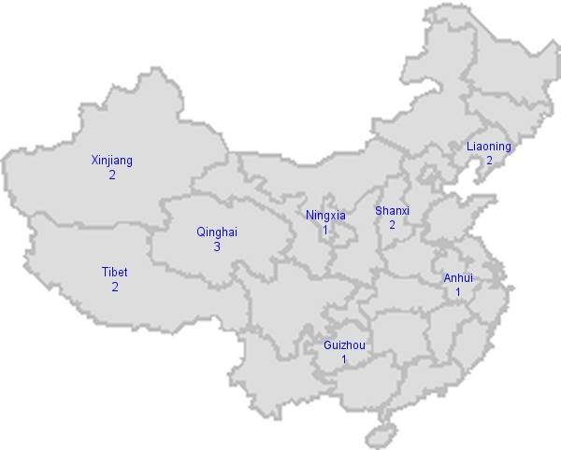

End of report

