Giant Sandreed
Calamovilfa gigantea (Nutt.) Scribn. & Merr.
Plant Symbol = CAGI3

Contributed by: USDA NRCS Manhattan Plant Materials Center

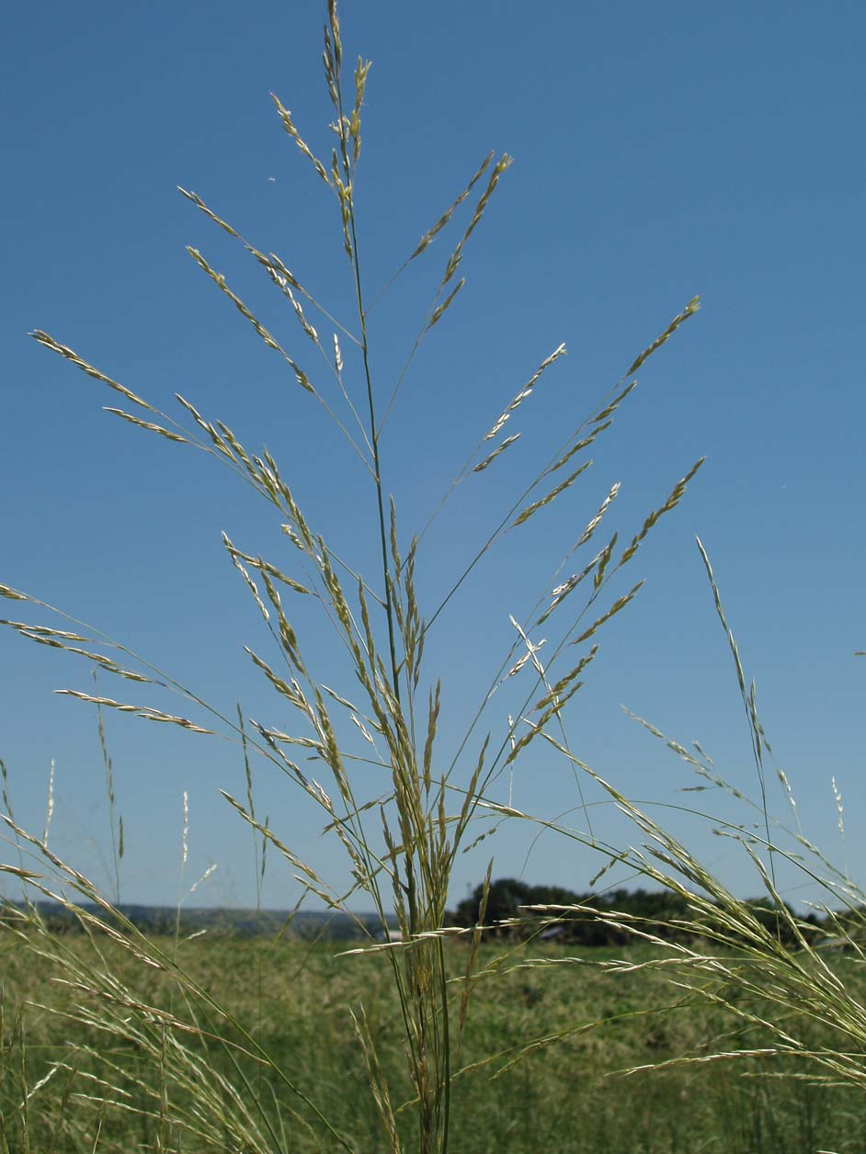
Alan Shadow, USDA NRCS Manhattan Plant Materials Center

Alternate Names
Big sandreed, big sandreed grass

Uses
Giant sandreed is valuable for controlling erosion on deep sands subject to severe wind erosion. It cures well on the stem, thus providing good winter forage for livestock. When grown on sites large enough to be managed as a separate unit it can be hayed or used as reserve for winter forage.

Status
Please consult the PLANTS Web site and your State Department of Natural Resources for this plant’s current status (e.g. threatened or endangered species, state noxious status, and wetland indicator values).

Description
General: Giant sandreed is a robust perennial, native, warm season grass with strong creeping rhizomes. The culms are erect, thick and solid or hollow near the base. Culm height ranges between 1 and 2 meters tall. The leaf blade is 7 to 11 mm wide at the base and rolls inward tapering to a long tip. The leaf sheath is usually glabrous or sometimes pubescent in the vicinity of the ligule. The inflorescence is an open panicle 30 to 65 cm long with lemmas that are villous on their backs.

Distribution: For current distribution, please consult the Plant Profile page for this species on the PLANTS Web site. Giant sandreed can be found from southern Utah (north of Kanab, Kane County) to Arizona, east to southwestern Nebraska, Kansas, Oklahoma, and to central Texas.

Habitat: A valuable sand binder that is closely related to Calamovilfa longifolia of the mid-western states. A valuable species to control erosion on deep sandy soils subjected to severe wind erosion. Will grow in large colonies and dominate a site if properly managed.

Adaptation
This species exhibits optimal performance on sandy textured soils.

Establishment
Normally this species exhibits weak seedling vigor and slow growth once it has germinated. This species is typically slow to establish from the seedling stage to a mature plant. It tends to put the majority of its resources into root and rhizome development during the seedling stage. Drill seed 2.54 cm deep in sandy soil and shallower in medium textured soils. Drilling into crop stubble improves stand establishment on erosive sites. Species may be sprigged in sand dunes or erosive “blowout” sites.

Management
Spring growth of this species begins several days before other warm season grasses in the same locality. This provides an advantage when early forage is desired for livestock species. When grown on large sites that require separate management this species can be hayed or grazed. It provides good winter forage for livestock. Summer grazing should be limited to no more than 50 percent removal of the current year’s growth. This will maintain a vigorous stand of grass, while leaving adequate amounts of mulch for control of wind erosion.

Pests and Potential Problems
There are rust fungi that infect or cause disease on both Calamovilfa and Sporobolus.

Environmental Concerns
There are no environmental concerns with this species. Generally, it has reduced seedling vigor and is only adapted to conditions in a sandy soil type environment. It has a very low probability of becoming a weed problem.

Seeds and Plant Production
The species is difficult to harvest due to late maturity, seed shatter, and hairy seed units. Combine in dough stage, process with hammer mill and fanning mill for best results. Seed quality at best has a purity of 98% and germination of 70% for a Pure Live Seed percentage of 69.

Cultivars, Improved, and Selected Materials (and area of origin)
Contact your local Natural Resources Conservation Service (formerly Soil Conservation Service) office for more information. Look in the phone book for”United States Government”. The Natural Resources Conservation Service will be listed under the subheading “Department of Agriculture.” There are currently no cultivars or improved varieties of giant sandreed available on the commercial market.

References
Cummins, G.B. and H.C. Greene. 1961. The rust fungi of Muhlenbergia, Sporobolus, and related genera. Brittonia. Volume 13: 277-285.

Cornelius, D.R. and M.D. Atkins. 1946. Grass establishment and development studies in Morton County, Kansas. Ecology. Volume 27: 342-353.

Leithead, H.L., L.L. Yarlett, and T.N. Shiflet. 1971. 100 native forage grasses in 11 southern states. USDA, SCS Agriculture Handbook No. 389, Washington, DC.

Rogers, K.E. 1970. A new species of Calamovilfa (Gramineae) from North America. Rhodora. Volume 72: 72-79.

Reeder, J.R. and M.A. Ellington. 1960. Calamovilfa, a misplaced genus of Gramineae. Brittonia. Volume 12: 71-77.

Reeder, J.R. and D.N. Singh. 1967. Chromosome number in Calamovilfa. Bulletin of the Torrey Botanical Club. Volume 94: 199-200.

Thieret, J.W. 1966. Synopsis of the genus Calamovilfa (Gramineae). Castanea. 31:145-152.

Prepared By:
Richard Wynia, USDA NRCS Plant Materials Center
Manhattan, Kansas

Species Coordinator:
Richard Wynia, USDA NRCS Plant Materials Center
Manhattan, Kansas

Edited: 070414 jsp

For more information about this and other plants, please contact your local NRCS field office or Conservation District, and visit the PLANTS Web site<http://plants.usda.gov> or the Plant Materials Program Web site <http://Plant-Materials.nrcs.usda.gov>

The U.S. Department of Agriculture (USDA) prohibits discrimination in all its programs and activities on the basis of race, color, national origin, sex, religion, age, disability, political beliefs, sexual orientation, and marital or family status. (Not all prohibited bases apply to all programs.) Persons with disabilities who require alternative means for communication of program information (Braille, large print, audiotape, etc.) should contact USDA's TARGET Center at 202-720-2600 (voice and TDD).
To file a complaint of discrimination write USDA, Director, Office of Civil Rights, Room 326-W, Whitten Building, 14th and Independence Avenue, SW, Washington, DC 20250-9410 or call 202-720-5964 (voice or TDD). USDA is an equal opportunity provider and employer.
Read about Civil Rights at the Natural Resources Conservation Service.

