

APRIL 2007

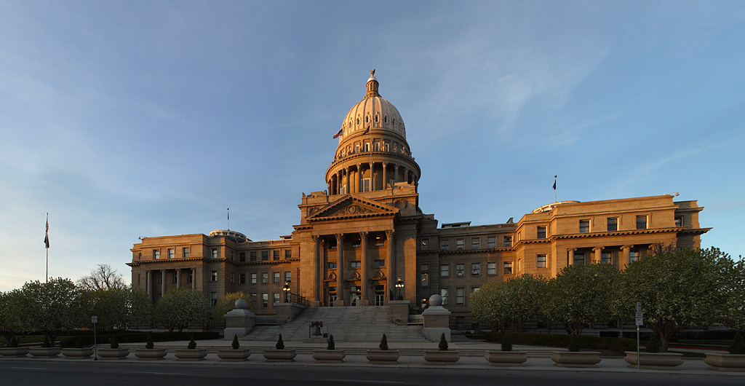

This Month’s Topics Page

National Restaurant Show 2007 – HOT TOPIC! 2
New Markets of the Month – North Africa and the Middle East 3
Americas Competitiveness Forum – HOT TOPIC! 4
“Alberta Oil Sands Opportunities for U.S. Exporters” Webinar 5
“Dos and Don’ts of NAFTA Certificates of Origin” Webinar 6
Trade Winds Forum 2007 7
CS Global Environmental Team – Upcoming Events 8
NEWS: Some Customs and Border Protection Rates to Rise 10% 9
CS TIP: Boost Sales, Profits by Listing Prices in Foreign Currency 10

2007 NATIONAL RESTAURANT SHOW

Meet with USDOC Specialists in the Hotel/Restaurant Equipment Industry – from 9 different countries – at the National Restaurant Show in Chicago, IL

May 20-21, 2007

Meet with Hotel/Restaurant Specialists at National Restaurant Association Show 2007. TS Janet Bauermeister of the Spokane Export Assistance Center will be in attendance to provide assistance to exhibitors and attendees. U.S. Department of Commerce Hotel/Restaurant Commercial Specialists and Foreign Agricultural Service Marketing Specialists from several countries will also be at National Restaurant Association show. Meet one-on-one with these Specialists to discuss the current market situation, export issues important to your firm, and export opportunities in their respective markets!

Advance Registration Required

Appointments are available at either your booth or ours. If you register on-line now, the Commercial and Marketing Specialists will be better prepared to focus on your needs/objectives. To enhance the quality of your appointmnents, please submit advance registration ASAP at: http://www.buyusa.gov/eme/nra2007.html.

Appointments are available on a first-come, first-serve basis. As we get closer to the show, we will confirm your appointments. There is no charge for this service of the U.S. Department of Commerce, U.S. Commercial Service! If you have any questions, please do not hesitate to contact Janet Bauermeister at Janet.Bauermeister@mail.doc.gov or at 509-353-2625.



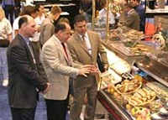

For More Information

If you would like to learn more about the Western Hemisphere's Largest Foodservice and Hospitality Event, visit http://www.restaurant.org/show/index.cfm.

NEW MARKETS OF THE MONTH –
NORTH AFRICA AND THE MIDDLE EAST

Take Advantage of Middle East/North Africa Opportunities as Free Trade Agreements in the Regions Promote U.S. Bilateral Trade
For U.S. companies looking to increase their bottom line by making new sales abroad, there’s never been a better time to export. As more and more American companies discover the opportunities that lie beyond our borders, many are taking advantage of free trade agreements (FTAs) to reach new customers around the world. Now take a closer look at why you should consider doing business in Israel, Morocco, Jordan and Bahrain.

Israel – Read more...


Morocco – Read more...


Jordan – Read more...


Bahrain – Read more...


For more Markets of the Month, visit http://www.export.gov/archive/index.asp.

AMERICAS COMPETITIVENESS FORUM

Don’t Miss the Inaugural Event on Competitiveness in the Western Hemisphere!

June 11-12, 2007 – Atlanta, GA

U.S. Department of Commerce Secretary Carlos Gutierrez invites you to participate in the Americas Competitiveness Forum. Seldom will you have the opportunity to contribute to a lively dialog with distinguished leaders (including minister-level officials) and experts from across the hemisphere on how to compete in the global marketplace!
During the conference you will have a voice in how to spark and sustain innovation, create solutions in education and workforce development, design successful global supply chain strategies and foster small business development and growth. In addition, you will learn from 13 Senior Commercial Officers offering insights and have access to one-on-one meetings following the conference.

Don’t miss this opportunity to enhance your company’s strategy to thrive in an increasingly competitive environment. For more information or to register for the conference, click here. Also, please view the documents below for more information.


FACT SHEET.PDF SAVE-THE-DATE.PDF

For questions or comments regarding the conference, please contact Tom Strauss at 404-897-6080 or Thomas.Strauss@mail.doc.gov or Terri Batch at 310-597-3575 or Terri.Batch@mail.doc.gov .

“ALBERTA OIL SANDS OPPORTUNITIES” WEBINAR

May 9, 2007 -- 10:00 AM PST

Heard about the Alberta Oil Sands but not sure if they represent real opportunities for your company? The U.S. Commercial Service presents a webinar explaining these opportunities and how U.S. exporters can benefit. This webinar is for everyone - the oil sands present terrific opportunities for the mining sector and beyond!

Industry Opportunities
- Oil & Gas Field machinery (heavy-duty equipment rental, repairs, services);
- Pipes, valves and fittings;
- Refinery equipment and Mining equipment
- Fuels and Fuel Storage;
- Construction Equipment, Materials & Services (building, electrical, plumbing, carpentry, concrete, etc.);
- Security equipment;
- Accommodation and Related Services;
- Communication Systems (telecommunications, cellular, internet, cable);
- Safety & Medical (facilities, supplies, services);
- Logistics (materials handling, freight, vehicle sales rentals & repairs); and
- Environmental control equipment

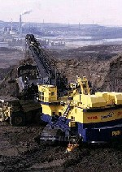

Speakers
- Sharon Atkins – Sr. Commercial Specialist
- U.S. Consulate General – Calgary
- Kent McMullin – Director, Business Attraction, Edmonton Economic Development Corporation
- Dave Gering – Executive Director, Manufacturing Industrial Council.

This webinar costs $35 and will have a duration of 75 minutes. To register, click here. For more information, please contact Diane Mooney at dmooney@mail.doc.gov or at 206-553-5615, ext. 236.

“NAFTA CERTIFICATES OF ORIGIN” WEBINAR
A Basic Presentation for NAFTA Beginners on the Dos and Don’ts of the NAFTA Certificate of Origin

May 16, 2007 -- 12 PM CST

Most American companies know that under the North American Free Trade Agreement (NAFTA) products made in the United States are eligible for preferential tariff treatment when exported to Mexico. However, too many companies still do not prepare properly, and either incur fines and delays, or miss out altogether, on this important and valuable benefit.

Learn the basic dos and don’ts of filling out the NAFTA Certificate of Origin, and ask questions of experts on the ground in Mexico. Register for this WebEx Seminar for U.S. exporters to Mexico today!

Speakers
- Aaron Held - Vice Consul for Commercial Affairs
- Manuel Velazquez - Commercial Assistant
- American Consulate General - Monterrey, Mexico

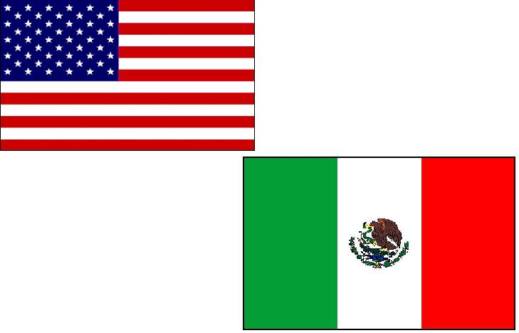

Log-on and dial-in access is limited! Contact Manuel Velazquez to register at Manuel.Velazquez@mail.doc.gov.

TRADE WINDS FORUM 2007
The U.S. Commercial Service of the U.S. Department of Commerce is pelase to announce its Signature Trade Event of 2007: Trade Winds Forum: Africa, Europe, and India – Profitable Crossroads of Trade, All in One Location!

May 15-16, 2007 – Hyatt Regency in Crystal City, VA

Trade Winds Forum will feature 33 U.S. Senior Commercial Service Officers arriving from U.S. Embassies across Europe, Africa and India. Currently stationed overseas, each of these Commercial Officers are in a unique position to deliver the most up-to-date information on developing opportunities for U.S. business. While at the conference you will have the opportunity to meet privately with the U.S. Senior Commercial Officers to discuss business opportunities for your company. Private appointments are on a first come, first served basis, so register today while space is still available.

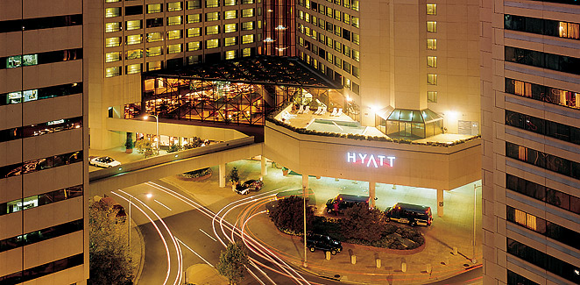

Trade Winds Forum will also feature leading experts from the private sector and key U.S. government officials addressing important industry trends and trade topics critical to all successful U.S. exporters. Participants will be able to customize their conference experience by selecting from over 25 breakout panel sessions. Whether you have been exporting for decades or are just preparing a market-entry strategy, you can't miss this opportunity to get the latest market information and advice your company needs to grow your international business!

For more information and to register visit http://www.tradewindsforum.com/. To view the official flyer for this event, click here. Register by March 31 to secure Early Bird Rates!

CS GLOBAL ENVIRONMENTAL TEAM –
UPCOMING EVENTS

American Water Works Association – Annual Conference & Exhibition

June 24-28, 2007 -- Toronto

Industry Coverage:
- Analysis and testing,
- chemicals and chemical handling products,
- computer software,
- disinfection equipment systems,
- environmental & engineering services,
- hydrants,
- pumps/ pipes/ tanks/valves,
- instrumentation,
- laboratories/field testing equipment,
- meters, and
- water and wastewater treatment equipment.
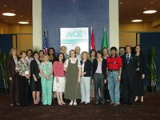

Other Information:
- 16+ Commercial Specialists and buyer delegations confirmed.
- Industry Focused Promotion
- Registration Deadline – May 8, 2007
- Showtime and International Buyer Matchmaking available
- Full details at http://www.buyusa.gov/environmental/awwa2007.html.

Environmental Trade Mission to Bulgaria, Romania, and Turkey

October 1-5, 2007

Full details and online registration at http://www.buyusa.gov/environmental/tbrtm.html.

CERTAIN CBP USER FEES TO RISE TO 10%

Beginning April 1, 2007, U.S. importers that utilize a range of customs services will need to adjust their costs to reflect an increased duty of 10% on those services. Customs and Border Protection (CBP) is increasing the user fees for certain customs services (see accompanying table) by that amount to more accurately reflect the actual costs of providing the services.

The increase was authorized by the American Jobs Creation Act of 2004, signed into law on Oct. 22, 2004. Section 892 of the act amended Title 19 United States Code 58c to renew the fees provided under the Consolidated Omnibus Budget Reconciliation Act of 1985 (which would otherwise have expired on March 1, 2005) and to allow a fee increase not to exceed 10% beginning in fiscal year 2006.
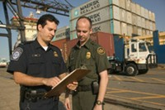

On April 24, 2006, CBP published a Notice of Proposed Rulemaking in the Federal Register to amend the regulations in accordance with the current statutory provisions by increasing the fees for:
- Customs services provided in connection with the arrival of certain commercial vessels, commercial trucks, railroad cars, private aircraft and private vessels, passengers aboard commercial aircraft and commercial vessels, and barges or other bulk carrier arrivals;
- Each item of dutiable mail for which a customs officer prepares documentation; and
- Annual customs brokers’ permits.

For more information on CBP user fee policies and rates, please contact:

Jerry Petty
Director, Cost Management Division
Phone: 202-344-1317
Jerry.Petty@dhs.gov

For the full text of the CBP statement, go to http://www.cbp.gov/xp/cgov/import/carriers/fee_increase.

OTHER IMPORTANT EVENTS & INFORMATION

“Translating” a transaction into your customers’ local currency can smooth communication between buyer and seller. In certain circumstances, you may even be able to utilize favorable currency movements to manage your exposure and boost profits. Since your European, Japanese, and other global competitors are used to quoting prices in foreign importers’ local currency, not doing so can put you at a competitive disadvantage. Taking the risk of potential currency fluctuations onto your own shoulders, as opposed to placing it on the customer, can earn you good will and even seal the deal.

Understand Foreign Exchange Issues

The corollary to quoting in the overseas buyer’s currency, however, is that you must educate yourself about foreign exchange issues and how to manage your exposure to currency fluctuations. Concretely, this means you must carefully consider your margins and price sensitivity, as well as the time frame in which the transaction is likely to be completed.
In relation to your margins, the tighter these are, the greater your need to hedge against foreign-exchange risk, since a slight adverse movement could erase your profits—or even leave you in the red. I n relation to the transaction’s time frame, the longer your price offer stands, the more you need to consider hedging. Options include the following:



- Estimate the currency rate for the date you expect the deal to go through (risky, but a good global bank can advise you on this) and incorporate that into your price.
- Structure the sales contract to allow price adjustments to reflect movements in the exchange rate between the time you quote and the time the transaction is completed (the disadvantage here is that it doesn’t free your buyer from currency risk, the advantage you aimed to provide it in the first place).
- Price the goods based on your best estimate of the foreign-currency rate and purchase an appropriate forward or options contract to hedge against adverse currency movements. Such options grant you the right to purchase the currency at the option price on the date you anticipate your bid will be accepted (though you aren’t obligated to exercise that right). If a favorable currency movement occurs in the interim, you can swap the option for a forward contract to coincide with the payment date. If an adverse currency movement has occurred, you allow the option to expire and enter into a forward contract that matches the payment date. (Again, go to your bank to learn about alternatives to forward or options contracts).

When hedging against fluctuations in foreign exchange, the terms you are offering (whether 30, 60, or 90 days) become a key issue, since the longer you are exposed to potential negative foreign-exchange movements, the greater your risk level.

Five Alternatives
The five main alternative techniques for hedging against adverse foreign currency movements—in order of risk—are:
- Spot transactions (highest risk)
- Standard option contracts
- Zero cost/limited cost/collar options
- Forward contracts; and
- Window forwards (lowest risk).

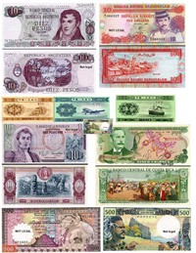

Successful use of such tools depends on thoroughly understanding their use and getting the best possible advice from your bank services providers.

For more information regarding the above events, or if you are a small business seriously interested in exporting, please contact Amy Benson, Director of the Boise Export Assistance Center, at (208) 364-7791 or by email at Amy.Benson@mail.doc.gov. Please visit the Boise USEAC website to learn more about how the U.S. Commercial Service can assist your business.

