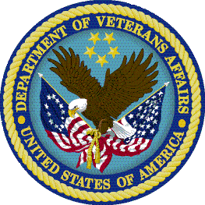 Office of Research Oversight 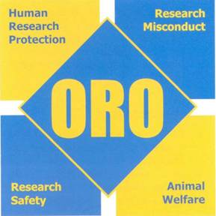
Lessons Learned – CY2007

Research Oversight
  - Strong commitment of the Facility Director is essential for research compliance
  - Research & Development (R&D) Committee must exercise strong program oversight
  - R&D Committee and Subcommittees must be serious about annual program reviews
  - Deficiencies identified in annual reviews must be addressed promptly and effectively
  - Use of affiliate committees requires formal and reliable communications mechanisms
  - Ongoing investigator training is critical to good compliance
  - New and dual-appointment researchers need multiple reminders about the requirement for R&D Committee approval prior to initiating research

Human Research Protections
- Privacy Officer and Information Security Officer (ISO) must review research as nonvoting members of the Institutional Review Board (IRB) or R&D Committee
- Investigators should consult Privacy Officer and ISO early in planning research
- Researchers need help understanding IRB requirements for reporting adverse events and unanticipated problems in research
- A robust facility program for monitoring on-going research is critical to compliance
- Changes in on-going research require prospective IRB approval

Laboratory Animal Welfare
- Implementation of an Occupational Safety & Health Program is essential
- Semi-Annual Program and Facility Reviews must be done thoroughly and on time
- Category D and E protocols require clear justification and thoughtful review
- Post-surgical care and monitoring should not be taken lightly
- Use of out-dated and non-pharmaceutical grade drugs is generally inappropriate

Research Safety and Security
- Annual review of research areas must be thorough – deficiencies must be addressed
- Other requirements include annual review of chemical hygiene plan and semi-annual reviews of personnel access, hazardous agent inventory, and select agent/toxin exempt quantity logs
- Annual research-specific safety training is critical to maintaining safe programs
- Special steps are needed to meet National Institutes of Health (NIH) Institutional Biosafety Committee (IBC) and rDNA requirements
- Compliance with national standards for eyewash stations, storage of flammable chemicals, labeling and containment of hazardous chemical wastes is mandatory

