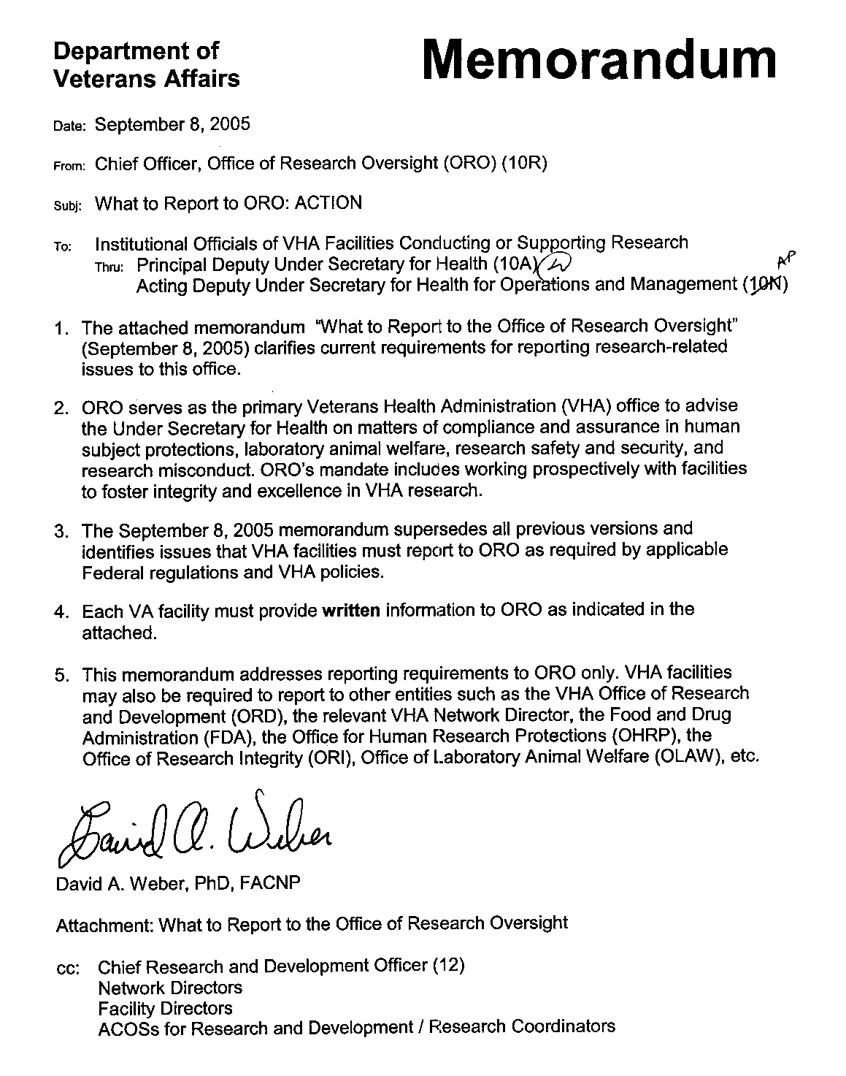

Department of

Memorandum

Veterans Affairs

Date: September 8, 2005

From: Chief Officer, Office of Research Oversight (ORO) (10R)

To: Institutional Officials of VHA Facilities Conducting or Supporting Research

What to Report to the Office of Research Oversight

This memorandum identifies issues that VHA facilities must report to ORO as required by applicable Federal regulations and VHA policies.
The memorandum addresses reporting requirements to ORO only. VHA facilities may also be required to report information to other entities such as the VHA Office of Research and Development (ORD), the relevant VHA Network Director, the Food and Drug Administration (FDA), the Department of Health and Human Services (DHHS) Office for Human Research Protections (OHRP), the DHHS Office of Research Integrity (ORI), and/or the National Institutes of Health (NIH) Office of Laboratory Animal Welfare (OLAW).

Guiding Principles

- Report in Writing. Although ORO staff are available for consultation regarding the content and scope of reports, each VA facility must provide the required information to ORO in a written report from the facility Director. Reports should first be sent by FAX or e-mail and then promptly forwarded in hard copy.

- Report Promptly. Reports should be provided to ORO as soon as possible, but no later than 10 working days after the issue has come before the responsible facility official or oversight committee (e.g., Institutional Review Board, Institutional Animal Care and Use Committee), unless otherwise indicated in the following material. If the facility has not made a final determination as to disposition of the issue within this 10 day period, the facility Director should provide ORO with a preliminary report and with followup reports as needed until the issue is resolved.

- Report to ORO Regional Office. Reports should be addressed to the ORO Regional Office Director for the region in which the facility is located, unless otherwise indicated (see contact information attached).

- Report Descriptive Information and Actions. Reports should include:

  - The name and any relevant Assurance number of the reporting VA facility.
  - The title of the research project(s) involved.
  - The name of the principal investigator(s) involved (except for animal research).
  - The number(s) used by the facility’s Institutional Review Board (IRB), Institutional Animal Care and Use Committee (IACUC), and/or Research Service to identify the project(s) involved.
  - The name of any external sponsor(s) of the project(s) involved.
  - The funding source(s) for the project(s) involved.
  - A detailed description of the issue being reported.
  - A detailed description of the actions the facility is taking, or plans to take, to address the issue.

What to Report to ORO: Protection of Human Subjects in VA Research

- Any adverse event (i.e., an untoward physical, psychological, social, or economic occurrence) in a human subject, or an imminent threat of an adverse event, that results in a substantive action by the Institutional Review Board (IRB) under VHA Handbook 1058.1 on Reporting Adverse Events in Research (attached).
- Any unexpected death of a human subject under VHA Handbook 1058.1 NOTE: Such deaths must be reported within 24 hours of the IRB’s determination that the death was unexpected or within 10 working days if the IRB has not yet made a determination about whether the death was unexpected.
- Any unanticipated problem involving risks to subjects or others that results in a substantive action by the IRB.
- Any for-cause suspension or termination of VA human subject research by the IRB, the VA facility, or a VA affiliate institution. NOTE: This does NOT include suspensions or terminations resulting solely from the expiration of the IRB approval period.
- Any serious or continuing noncompliance with federal regulations or VHA policies for the protection of human subjects (including 38 CFR Part 16; 45 CFR Part 46; 21 CFR Parts 50, 56, 312 or 812; and VHA Handbook 1200.5).
- Any serious or continuing noncompliance with IRB requirements or determinations.
- Any findings of noncompliance in human research protections from the VHA Office of Research and Development (ORD) or other VA office. NOTE: The report to ORO should include a copy of the official findings. The facility should promptly provide ORO with copies of all subsequent correspondence between the office and the facility until the issue is resolved.

- Any findings of noncompliance in human subject protections from external oversight agencies such as the Office for Human Research Protections (OHRP), the Food and Drug Administration (FDA), etc. NOTE: The report to ORO should include a copy of the official findings (e.g., FDA Form 483, Inspectional Observations). The facility should promptly provide ORO with copies of all subsequent correspondence between the agency and the facility until the issue is resolved.
- Any change in the facility’s accreditation status from a VA-recognized accreditation organization for human research protections, or in the accreditation status of an affiliate institution or other VA facility upon which the facility relies.
- Any change in the facility's Federalwide Assurance (FWA) or designated IRB(s) as filed with OHRP. NOTE: Report such changes directly to ORO Central Office and simultaneously copy the ORO Regional Office.
- Any significant change in the facility's Memorandum of Understanding (MOU) with an affiliate institution or other VA facility regarding the designation of IRB(s) or other human research protection function. NOTE: Report such changes directly to ORO Central Office and simultaneously copy the ORO Regional Office.

What to Report to ORO: Laboratory Animal Welfare in VA Research

NOTE: Reports regarding VA animal research should NOT include the name(s) of the investigator(s) unless this information has been specifically requested by ORO.

- Any incident that seriously affects the health or safety of laboratory animals.
- Any loss of animal life due to physical plant deficiencies and/or engineering failures or mishaps.
- Any work related injury to personnel working within an animal facility that requires more than minor medical intervention or leads to serious complications or death.
- Any for-cause suspension or termination of VA animal research by the Institutional Animal Care and Use Committee (IACUC).
- Any serious or continuing noncompliance with the Public Health Service (PHS) Policy on Humane Care and Use of Laboratory Animals or VHA Handbook 1200.7 on Use of Animals in Research.
- Any serious deviation from the requirements of the Animal Welfare Act under 9 CFR Parts 1, 2, and 3.
- Any serious deviation from the Guide for the Care and Use of Laboratory Animals.

- Any findings of noncompliance in laboratory animal care from the VHA Office of Research and Development (ORD) or other VA office. NOTE: The report to ORO should include a copy of the official findings. The facility should promptly provide ORO with copies of all subsequent correspondence between the office and the facility until the issue is resolved.
- Any findings of noncompliance in laboratory animal care from external oversight agencies such as the US Department of Agriculture (USDA) Animal and Plant Health Inspection Service (APHIS), the National Institutes of Health (NIH) Office for Laboratory Animal Welfare (OLAW), etc. NOTE: The report to ORO should include a copy of the official findings. The facility should promptly provide ORO with copies of all subsequent correspondence between the agency and the facility until the issue is resolved.
- Any change in the facility’s accreditation status from a VA-recognized accreditation organization for laboratory animal welfare, such as the Association for Assessment and Accreditation of Laboratory Animal Care International (AAALAC), or in the accreditation status of an affiliate institution or other VA facility upon which the facility relies.
- Any change in the facility's Animal Welfare Assurance status as filed with OLAW, or in the Animal Welfare Assurance status of an affiliate institution or other VA facility upon which the facility relies.
- Any significant change in the facility's Memorandum of Understanding (MOU) with an affiliate institution or other VA facility regarding animal care and use arrangements. NOTE: Report such changes directly to ORO Central Office and simultaneously copy the ORO Regional Office.

What to Report to ORO: Safety and Security in VA Research

- Any work-related occupational injury to personnel working within a research facility that requires more than minor medical intervention or leads to serious complications or death.
- Any significant, work-related exposure to hazardous materials of personnel working within a research facility.
- Any for-cause suspension or termination of VA research by the Subcommittee on Research Safety (SRS) or other institutional safety committee.
- Any serious or continuing noncompliance with federal regulations or VHA policies governing research safety and security, including 7 CFR Part 331; 9 CFR Part 121; 29 CFR Part 1910, Sections 1910.1030, 1910.1200, 1910.1450; 29 CFR Part 1960; 42 CFR Part 73; VHA Handbook 1200.6; VHA Handbook 1200.8; VHA Directive 2003-030; and VHA Directive 2005-003.

- Any exposure, release, loss, or theft of hazardous materials, including select agents and toxins.
- Any findings of noncompliance in research safety or security from the VHA Office of Research and Development (ORD), the VA National Health Physics Program Office, the VA Office of Inspector General (OIG), or other VA office. NOTE: The report to ORO should include a copy of the official findings. The facility should promptly provide ORO with copies of all subsequent correspondence between the office and the facility until the issue is resolved.
- Any findings of noncompliance in research safety or security from external oversight agencies such as the National Institutes for Health (NIH) regarding the use of recombinant DNA; the Centers for Disease Control and Prevention (CDC) regarding hazardous materials, including select agents and toxins in research areas; the United States Department of Agriculture (USDA) regarding hazardous materials including select agents and toxins in research areas; the Occupational Health and Safety Administration (OSHA); the Nuclear Regulatory Commission (NRC); etc. NOTE: The report to ORO should include a copy of the official findings. The facility should promptly provide ORO with copies of all subsequent correspondence between the agency and the facility until the issue is resolved.

What to Report to ORO: Misconduct in VA Research

NOTE: Report the following DIRECTLY to the ORO CENTRAL OFFICE. ORO Central Office will notify the appropriate ORO Regional Office.

- During the course of a research misconduct proceeding, ORO should be notified immediately of the following, and of any interim administrative actions taken to minimize resultant damage: any harm or threatened harm to research subjects; harm or threat of harm to those involved in an inquiry or investigation into research misconduct; serious violations of animal welfare requirements; research safety or security compromises; risks to public health or safety; loss or destruction of VA funds or property; possible violations of civil or criminal law associated with the alleged research misconduct. (VHA Handbook 1058.2 §12.e.1)
- Any requests for pre-approval of significant changes or departures from the procedures outlined in VHA Research Misconduct Handbook. NOTE: Pre-approval of such changes by ORO is REQUIRED. (VHA Handbook 1058.2 §12.b & 12.d)
- Any opening of a research misconduct inquiry. (VHA Handbook 1058.2 §14.c)
- Any requests for approval of extensions of the normal 30-day period for the inquiry review. NOTE: Requests for extension of the inquiry review period must be timely. (VHA Handbook 1058.2 §14.e.1)

- Any closure of a research misconduct inquiry without further investigation. NOTE: The report to ORO must include a copy of the Inquiry Report and the concurrence of the Facility Director. (VHA Handbook 1058.2 §14.g)
- Any opening of a research misconduct investigation. (VHA Handbook 1058.2 §15.c)
- Any requests for approval of extensions of the normal 90-day period for the investigation review. NOTE: Requests for extension of the investigation review period must be made at least 5 working days prior to the end of the initial investigation review period. (VHA Handbook 1058.2 §15.f.1)
- Closure of a research misconduct investigation. NOTE: The report to ORO must include a copy of the final Investigation Report and the recommendations of the Facility Director. (VHA Handbook 1058.2 §15.h.3)
- The final decision of the Director of the Veterans Integrated Services Network (VISN) on the merits of a research misconduct case. (VHA Handbook 1058.2 §16.f)

David A. Weber, PhD, FACNP

Attachments:

Office of Research Oversight (ORO). Contacts for Reporting to ORO.

VHA Handbook 1058.1, Reporting Adverse Events in Research to the Office of Research Oversight. (November 19, 2004).

Adverse Events (AEs) in VA Research AE – Report Format. VA Form 10-0420.

OFFICE OF RESEARCH OVERSIGHT (ORO)
CONTACTS FOR REPORTING TO ORO
Send written report to the appropriate ORO Office first by FAX or e-mail
and then forward promptly in hard copy.
For additional resources, reference ORO’s website: http://www1.va.gov/oro/

CENTRAL OFFICE
811 Vermont Avenue, N.W., Suite 574 (10R)
Washington, D.C. 20420
PHONE: (202) 565-5184
FAX: (202) 565-9194

NORTHEASTERN REGIONAL OFFICE (VISNs 1, 2, 3)
Bedford VAMC – 200 Springs Road, Bldg 7, Room B-08 (10R)
Bedford, MA 01730
PHONE: (781) 687-3850
FAX: (781) 687-3858

MID-ATLANTIC REGIONAL OFFICE (VISNs 4, 5, 6, 9, 10)
50 Irving Street, N.W. (10R)

Washington, D.C. 20422

PHONE: (202) 745-8110

FAX: (202) 745-8538

SOUTHERN REGIONAL OFFICE (VISNs 7, 8, 16, 17)
1670 Clairmont Road (10R)
Decatur, GA 30033

PHONE: (404) 417-2929

FAX: (404) 417-2935

MIDWESTERN REGIONAL OFFICE (VISNs 11, 12, 15, 19, 23)
PO Box 5000, Building 1, Room B-103 (10R)
5th Avenue & Roosevelt Road
Hines, IL 60141

PHONE: (708) 202-7254

FAX: (708) 202-7250

WESTERN REGIONAL OFFICE (VISNs 18, 20, 21, 22)
P.O. Box 7360, Moreno Valley, CA 92552-7360

Express Delivery: ORO Western Regional Office (10R)
March Air Reserve Base – 5029 4th Street, Bldg. 2641
March Air Reserve Base, CA 92518
PHONE: (909) 801-5164

FAX: (909) 801-5176
Revised: September 8, 2005

November 19, 2004 VHA HANDBOOK 1058.1

REPORTING ADVERSE EVENTS IN RESEARCH
TO THE OFFICE OF RESEARCH OVERSIGHT

1. PURPOSE

This Veterans Health Administration (VHA) Handbook sets forth the requirements for reporting certain adverse events (AEs) in research to the Office of Research Oversight (ORO) (10R) (formerly, ORCA). NOTE: This Handbook does not preempt or otherwise alter any other applicable adverse event reporting requirements, whether within the Department of Veterans Affairs (VA) or to other Federal and state agencies or commercial sponsors.

2. BACKGROUND

a. ORO serves as the primary VHA office for advising the Under Secretary for Health on all matters of compliance and assurance related to human subjects’ protections. As part of its mission, ORO is responsible for overseeing compliance with the system-wide requirements for reporting AEs in research.

b. VA is committed to supporting high quality human research protection programs (HRPPs) in all its facilities involved in research. Reporting and management of AEs in research are important aspects of HRPPs. The Institutional Review Boards (IRBs) are integral parts of institutions’ HRPPs and, as such, are responsible for reviewing and managing AEs in research (Title 38 Code of Federal Regulations [CFR] 16). Specifically, VA regulation requires prompt reporting of any unanticipated problems involving risks to subjects and others to the IRB, appropriate institutional officials, and the department or agency head (see 38 CFR 16.103(b)[5]). NOTE: Likewise, Food and Drug Administration (FDA) regulations require investigators to report promptly to the sponsor any adverse effect that may reasonably be regarded as caused by, or probably caused by, an investigational new drug (IND) (21 CFR 312.64(b)). Further investigators must submit to the sponsor and reviewing IRB a report of any unanticipated adverse investigational device effect occurring during an investigation as soon as possible, but in no event later than 10 working days after the investigator first learns of the effect (see 21 CFR 812.150[a][1]).

c. Each IRB needs to develop Standard Operation Procedures (SOPs) that provide detailed instructions on how to report and manage AEs consistent with all relevant regulations and VHA policies, including the VHA Handbook 1050.1.

d. This VHA Handbook addresses only the reporting of certain AEs in research to ORO. Since ORO serves as the primary VHA office for advising the Under Secretary for Health on all matters of compliance and assurance related to human subjects’ protections, ORO is responsible for overseeing compliance with the system-wide requirements for reporting AEs in research.

e. In the past, facilities were required to report all serious and unexpected AEs in research to ORO. This Handbook replaces that reporting requirement with a more narrowly defined reporting requirement. The new procedure set forth in this Handbook allows ORO to focus on

1
VHA HANDBOOK 1058.1 November 19, 2004

the most serious AEs in research and better assess how such incidents are being reported and managed by investigators and IRBs.

3. SCOPE

a. This Handbook:

(1) Identifies the AEs in research that must be reported to the relevant ORO Regional Office (ORO RO);

(2) Provides the timelines for reporting such AEs; and

(3) Indicates what information must be provided in such reports.

b. In addition to following this Handbook’s reporting requirements, VA facilities must continue to follow all other relevant laws, regulations, and policies related to AE reporting (see par. 7). For example, VHA facilities must continue to report “unanticipated problems” and “adverse events” to their IRBs of record and to other oversight agencies such as the Office for Human Research Protections (OHRP), the FDA, and sponsors. It is essential that principal investigators report all research-related incidents to the IRB as required in the facility’s IRB SOP, or any Office of Research and Development (ORD) policies on reporting of incidents. The definitions, procedures, and timelines contained in this Handbook pertain solely to the reporting requirements of this Handbook.

4. REPORTING REQUIREMENT GOALS

These reporting requirements are designed to:

a. Facilitate ORO’s oversight of AEs in VA research;

b. Specify which AEs are to be reported to ORO, the details to be reported, and the timeline for reporting; and

c. Collect information to provide better oversight, guidance, and support for protecting research subjects and to assist IRBs in taking appropriate actions.

5. DEFINITIONS

a. Adverse Event (AE) in Research. An AE in research is defined for purposes of this Handbook as any untoward occurrence (physical, psychological, social, or economic) in a human subject participating in research. An AE in research can be any unfavorable or unintended event including abnormal laboratory finding, symptom, disease, or death associated with the research or the use of a medical investigational test article. An AE in research may occur even in the absence of any error or protocol deviation, and does not necessarily have to be caused by any identifiable aspect of the research.

2
November 19, 2004 VHA HANDBOOK 1058.1

b. Imminent Threat of an AE in Research. Any issue in which an AE in research has not yet occurred but is likely to occur, as determined by an IRB, research, or clinical team member, without preventative measures.

c. Substantive Action. An action taken by an IRB that materially alters the substance and meaning of a protocol, informed consent form or process, or investigator status, including, but not limited to, restriction, suspension or termination of a study or investigator participation, and actions taken to prevent future occurrence(s) of the AE in research.

d. Unexpected Death. The death of a research subject in which a high risk of death is not projected, as indicated by the written protocol, informed consent form, or sponsor brochure. This definition does not include deaths associated with a terminal condition unless the research intervention clearly hastened the subject’s death. A subject’s death that is determined to be clearly not associated with the research is also not an “unexpected death” for purposes of the reporting requirements of this Handbook.

6. REPORTING REQUIREMENTS

a. Each VHA facility must report to the appropriate ORO RO (see sub. 6b) all AEs in research and imminent threats of AEs in research conducted on site that result in either:

(1) An IRB taking substantive action(s) as defined in subparagraph 5c. A written report of the AE in research (or an imminent threat thereof), and the IRB action(s) to be taken, must be submitted to the ORO RO within 10 working days of the IRB’s determination to take such action(s).

Or

(2) An unexpected death of a research subject, regardless of IRB action. Such deaths must be reported to the ORO RO within 24 hours after the IRB determines that the death was unexpected, as defined in subparagraph 5d. If the IRB is unable to determine whether a research subject’s death was unexpected after 10 working days of being informed of the death, the death must then be reported to the ORO RO. When a final determination is made as to whether or not the death was unexpected, a follow-up report must be made to the ORO RO.

b. Written Report. The institutional official (VHA facility Director), or designee, must:

(1) Prepare a separate report, for each AE in research (or imminent threat thereof) required to be reported by this Handbook, following the format indicated in Appendix A.

(2) Initial the completed report and facilitate its submission to the Director of the ORO RO that oversees the VHA facility, using express mail (e.g., Fed Ex) and either e-mail or fax. A copy of all IRB minutes from meetings in which the AE in research and subsequent actions were discussed, ratified, or summarized needs to accompany the report to the ORO RO, or be sent when the IRB minutes become available, but in no case no later than 4 weeks after the IRB meeting.

3
November 19, 2004 VHA HANDBOOK 1058.1

7. REFERENCES

- Title 38 CFR 16.

- Title 45 CFR 46.

- Title 21 CFR 56.

- Title 21 CFR 312.

- Title 21 CFR 812.

- VHA Handbook 1200.5.

- VHA Handbook 1050.1.

4
