PCMS Desktop Setup Procedures

This document contains information on the PCMS browser plug-in and recommended PC settings for PCMS.

PCMS Browser Plug-In

A Java plug-in named Jinitiator is required to access PCMS with your web browser.
There are two options for installing the plug-in. The plug-in requires at least 10MB of hard disk space on the PC. The plug-in is a large file and the download/installation process may take a few minutes.

Access Considerations

For some agencies, the privileges assigned to your User ID on your local workstation determine whether or not the plug-in can be downloaded and installed.

For example, if your are running Windows 2000 or Windows XP, and have Administrator or Standard User (Power Users Group) privileges, you may proceed with the installation of the plug-in.

If you do not have the proper privileges, or may be having problems with the plug-in installation, contact your Agency Help Desk for further assistance. The IT Support Staff with need to complete the installation on your workstation for you. The browsers JAVA permissions will need to be reviewed and changed by them.

Some Agencies will be accessing PCMS through a Proxy Server. If so, you will need to contact the PCMS Help Desk for additional information.

Plug-In System Requirements
Oracle JInitiator supports the following browser and OS configurations:
Platform | Internet Explorer 5.5* | Internet Explorer 6.0* | Netscape Navigator 4.7.x**
Windows 98 | X | X | X
Windows NT | X | X | X
Windows 2000 | X | X | X
Windows XP |  | X | X
* Although JInitiator 1.3.1.17 is certified on Internet Explorer 5.5/6.0. It is in noway imply that other Oracle Java applications are certified to run on Internet Explorer. Please consult corresponding documentation from for supported browsers.
** Oracle JInitiator 1.3.1.17 has been shown (by both internal testing and the absence of any customer reported issues) not to be sensitive to any particular version of Netscape 4.7.x. It is therefore certified for use against all versions from 4.7.x onwards. Currently we test Oracle JInitiator on Netscape 4.78 and will continue to install and test against the latest version of Netscape 4.7.x .
For more information regarding certifications please refer to the Client Platform Support, Statement of Directions available on OTN (http://otn.oracle.com/products/forms/content.html)

Other minimum system requirements for Oracle JInitiator are:

Pentium 166 MHz or better processor
70 MB free hard disk space before installing
32-48 MB system RAM minimum for running Oracle Forms applications
Plug-In Installation Option 1

The plug-in can be installed prior to accessing to PCMS for the first time. It can be downloaded from the PCMS page at USDA Corporate Systems web site at http://www.nfc.usda.gov/corporate.

Plug-in Installation Option 2

The plug-in can be automatically installed when accessing PCMS for the first time.

- Navigate to the PCMS application by going to the USDA Corporate Systems web site at http://www.nfc.usda/corporate. Click on “PCMS” in the “Browse by Subject”. On the next page click on “PCMS Application Login”. “Discoverer”, or “SAMS”

- This will start the execution of a Form, or Discoverer. This is the step where Jinitiator will be downloaded to your desktop.

- The plug-in will be installed through your web browser as any regular plug-in would typically be installed.

- The download of the plug-in takes place in the background with a white, blank screen titled “Oracle9iAS Forms Services” displayed during the download.

- After the plug-in is downloaded, the installation process will automatically start. Follow the directions for the installation process and accept the indicated defaults.

- Upon completion of the installation, the Form, or Discoverer will execute and open.

PC Settings and Requirements

Minimum screen resolution should be set to 1024 x 768 pixels with small fonts.

To set resolution: Start → Settings → Control Panel → Display → Settings tab → set screen area to 1024 X 768.

To set fonts: Start → Settings → Control Panel → Display → Settings tab → click on Advanced button → choose ‘small font’ for font size.

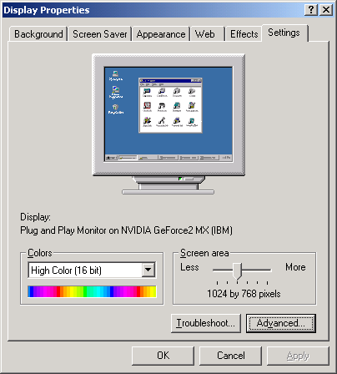

- Minimum PC memory required is 256 MB or higher

- Microsoft Windows/2000, Windows/XP or newer. (Windows NT and/or Windows 98 may run but is not supported).
- Internet Explorer v5.5 or higher.
- If a pop up blocker is installed in the browser, please disable it prior to logging in to the PCMS application or in same cases pressing shift while clicking on a form works.
- If you have SecureRemote installed, you must disable it before accessing PCMS.

