OMB Control Number 1205-0420

Expiration Date 02/28/2009

Workforce Investment Act Annual Report:
General Reporting Instructions and ETA Form 9091
Revised 2006

Prepared By
Office of Performance and Technology
Employment and Training Administration

This reporting requirement is approved under the Paperwork Reduction Act of 1995, OMB Control No. 1205-0420, expiring 02/28/2009. Persons are not required to respond to this collection of information unless it displays a currently valid OMB number. Public reporting burden for this collection of information is estimated to average 400 hours per annual report per state, including time for reviewing instructions, searching existing data sources, gathering and reviewing the collection of information. Respondent’s obligation to reply is mandatory. The reason for the collection of information is general program oversight, evaluation and performance assessment. Send comments regarding this burden estimate or any other aspect of this collection, including suggestions for reducing this burden, to the U. S. Department of Labor, Employment and Training Administration, Office of Performance and Technology, 200 Constitution Avenue, NW, Room S-5206, Washington, D.C. 20210 (Paperwork Reduction Project 1205-0420).

GENERAL INSTRUCTIONS

Each state that receives an allotment under WIA section 127 (youth activities) or
Section 132 (adult and dislocated worker activities) of the WIA of 1998 must prepare and submit an Annual Report to the Secretary in accordance with WIA sections 136(d)(1) and 185(d).

The Department of Labor, in consultation with states and other partners, has developed a strategy for the Annual Report that is designed to meet these requirements and also provides states the flexibility to showcase their unique programs, strategies and accomplishments. The Annual Report will emulate the Private Sector’s Report to Stockholders. Just as a Report to Stockholders presents a company portrait painted in a particular style of the corporate culture, states are encouraged to design their Annual Reports to stakeholders in a manner that makes use of graphics and other communication devices so that the report highlights the programs in the most advantageous manner to all stakeholders, including Congress, Governors, state legislators, workforce investment boards and the public. For example, states may want to include success stories that focus attention on successful programming for participants, employers and communities. States may also consider including messages from the Governor, information about State Workforce Investment Board members, market analysis, strategies for improvement, and analysis of programs’ effects on major industries in the reports.

There is great flexibility in the contents of the annual report narrative, but there are three sets of information that are required elements for each states’ annual report, as described in WIA section 136:

- Performance data on the core and customer satisfaction measures, including progress of local areas in the state in achieving local performance measures;
- Information on the status of state evaluation activities; and
- Information on the cost of workforce investment activities relative to the effect of the activities on the performance of participants.

More information on these requirements is provided in Section III below. States should be aware that the Secretary utilizes the Annual Reports to fulfill the requirement to disseminate state-by-state comparisons of the information (WIA section 136(d)(3)(B)). Additionally, this information is used to determine states’ eligibility for incentive grants (WIA section 503) or whether the Secretary will impose a sanction based on performance failure (WIA section 136(g)).

Performance data reported in the WIA Annual Report must be comprised of information provided by each state from their individual Workforce Investment Act Standardized Record Data (WIASRD) files through matching client information with the employment outcome information obtained from Unemployment Insurance (UI) and other administrative wage records or from other supplemental data sources. Therefore, ETA requires that performance information received from states on the WIA Annual Report be based upon the submission of WIASRD files (sec. 136(f) and 185). The WIA Annual Report must be complete and accurate (WIA section 185 (29 USC 2935).

COVERED PROGRAMS

The WIA Annual Report will cover participants who receive services financially assisted by formula or statewide reserve funds under the following ETA programs:

- WIA Adult Program
- WIA Dislocated Worker Program (including dislocated workers participating in programs funded under WIA section 134(a)(2)(A)(ii) – rapid response additional assistance)
- WIA Youth Program

Performance information about participants who only receive services financially assisted by National Emergency Grants (NEGs) will not be included, since this information will be obtained through the WIA Quarterly Report (ETA 9090). However, performance information about participants who received services financially assisted by WIA Title IB and NEGs are included in the Annual Report. In addition, WIA statewide activities that are included in the Annual Report are those statewide activities that involve the enrollment of individuals eligible to receive WIA Title I-B services (e.g., adult, dislocated worker, or youth). Conversely, if state or local activities do not involve the enrollment of individuals to receive services, performance information is not included in the WIA Annual Report. Examples of such exceptions include activities where (a) the state is conducting a statewide activity that does not involve direct services (e.g., research or evaluation), or (b) the statewide activity is structured to provide services that are highly specialized, such as in a pilot or demonstration activity (e.g., incumbent worker training, project for chemically dependent TANF recipients).

ANNUAL REPORT SPECIFICATIONS

The Annual Report reflects performance outcome information that becomes available by the time the Annual Report for the program year is due to ETA. Appendix A explains the applicable time periods that states should use when preparing performance information for the WIA Annual Report. The reporting format for the WIA Annual Report can be found under Appendix B. Performance information received from the states on Tables B through M (excluding all program participant counts and exiter counts of self-service participants) of the WIA Annual Report must be based on the annual submission of individual WIASRD files.

At a minimum, the Annual Report must be submitted in accordance with the following guidelines:

- Indicate the name of your state and the date on which the Annual Report was submitted electronically to ETA.
- On the electronic version of the report, include the name and title of the authorized official of the governor responsible for certifying that the data submitted is complete and accurate.

- NARRATIVE SECTION

- This portion of the narrative is a discussion of the cost of workforce investment activities relative to the effect of the activities on the performance of the participants as required in WIA section 136(d)(2)(C). In addressing this item, states may want to include information from their strategic plans that highlight innovative service delivery strategies, including program activities that support high growth/high demand industries, the outcomes expected from these activities as well as the actual outcomes for their major customer segments. States may indicate actual federal outlays for these selected activities, if the information is available.

States must explain how the allocation of resources for adults, dislocated workers, and youth activities affected the outcomes. For adults and dislocated workers the activities that states may wish to address is core, intensive and training services. For youth, states should include information about front-end costs (e.g., intake, assessment and case management) and aggregated direct service costs for the ten youth program elements described in WIA section 129(c)(2).

- This portion of the narrative is a description of state evaluations of workforce investment activities (if any) is required by WIA section 136(d)(1), including:

  - The questions the evaluation will/did address;
  - A description of the evaluation's methodology; and
  - Information about the timing of feedback and deliverables.

The required state evaluations of workforce investment activities are described in WIA section 136(e) and include evaluation studies of workforce investment activities conducted under WIA title I-B to establish, implement, and use methods for continuous improvement in the efficiency and effectiveness of the statewide workforce investment system in improving employability for job seekers and competitiveness for employers.

- TABLE SECTION

The reporting format and specifications for preparing performance calculations for tables A through O of the WIA Annual Report can be found under Appendix B and Appendix C. States do not need to separately report the performance information submitted online within the body of the Annual Report narratives.

Special Instruction: The youth common performance measures contained within Table H.1 are for reporting purposes only. States will not be required to establish negotiated performance levels nor be held accountable through the WIA accountability system. States should ensure that a “null or blank” for each measure is placed under the Negotiated Performance Levels column in Table H.1. until further guidance is issued by the Department.

DUE DATE

The report is due no later than October 1st following the end of each Program Year (July – June). The following table shows the expected due dates for the WIA Annual Report for the next three Program Years.

Program Year | Due Dates
PY 2005 | October 1st, 2006
PY 2006 | October 1st, 2007
PY 2007 | October 1st, 2008

Should the due date of the report fall on a Saturday or Sunday, the annual report is due the Friday before.

SUBMISSION PROCEDURES

Information contained on the WIA Annual Report must be submitted directly to ETA’s Enterprise Business Support System (EBSS) (formerly called the Enterprise Information Management System (EIMS)) via technical instructions available through the appropriate Regional Office or the ETA performance website (www.doleta.gov/performance). ETA intends to provide Congress with a copy of the Annual Report submitted by each state and publish each state’s report on its Web site (www.doleta.gov/performance). Therefore, states should also provide ETA with a computerized copy of the report in a format usable for inclusion on ETA’s Web site. Acceptable formats include WordPerfect, Microsoft Word, Acrobat, and other commonly used formats.

States must complete the Report Validation report prior to submitting the WIA Annual Report (WIA Section 185, 29 USC 2935). Further information may be found on ETA’s Performance and Results website, under Data Validation.

APPENDIX A

Time Periods for Reporting Performance Information

WIA Annual Report

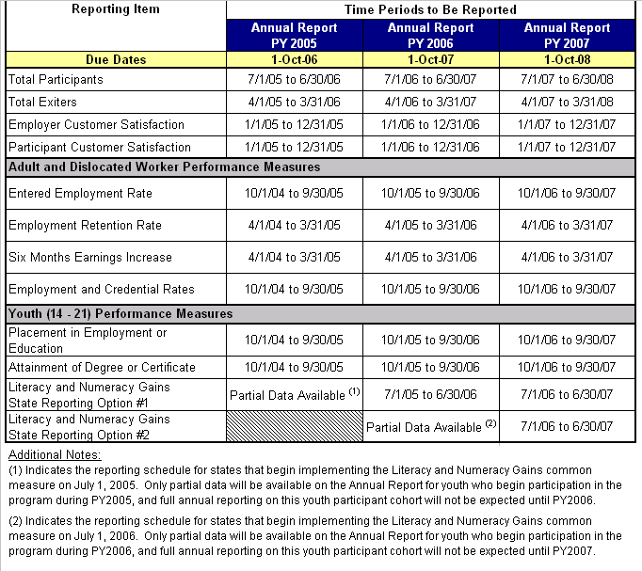
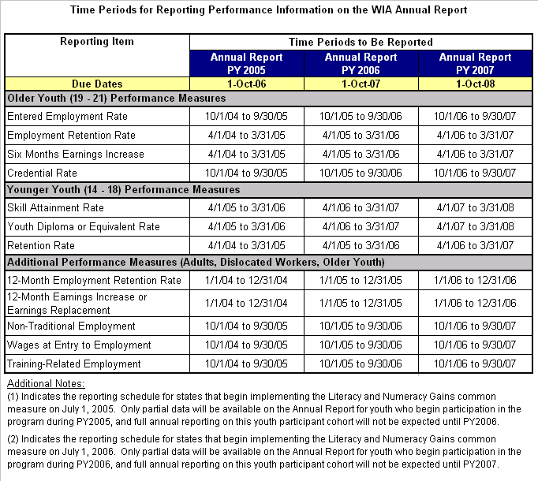

APPENDIX B
WIA Annual Report Format (ETA Form 9091)


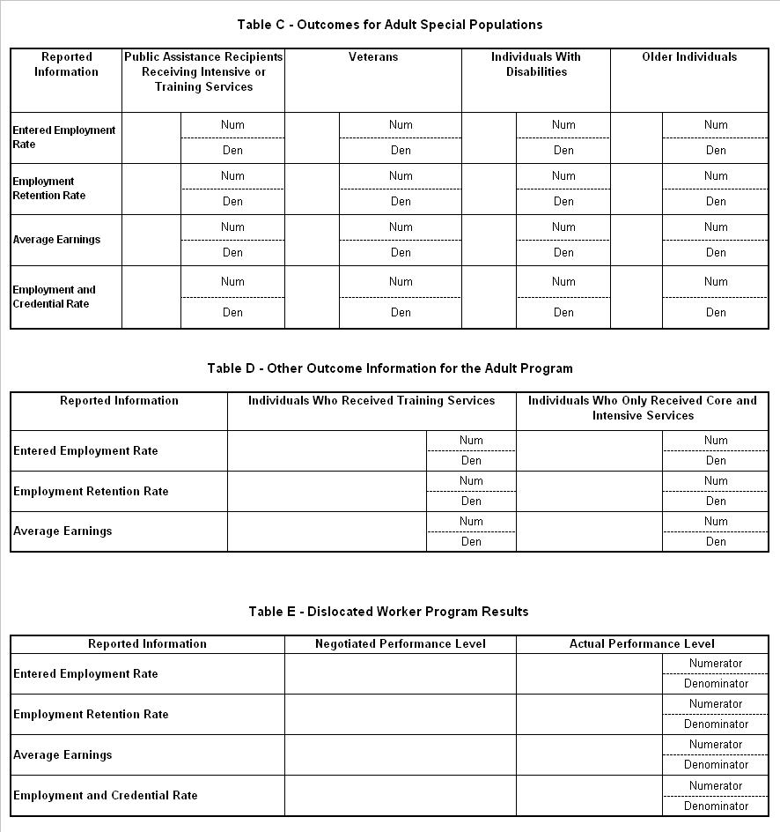
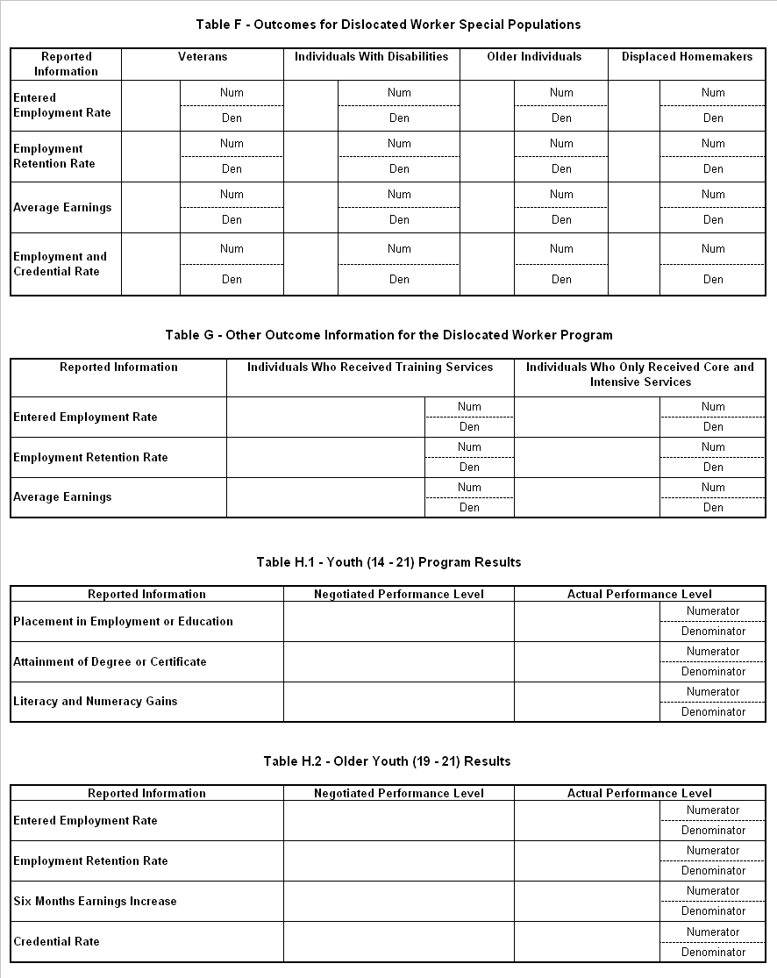
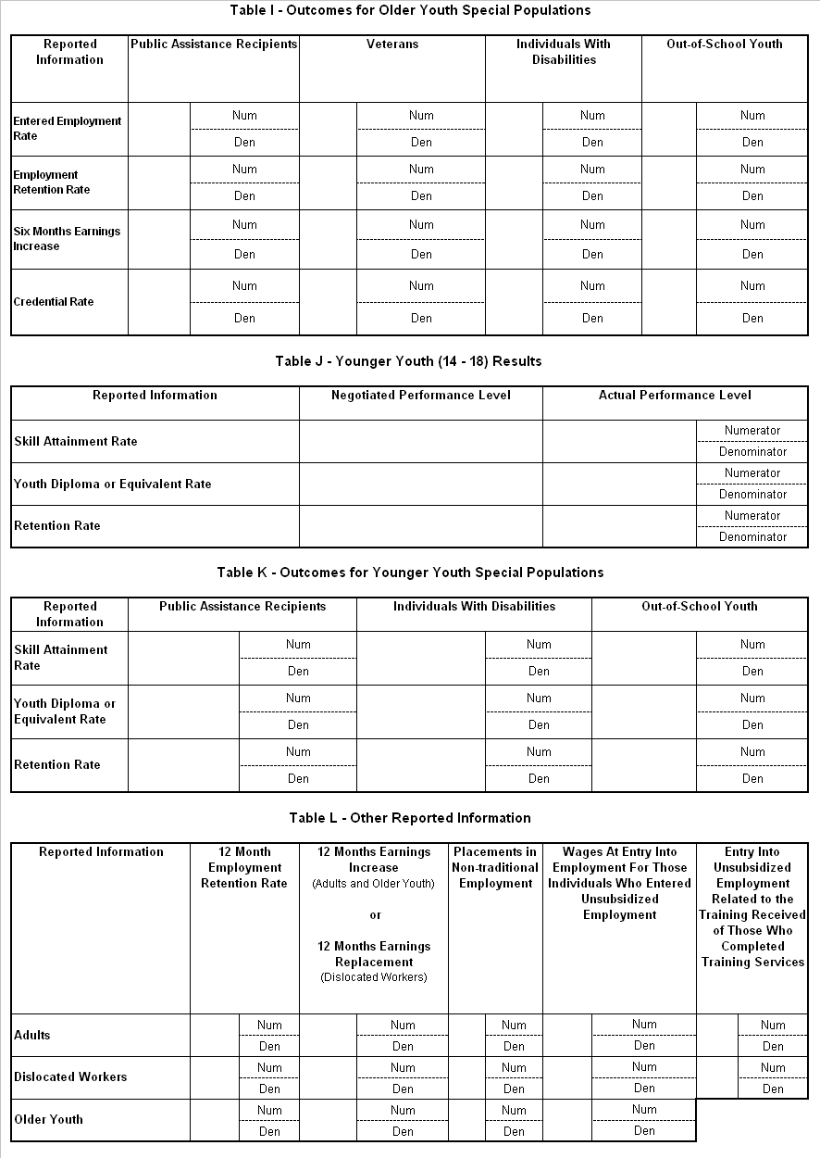
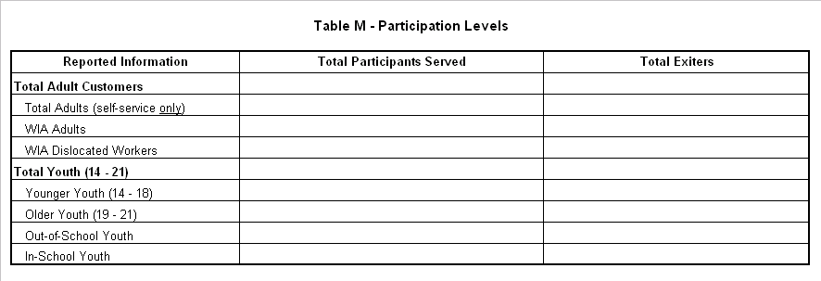

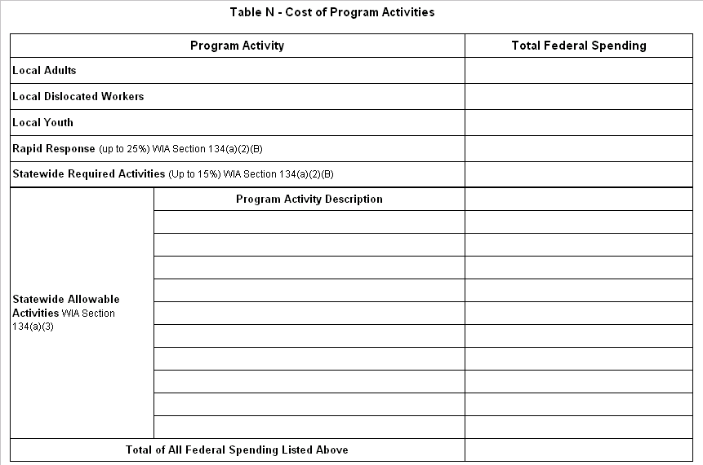

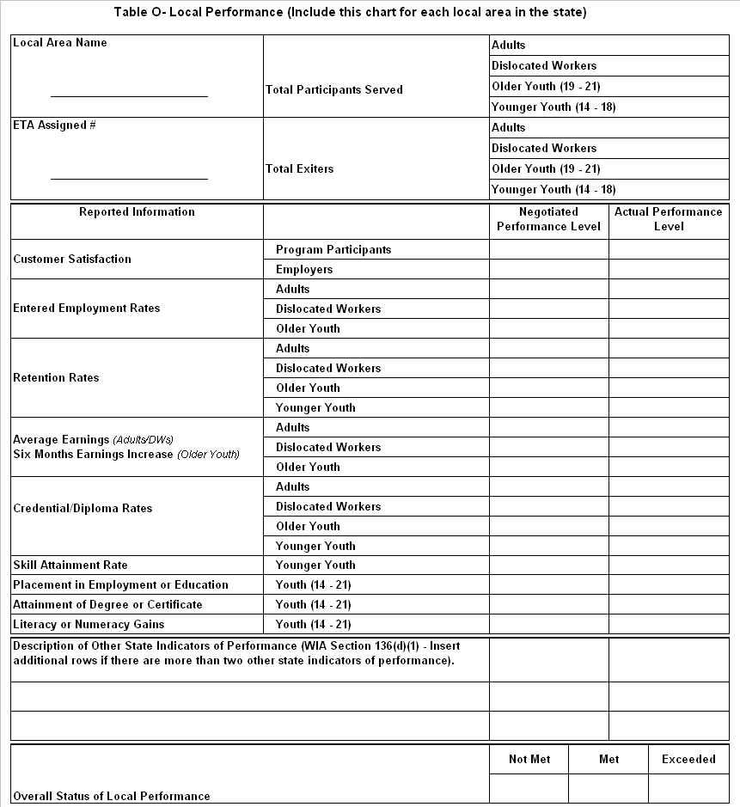

APPENDIX C
Reporting Specifications for Tables A through O

Table A: Workforce Investment Act Customer Satisfaction Results

Enter the following information separately for program participants and employers. Additional information about Customer Satisfaction Indicators is available on ETA’s website at http://www.doleta.gov/performance. Customer satisfaction results are based on exiters from the calendar year.

Table A. CUSTOMER SATISFACTION (PARTICIPANTS AND EMPLOYERS)
Negotiated Performance Level | Record the level of performance negotiated between the State and USDOL.
Actual Performance  Level | Record the actual performance levels on the American Customer Satisfaction Index (ACSI).
Number of Surveys Completed | Record the number of surveys with answers to each of the three required questions.
Number of Customers Eligible for the Survey | Record the number of participants/employers in the group (sample frame) from which the customer sample was drawn. This information is needed to aggregate customer satisfaction across all States.
Number of Customers Included in the Sample | Record the representative subset of participants/employers eligible for the surveys that were selected for interviews. If no sampling is used by the state, the sample size equals the number eligible for the survey.
Response Rate | Record the response rate by dividing the number of completed surveys by the number included in the sample.
States using the ACSI methodology to measure Local Board performance are not required to conduct separate customer satisfaction surveys to obtain State level results. In situations where a single sampling rate is used throughout the State, the Local Board ACSI results on a customer satisfaction measure may simply be aggregated to obtain State level results.

In situations where different sampling rates exist for the Local Boards in a State, each Local Board's ACSI score will need to be weighted before aggregating the outcomes to obtain results that are representative of the State overall. The information needed to compute these weighted scores are the sample frames for each Local Board in the State and each Local Board's ACSI score.

To illustrate how these weights are derived, consider the following example:
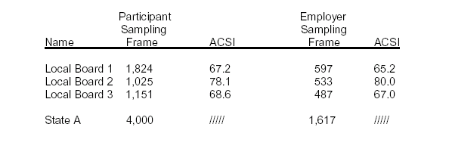

The weighted score would be calculated for each Local Board by multiplying the ACSI score by the number in the Local Board sample frame. These weighted Local Board scores would then be totaled and divided by the sum of the sampling frame sizes for all Local Boards in the State to obtain a State ACSI.

Using the figures provided in the above example, the ACSI scores for the State are calculated in the following manner:
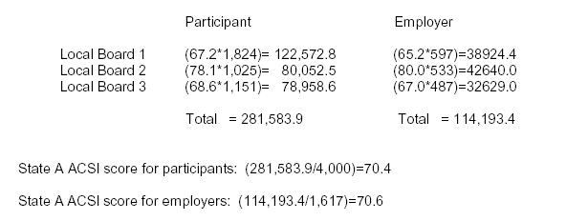

Tables B through M: Establishing Program Performance Groups

Use the following specifications to complete the performance calculations for Tables B through M. The chart below provides an explanation of how program participants are classified as adults, dislocated workers, and youth for the purposes of calculating program performance. These classifications are based upon one or more data elements contained within the WIASRD. In order for a participant to be included in a particular program performance group, at least one of the corresponding conditions in “Specifications” column needs to be true. For instance, as shown in the row labeled “Adult,” if either Adult (Local Formula) (WIASRD Element 304) = 1 or Adult (Statewide 15% Activities) (WIASRD Element 310) = 1, the participant is included in the WIA Adult performance measures.

Important Note: These funding stream specifications apply to the statewide annual performance calculations. They do not apply to local level performance calculated for Table O of this annual report.

WIA Performance Group Specifications
Program | Specifications
Self-Service Only | RECEIVED CORE SELF-SERVICES AND INFORMATIONAL ACTIVITIES = 1 and DATE OF FIRST STAFF-ASSISTED CORE SERVICE is null and DATE OF FIRST INTENSIVE SERVICE is null and DATE ENTERED TRAINING is null and (TYPE OF TRAINING SERVICE #1 = 0 or TYPE OF TRAINING SERVICE #1 is null).
More than Self-Service | (DATE OF FIRST STAFF-ASSISTED CORE SERVICE is not null or DATE OF FIRST INTENSIVE SERVICE is not null or (DATE ENTERED TRAINING is not null and TYPE OF TRAINING SERVICE #1 > 0).
Adult | (ADULT (LOCAL FORMULA) = 1 or ADULT (STATEWIDE 15% ACTIVITIES) = 1)
Dislocated  Worker | (DISLOCATED WORKER (LOCAL FORMULA) = 1 or DISLOCATED WORKER (STATEWIDE 15% ACTIVATES) = 1 or RAPID RESPONSE (ADDITIONAL ASSISTANCE) = 1)
Older Youth | DATE OF FIRST YOUTH SERVICE is not null  and (DATE OF FIRST YOUTH SERVICE - DATE OF BIRTH) >=19  and (DATE OF FIRST YOUTH SERVICE - DATE OF BIRTH) <= 21
Younger Youth | DATE OF FIRST YOUTH SERVICE is not null  and (DATE OF FIRST YOUTH SERVICE - DATE OF BIRTH) >=14  and (DATE OF FIRST YOUTH SERVICE - DATE OF BIRTH) <= 18
Youth | DATE OF FIRST YOUTH SERVICE is not null  and (DATE OF FIRST YOUTH SERVICE - DATE OF BIRTH) >=14  and (DATE OF FIRST YOUTH SERVICE - DATE OF BIRTH) <= 21

It is important to note that participant records can be included in more than one WIA performance group. Participants who are co-enrolled in multiple funding streams are included in the calculation of the performance measures for all funding streams in which they are enrolled. For example, a participant record could have Date of First Youth Service populated (WIASRD Element 306) and Adult (local) (WIASRD Element 304) = 1. In this case, the participant is included in the performance measure calculations both for youth and for adults.

Tables B through G: WIA Adult and Dislocated Worker Performance

The following specifications provide guidance for states to calculate performance for two sets of adults and dislocated workers who exited from WIA services during a specific reporting period:

- All adult and dislocated worker exiters are subject to the entered employment, employment retention, and average earnings measures; and

- Those adults and dislocated workers who received training services and exited are also subject to the employment and credential rate measure.

This section outlines the mathematical formulae and data element specifications for states to report on the following adult and dislocated worker performance measures:

Entered Employment Rate

Of those who are not employed at the date of participation:

# of participants who are employed in the first quarter (qtr) after the exit qtr

# of participants who exit during the qtr

Employment Retention Rate

Of those who are employed in the first quarter after the exit qtr:

# of participants who are employed in both the second and third qtrs after the exit qtr

# of participants who exit during the qtr

Employment and Credential Rate

Of those who receive training services:

# of participants who were employed in the first qtr after the exit qtr and received a credential by the end of the third qtr after the exit qtr

# of participants who exit during the qtr

Average Earnings

Of those who are employed in the first, second, and third quarters after the exit quarter:

[Total earnings in the second quarter plus total earnings in the third quarter after the exit quarter]

# of participants who exit during the qtr

Table B. aDULT PROGRAM RESULTS
Negotiated Performance Level |  | Record the level of performance negotiated between the State and USDOL.
Actual Performance Level |  | Use the data element specifications below to record the actual performance levels (including numerators and denominators) achieved by the state in each of the performance measures. To derive the value of each performance measure, states should divide the numerator calculation by the denominator calculation.
Entered Employment Rate (EER) | Adult EER Numerator | Count of UNIQUE RECORDS where ADULT and MORE THAN SELF-SERVICE and (EMPLOYMENT STATUS AT PARTICIPATION = 2 or EMPLOYMENT STATUS AT PARTICIPATION = 3) and ((EMPLOYED 1ST QUARTER AFTER EXIT QUARTER = 1 and TYPE OF EMPLOYMENT MATCH 1ST QUARTER AFTER EXIT QUARTER = 5) or (WAGES 1ST QUARTER AFTER THE EXIT QUARTER > 0 and WAGES 1ST QUARTER AFTER THE EXIT QUARTER < 999999.99)) and DATE OF EXIT is within the report period and (OTHER REASONS FOR EXIT is null or OTHER REASONS FOR EXIT = 00 or OTHER REASONS FOR EXIT = 98)
Entered Employment Rate (EER) | Adult EER Denominator | Count of UNIQUE RECORDS where ADULT and MORE THAN SELF-SERVICE and (EMPLOYMENT STATUS AT PARTICIPATION = 2 or EMPLOYMENT STATUS AT PARTICIPATION = 3) and DATE OF EXIT is within the report period and (OTHER REASONS FOR EXIT is null or OTHER REASONS FOR EXIT = 00 or OTHER REASONS FOR EXIT = 98)
Employment Retention Rate (ERR) | Adult ERR Numerator | Count of UNIQUE RECORDS where ADULT and MORE THAN SELF-SERVICE and ((EMPLOYED 1ST QUARTER AFTER EXIT QUARTER = 1 and TYPE OF EMPLOYMENT MATCH 1ST QUARTER AFTER EXIT QUARTER = 5) or (WAGES 1ST QUARTER AFTER THE EXIT QUARTER > 0 and WAGES 1ST QUARTER AFTER THE EXIT QUARTER < 999999.99)) and ((EMPLOYED 2ND QUARTER AFTER EXIT QUARTER = 1 and TYPE OF EMPLOYMENT MATCH 2ND QUARTER AFTER EXIT QUARTER = 5) or (WAGES 2ND QUARTER AFTER THE EXIT QUARTER > 0 and WAGES 2ND QUARTER AFTER THE EXIT QUARTER < 999999.99)) and ((EMPLOYED 3RD QUARTER AFTER EXIT QUARTER = 1 and TYPE OF EMPLOYMENT MATCH 3RD QUARTER AFTER EXIT QUARTER = 5) or (WAGES 3RD QUARTER AFTER EXIT QUARTER > 0 and WAGES 3RD QUARTER AFTER EXIT QUARTER < 999999.99)) and DATE OF EXIT is within the report period and (OTHER REASONS FOR EXIT is null or OTHER REASONS FOR EXIT = 00 or OTHER REASONS FOR EXIT = 98)
Employment Retention Rate (ERR) | Adult ERR Denominator | Count of UNIQUE RECORDS where ADULT and MORE THAN SELF-SERVICE and ((EMPLOYED 1ST QUARTER AFTER EXIT QUARTER = 1 and TYPE OF EMPLOYMENT MATCH 1ST QUARTER AFTER EXIT QUARTER = 5) or (WAGES 1ST QUARTER AFTER THE EXIT QUARTER > 0 and WAGES 1ST QUARTER AFTER THE EXIT QUARTER < 999999.99)) and DATE OF EXIT is within the report period and (OTHER REASONS FOR EXIT is null or OTHER REASONS FOR EXIT = 00 or OTHER REASONS FOR EXIT = 98)
Employment and Credential Rate (ECR) | Adult ECR Numerator | Count of Unique RECORDs where ADULT and MORE THAN SELF-SERVICE and ((EMPLOYED 1ST QUARTER AFTER EXIT QUARTER = 1 and TYPE OF EMPLOYMENT MATCH 1ST QUARTER AFTER EXIT QUARTER = 5) or (WAGES 1ST QUARTER AFTER THE EXIT QUARTER > 0 and WAGES 1ST QUARTER AFTER THE EXIT QUARTER < 999999.99)) and DATE ENTERED TRAINING is not null and TYPE OF TRAINING #1 > 0 and TYPE OF RECOGNIZED CREDENTIAL > 0 and DATE OF EXIT is within the reporting period and (OTHER REASONS FOR EXIT is null or OTHER REASONS FOR EXIT = 00 or OTHER REASONS FOR EXIT = 98).
Employment and Credential Rate (ECR) | Adult ECR Denominator | Count of Unique RECORDs where ADULT and MORE THAN SELF-SERVICE and DATE ENTERED TRAINING is not null and TYPE OF TRAINING #1 > 0 and DATE OF EXIT is within the reporting period and (OTHER REASONS FOR EXIT is null or OTHER REASONS FOR EXIT = 00 or OTHER REASONS FOR EXIT = 98)
Six Months Earnings Increase | Adult Average Earnings Numerator | Sum of (WAGES 2nd QUARTER AFTER THE EXIT QUARTER and WAGES 3rd QUARTER AFTER THE EXIT QUARTER) where ADULT and MORE THAN SELF-SERVICE and (WAGES 1ST QUARTER AFTER EXIT QUARTER > 0 and WAGES 1ST QUARTER AFTER EXIT QUARTER < 999999.99) and (WAGES 2nd QUARTER AFTER EXIT QUARTER > 0 and WAGES 2nd QUARTER AFTER EXIT QUARTER < 999999.99) and (WAGES 3rd QUARTER AFTER EXIT QUARTER > 0 and WAGES 3rd QUARTER AFTER EXIT QUARTER < 999999.99) and DATE OF EXIT is within the reporting period and (OTHER REASONS FOR EXIT is null or OTHER REASONS FOR EXIT = 00 or OTHER REASONS FOR EXIT = 98)
Six Months Earnings Increase | Adult Average Earnings Denominator | Count of unique RECORDS where ADULT and MORE THAN SELF-SERVICE and (WAGES 1ST QUARTER AFTER EXIT QUARTER > 0 and WAGES 1ST QUARTER AFTER EXIT QUARTER < 999999.99) and (WAGES 2nd QUARTER AFTER EXIT QUARTER > 0 and WAGES 2nd QUARTER AFTER EXIT QUARTER < 999999.99) and (WAGES 3rd QUARTER AFTER EXIT QUARTER > 0 and WAGES 3rd QUARTER AFTER EXIT QUARTER < 999999.99) and DATE OF EXIT is within the reporting period and (OTHER REASONS FOR EXIT is null or OTHER REASONS FOR EXIT = 00 or OTHER REASONS FOR EXIT = 98)

To calculate the measures in tables C and D, apply the filters described below to the specification for the appropriate measure provided for table B, above.

TABLE c. OUTCOMES FOR ADULT SPECIAL POPULATIONS
A | Public Assistance Recipients Receiving Intensive or Training Services | TEMPORARY ASSISTANCE TO NEEDY FAMILIES (TANF) = 1 or  OTHER PUBLIC ASSISTANCE RECIPIENT = 1 and (DATE OF FIRST INTENSIVE SERVICE is not null or (DATE ENTERED TRAINING is not null and TYPE OF TRAINING SERVICE #1 > 0))
B | Veterans | ELIGIBLE VETERAN STATUS > 0 and ELIGIBLE VETERAN STATUS < 4
C | Individuals with Disabilities | INDIVIDUAL WITH A DISABILITY = 1
D | Older Individual | DATE OF PARTICIPATION minus DATE OF BIRTH => 55 years

TABLE D. OTHER OUTCOME INFORMATION FOR ADULT PROGRAM
A | Individuals who Received Training Services | DATE ENTERED TRAINING is not null and TYPE OF TRAINING SERVICE #1 > 0
B | Individuals who Only Received Core and Intensive Services | DATE ENTERED TRAINING is null and (TYPE OF TRAINING SERVICE #1 = 0 or  TYPE OF TRAINING SERVICE #1 is null)

Table E. dislocated worker PROGRAM RESULTS
Negotiated Performance Level |  |  | Record the level of performance negotiated between the State and USDOL.
Actual Performance Level |  |  | Use the data element specifications below to record the actual performance levels (including numerators and denominators) achieved by the state in each of the performance measures. To derive the value of each performance measure, states should divide the numerator calculation by the denominator calculation.
Entered Employment Rate (EER) |  | DW EER Numerator | Count of UNIQUE RECORDS where DISLOCATED WORKER and MORE THAN SELF-SERVICE and (EMPLOYMENT STATUS AT PARTICIPATION = 2 or EMPLOYMENT STATUS AT PARTICIPATION = 3) and ((EMPLOYED 1ST QUARTER AFTER EXIT QUARTER = 1 and TYPE OF EMPLOYMENT MATCH 1ST QUARTER AFTER EXIT QUARTER = 5) or (WAGES 1ST QUARTER AFTER THE EXIT QUARTER > 0 and WAGES 1ST QUARTER AFTER THE EXIT QUARTER < 999999.99)) and DATE OF EXIT is within the report period and (OTHER REASONS FOR EXIT is null or OTHER REASONS FOR EXIT = 00 or OTHER REASONS FOR EXIT = 98)
 |  | DW EER Denominator | Count of UNIQUE RECORDS where DISLOCATED WORKER and MORE THAN SELF-SERVICE and (EMPLOYMENT STATUS AT PARTICIPATION = 2 or EMPLOYMENT STATUS AT PARTICIPATION = 3) and DATE OF EXIT is within the report period and (OTHER REASONS FOR EXIT is null or OTHER REASONS FOR EXIT = 00 or OTHER REASONS FOR EXIT = 98)
Employment Retention Rate (ERR) |  | DW ERR Numerator | Count of UNIQUE RECORDS where DISLOCATED WORKER and MORE THAN SELF-SERVICE and ((EMPLOYED 1ST QUARTER AFTER EXIT QUARTER = 1 and TYPE OF EMPLOYMENT MATCH 1ST QUARTER AFTER EXIT QUARTER = 5) or (WAGES 1ST QUARTER AFTER THE EXIT QUARTER > 0 and WAGES 1ST QUARTER AFTER THE EXIT QUARTER < 999999.99)) and ((EMPLOYED 2ND QUARTER AFTER EXIT QUARTER = 1 and TYPE OF EMPLOYMENT MATCH 2ND QUARTER AFTER EXIT QUARTER = 5) or (WAGES 2ND QUARTER AFTER THE EXIT QUARTER > 0 and WAGES 2ND QUARTER AFTER THE EXIT QUARTER < 999999.99)) and ((EMPLOYED 3RD QUARTER AFTER EXIT QUARTER = 1 and TYPE OF EMPLOYMENT MATCH 3RD QUARTER AFTER EXIT QUARTER = 5) or (WAGES 3RD QUARTER AFTER EXIT QUARTER > 0 and WAGES 3RD QUARTER AFTER EXIT QUARTER < 999999.99)) and DATE OF EXIT is within the report period and (OTHER REASONS FOR EXIT is null or OTHER REASONS FOR EXIT = 00 or OTHER REASONS FOR EXIT = 98)
 |  | DW ERR Denominator | Count of UNIQUE RECORDS where DISLOCATED WORKER and MORE THAN SELF-SERVICE and ((EMPLOYED 1ST QUARTER AFTER EXIT QUARTER = 1 and TYPE OF EMPLOYMENT MATCH 1ST QUARTER AFTER EXIT QUARTER = 5) or (WAGES 1ST QUARTER AFTER THE EXIT QUARTER > 0 and WAGES 1ST QUARTER AFTER THE EXIT QUARTER < 999999.99)) and DATE OF EXIT is within the report period and (OTHER REASONS FOR EXIT is null or OTHER REASONS FOR EXIT = 00 or OTHER REASONS FOR EXIT = 98)
Employment and Credential Rate (ECR) | DW ECR Numerator |  | Count of Unique RECORDs where DISLOCATED WORKER and MORE THAN SELF-SERVICE and ((EMPLOYED 1ST QUARTER AFTER EXIT QUARTER = 1 and TYPE OF EMPLOYMENT MATCH 1ST QUARTER AFTER EXIT QUARTER = 5) or (WAGES 1ST QUARTER AFTER THE EXIT QUARTER > 0 and WAGES 1ST QUARTER AFTER THE EXIT QUARTER < 999999.99)) and DATE ENTERED TRAINING is not null and TYPE OF TRAINING #1 > 0 and TYPE OF RECOGNIZED CREDENTIAL > 0 and DATE OF EXIT is within the reporting period and (OTHER REASONS FOR EXIT is null or OTHER REASONS FOR EXIT = 00 or OTHER REASONS FOR EXIT = 98)

Table E. dislocated worker PROGRAM RESULTS (continued)
 | DW ECR Denominator | Count of Unique RECORDs where DISLOCATED WORKER and MORE THAN SELF-SERVICE and DATE ENTERED TRAINING is not null and TYPE OF TRAINING #1 > 0 and DATE OF EXIT is within the reporting period and (OTHER REASONS FOR EXIT is null or OTHER REASONS FOR EXIT = 00 or OTHER REASONS FOR EXIT = 98)
Six Months Earnings Increase | DW Average Earnings Numerator | Sum of (WAGES 2nd QUARTER AFTER THE EXIT QUARTER and WAGES 3rd QUARTER AFTER THE EXIT QUARTER) where DISLOCATED WORKER and MORE THAN SELF-SERVICE and (WAGES 1ST QUARTER AFTER EXIT QUARTER > 0 and WAGES 1ST QUARTER AFTER EXIT QUARTER < 999999.99) and (WAGES 2nd QUARTER AFTER EXIT QUARTER > 0 and WAGES 2nd QUARTER AFTER EXIT QUARTER < 999999.99) and (WAGES 3rd QUARTER AFTER EXIT QUARTER > 0 and WAGES 3rd QUARTER AFTER EXIT QUARTER < 999999.99) and DATE OF EXIT is within the reporting period and (OTHER REASONS FOR EXIT is null or OTHER REASONS FOR EXIT = 00 or OTHER REASONS FOR EXIT = 98)
Six Months Earnings Increase | DW Average Earnings Denominator | Count of unique RECORDS where DISLOCATED WORKER and MORE THAN SELF-SERVICE and (WAGES 1ST QUARTER AFTER EXIT QUARTER > 0 and WAGES 1ST QUARTER AFTER EXIT QUARTER < 999999.99) and (WAGES 2nd QUARTER AFTER EXIT QUARTER > 0 and WAGES 2nd QUARTER AFTER EXIT QUARTER < 999999.99) and (WAGES 3rd QUARTER AFTER EXIT QUARTER > 0 and WAGES 3rd QUARTER AFTER EXIT QUARTER < 999999.99) and DATE OF EXIT is within the reporting period and (OTHER REASONS FOR EXIT is null or OTHER REASONS FOR EXIT = 00 or OTHER REASONS FOR EXIT = 98

To calculate the measures in tables F and G, apply the filters described below to the specification for the appropriate measure provided for table E, above.

TABLE F. OUTCOMES FOR DISLOCATED WORKER SPECIAL POPULATIONS
A | Veterans | ELIGIBLE VETERAN STATUS > 0 and ELIGIBLE VETERAN STATUS < 4
B | Individuals with Disabilities | INDIVIDUAL WITH A DISABILITY = 1
C | Older Individual | DATE OF PARTICIPATION minus DATE OF BIRTH => 55 years
D | Displaced Homemaker | DISPLACED HOMEMAKER = 1

TABLE g. OTHER OUTCOME INFORMATION FOR DISLOCATED WORKER PROGRAM
A | Individuals who Received Training Services | DATE ENTERED TRAINING is not null and TYPE OF TRAINING SERVICE #1 > 0
B | Individuals who Only Received Core and Intensive Services | DATE ENTERED TRAINING is null and (TYPE OF TRAINING SERVICE #1 = 0 or  TYPE OF TRAINING SERVICE #1 is null)

Table H.1: Youth (14 – 21) Common Performance Measures

The following specifications provide guidance for states to calculate youth who received services financially assisted by the WIA Title I-B program during a specific reporting period:

  - All youth exiters are subject to the placement in employment or education and attainment of degree or certificate measures;

  - Out-of-school youth participants and exiters who are basic skills deficient are subject to the Literacy and Numeracy Gains measure; and

  - Youth are those aged 14 through 21 on the date that they participate in WIA services.

This section outlines the mathematical formulae and data element specifications for states to report on the following youth performance measures:

Placement in Employment or Education

Of those who are not in post-secondary education or employment (including the military) at the date of participation:

# of participants who are in employment (including the military) or enrolled in post-secondary education and/or advanced training/occupational skills training in the first quarter (qtr) after the exit qtr

# of participants who exit during the qtr

Attainment of a Degree or Certificate

Of those enrolled in education (at the date of participation or at any point during the program):

# of participants who attain a diploma, GED, or certificate by the end of the third qtr after the exit qtr

# of participants who exit during the qtr

Literacy and Numeracy Gains

Of those out-of-school youth who are basic skills deficient:

# of participants who increase one or more educational functioning levels

# of participants who have completed a year in the youth program (i.e., one year from the date of first youth program service) plus the # of participants who exit before completing a year in the youth program

TABLE h.1. youth (14 – 21) Program results
Negotiated Performance Level |  | Record the level of performance negotiated between the State and USDOL.
Actual Performance Level |  | Use the data element specifications below to record the actual performance levels (including numerators and denominators) achieved by the state in each of the performance measures. To derive the value of each performance measure, states should divide the numerator calculation by the denominator calculation.
Placement in Employment or Education | Placement Numerator | Count of UNIQUE RECORDS where YOUTH and (EMPLOYMENT STATUS AT PARTICIPATION => 2 and (SCHOOL STATUS AT PARTICIPATION <> 3 or SCHOOL STATUS AT PARTICIPATION is null) and ((YOUTH PLACEMENT INFORMATION => 1 and YOUTH PLACEMENT INFORMATION <= 4) or ((EMPLOYED 1ST QUARTER AFTER EXIT QUARTER = 1 and TYPE OF EMPLOYMENT MATCH 1ST QUARTER AFTER EXIT QUARTER = 5) or (WAGES 1ST QUARTER AFTER THE EXIT QUARTER > 0 and WAGES 1ST QUARTER AFTER THE EXIT QUARTER < 999999.99)) and DATE OF EXIT is within the report period and (OTHER REASONS FOR EXIT is null or OTHER REASONS FOR EXIT = 00 or OTHER REASONS FOR EXIT = 98).
Placement in Employment or Education | Placement Denominator | Count of UNIQUE RECORDS where YOUTH and (EMPLOYMENT STATUS AT PARTICIPATION => 2 and (SCHOOL STATUS AT PARTICIPATION <> 3 or SCHOOL STATUS AT PARTICIPATION is null)) and DATE OF EXIT is within the report period and (OTHER REASONS FOR EXIT is null or OTHER REASONS FOR EXIT = 00 or OTHER REASONS FOR EXIT = 98).
Attainment of Degree or Certificate (ADC) | ADC Numerator | Count of UNIQUE RECORDS where YOUTH and ENROLLED IN EDUCATION = 1 and ATTAINED DIPLOMA, GED, OR CERTIFICATE > 0 and ATTAINED DIPLOMA, GED, OR CERTIFICATE < 4 and DATE ATTAINED DEGREE OR CERTIFICATE <= end of quarter of DATE OF EXIT + 3 quarters and DATE OF EXIT is within the report period and (OTHER REASONS FOR EXIT is null or OTHER REASONS FOR EXIT = 00 or OTHER REASONS FOR EXIT = 98).
Attainment of Degree or Certificate (ADC) | ADC Denominator | Count of UNIQUE RECORDS where YOUTH and ENROLLED IN EDUCATION = 1 and DATE OF EXIT is within the report period and (OTHER REASONS FOR EXIT is null or OTHER REASONS FOR EXIT = 00 or OTHER REASONS FOR EXIT = 98).

TABLE h.1. youth (14 – 21) common measures results at-a-glance (continued)
Literacy and Numeracy Gains | Literacy/  Numeracy Gains  Youth (14 - 21) Numerator | Count of unique RECORDS where YOUTH and BASIC SKILLS DEFICIENTand SCHOOL STATUS AT PARTICIPATION => 3  and  the earliest SUCCESSFUL TEST DATE IN A PARTICIPATION YEAR is within the reporting period and (OTHER REASONS FOR EXIT is null or OTHER REASONS FOR EXIT = 00 or OTHER REASONS FOR EXIT = 98))  (First year of implementation)  the earliest SUCCESSFUL TEST DATE IN A PARTICIPATION YEAR is not null and LAST DATE OF PARTICIPATION YEAR is within the reporting period and (DATE OF EXIT is null or DATE OF EXIT > LAST DATE OF PARTICIPATION YEAR or DATE OF EXIT <= DATE OF FIRST YOUTH SERVICE + 1 year). and (OTHER REASONS FOR EXIT is null or OTHER REASONS FOR EXIT = 00 or OTHER REASONS FOR EXIT = 98))  (second and subsequent years of implementation).
Literacy and Numeracy Gains | Literacy/  Numeracy Gains  Youth (14 - 21) Denominator  (First year of implementation) | Count of unique RECORDS where YOUTH and BASIC SKILLS DEFICIENT and (SCHOOL STATUS AT PARTICIPATION > 3 or (SCHOOL STATUS AT PARTICIPATION = 3 and (BASIC LITERACY SKILLS DEFICIENCY = 1)  And  ((the earliest SUCCESSFUL TEST DATE IN A PARTICIPATION YEAR is within the reporting period (see numerator for definition) and (OTHER REASONS FOR EXIT is null or OTHER REASONS FOR EXIT = 00 or OTHER REASONS FOR EXIT = 98))  or  (date OF EXIT is within the reporting period and (OTHER REASONS FOR EXIT is null or OTHER REASONS FOR EXIT = 00 or OTHER REASONS FOR EXIT = 98))  or  (Last Date of Participation Year is within the reporting period and (date OF EXIT is null or DATE OF EXIT > LAST DAY OF THE PARTICIPATION YEAR) and (OTHER REASONS FOR EXIT is null or OTHER REASONS FOR EXIT = 00 or OTHER REASONS FOR EXIT = 98)))
Literacy and Numeracy Gains | Literacy/  Numeracy Gains  Youth (14 - 21) Denominator  (Second and subsequent years of implementation) | Count of unique RECORDS where YOUTH and BASIC SKILLS DEFICIENCT and SCHOOL STATUS AT PARTICIPATION => 3.  and  ((Last Date of Participation Year is within the reporting period and (DATE OF EXIT is null or DATE OF EXIT > LAST DATE IN THE PARTICIPATION YEAR) and (OTHER REASONS FOR EXIT is null or OTHER REASONS FOR EXIT = 00 or OTHER REASONS FOR EXIT = 98))  or  (DATE OF EXIT <= DATE OF FIRST YOUTH SERVICE + 1 YEAR and (OTHER REASONS FOR EXIT is null or OTHER REASONS FOR EXIT = 00 or OTHER REASONS FOR EXIT = 98)))

Additional specifications for literacy and numeracy measure
Constructed variables to support performance calculations | Definition of Constructed Variables: In order to calculate the Literacy and Numeracy rate it will be necessary to analyze various fields in the WIASRD record and to create a new set of variables:  These variables include  1. BASIC SKILLS DEFICIENT  2. FIRST DATE OF PARTICIPATION YEAR  3. LAST DATE OF PARTICIPATION YEAR  4. SUCCESSFUL TEST COMPLETION DATE  5. EARLIEST SUCCESSFUL TEST COMPLETION DATE IN A PARTICIPATION YEAR
Constructed variables to support performance calculations | Definition of BASIC SKILLS DEFICIENT  and  BASIC LITERACY SKILLS DEFICIENCY = 1  and  ((EDUCATIONAL FUNCTIONING LEVEL POST-TEST #1 < 5 or EDUCATIONAL FUNCTIONING LEVEL POST-TEST #1 is null and DATE ADMINISTERED POST-TEST #1 is prior to the report period) or (EDUCATIONAL FUNCTIONING LEVEL POST-TEST #2 < 5 or EDUCATIONAL FUNCTIONING LEVEL POST-TEST #2 is null and DATE ADMINISTERED POST-TEST #2 is prior to the report period) or (EDUCATIONAL FUNCTIONING LEVEL POST-TEST #3 < 5 or EDUCATIONAL FUNCTIONING LEVEL POST-TEST #3 is null and DATE ADMINISTERED POST-TEST #3 is prior to the report period)  and  ((EDUCATIONAL FUNCTIONING LEVEL POST-TEST #4 < 5 or EDUCATIONAL FUNCTIONING LEVEL POST-TEST #4 is null and DATE ADMINISTERED POST-TEST #4 is prior to the report period) or (EDUCATIONAL FUNCTIONING LEVEL POST-TEST #5 < 5 or EDUCATIONAL FUNCTIONING LEVEL POST-TEST #5 is null and DATE ADMINISTERED POST-TEST #5 is prior to the report period) or (EDUCATIONAL FUNCTIONING LEVEL POST-TEST #6 < 5 or EDUCATIONAL FUNCTIONING LEVEL POST-TEST #6 is null and DATE ADMINISTERED POST-TEST #6 is prior to the report period)  and  ((EDUCATIONAL FUNCTIONING LEVEL POST-TEST #7 < 5 or EDUCATIONAL FUNCTIONING LEVEL POST-TEST #7 is null and DATE ADMINISTERED POST-TEST #7 is prior to the report period) or (EDUCATIONAL FUNCTIONING LEVEL POST-TEST #8 < 5 or EDUCATIONAL FUNCTIONING LEVEL POST-TEST #8 is null and DATE ADMINISTERED POST-TEST #8 is prior to the report period) or (EDUCATIONAL FUNCTIONING LEVEL POST-TEST #9 < 5 or EDUCATIONAL FUNCTIONING LEVEL POST-TEST #9 is null and DATE ADMINISTERED POST-TEST #9 is prior to the report period)
Constructed variables to support performance calculations | Definition of FIRST DATE OF PARTICIPATION YEAR:  FIRST DATE OF PARTICIPATION YEAR N = DATE OF FIRST YOUTH SERVICE + (N-1) Years  Each Youth Record may have up to three participation years

Additional specifications for literacy and numeracy measure (continued)
Constructed variables (continued) | Definition of LAST DATE OF PARTICIPATION YEAR:  FIRST DATE OF PARTICIPATION YEAR N+1 minus 1 day where exit date is null or EXIT DATE => FIRST DATE OF PARTICIPATION YEAR N+1
Constructed variables (continued) | Definition of SUCCESSFUL TEST COMPLETION DATE:  Date Administered (Post-Test #1)  where EDUCATIONAL FUNCTIONING LEVEL (POST-TEST #1) minus EDUCATIONAL FUNCTIONING LEVEL >0  or  Date Administered (Post-Test #2)  where EDUCATIONAL FUNCTIONING LEVEL POST-TEST #2 minus EDUCATIONAL FUNCTIONING LEVEL > 0  or  Date Administered (Post-Test #3)  where EDUCATIONAL FUNCTIONING LEVEL(POST-TEST #3) minus EDUCATIONAL FUNCTIONING LEVEL >0  (This set of conditions repeats for each functional area)
Constructed variables (continued) | Definition of EARLIEST SUCCESSFUL TEST COMPLETION DATE IN A PARTICIPATION YEAR:  From all SUCCESSFUL TEST COMPLETION DATEs >= FIRST DATE OF PARTICIPATION YEAR and <= LAST DATE OF PARTICIPATION YEAR  Select the earliest date. This repeats for each participation year.

Tables H.2 and I: Older Youth (19 – 21) Performance

The following specifications provide guidance for states to calculate performance for older youth who exited from WIA services during a specific reporting period:

    - All older youth exiters except those who move into post-secondary education or advanced training and are not employed in the measurement quarter are subject to the entered employment, employment retention, six months earnings increase, and credential rate measures; and

    - Older youth are those aged 19 through 21 on the date that they participate in WIA services.

This section outlines the mathematical formula and data element specifications for states to report on the following older youth performance measures:

Entered Employment Rate

Of those who are not employed at the date of participation and who are either not enrolled in post-secondary education or advanced training in the first quarter (qtr) after the exit qtr or are employed in the first qtr after the exit qtr:

# of participants who are employed in the first qtr after the exit qtr

# of participants who exit during the qtr

Employment Retention Rate

Of those who are employed in the first qtr after the exit qtr and who are either not enrolled in post-secondary education or advanced training in the third qtr after the exit qtr or are employed in the third qtr after the exit qtr:

# of participants who are employed in the third qtr after the exit qtr

# of participants who exit during the qtr

Six Months Earnings Increase

Of those who are employed in the first qtr after the exit qtr and who are either not enrolled in post-secondary education or advanced training in the third qtr after the exit qtr or are employed in the third qtr after the exit qtr:

[Earnings in the second + third qtrs after the exit qtr] minus [Earnings in the second + third qtrs prior to the participation qtr]

# of participants who exit during the qtr

Credential Rate

# of participants who were either employed, in post-secondary education, or in advanced training in the first qtr after the exit qtr and received a credential by the end of the third qtr after the exit qtr

# of participants who exit during the qtr

Table H.2 OLDER YOUTH (19 - 21) RESULTS
Negotiated Performance Level | Record the level of performance negotiated between the State and USDOL.
Actual Performance Level | Use the data element specifications below to record the actual performance levels (including numerators and denominators) achieved by the state in each of the performance measures. To derive the value of each performance measure, states should divide the numerator calculation by the denominator calculation.
Entered Employment Rate (EER) | Older Youth EER Numerator | Count of Unique RECORDs where OLDER YOUTH and (EMPLOYMENT STATUS AT PARTICIPATION = 2 or EMPLOYMENT STATUS AT PARTICIPATION = 3) and ((WAGES 1ST QUARTER AFTER THE EXIT QUARTER > 0 and WAGES 1ST QUARTER AFTER THE EXIT QUARTER < 999999.99) or (EMPLOYED IN 1ST QUARTER AFTER EXIT QUARTER = 1 and TYPE OF EMPLOYMENT MATCH 1ST QUARTER AFTER EXIT QUARTER = 5)) and DATE OF EXIT is within the reporting period and (OTHER REASONS FOR EXIT is null or OTHER REASONS FOR EXIT = 00 or OTHER REASONS FOR EXIT = 98).
Entered Employment Rate (EER) | Older Youth EER Denominator | Count of Unique RECORDs where OLDER YOUTH and (EMPLOYMENT STATUS AT PARTICIPATION = 2 or EMPLOYMENT STATUS AT PARTICIPATION = 3) and ((YOUTH PLACEMENT INFORMATION = 0 or YOUTH PLACEMENT INFORMATION >= 3 or YOUTH PLACEMENT INFORMATION is null) or ((WAGES 1ST QUARTER AFTER THE EXIT QUARTER > 0 and WAGES 1ST QUARTER AFTER THE EXIT QUARTER < 999999.99) or (EMPLOYED IN 1ST QUARTER AFTER EXIT QUARTER = 1 and TYPE OF EMPLOYMENT MATCH 1ST QUARTER AFTER EXIT QUARTER = 5))) and DATE OF EXIT is within the reporting period and (OTHER REASONS FOR EXIT is null or OTHER REASONS FOR EXIT = 00 or OTHER REASONS FOR EXIT = 98).
Employment Retention Rate (ERR) | Older Youth ERR Numerator | Count of Unique RECORDs where OLDER YOUTH and ((WAGES 1ST QUARTER AFTER THE EXIT QUARTER > 0 and WAGES 1ST QUARTER AFTER THE EXIT QUARTER < 999999.99) or (EMPLOYED 1ST QUARTER AFTER EXIT QUARTER = 1 and TYPE OF EMPLOYMENT MATCH 1ST QUARTER AFTER EXIT QUARTER = 5)) and ((WAGES 3RD QUARTER AFTER THE EXIT QUARTER > 0 and WAGES 3RD QUARTER AFTER THE EXIT QUARTER < 999999.99) or (EMPLOYED 3RD QUARTER AFTER EXIT QUARTER = 1 and TYPE OF EMPLOYMENT MATCH 3RD QUARTER AFTER EXIT QUARTER = 5)) and DATE OF EXIT is within the reporting period and (OTHER REASONS FOR EXIT is null or OTHER REASONS FOR EXIT = 00 or OTHER REASONS FOR EXIT = 98).

Table H.2 OLDER YOUTH (19 - 21) PROGRAM RESULTS AT-A-GLANCE (continued)
 | Older Youth ERR Denominator | Count of Unique RECORDs where OLDER YOUTH and ((EMPLOYED 1ST QUARTER AFTER EXIT QUARTER = 1 and TYPE OF EMPLOYMENT MATCH 1ST QUARTER AFTER EXIT QUARTER = 5) or (WAGES 1ST QUARTER AFTER THE EXIT QUARTER > 0 and WAGES 1ST QUARTER AFTER THE EXIT QUARTER < 999999.99)) and ((YOUTH RETENTION INFORMATION = 0 or YOUTH RETENTION INFORMATION >= 3 or YOUTH RETENTION INFORMATION is null) or ((WAGES 3RD QUARTER AFTER THE EXIT QUARTER > 0 and WAGES 3RD QUARTER AFTER THE EXIT QUARTER < 999999.99) or (EMPLOYED 3RD QUARTER AFTER EXIT QUARTER = 1 and TYPE OF EMPLOYMENT MATCH 3RD QUARTER AFTER EXIT QUARTER = 5))) and DATE OF EXIT is within the reporting period and (OTHER REASONS FOR EXIT is null or OTHER REASONS FOR EXIT = 00 or OTHER REASONS FOR EXIT = 98).
Credential Rate (CR) | Older Youth CR Numerator | Count of Unique RECORDs where OLDER YOUTH and ((YOUTH PLACEMENT INFORMATION >= 1 and YOUTH PLACEMENT INFORMATION < 3) or ((WAGES 1ST QUARTER AFTER EXIT QUARTER > 0 and WAGES 1ST QUARTER AFTER EXIT QUARTER < 999999.99) or (EMPLOYED 1ST QUARTER AFTER EXIT QUARTER = 1 and TYPE OF EMPLOYMENT MATCH 1ST QUARTER AFTER EXIT QUARTER = 5))) and TYPE OF RECOGNIZED CREDENTIAL > 0 and DATE OF EXIT is within the reporting period and (OTHER REASONS FOR EXIT is null or OTHER REASONS FOR EXIT = 00 or OTHER REASONS FOR EXIT = 98).
Credential Rate (CR) | Older Youth CR Denominator | Count of Unique RECORDs where OLDER YOUTH and DATE OF EXIT is within the reporting period and (OTHER REASONS FOR EXIT is null or OTHER REASONS FOR EXIT = 00 or OTHER REASONS FOR EXIT = 98).
Six Months Earnings Increase | Older Youth Earnings Increase Numerator | Sum of (WAGES 3RD QUARTER AFTER THE EXIT QUARTER plus WAGES 2ND QUARTER AFTER THE EXIT QUARTER) minus sum of (WAGES 2ND QUARTER PRIOR TO PARTICIPATION QUARTER and WAGES 3RD QUARTER PRIOR TO PARTICIPATION QUARTER) where OLDER YOUTH and WAGES 1ST QUARTER AFTER EXIT QUARTER > 0 and WAGES 1ST QUARTER AFTER EXIT QUARTER < 999999.99 and TYPE OF EMPLOYMENT MATCH 1ST QUARTER AFTER EXIT QUARTER => 1 and TYPE OF EMPLOYMENT MATCH 1ST QUARTER AFTER EXIT QUARTER <= 4 and ((YOUTH RETENTION INFORMATION = 0 or YOUTH RETENTION INFORMATION >= 3 or YOUTH RETENTION INFORMATION is null) or (WAGES 3RD QUARTER AFTER EXIT QUARTER > 0 and WAGES 3RD QUARTER AFTER EXIT QUARTER < 999999.99)) and (TYPE OF EMPLOYMENT MATCH 3RD QUARTER AFTER EXIT QUARTER <> 5 or TYPE OF EMPLOYMENT MATCH 3RD QUARTER AFTER EXIT QUARTER is null) and ((WAGES 2ND QUARTER PRIOR TO PARTICIPATION QUARTER < 999999.99 or WAGES 2ND QUARTER PRIOR TO PARTICIPATION QUARTER is null) and (WAGES 3RD QUARTER PRIOR TO PARTICIPATION QUARTER < 999999.99 or WAGES 3RD QUARTER PRIOR TO PARTICIPATION QUARTER is null)) and DATE OF EXIT is within the report period and (OTHER REASONS FOR EXIT is null or OTHER REASONS FOR EXIT = 00 or OTHER REASONS FOR EXIT = 98)

Table H.2 OLDER YOUTH (19 - 21) PROGRAM RESULTS AT-A-GLANCE (continued)
 | Older Youth Earnings Increase Denominator | Count of Unique RECORDs where OLDER YOUTH and WAGES 1ST QUARTER AFTER EXIT QUARTER > 0 and WAGES 1ST QUARTER AFTER EXIT QUARTER < 999999.99 and TYPE OF EMPLOYMENT MATCH 1ST QUARTER AFTER EXIT QUARTER => 1 and TYPE OF EMPLOYMENT MATCH 1ST QUARTER AFTER EXIT QUARTER <= 4 and ((YOUTH RETENTION INFORMATION = 0 or YOUTH RETENTION INFORMATION >= 3 or YOUTH RETENTION INFORMATION is null) or (WAGES 3RD QUARTER AFTER EXIT QUARTER > 0 and WAGES 3RD QUARTER AFTER EXIT QUARTER < 999999.99)) and (TYPE OF EMPLOYMENT MATCH 3rd QUARTER AFTER EXIT QUARTER <> 5 or TYPE OF EMPLOYMENT MATCH 3rd QUARTER AFTER EXIT QUARTER is null) and ((WAGES 2ND QUARTER PRIOR TO PARTICIPATION QUARTER < 999999.99 or WAGES 2ND QUARTER PRIOR TO PARTICIPATION QUARTER is null) and (WAGES 3RD QUARTER PRIOR TO PARTICIPATION QUARTER < 999999.99 or WAGES 3RD QUARTER PRIOR TO PARTICIPATION QUARTER is null)) and DATE OF EXIT is within the report period and (OTHER REASONS FOR EXIT is null or OTHER REASONS FOR EXIT = 00 or OTHER REASONS FOR EXIT = 98)

To calculate the measures in table I, apply the filters described below to the specification for the appropriate measure provided for table H, above.

TABLE I. OUTCOMES FOR OLDER YOUTH SPECIAL POPULATIONS
A. | Public Assistance Recipients | (TEMPORARY ASSISTANCE TO NEEDY FAMILIES (TANF) = 1 or OTHER PUBLIC ASSISTANCE RECIPIENT = 1)
B. | Veterans | ELIGIBLE VETERAN STATUS > 0 and ELIGIBLE VETERAN STATUS < 4
C. | Individuals with Disabilities | INDIVIDUAL WITH A DISABILITY = 1
D. | Out-Of-School-Youth | (SCHOOL STATUS AT PARTICIPATION > 3 or (SCHOOL STATUS AT PARTICIPATION = 3 and BASIC LITERACY SKILLS DEFICIENCY = 1)).

Tables J and K: Younger Youth (14 – 18) Performance

The following specifications provide guidance for states to calculate performance for younger youth who received services financially assisted by WIA Title I-B programs during a specific reporting period:

      - All younger youth exiters except those who are still in secondary school at exit are subject to the diploma or equivalent attainment and retention rate measures; and

      - Younger youth are those aged 14 through 18 on the date that they participate in WIA services.

This section outlines the mathematical formula and data element specifications for states to report on the following younger youth performance measures:

Skill Attainment Rate

Of all in-school youth and any out-of-school youth assessed to be in need of basic skills, work readiness skills, and/or occupational skills:

Total # of basic skills goals attained + Total # of work readiness skills goals attained + Total # of occupational skills goals attained

Total # of basic skills goals + Total # of work readiness skills goals + Total # of occupational skills goals set

Diploma or Equivalent Attainment Rate

Of those who participate in the program without a diploma or equivalent:

# of participants who attained a secondary school diploma or equivalent by the end of the first quarter (qtr) after the exit qtr

# of participants who exit during the qtr (except those still in secondary school at exit)

Retention Rate

# of participants who were found in either post-secondary education, advanced training, employment, military service, or a qualified apprenticeship in the third qtr after the exit qtr

# of participants who exit during the qtr (except those still in secondary school at exit)

Table J. YOUNGER YOUTH (14 - 18) RESULTS
Negotiated Performance Level |  | Record the level of performance negotiated between the State and USDOL.
Actual Performance Level |  | Use the data element specifications below to record the actual performance levels (including numerators and denominators) achieved by the state in each of the performance measures. To derive the value of each performance measure, states should divide the numerator calculation by the denominator calculation.
Skill Attainment Rate (SRR) | Younger Youth SRR Numerator | Of all in-school youth and any out-of-school youth assessed to be in need of basic skills, work readiness skills, and/or occupational skills:  Total # of basic skills goals attained + Total # of work readiness skills goals attained + Total # of occupational skills goals attained  divided by  Total # of basic skills goals + Total # of work readiness skills goals + Total # of occupational skills goals set
Skill Attainment Rate (SRR) | Younger Youth SRR Denominator
Diploma or Equivalent Rate (DER) | Younger Youth DER Numerator | Count of Unique RECORDs where YOUNGER YOUTH and (SCHOOL STATUS AT PARTICIPATION = 1 or SCHOOL STATUS AT PARTICIPATION = 2 or SCHOOL STATUS AT PARTICIPATION = 4) and (ATTAINED DIPLOMA, GED, OR CERTIFICATE = 1 or ATTAINED DIPLOMA, GED, OR CERTIFICATE = 2) and DATE ATTAINED DEGREE OR CERTIFICATE <= end of quarter of DATE OF EXIT + 1 quarter and (SCHOOL STATUS AT EXIT is null or (SCHOOL STATUS AT EXIT <> 1 and SCHOOL STATUS AT EXIT <> 2)) and DATE OF EXIT is within the reporting period and (OTHER REASONS FOR EXIT is null or OTHER REASONS FOR EXIT = 00 or OTHER REASONS FOR EXIT = 98).
Diploma or Equivalent Rate (DER) | Younger Youth DER Denominator | Count of Unique RECORDs where YOUNGER YOUTH and (SCHOOL STATUS AT PARTICIPATION = 1 or SCHOOL STATUS AT PARTICIPATION = 2 or SCHOOL STATUS AT PARTICIPATION = 4) and (SCHOOL STATUS AT EXIT is null or (SCHOOL STATUS AT EXIT <> 1 and SCHOOL STATUS AT EXIT <> 2)) and DATE OF EXIT is within the reporting period and (OTHER REASONS FOR EXIT is null or OTHER REASONS FOR EXIT = 00 or OTHER REASONS FOR EXIT = 98)
Retention Rate (RR) | Younger Youth RR Numerator | Count of Unique RECORDs where YOUNGER YOUTH and ((YOUTH RETENTION INFORMATION > 0 and YOUTH RETENTION INFORMATION <= 4) or ((WAGES 3RD QUARTER AFTER THE EXIT QUARTER > 0 and WAGES 3RD QUARTER AFTER THE EXIT QUARTER < 999999.99) or (EMPLOYED 3RD QUARTER AFTER EXIT QUARTER = 1 and TYPE OF EMPLOYMENT MATCH 3RD QUARTER AFTER EXIT QUARTER = 5))) and (SCHOOL STATUS AT EXIT is null or (SCHOOL STATUS AT EXIT <> 1 and SCHOOL STATUS AT EXIT <> 2)) and DATE OF EXIT is within the reporting period and (OTHER REASONS FOR EXIT is null or OTHER REASONS FOR EXIT = 00 or OTHER REASONS FOR EXIT = 98).
Retention Rate (RR) | Younger Youth RR Denominator | Count of Unique RECORDs where YOUNGER YOUTH and (SCHOOL STATUS AT EXIT is null or (SCHOOL STATUS AT EXIT <> 1 and SCHOOL STATUS AT EXIT <> 2)) and DATE OF EXIT is within the reporting period and (OTHER REASONS FOR EXIT is null or OTHER REASONS FOR EXIT = 00 or OTHER REASONS FOR EXIT = 98).

To calculate the measures in table K, apply the filters described below to the specification for the appropriate measure provided for table J, above.

TABLE K. OUTCOMES FOR YOUNGER YOUTH SPECIAL POPULATIONS
A. | Public Assistance Recipients | TEMPORARY ASSISTANCE TO NEEDY FAMILIES (TANF) = 1 or OTHER PUBLIC ASSISTANCE RECIPIENT = 1
B. | Individuals with Disabilities | INDIVIDUAL WITH A DISABILITY = 1
C. | Out-Of-School-Youth | (SCHOOL STATUS AT PARTICIPATION > 3 or (SCHOOL STATUS AT PARTICIPATION = 3 and BASIC LITERACY SKILLS DEFICIENCY = 1)).

Table L: Other Reported Information

The requirements for this table are prescribed in the Workforce Investment Act, including the requirements that States provide the following information:

- Section 136(d)(2)(B) for wages at entry into employment for participants in workforce investment activities who entered employment, including the rate of wage replacement for such participants who are dislocated workers;
- Section 136(d)(2)(D) for retention and earnings received in employment 12 months after entry into the employment;
- Section 136(d)(2)(E) for individuals who received training services compared with the performance of participants in workforce investment activities who received only services other than training services (excluding participants who received only self-service and informational activities); and
- Section 185(d)(1)(C) for information regarding programs and activities carried out under this title pertaining to placement for participants in nontraditional employment.

This section outlines the mathematical formula and data element specifications for states to report on the following performance measures:

Twelve-Month Employment Retention Information

For adults and dislocated workers, use the following mathematical formula:

Of those who are employed in the first qtr after the exit qtr:

# of participants who are employed in the fourth qtr after the exit qtr

# of participants who exit during the qtr

For older youth, use the following mathematical formula:

Of those who are employed in the first qtr after the exit qtr and who are either not enrolled in post-secondary education or advanced training in the third qtr after the exit qtr or are employed in the first qtr after the exit qtr:

# of participants who are employed in the fourth qtr after the exit qtr

# of participants who exit during the qtr

Twelve-Month Earnings Increase/Replacement Information

For adults, use the following mathematical formula:

Of those who are employed in the first qtr after the exit qtr:

[Earnings in the third + fourth qtrs after the exit qtr] minus [Earnings in the second + third qtrs prior to the participation qtr]

# of participants who exit during the qtr

For dislocated workers, use the following mathematical formula:

Of those who are employed in the first qtr after the exit qtr:

[Earnings in the third + fourth qtrs after the exit qtr]

[Earnings in the second + third qtrs prior to the participation qtr]

For older youth, use the following mathematical formula:

Of those who are employed in the first qtr after the exit qtr and who are either not enrolled in post-secondary education or advanced training in the third qtr after the exit qtr or are employed in the first qtr after the exit qtr:

[Earnings in the third + fourth qtrs after the exit qtr] minus [Earnings in the second + third qtrs prior to the participation qtr]

# of participants who exit during the qtr

Placements in Non-Traditional Employment

Non-traditional employment is employment in an occupation or field of work for which individuals of the participant’s gender comprise less than 25% of the individuals employed in such occupation or field of work (WIA section 101(26)). This determination may be made using either state or national data. Both males and females can be in nontraditional employment. This information can be based on any job held after exit and only applies to adults, dislocated workers and older youth who entered employment in the quarter after the exit quarter.

Wages at Entered Employment

For adults, dislocated workers, and older youth, use the following mathematical formula:

Of those who are employed in the first qtr after the exit qtr

Total Earnings in the first qtr after the exit qtr

# of participants who exit during the qtr

Additional Operational Parameters:

    - Individuals who are employed at participation are excluded from this measure
    - Older youth in both employment and post-secondary education or advanced training in the first quarter after exit are included in the measure.
    - Older Youth who are not employed, but who are in post-secondary education or advanced training in the first quarter after exit is excluded from this measure.

Training-Related Employment

Training-related employment is employment in which the individual uses a substantial portion of the skills taught in the training received by the individual. This information can be based on any job held after exit and only applies to adults, dislocated workers and older youth who entered employment in the quarter after the exit quarter.

Table L. OTHER REPORTED INFORMATION
12-MONTH EMPLOYMENT RETENTION INFORMATION
WIA ADULTS | Adult 12-Month ERR Numerator | Count of UNIQUE RECORDS where ADULT and MORE THAN SELF-SERVICE and ((EMPLOYED 1ST QUARTER AFTER EXIT QUARTER = 1 and TYPE OF EMPLOYMENT MATCH 1ST QUARTER AFTER EXIT QUARTER = 5) or (WAGES 1ST QUARTER AFTER THE EXIT QUARTER > 0 and WAGES 1ST QUARTER AFTER THE EXIT QUARTER < 999999.99)) and ((EMPLOYED 4TH QUARTER AFTER EXIT QUARTER = 1  And TYPE OF EMPLOYMENT MATCH 4TH QUARTER AFTER EXIT QUARTER = 5) or (WAGES 4TH QUARTER AFTER THE EXIT QUARTER > 0  and WAGES 4TH QUARTER AFTER THE EXIT QUARTER < 999999.99)) and DATE OF EXIT is within the report period and (OTHER REASONS FOR EXIT is null or OTHER REASONS FOR EXIT = 00 or OTHER REASONS FOR EXIT = 98)
WIA ADULTS | Adult 12-Month ERR Denominator | Count of UNIQUE RECORDS where ADULT and MORE THAN SELF-SERVICE and ((EMPLOYED 1ST QUARTER AFTER EXIT QUARTER = 1 and TYPE OF EMPLOYMENT MATCH 1ST QUARTER AFTER EXIT QUARTER = 5) or (WAGES 1ST QUARTER AFTER THE EXIT QUARTER > 0 and WAGES 1ST QUARTER AFTER THE EXIT QUARTER < 999999.99)) and DATE OF EXIT is within the report period and (OTHER REASONS FOR EXIT is null or OTHER REASONS FOR EXIT = 00 or OTHER REASONS FOR EXIT = 98)
WIA DISLOCATED WORKERS | DW 12-Month ERR Numerator | Count of UNIQUE RECORDS where DISLOCATED WORKER and MORE THAN SELF-SERVICE and ((EMPLOYED 1ST QUARTER AFTER EXIT QUARTER = 1 and TYPE OF EMPLOYMENT MATCH 1ST QUARTER AFTER EXIT QUARTER = 5) or (WAGES 1ST QUARTER AFTER THE EXIT QUARTER > 0 and WAGES 1ST QUARTER AFTER THE EXIT QUARTER < 999999.99)) and ((EMPLOYED 4TH QUARTER AFTER EXIT QUARTER = 1 and TYPE OF EMPLOYMENT MATCH 4TH QUARTER AFTER EXIT QUARTER = 5) or (WAGES 4TH QUARTER AFTER THE EXIT QUARTER > 0 and WAGES 4TH QUARTER AFTER THE EXIT QUARTER < 999999.99)) and DATE OF EXIT is within the report period and (OTHER REASONS FOR EXIT is null or OTHER REASONS FOR EXIT = 00 or OTHER REASONS FOR EXIT = 98)
WIA DISLOCATED WORKERS | DW 12-Month ERR Denominator | Count of UNIQUE RECORDS where DISLOCATED WORKER and MORE THAN SELF-SERVICE and ((EMPLOYED 1ST QUARTER AFTER EXIT QUARTER = 1 and TYPE OF EMPLOYMENT MATCH 1ST QUARTER AFTER EXIT QUARTER = 5) or (WAGES 1ST QUARTER AFTER THE EXIT QUARTER > 0 and WAGES 1ST QUARTER AFTER THE EXIT QUARTER < 999999.99)) and DATE OF EXIT is within the report period and (OTHER REASONS FOR EXIT is null or OTHER REASONS FOR EXIT = 00 or OTHER REASONS FOR EXIT = 98)
WIA OLDER YOUTH | Older Youth 12-Month ERR Numerator | Count of UNIQUE RECORDS where OLDER YOUTH and ((EMPLOYED 1ST QUARTER AFTER EXIT QUARTER = 1 and TYPE OF EMPLOYMENT MATCH 1ST QUARTER AFTER EXIT QUARTER = 5) or (WAGES 1ST QUARTER AFTER THE EXIT QUARTER > 0 and WAGES 1ST QUARTER AFTER THE EXIT QUARTER < 999999.99)) and ((EMPLOYED 4TH QUARTER AFTER EXIT QUARTER = 1 and TYPE OF EMPLOYMENT MATCH 4TH QUARTER AFTER EXIT QUARTER = 5) or (WAGES 4THQUARTER AFTER THE EXIT QUARTER > 0 and WAGES 4TH QUARTER AFTER THE EXIT QUARTER < 999999.99)) and DATE OF EXIT is within the report period and (OTHER REASONS FOR EXIT is null or OTHER REASONS FOR EXIT = 00 or OTHER REASONS FOR EXIT = 98).
WIA OLDER YOUTH | Older Youth 12-Month ERR Denominator | Count of UNIQUE RECORDS where OLDER YOUTH and ((EMPLOYED 1ST QUARTER AFTER EXIT QUARTER = 1 and TYPE OF EMPLOYMENT MATCH 1ST QUARTER AFTER EXIT QUARTER = 5) or (WAGES 1ST QUARTER AFTER THE EXIT QUARTER > 0 and WAGES 1ST QUARTER AFTER THE EXIT QUARTER < 999999.99)) and ((YOUTH RETENTION INFORMATION = 0 or YOUTH RETENTION INFORMATION >= 3 or YOUTH RETENTION INFORMATION is null) or ((WAGES 3RD QUARTER AFTER THE EXIT QUARTER > 0 and WAGES 3RD QUARTER AFTER THE EXIT QUARTER < 999999.99) or (EMPLOYED 3RD QUARTER AFTER EXIT QUARTER = 1 and TYPE OF EMPLOYMENT MATCH 3RD QUARTER AFTER EXIT QUARTER = 5))) and DATE OF EXIT is within the report period and (OTHER REASONS FOR EXIT is null or OTHER REASONS FOR EXIT = 00 or OTHER REASONS FOR EXIT = 98).

Table L. OTHER REPORTED INFORMATION (continued)
12-MONTH EARNINGS CHANGE (EC) / REPLACEMENT (ER) INFORMATION
WIA ADULTS | Adult 12-Month EC Numerator | Sum of (WAGES 4TH QUARTER AFTER EXIT QUARTER plus WAGES 3RD QUARTER AFTER EXIT QUARTER) minus sum of (WAGES 2ND QUARTER PRIOR TO PARTICIPATION and WAGES 3RD QUARTER PRIOR TO PARTICIPATION) where ADULT and MORE THAN SELF-SERVICE and WAGES 1ST QUARTER AFTER EXIT QUARTER > 0 and WAGES 1ST QUARTER AFTER EXIT QUARTER < 999999.99 and TYPE OF EMPLOYMENT MATCH 3RD QUARTER AFTER EXIT QUARTER <> 5 and TYPE OF EMPLOYMENT MATCH 4TH QUARTER AFTER THE EXIT QUARTER <> 5 and (WAGES 2ND QUARTER PRIOR TO PARTICIPATION < 999999.99 or WAGES 2ND QUARTER PRIOR TO PARTICIPATION is null) and (WAGES 3RD QUARTER PRIOR TO PARTICIPATION < 999999.99 or WAGES 3RD QUARTER PRIOR TO PARTICIPATION is null) and DATE OF EXIT is within the reporting period and (OTHER REASONS FOR EXIT is null or OTHER REASONS FOR EXIT = 00 or OTHER REASONS FOR EXIT = 98)
WIA ADULTS | Adult 12-Month EC Denominator | Count of unique RECORDs where ADULT and MORE THAN SELF-SERVICE and WAGES 1ST QUARTER AFTER EXIT QUARTER > 0 and WAGES 1ST QUARTER AFTER EXIT QUARTER < 999999.99 and TYPE OF EMPLOYMENT MATCH 3RD QUARTER AFTER EXIT QUARTER <> 5 and TYPE OF EMPLOYMENT MATCH 4TH QUARTER AFTER THE EXIT QUARTER <> 5 and (WAGES 2ND QUARTER PRIOR TO PARTICIPATION < 999999.99 or WAGES 2ND QUARTER PRIOR TO PARTICIPATION is null) and (WAGES 3RD QUARTER PRIOR TO PARTICIPATION < 999999.99 or WAGES 3RD QUARTER PRIOR TO PARTICIPATION is null) and DATE OF EXIT is within the reporting period and (OTHER REASONS FOR EXIT is null or OTHER REASONS FOR EXIT = 00 or OTHER REASONS FOR EXIT = 98)
WIA DISLOCATED WORKERS | DW 12-Month ER Numerator | Sum of (WAGES 4TH QUARTER AFTER EXIT QUARTER plus WAGES 3RD QUARTER AFTER EXIT QUARTER) where DISLOCATED WORKER and MORE THAN SELF-SERVICE and WAGES 1ST QUARTER AFTER EXIT QUARTER > 0 and WAGES 1ST QUARTER AFTER EXIT QUARTER < 999999.99 and TYPE OF EMPLOYMENT MATCH 3RD QUARTER AFTER EXIT QUARTER <> 5 and TYPE OF EMPLOYMENT MATCH 4TH QUARTER AFTER THE EXIT QUARTER <> 5 and (WAGES 2ND QUARTER PRIOR TO PARTICIPATION < 999999.99 or WAGES 2ND QUARTER PRIOR TO PARTICIPATION is null) and (WAGES 3RD QUARTER PRIOR TO PARTICIPATION < 999999.99 or WAGES 3RD QUARTER PRIOR TO PARTICIPATION is null) and DATE OF EXIT is within the reporting period and (OTHER REASONS FOR EXIT is null or OTHER REASONS FOR EXIT = 00 or OTHER REASONS FOR EXIT = 98)
WIA DISLOCATED WORKERS | DW 12-Month ER Denominator | Sum of (WAGES 2ND QUARTER PRIOR TO PARTICIPATION and WAGES 3RD QUARTER PRIOR TO PARTICIPATION) where DISLOCATED WORKER and MORE THAN SELF-SERVICE and WAGES 1ST QUARTER AFTER EXIT QUARTER > 0 and WAGES 1ST QUARTER AFTER EXIT QUARTER < 999999.99 and TYPE OF EMPLOYMENT MATCH 3RD QUARTER AFTER EXIT QUARTER <> 5 and TYPE OF EMPLOYMENT MATCH 4TH QUARTER AFTER THE EXIT QUARTER <> 5 and (WAGES 2ND QUARTER PRIOR TO PARTICIPATION < 999999.99 or WAGES 2ND QUARTER PRIOR TO PARTICIPATION is null) and (WAGES 3RD QUARTER PRIOR TO PARTICIPATION < 999999.99 or WAGES 3RD QUARTER PRIOR TO PARTICIPATION is null) and DATE OF EXIT is within the reporting period and (OTHER REASONS FOR EXIT is null or OTHER REASONS FOR EXIT = 00 or OTHER REASONS FOR EXIT = 98)

Table L. OTHER REPORTED INFORMATION (continued)
12-MONTH EARNINGS CHANGE (EC) / REPLACEMENT (ER) INFORMATION
WIA OLDER YOUTH | Older Youth 12-Month EC Numerator | Sum of (WAGES 4TH QUARTER AFTER EXIT QUARTER plus WAGES 3RD QUARTER AFTER EXIT QUARTER) minus sum of (WAGES 2ND QUARTER PRIOR TO PARTICIPATION and WAGES 3RD QUARTER PRIOR TO PARTICIPATION) where OLDER YOUTH and WAGES 1ST QUARTER AFTER EXIT QUARTER > 0 and WAGES 1ST QUARTER AFTER EXIT QUARTER < 999999.99 and TYPE OF EMPLOYMENT MATCH 3RD QUARTER AFTER EXIT QUARTER <> 5 and TYPE OF EMPLOYMENT MATCH 4TH QUARTER AFTER THE EXIT QUARTER <> 5 and (WAGES 2ND QUARTER PRIOR TO PARTICIPATION < 999999.99 or WAGES 2ND QUARTER PRIOR TO PARTICIPATION is null) and (WAGES 3RD QUARTER PRIOR TO PARTICIPATION < 999999.99 or WAGES 3RD QUARTER PRIOR TO PARTICIPATION is null) and DATE OF EXIT is within the reporting period and (OTHER REASONS FOR EXIT is null or OTHER REASONS FOR EXIT = 00 or OTHER REASONS FOR EXIT = 98).
WIA OLDER YOUTH | Older Youth 12-Month EC Denominator | Count of unique RECORDs where OLDER YOUTH and WAGES 1ST QUARTER AFTER EXIT QUARTER > 0 and WAGES 1ST QUARTER AFTER EXIT QUARTER < 999999.99 and TYPE OF EMPLOYMENT MATCH 3RD QUARTER AFTER EXIT QUARTER <> 5 and ((YOUTH RETENTION INFORMATION = 0 or YOUTH RETENTION INFORMATION >= 3 or YOUTH RETENTION INFORMATION is null) or ((WAGES 3RD QUARTER AFTER THE EXIT QUARTER > 0 and WAGES 3RD QUARTER AFTER THE EXIT QUARTER < 999999.99) or (EMPLOYED 3RD QUARTER AFTER EXIT QUARTER = 1 and TYPE OF EMPLOYMENT MATCH 3RD QUARTER AFTER EXIT QUARTER = 5))) and TYPE OF EMPLOYMENT MATCH 4TH QUARTER AFTER THE EXIT QUARTER <> 5 and (WAGES 2ND QUARTER PRIOR TO PARTICIPATION < 999999.99 or WAGES 2ND QUARTER PRIOR TO PARTICIPATION is null) and (WAGES 3RD QUARTER PRIOR TO PARTICIPATION < 999999.99 or WAGES 3RD QUARTER PRIOR TO PARTICIPATION is null) and DATE OF EXIT is within the reporting period and (OTHER REASONS FOR EXIT is null or OTHER REASONS FOR EXIT = 00 or OTHER REASONS FOR EXIT = 98).
PLACEMENTS IN NON-TRADITIONAL EMPLOYMENT
WIA ADULTS | Adults in Non-Traditional Employment Numerator | Count of unique RECORDs where ADULT and MORE THAN SELF-SERVICE and (EMPLOYMENT STATUS AT PARTICIPATION = 2 or EMPLOYMENT STATUS AT PARTICIPATION = 3) and ((EMPLOYED 1ST QUARTER AFTER EXIT QUARTER = 1 and TYPE OF EMPLOYMENT MATCH 1ST QUARTER AFTER EXIT QUARTER = 5) or (WAGES 1ST QUARTER AFTER THE EXIT QUARTER > 0 and WAGES 1ST QUARTER AFTER THE EXIT QUARTER < 999999.99)) and ENTERED NON-TRADITIONAL EMPLOYMENT = 1 and DATE OF EXIT is within the reporting period and (OTHER REASONS FOR EXIT is null or OTHER REASONS FOR EXIT = 00 or OTHER REASONS FOR EXIT = 98)
WIA ADULTS | Adults in Non-Traditional Employment Denominator | Count of unique RECORDs where ADULT and MORE THAN SELF-SERVICE and (EMPLOYMENT STATUS AT PARTICIPATION = 2 or EMPLOYMENT STATUS AT PARTICIPATION = 3) and ((EMPLOYED 1ST QUARTER AFTER EXIT QUARTER = 1 and TYPE OF EMPLOYMENT MATCH 1ST QUARTER AFTER EXIT QUARTER = 5) or (WAGES 1ST QUARTER AFTER THE EXIT QUARTER > 0 and WAGES 1ST QUARTER AFTER THE EXIT QUARTER < 999999.99)) and DATE OF EXIT is within the reporting period and (OTHER REASONS FOR EXIT is null or OTHER REASONS FOR EXIT = 00 or OTHER REASONS FOR EXIT = 98)

Table L. OTHER REPORTED INFORMATION (Continued)
PLACEMENTS IN NON-TRADITIONAL EMPLOYMENT
WIA DISLOCATED WORKERS | DWs in Non-Traditional Employment Numerator | Count of unique RECORDs where DISLOCATED WORKER and MORE THAN SELF-SERVICE and (EMPLOYMENT STATUS AT PARTICIPATION = 2 or EMPLOYMENT STATUS AT PARTICIPATION = 3) and ((EMPLOYED 1ST QUARTER AFTER EXIT QUARTER = 1 and TYPE OF EMPLOYMENT MATCH 1ST QUARTER AFTER EXIT QUARTER = 5) or (WAGES 1ST QUARTER AFTER THE EXIT QUARTER > 0 and WAGES 1ST QUARTER AFTER THE EXIT QUARTER < 999999.99)) and ENTERED NON-TRADITIONAL EMPLOYMENT = 1 and DATE OF EXIT is within the reporting period and (OTHER REASONS FOR EXIT is null or OTHER REASONS FOR EXIT = 00 or OTHER REASONS FOR EXIT = 98)
WIA DISLOCATED WORKERS | DWs in Non-Traditional Employment Denominator | Count of unique RECORDs where DISLOCATED WORKER and MORE THAN SELF-SERVICE and (EMPLOYMENT STATUS AT PARTICIPATION = 2 or EMPLOYMENT STATUS AT PARTICIPATION = 3) and ((EMPLOYED 1ST QUARTER AFTER EXIT QUARTER = 1 and TYPE OF EMPLOYMENT MATCH 1ST QUARTER AFTER EXIT QUARTER = 5) or (WAGES 1ST QUARTER AFTER THE EXIT QUARTER > 0 and WAGES 1ST QUARTER AFTER THE EXIT QUARTER < 999999.99)) and DATE OF EXIT is within the reporting period and (OTHER REASONS FOR EXIT is null or OTHER REASONS FOR EXIT = 00 or OTHER REASONS FOR EXIT = 98)
WIA OLDER YOUTH | Older Youth in Non-Traditional Employment Numerator | Count of unique RECORDs where OLDER YOUTH and (EMPLOYMENT STATUS AT PARTICIPATION = 2 or EMPLOYMENT STATUS AT PARTICIPATION = 3) and ((EMPLOYED 1ST QUARTER AFTER EXIT QUARTER = 1 and TYPE OF EMPLOYMENT MATCH 1ST QUARTER AFTER EXIT QUARTER = 5) or (WAGES 1ST QUARTER AFTER THE EXIT QUARTER > 0 and WAGES 1ST QUARTER AFTER THE EXIT QUARTER < 999999.99)) and ENTERED NON-TRADITIONAL EMPLOYMENT = 1 and DATE OF EXIT is within the reporting period and (OTHER REASONS FOR EXIT is null or OTHER REASONS FOR EXIT = 00 or OTHER REASONS FOR EXIT = 98)
WIA OLDER YOUTH | Older Youth in Non-Traditional Employment Denominator | Count of unique RECORDs where OLDER YOUTH and (EMPLOYMENT STATUS AT PARTICIPATION = 2 or EMPLOYMENT STATUS AT PARTICIPATION = 3) and ((EMPLOYED 1ST QUARTER AFTER EXIT QUARTER = 1 and TYPE OF EMPLOYMENT MATCH 1ST QUARTER AFTER EXIT QUARTER = 5) or (WAGES 1ST QUARTER AFTER THE EXIT QUARTER > 0 and WAGES 1ST QUARTER AFTER THE EXIT QUARTER < 999999.99)) and DATE OF EXIT is within the reporting period and (OTHER REASONS FOR EXIT is null or OTHER REASONS FOR EXIT = 00 or OTHER REASONS FOR EXIT = 98)
WAGES AT ENTERED EMPLOYMENT
WIA ADULTS | Adult Wages At Entered Employment Numerator | Sum of WAGES 1ST QUARTER AFTER THE EXIT QUARTER where ADULT and MORE THAN SELF-SERVICE and (EMPLOYMENT STATUS AT PARTICIPATION = 2 or EMPLOYMENT STATUS AT PARTICIPATION = 3) and WAGES 1ST QUARTER AFTER THE EXIT QUARTER > 0 and WAGES 1ST QUARTER AFTER THE EXIT QUARTER < 999999.99 and (OTHER REASONS FOR EXIT is null or OTHER REASONS FOR EXIT = 00 or OTHER REASONS FOR EXIT = 98)
WIA ADULTS | Adult Wages At Entered Employment Denominator | Count of unique RECORDs where ADULT and MORE THAN SELF-SERVICE and (EMPLOYMENT STATUS AT PARTICIPATION = 2 or EMPLOYMENT STATUS AT PARTICIPATION = 3) and WAGES 1ST QUARTER AFTER THE EXIT QUARTER > 0 and WAGES 1ST QUARTER AFTER THE EXIT QUARTER < 999999.99 and (OTHER REASONS FOR EXIT is null or OTHER REASONS FOR EXIT = 00 or OTHER REASONS FOR EXIT = 98)

Table L. OTHER REPORTED INFORMATION (Continued)
WAGES AT ENTERED EMPLOYMENT
WIA DISLOCATED WORKERS | DW Wages At Entered Employment Numerator | Sum of WAGES 1ST QUARTER AFTER THE EXIT QUARTER where DISLOCATED WORKER and MORE THAN SELF-SERVICE and (EMPLOYMENT STATUS AT PARTICIPATION = 2 or EMPLOYMENT STATUS AT PARTICIPATION = 3) and WAGES 1ST QUARTER AFTER THE EXIT QUARTER > 0 and WAGES 1ST QUARTER AFTER THE EXIT QUARTER < 999999.99 and (OTHER REASONS FOR EXIT is null or OTHER REASONS FOR EXIT = 00 or OTHER REASONS FOR EXIT = 98)
WIA DISLOCATED WORKERS | DW Wages At Entered Employment Denominator | Count of unique RECORDs where DISLOCATED WORKER and MORE THAN SELF-SERVICE and (EMPLOYMENT STATUS AT PARTICIPATION = 2 or EMPLOYMENT STATUS AT PARTICIPATION = 3) and WAGES 1ST QUARTER AFTER THE EXIT QUARTER > 0 and WAGES 1ST QUARTER AFTER THE EXIT QUARTER < 999999.99 and (OTHER REASONS FOR EXIT is null or OTHER REASONS FOR EXIT = 00 or OTHER REASONS FOR EXIT = 98)
WIA OLDER YOUTH | Older Youth Wages At Entered Employment Numerator | Sum of WAGES 1ST QUARTER AFTER THE EXIT QUARTER where OLDER YOUTH and (EMPLOYMENT STATUS AT PARTICIPATION = 2 or EMPLOYMENT STATUS AT PARTICIPATION = 3) and WAGES 1ST QUARTER AFTER THE EXIT QUARTER > 0 and WAGES 1ST QUARTER AFTER THE EXIT QUARTER < 999999.99 and (OTHER REASONS FOR EXIT is null or OTHER REASONS FOR EXIT = 00 or OTHER REASONS FOR EXIT = 98).
WIA OLDER YOUTH | Older Youth Wages At Entered Employment Denominator | Count of unique RECORDs where OLDER YOUTH and (EMPLOYMENT STATUS AT PARTICIPATION = 2 or EMPLOYMENT STATUS AT PARTICIPATION = 3) and WAGES 1ST QUARTER AFTER THE EXIT QUARTER > 0 and WAGES 1ST QUARTER AFTER THE EXIT QUARTER < 999999.99 and (OTHER REASONS FOR EXIT is null or OTHER REASONS FOR EXIT = 00 or OTHER REASONS FOR EXIT = 98).
EMPLOYMENT RELATED TO TRAINING INFORMATION
WIA ADULTS | Adult Employment Related to Training Numerator | Count of unique RECORDs where ADULT and MORE THAN SELF-SERVICE and (EMPLOYMENT STATUS AT PARTICIPATION = 2 or EMPLOYMENT STATUS AT PARTICIPATION = 3) and ((EMPLOYED 1ST QUARTER AFTER EXIT QUARTER = 1 and TYPE OF EMPLOYMENT MATCH 1ST QUARTER AFTER EXIT QUARTER = 5) or (WAGES 1ST QUARTER AFTER THE EXIT QUARTER > 0 and WAGES 1ST QUARTER AFTER THE EXIT QUARTER < 999999.99)) and DATE ENTERED TRAINING is not null and TYPE OF TRAINING > 0 and DATE COMPLETED TRAINING is not null and ENTERED TRAINING RELATED EMPLOYMENT = 1 and (OTHER REASONS FOR EXIT is null or OTHER REASONS FOR EXIT = 00 or OTHER REASONS FOR EXIT = 98)
WIA ADULTS | Adult Employment Related to Training Denominator | Count of unique RECORDs where ADULT and MORE THAN SELF-SERVICE and (EMPLOYMENT STATUS AT PARTICIPATION = 2 or EMPLOYMENT STATUS AT PARTICIPATION = 3) and ((EMPLOYED 1ST QUARTER AFTER EXIT QUARTER = 1 and TYPE OF EMPLOYMENT MATCH 1ST QUARTER AFTER EXIT QUARTER = 5) or (WAGES 1ST QUARTER AFTER THE EXIT QUARTER > 0 and WAGES 1ST QUARTER AFTER THE EXIT QUARTER < 999999.99)) and DATE ENTERED TRAINING is not null and TYPE OF TRAINING > 0 and DATE COMPLETED TRAINING is not null and (OTHER REASONS FOR EXIT is null or OTHER REASONS FOR EXIT = 00 or OTHER REASONS FOR EXIT = 98)

Table L. OTHER REPORTED INFORMATION (Continued)
EMPLOYMENT RELATED TO TRAINING INFORMATION
WIA DISLOCATED WORKERS | DW Employment Related to Training Numerator | Count of unique RECORDs where DISLOCATED WORKER and MORE THAN SELF-SERVICE and (EMPLOYMENT STATUS AT PARTICIPATION = 2 or EMPLOYMENT STATUS AT PARTICIPATION = 3) and ((EMPLOYED 1ST QUARTER AFTER EXIT QUARTER = 1 and TYPE OF EMPLOYMENT MATCH 1ST QUARTER AFTER EXIT QUARTER = 5) or (WAGES 1ST QUARTER AFTER THE EXIT QUARTER > 0 and WAGES 1ST QUARTER AFTER THE EXIT QUARTER < 999999.99)) and DATE ENTERED TRAINING is not null and TYPE OF TRAINING > 0 and DATE COMPLETED TRAINING is not null and ENTERED TRAINING RELATED EMPLOYMENT = 1 and (OTHER REASONS FOR EXIT is null or OTHER REASONS FOR EXIT = 00 or OTHER REASONS FOR EXIT = 98)
WIA DISLOCATED WORKERS | DW Employment Related to Training Denominator | Count of unique RECORDs where DISLOCATED WORKER and MORE THAN SELF-SERVICE and (EMPLOYMENT STATUS AT PARTICIPATION = 2 or EMPLOYMENT STATUS AT PARTICIPATION = 3) and ((EMPLOYED 1ST QUARTER AFTER EXIT QUARTER = 1 and TYPE OF EMPLOYMENT MATCH 1ST QUARTER AFTER EXIT QUARTER = 5) or (WAGES 1ST QUARTER AFTER THE EXIT QUARTER > 0 and WAGES 1ST QUARTER AFTER THE EXIT QUARTER < 999999.99)) and DATE ENTERED TRAINING is not null and TYPE OF TRAINING > 0 and DATE COMPLETED TRAINING is not null and (OTHER REASONS FOR EXIT is null or OTHER REASONS FOR EXIT = 00 or OTHER REASONS FOR EXIT = 98)

Table M: Participation Levels

Use the following specifications to complete Table M:

Total Participants. The total number of individuals served by WIA Title I-B funds during the program year. This should include individuals who received services with adult, dislocated worker, youth and 15% funds. This should not include individuals who only participated in National Emergency Grant services.

Total Exiters. The total number of WIA registrants who exited WIA in the program year.

TABLE M. PARTICIPATION LEVELS
Total Adult Customers | Count of UNIQUE RECORDS where (ADULT or DISLOCATED WORKER) and DATE OF PARTICIPATION <= end of the report period and (DATE OF EXIT => beginning of the report period or DATE OF EXIT is null)
Total Adults self-service only Participants | Count of UNIQUE RECORDS where (ADULT or DISLOCATED WORKER) and SELF-SERVICE ONLY and DATE OF PARTICIPATION <= end of the report period and (DATE OF EXIT => beginning of the report period or DATE OF EXIT is null)
WIA Adult Participants | Count of UNIQUE RECORDS where ADULT and DATE OF PARTICIPATION <= end of the report period and (DATE OF EXIT => beginning of the report period or DATE OF EXIT is null)
WIA Dislocated Worker Participants | Count of UNIQUE RECORDS where DISLOCATED WORKER and DATE OF PARTICIPATION <= end of the report period and (DATE OF EXIT => beginning of the report period or DATE OF EXIT is null)
Total Youth Participants (14-21) | Count of UNIQUE RECORDS where YOUTH and DATE OF FIRST YOUTH SERVICE <= end of the report period and (DATE OF EXIT => beginning of the report period or DATE OF EXIT is null)
Younger Youth Participants (14-18) | Count of UNIQUE RECORDS where YOUNGER YOUTH and DATE OF FIRST YOUTH SERVICE <= end of the report period and (DATE OF EXIT => beginning of the report period or DATE OF EXIT is null)
Older Youth Participants (19-21) | Count of UNIQUE RECORDS where OLDER YOUTH and DATE OF FIRST YOUTH SERVICE <= end of the report period and (DATE OF EXIT => beginning of the report period or DATE OF EXIT is null)
Out-of-School Youth Participants | Count of UNIQUE RECORDS where YOUTH and DATE OF FIRST YOUTH SERVICE <= end of the report period and (DATE OF EXIT => beginning of the report period or DATE OF EXIT is null) and (SCHOOL STATUS AT PARTICIPATION > 3 or (SCHOOL STATUS AT PARTICIPATION = 3 and BASIC LITERACY SKILLS DEFICIENCY = 1))
In-School-Youth Participants | Count of UNIQUE RECORDS where YOUTH and DATE OF FIRST YOUTH SERVICE <= end of the report period and (DATE OF EXIT => beginning of the report period or DATE OF EXIT is null) and ((SCHOOL STATUS AT PARTICIPATION <= 2 and SCHOOL STATUS AT PARTICIPATION => 1) or (SCHOOL STATUS AT PARTICIPATION = 3 and (BASIC LITERACY SKILLS DEFICIENCY = 2 or BASIC LITERACY SKILLS DEFICIENCY is null)))

TABLE M. PARTICIPATION LEVELS (continued)
Total Adult Exiters | Count of UNIQUE RECORDS where (ADULT or DISLOCATED WORKER) and DATE OF EXIT is within the report period
Total Adult self-service only Exiters | Count of UNIQUE RECORDS where (ADULT or DISLOCATED WORKER) and SELF-SERVICE ONLY and DATE OF EXIT is within the report period
WIA Adult Exiters | Count of UNIQUE RECORDS where ADULT and DATE OF EXIT is within the report period.
WIA Dislocated Worker Exiters | Count of UNIQUE RECORDS where DISLOCATED WORKER and DATE OF EXIT is within the report period
Total Youth Exiters (14-21) | Count of UNIQUE RECORDS where YOUTH and DATE OF EXIT is within the report period.
Younger Youth Exiters (14-18) | Count of UNIQUE RECORDS where YOUNGER YOUTH and DATE OF EXIT is within the report period
Older Youth Exiters (19-21) | Count of UNIQUE RECORDS where OLDER YOUTH and DATE OF EXIT is within the report period
Out-of-School Youth Exiters | Count of UNIQUE RECORDS where YOUTH and DATE OF EXIT is within the report period and SCHOOL STATUS AT PARTICIPATION > 3 or (SCHOOL STATUS AT PARTICIPATION = 3 and BASIC LITERACY SKILLS DEFICIENCY = 1)
In-School-Youth Exiters | Count of UNIQUE RECORDS where YOUTH and DATE OF EXIT is within the report period and ((SCHOOL STATUS AT PARTICIPATION <= 2 and SCHOOL STATUS AT PARTICIPATION => 1) or (SCHOOL STATUS AT PARTICIPATION = 3 and (BASIC LITERACY SKILLS DEFICIENCY = 2 or BASIC LITERACY SKILLS DEFICIENCY is null))

Table N: Cost of Program Activities

This data is required cumulatively on an accrual basis by program year.

Total Federal Spending for Adult, Dislocated Worker, and Youth Funding (Local) Activities. Enter the total accrued expenditures (federal outlays) which are the sum of actual cash disbursements for direct charges for goods and services, plus net increase or decrease in amounts owed by the recipient for goods and other property received; for services performed by employees, contractors, sub-grantees, and other payees and other amounts becoming owed for which no current services or performance is required.

These entries should be strictly program costs which are reported on the WIA Financial Status Report (FSR) (ETA 9076 D, E and F) (do not include administrative costs). This data should loosely match the data submitted on the June 30 FSR. Minor variances could occur based on the required due dates of August 15 for WIA FSR data and October 1 for the Annual Report.

Total Federal Spending for Rapid Response Activities. Of the up to 25% Dislocated Worker funds that a State may reserve for Statewide Rapid Response activities, enter total accrued expenditures for the program year. The entry should closely match the entry on the June 30 WIA FSR (ETA 9076-B) with variances that may occur due to the difference in report due dates.

Total Federal Spending for Statewide Required Activities. In the Federal Spending Column include only the sum of total federal outlays used for statewide required activities (up to 15%). This also includes all federal costs (program and administrative) used for operating the fiscal and management accountability system).

WIA section 134(a)(2)(B) describes the Statewide 15% Required Activities that are included in this item as follows: A State shall use funds reserved as described in sections 128(a) and 133(a)(1) (regardless of whether the funds were allotted to the State under section 127(b)(1) or paragraph (1) or (2) of section 132(b)) to carry out other statewide employment and training activities, which shall include--

- Disseminating the State list of eligible providers’ training services, including eligible providers of nontraditional training services, information identifying eligible providers of on-the-job training and customized training, and performance information and program cost information, as described in subsections (e) and (h) of section 122;
- Conducting evaluations, under section 136(e), of activities authorized in this section, in coordination with the activities carried out under section 172;
- Providing incentive grants to local areas for regional cooperation among local boards (including local boards for a designated region as described in section 116(c)), for local coordination of activities carried out under this Act, and for exemplary performance by local areas on the local performance measures;
- Providing technical assistance to local areas that fail to meet local performance measures;

- Assisting in the establishment and operation of one-stop delivery systems described in subsection (c); and
- Operating a fiscal and management accountability information system under section 136(f).

Statewide Allowable Activities Program Activity Description. In the Program Activity Description Column, States may individually describe the activities for which the State used any of the total federal programmatic outlay for the up to 15% allowable activities (e.g., funds passed through to local programs for use with Summer Employment opportunities).

States must individually describe all of the activities for which 10 percent or more of these funds were spent. A miscellaneous description line must also be included for all activities that States are not required to identify individually (because the outlay for the activity accounted for less than 10 percent of these funds) or chose not to identify individually. Do not include administrative outlays in this response.

Statewide (up to15%) Allowable Activities (WIA section 134(a)(3) are described as follows:

(A) In general.--A State may use funds reserved as described in sections 128(a) and 133(a)(1) (regardless of whether the funds were allotted to the State under section 127(b)(1) or paragraph (1) or (2) of section 132(b)) to carry out additional statewide employment and training activities, which may include—

- Subject to subparagraph (B), administration by the State of the activities authorized under this section;
- Provision of capacity building and technical assistance to local areas, one-stop operators, one-stop partners, and eligible providers, including the development and training of staff and the development of exemplary program activities;
- Conduct of research and demonstrations;
- (I) implementation of innovative incumbent worker training programs, which may include the establishment and implementation of an employer loan program to assist in skills upgrading; and (II) the establishment and implementation of programs targeted to empowerment zones and enterprise communities;
- Support for the identification of eligible providers of training services as required under section 122;
- (I) implementation of innovative programs for displaced homemakers, which for purposes of this subclause may include an individual who is receiving public assistance and is within 2 years of exhausting lifetime eligibility under part A of title IV of the Social Security Act (42 U.S.C. 601 et seq.); and (II) implementation of programs to increase the number of individuals training for and placed in nontraditional employment; and
- Carrying out other activities authorized in this section that the State determines to be necessary to assist local areas in carrying out activities described in subsection (d) or (e) through the statewide workforce investment system.

Total Federal Spending by Statewide Activities (15%) Allowable Activities. In the Federal Spending Column include the sum of total federal programmatic outlays used for activities. States may report any of these costs and should report costs which equaled 10 percent or greater of the total federal outlay for the up to 15% Statewide or Statewide allowable activities. Miscellaneous outlays must also be included for all activities that States are not required to identify individually (because the outlay for the activity accounted for less than 10 percent of these funds) or chose not to identify individually. Exclude administrative outlays in this response.

Total of All Federal Spending Listed Above. Enter the sum of the Total Federal Outlays for Adult, Dislocated Worker, and Youth Funding Stream Activities, Rapid Response Activities, Statewide Required Activities (up to 15%), plus Statewide Allowable Activities included in Table N. (Please note: Since this response is the sum of the amounts listed on each of the lines in the Total Federal Spending column, it should not exceed the sum of the other lines.)

Table O: Local Performance

Use the following definitions as well as the definitions contained earlier in the instructions to complete this table for each local area in the state:

Local Area Name. Record the name of the local area on the blank provided.

ETA Assigned #. Record the 5-digit ETA-assigned code for the local workforce investment area.

Other State Indicators of Performance. Provide a short description of the indicators of any other state indicators of performance (WIA section 136(d)(1)). Insert N/A if there were not any other state indicators of performance. Insert the negotiated level of performance and the actual performance level achieved on the other state indicators of performance.

Overall Status of Local Performance. Put an X in the box indicating whether the negotiated performance levels resulted in the local level meeting, exceeding or not meeting the negotiated levels of performance for the Core Indicators of Performance, the two customer satisfaction measures and other state indicators of performance, if any.

Important Note: To calculate the performance for Table O, states should use the performance specifications contained in the earlier instructions with one exception. Local level funding stream specifications differ from statewide specifications. The specifications below apply to local level performance calculated for Table O of this annual report.

WIA Performance Group Specifications
Program | Specifications
Adult | ADULT (LOCAL FORMULA) = 1
Dislocated Worker | DISLOCATED WORKER (LOCAL FORMULA) = 1
Older Youth | DATE OF FIRST YOUTH SERVICE is not null and (YOUTH (STATEWIDE 15% ACTIVITIES) = 2 or (YOUTH (STATEWIDE 15% ACTIVITIES) = 3)
Older Youth | and (DATE OF FIRST YOUTH SERVICE - DATE OF BIRTH) >=19  and (DATE OF FIRST YOUTH SERVICE - DATE OF BIRTH) <= 21
Younger Youth | DATE OF FIRST YOUTH SERVICE is not null and (YOUTH (STATEWIDE 15% ACTIVITIES) = 2 or (YOUTH (STATEWIDE 15% ACTIVITIES) = 3)
Younger Youth | and (DATE OF FIRST YOUTH SERVICE - DATE OF BIRTH) >=14  and (DATE OF FIRST YOUTH SERVICE - DATE OF BIRTH) <= 18
Youth | DATE OF FIRST YOUTH SERVICE is not null and (YOUTH (STATEWIDE 15% ACTIVITIES) = 2 or (YOUTH (STATEWIDE 15% ACTIVITIES) = 3)
Youth | and (DATE OF FIRST YOUTH SERVICE - DATE OF BIRTH) >=14  and (DATE OF FIRST YOUTH SERVICE - DATE OF BIRTH) <= 21

Italicized text refers to constructed variables; these variables are not in the WIASRD. Definitions for these variables are provided at the end of the literacy/numeracy specification.

