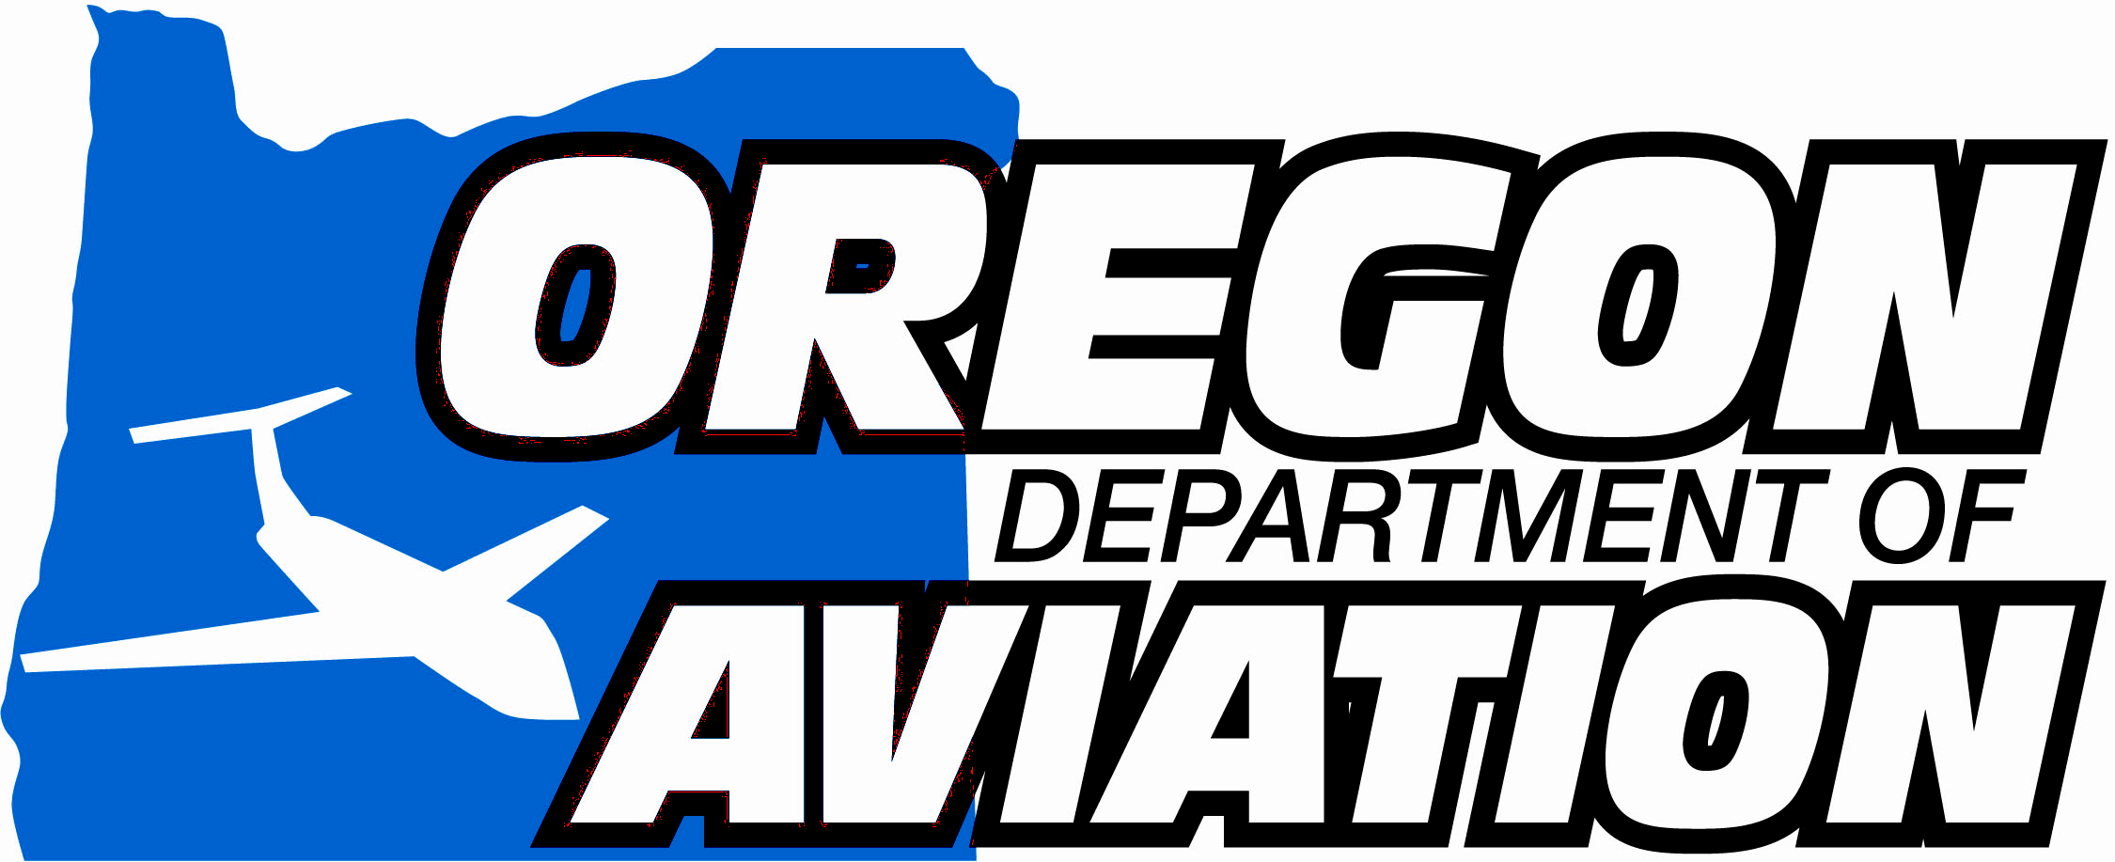
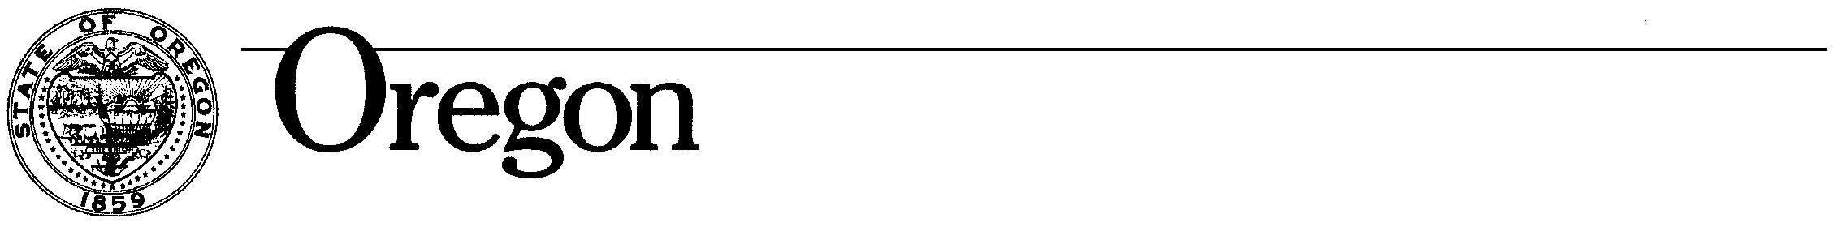

Oregon Aviation Board
3040 - 25th Street SE
Salem, OR 97302-1125
Telephone: (503) 378-4880
Toll Free: (800) 874-0102
Fax: (503) 373-1688

Theodore R. Kulongoski., Governor

Chris Corich
Board Vice Chair
Portland

R.P. Joe Smith
Portland

Steve Beckham
Aumsville

Jack Loacker
Portland

Larry Dalrymple
Pendleton

Nan Garnick
Redmond

Mark Gardiner
Portland

OUR MISSION:
Support our communities by preserving and enhancing aviation
An Invitation

The members of the State Aviation Board and the Director of the Oregon Department of Aviation are pleased to invite you to the following:

- The Oregon Aviation Board Meeting will be held at the Red Lion Hotel, 1313 N. Bayshore Drive, Coquille Conference Room, Coos Bay, Oregon, on Wednesday, Sept. 17, 2008, from 8:00 a.m. to 2:00 p.m. The Agenda may be found on the ODA website: http://www.oregon.gov/Aviation/agendas.shtml

- An “Evening with the Board” reception sponsored by the SouthWest Oregon Regional Airport (North Bend/Coos Bay) will be hosted by the Airport Director, Gary LeTellier. The reception will be held at the Red Lion Hotel, 1313 N. Bayshore Drive, South Umpqua Conf. Room, Coos Bay, Oregon, the evening of Sept. 16th from 6:00 p.m. to 7:00 p.m. Appetizers and beverages will be provided.

Please RSVP to Renee’ Stryker via e-mail at renee.stryker@state.or.us or 503-378-2197 to confirm your attendance.

We look forward to meeting you there!

