Procedure for Reporting Latitude and Longitude on Removal/Fill permit applications and Wetland Delineation Reports for DSL.

The Department of State Lands (DSL) requires that accurate latitude and longitude (lat/long) coordinates be reported on all wetland delineation reports and removal/fill permit applications. There are several methods available using free internet resources. The following outlines two such resources.

This document is divided into four sections.
Section A: Obtaining lat/long using Google Maps
Section B: Obtaining lat/long using Google Earth
Section C: Converting lat/long coordinated from “degrees/minutes/seconds” format to the “decimal degree” format
Section D: Reporting requirements for linear projects, projects that involve large acreages, and projects with multiple mitigation sites.

Section A: Procedure for Using Google Maps to determine Latitude and Longitude.

- Go to the website http://maps.google.com/. Enter the site address (Figure 1: Box 1) or as much information you have regarding the site location (i.e. Summer Street, Salem, OR).
- Hit the “Search Maps” button to the right of Box 1 (Figure 1).
- Navigate in to your location using your mouse or the buttons in the upper left hand corner of the map (Figure 1: Box 2).
- Once you have navigated to your project location, place the pointer (hand symbol) over the site and right click. Move the cursor to the CENTER OF THE SITE.
- A menu will appear; select “directions from here” (Figure 2: Box 3).
- After clicking “directions from here” the latitude and longitude will appear in the upper left hand corner of the screen (Figure 3: Box 4).
- This location information is what needs to be included on the application submitted to DSL.
- For linear projects go through all the steps outlined above to get the coordinates for the beginning of the project. Then navigate to the end point of the project, right click and select, “Directions to here” (Figure 3: Box 3). The coordinates of the end location will display in the portion of the screen entitled “End address” (Figure 4: Box 5).

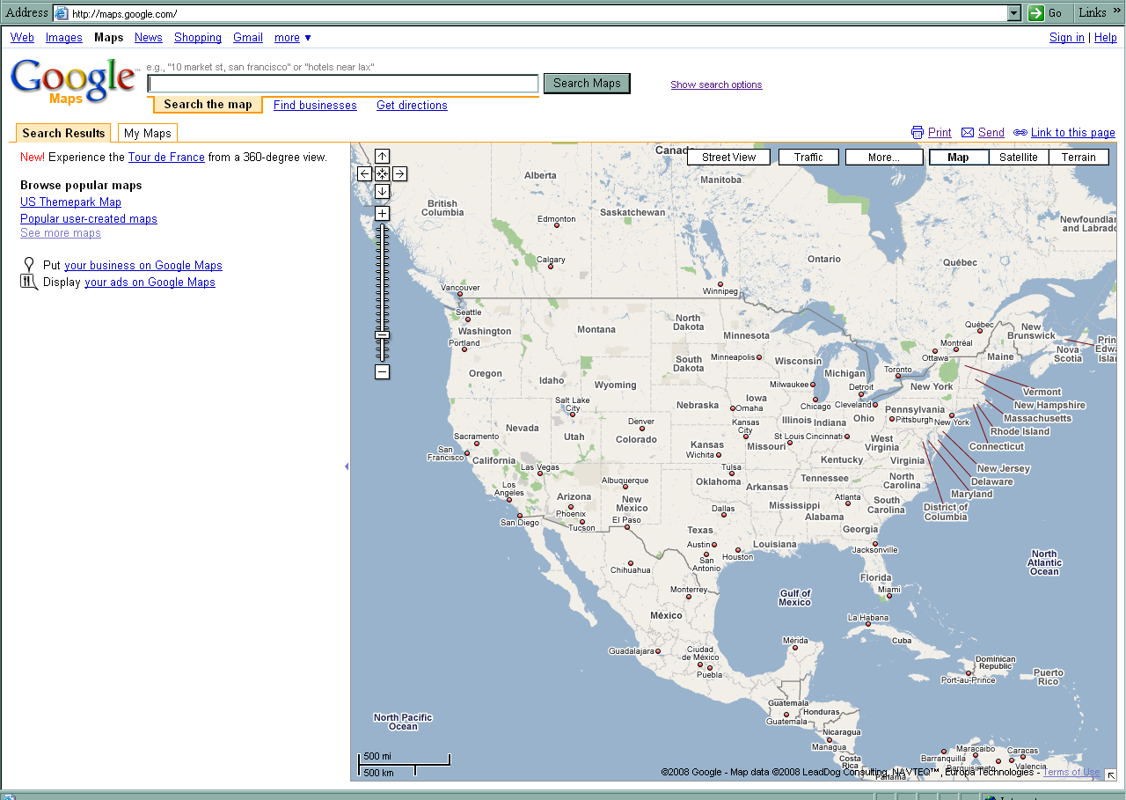Figure 1. Google Maps home page; depicts where to enter location information (Box 1) and the navigation tools (Box 2).

Box 1

Box 2

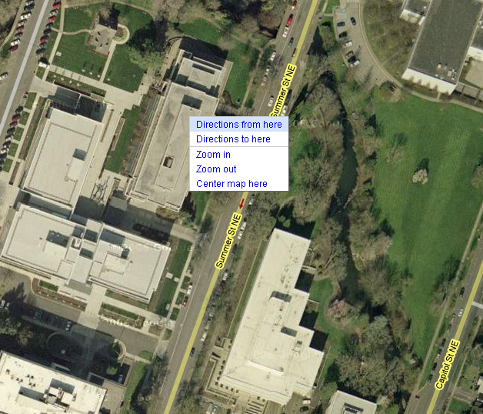

Box 3
Figure 2. Display of the box that appears when you right-click a location on the map

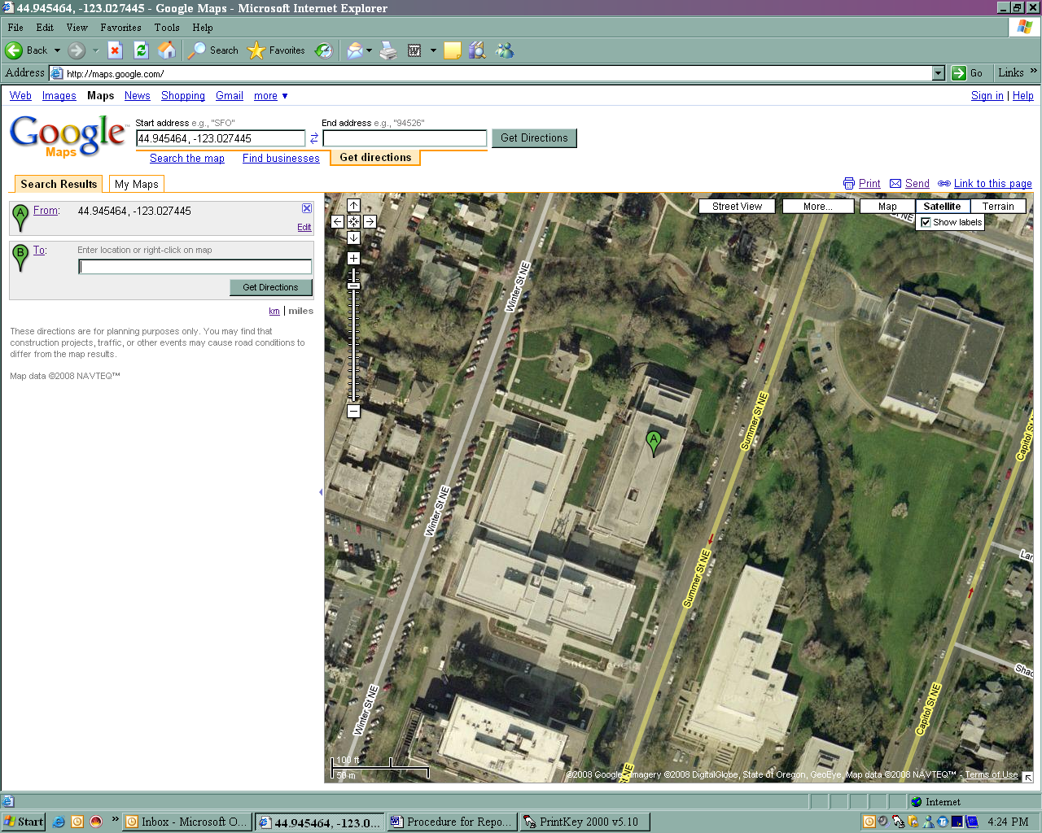

Box 4
Figure 3. Shows where to find the latitude and longitude once “Directions from here” has been selected.

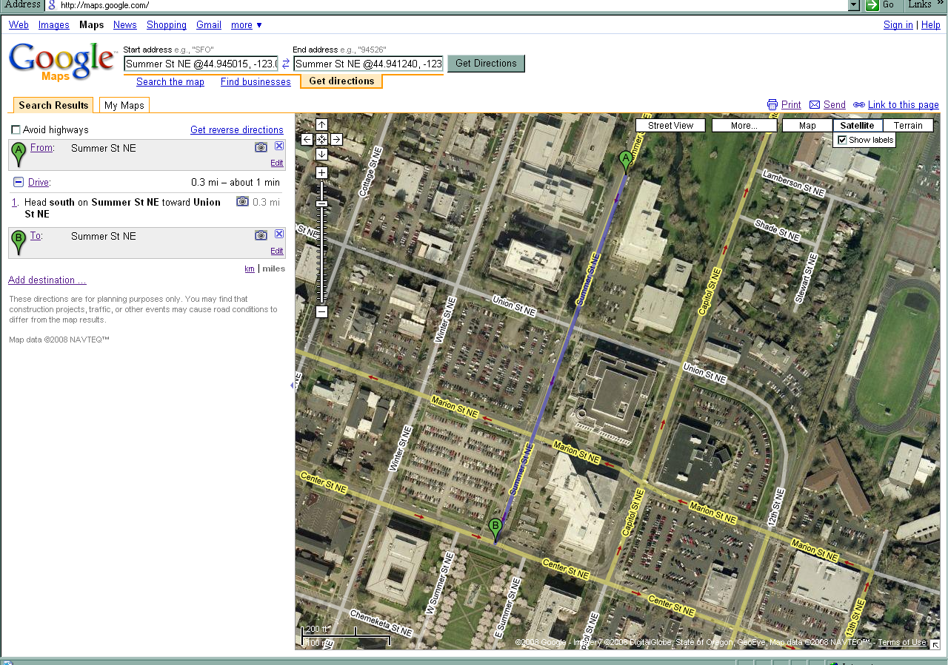

Box 5
Figure 4: Shows where to find the latitude and longitude once “Directions to here” has been selected. This would be the end coordinates for linear projects.

Section B. Procedure for Using Google Earth to determine Latitude and Longitude. If you do not currently have Google Earth down-loaded you can go to their web site for instruction on how to download this free software. http://earth.google.com/

1) Open Google Earth and set the options display for coordinates to decimal degree.
- Go to the tools dropdown menu and select options (Figure 5).
- Under Google earth options select the 3D view tab and check decimal degrees in the show lat/long box (Figure 6). This defaults the display lat/long coordinates to be in decimal degrees.

2) Enter the site address:
- Enter the site address in the “fly to” menu (Figure 7).
- The lat/ long coordinate value appears in the bottom left corner of the window (Figure 8). You can move the cursor around in the image to the correct location. Move the cursor to the CENTER OF THE SITE.
- Record the lat/long coordinates on the appropriate form. Remember- longitude is always a negative number.

Section C. Converting the lat /long coordinates to the correct “decimal degree” format.

- If the lat/long coordinates must be reported in decimal degree format. IF you have the lat/long coordinates in degrees/minutes seconds format, you can convert it to decimal degrees. Example of the differing formats for the same lat/long coordinate values:
Degrees/minutes/seconds: lat 45° 09’ 46.0794”
long –122° 56’ 17.8794”

Degree Decimal Minutes lat 45° 9.768’
long -122° 56.298’

Decimal Degrees: lat 45.16280°
long –122.9383°

- To convert from degrees/minutes/seconds or degree/decimal minutes (no seconds) to decimal degrees: http://www.directionsmag.com/latlong.php

- Scroll down to the boxes to convert latitude and longitude between degrees/minutes/seconds and decimal degrees (See Figure 9).

Section D. Procedure for selecting lat/long coordinates for projects with multiple sites.
- Linear projects
  - If the project is one long site, lat/long coordinates should be provided for the extent of the project (beginning and end) and the mid point
  - if there are multiple impact areas within a linear project, lat/long coordinates should be provided for each area of impact.
- For projects that involve large acreage (generally more than 20 acres) and multiple areas of impact, lat/long coordinates for each area of impact should be provided.

- Projects with multiple mitigation sites:
  - If a project has of-site mitigation separate lat/long data for the off-site mitigation should be provide
  - If a project has both on-site and off-site mitigation, lat/long coordinates must be provided for both areas.

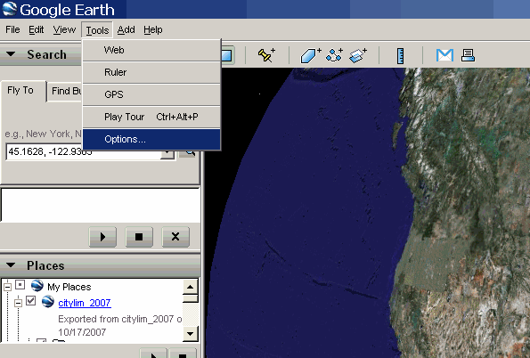
Figure 5. Setting the options display

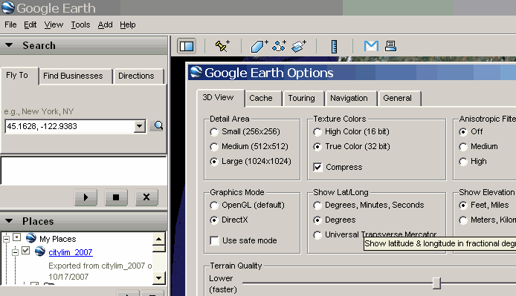
Figure 6. Setting decimal degrees for lat / long

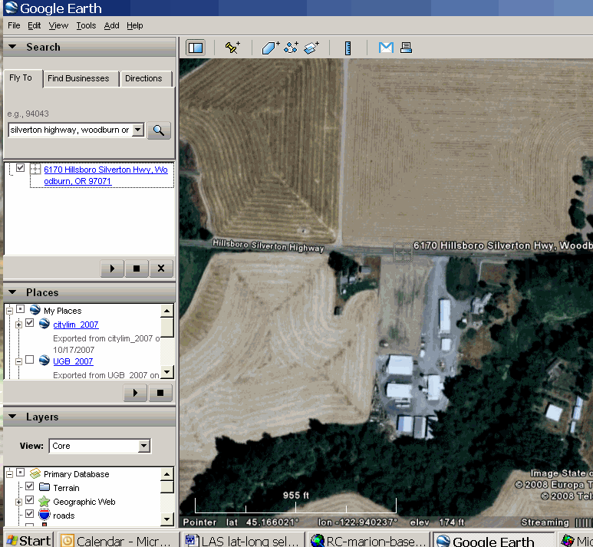
Figure 7. Entering the site address to obtain the lat/long coordinates. The current lat/long value in this screen is for the street address entered.

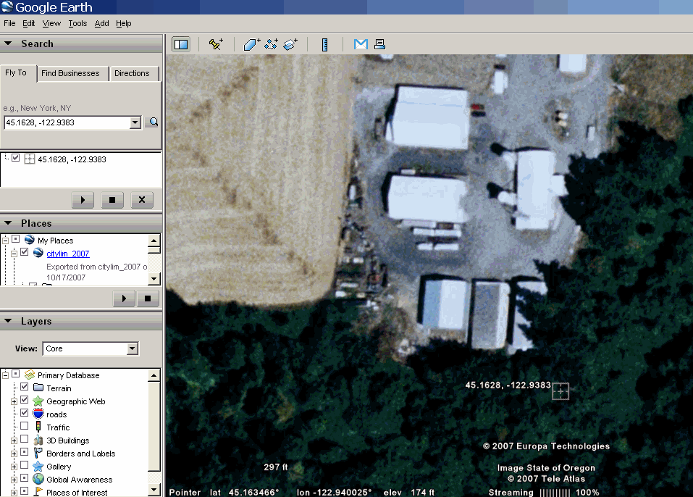
Figure 8. Identifying lat / long of the project site by moving the cursor to the correct location. Notice that the lat/long value changes as you move the cursor.

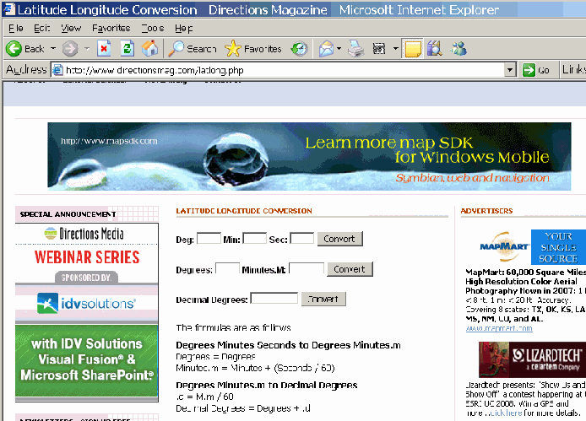

Figure 9. Scroll down to the boxes shown above to convert latitude and longitude between degrees, minutes, and seconds and decimal degrees.

