indian rice
Fritillaria camchatcensis (L.) Ker-Gawl
Plant Symbol = FRCA5

Contributed By: USDA NRCS National Plant Data Center

Alternative Names
Kamchatka lily, rice root, black lily, Mission bells

Uses
Ethnobotanic: Virtually all Northwest Coast peoples of British Columbia and southeast Alaska ate the bulbs of “Indian rice,” which resemble tight clusters of white rice. The bulblets grow relatively close to the surface and are easily extracted. They were dug up in the spring (before flowering), in the summer, or the fall (after flowering) using a digging stick, a wooden spade, or fingers. They were cooked immediately, or could be partially dried, then stored in a cool place for winter use. They were cooked for about 30 minutes in a cedarwood box, by boiling for a short time then mashing to a paste, or occasionally, by baking in ashes. Indian rice bulbs were used as an item of trade. Even when cooked, they are slightly bitter, and some people soaked them in water overnight to reduce the bitter flavor.

Status
Please consult the PLANTS Web site and your State Department of Natural Resources for this plant’s current status, such as, state noxious status and wetland indicator values.

Description
General: Lily Family (Liliaceae). Fritillaria camchatcensis is a tall herbaceous perennial growing from a white bulb surrounded by numerous, tightly clustered rice-like bulblets. The stems are 20-50 cm tall, sturdy and unbranched, bearing 1-3 whorls of 5-11 lance-shaped leaves. The flowers of Indian rice are bell-shaped and nodding, each with greenish-brown to brownish- purple tepals, sometimes streaked with yellow. The flowers have a disagreeable odor. The capsules are angled and many seeded. The species are attractive in native garden, but are fast disappearing from much of their range.
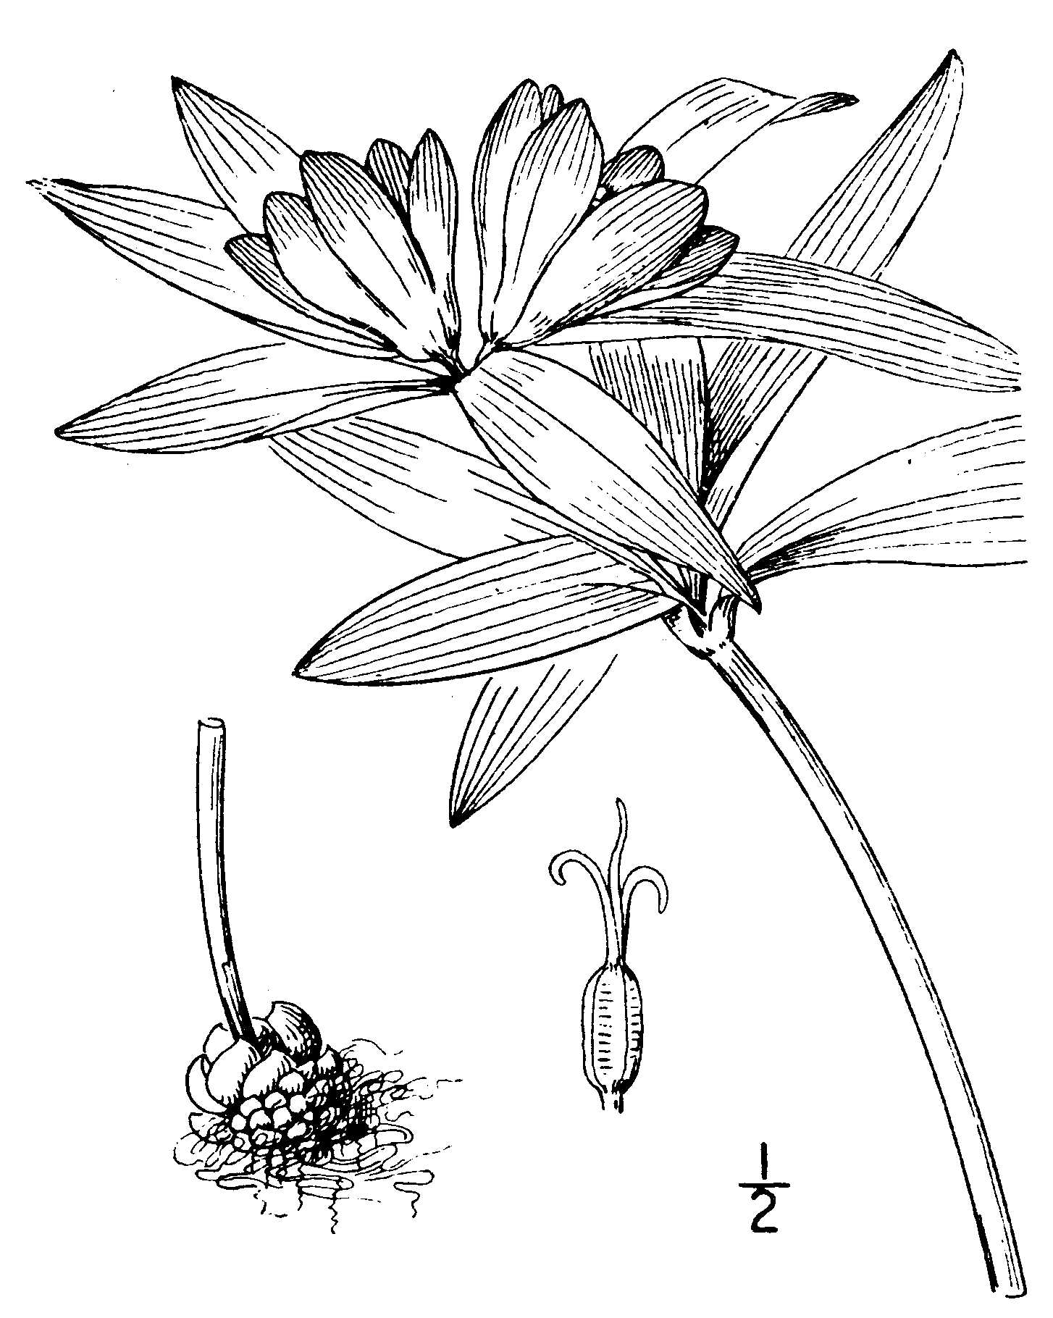
W.S. Atkinson
from Abrams (1940)
Used with permission of publishers
© Stanford University

Distribution
Indian rice grows in moist areas, from tidal flats to wet meadows, from Alaska to western Washington. Indian rice grows in prairies and grassy bluffs to woodland and coniferous forests from near sea level to above 5,000 ft. in elevation. It occurs from British Columbia to Oregon. In Washington, riceroot grows on both sides of the Cascades, but it only grows on the west side in Oregon. Riceroot extends east from British Columbia and Washington to northern Idaho. For current distribution, please consult the Plant Profile page for this species on the PLANTS Web site.

Establishment
Fritillaria camchatcensis has become quite uncommon in the wild. In addition, salt marsh, estuarine wetland, and freshwater wetland habitat has declined by over 90 percent throughout much of the United States. Wild harvesting for non-traditional use should be restricted to salvage sites with appropriate approvals and permits.

Fritillaria species are frequently found in areas with soil moisture persisting throughout most of the growing season. It is often found on coarse-grained soils of glacial origin. Riceroot tolerates shade, but prefers sun. Fritillaria propagates readily from seed, and the rice-like bulblets can be used for propagation. This species grows well in well-drained, loam soils that are neutral to slightly acid.

Live Plant (Bulb) Cultivation
Fritillaria species have bulbs that do well in moist shade. Bulbs may be planted in pots or in a greenhouse bed or bulb frame. It is best to store Fritillaria bulbs in slightly moist bark, peat, shredded wood, or some other material. Buy the bulbs as early as possible before they begin to grow. Bulbs tend to deteriorate or rot if kept too long.

Plant bulbs in soil that is rich in nutrients and humus and also retains moisture. Incorporate plenty of leafy mold or some other organic matter, such as well-rotted manure or compost, before planting. Acid-loving woodland bulbs thrive in the peat garden, where at least half the soil is leaf mold, peat, or compost.

Bulbs in containers should not be allowed to dry out when growing and should be fed regularly with a high-potassium fertilizer to boost flower production. Wait until seeds have set and foliage begins to senesce before lifting bulbs out of soil, then clean them and store them in a cool, moist place. Watch bulbs to prevent them from rotting or being affected by a fungal disease.

Bulbs can increase naturally by forming bulblets around the bulb (the “rice” in “Indian rice”). Propagate the bulbs by separating these bulblets from the mother bulb and planting them. Bulbs should be separated every year or two.

Seed Propagation
This species grows readily from seed. Most bulbs take 3-5 years to reach mature flowering stage. Fritillaria species do not flower regularly even in nature, and so are described as “shy-flowering.” Collect seed immediately when capsules are ripe, as they split and seeds may be shed quickly. Let the seeds dry without heat, and store them until sown in labeled paper packets in a cool, dry, airy place. Do not use plastic bags, as the seeds are likely to rot.

The best times to sow seeds are fall, but if seed is available earlier, sow immediately. Germination should follow in early spring.

The recommended potting soil for seed germination and emergence is a commercial sand-based mix; with one-quarter part coarse sand added if the mixture does not have a sandy appearance. Space large, flat seeds of Fritillaria one seed’s width apart. Sieve a light covering of the soil mix over the seeds so that they are no longer visible and then cover with a generous layer of grit or aquarium gravel. Label the pots with the plant name, seed source, and date. Stand the pots in a shady place in the open garden, or plunge them in a sand frame, and keep them moist.

When the seedlings have germinated, bring the pots into full light in a cold frame or greenhouse. Keep them moist until they show definite signs of dying down, and then water them very sparingly. Fritillaria seedlings should be kept slightly moist during this senescent period. Start watering again in early fall, or as soon as there is new growth, and keep the pots watered until the growth dies down. Leave most bulbs for two growing seasons before repotting, unless they grow vigorously. Larger bulbs are formed if these seedlings are fed the second year. Use a commercial liquid feed as used for tomatoes, but at half the manufacturer’s recommended strength. After two years, remove the bulbs from the pots after they have died back. Separate out the bulblets, clean them gently, and repot them in clean, moist soil. For Fritillaria species, use a soil mix of one part sterilized leaf mold, one part peat or compost, and one part sterilized soil, with a further 1.5 parts of coarse horticultural sand or seed-grown perlite. It is better to grow seedlings in pots for 3-4 years before planting them outside.

Management
Traditional resource management of Indian rice includes the following (Turner and Deur 1999):
- Ownership of individual patches and their output by chiefs, ensuring long-term care and enhancement of plant production.
- Root feasts as a means of redistributing plant wealth and meeting ceremonial obligations.
- Specialized digging sticks as a harvesting tool to cultivate and turn over the soil.
- Harvesting at a set time of year before or after plants have set seed.
- Regular use of same sites over time/generations.
- Care and assiduity in harvest.
- Turning of the soil or sod.
- Replanting and leaving bulblets behind, to re-grow the following year.
- Weeding root patches.
- Individual patches and landscapes were burned regularly.

Cultivars, Improved and Selected Materials (and area of origin)
FRCA2 is somewhat available through native plant nurseries within its range. Contact your local Natural Resources Conservation Service (formerly Soil Conservation Service) office for more information. Look in the phone book under ”United States Government.” The Natural Resources Conservation Service will be listed under the subheading “Department of Agriculture.”

References
Abrams, L. 1940. Illustrated flora of the Pacific states. Vol. I. Ophioglossaceae to Aristolochiaceae. Stanford University Press, Stanford University, California. p. 423.

Brickell, C. & E. McDonald (eds.) 1993. The American Horticultural Society encyclopedia of gardening. The definitive practical guide to gardening techniques, planning, and maintenance. Darling Kindersten.

Gunther, E. 1945 rev. 1973. Ethnobotany of western Washington. University of Washington Publications in Anthropology, 10(1). University of Washington Press, Seattle, Washington.

Hitchcock, C. L. & A. Cronquist (eds.) 1973. Flora of the Pacific Northwest. An illustrated manual. University of Washington Press, Seattle & London. 730 pp.

Kunlein, H.V. & N. J. Turner 1991. Traditional plant foods of Canadian indigenous peoples. Nutrition, Botany, and Use. Food and Nutrition in History and Anthropology Volume 8. Gordon & Breach Science Publishers. Pgs. 239-242.

Turner, N.J. 1975. Food plants of British Columbia Indians. Part I. Coastal peoples. B.C. Provincial Museum Handbook No. 34, Victoria, B.C., Canada.

Turner, N.J. 1978. Food plant of British Columbia Indians. Part II. Interior peoples. B.C. Provincial Museum Handbook No. 36, Victoria, B.C., Canada.

Turner, N.J. & M.A.M. Bell 1983. The ethnobotany of the Southern Kwakiutl Indians of British Columbia. Econ. Bot. 27:257-310.

Turner, N.J. & D.E. Deur 1999. “Cultivating the clover”: Managing plant resources on the northwest coast. Presentation at Society of Ethnobiology meetings, Oaxaca, Mexico.

Turner, N.J. & B.S. Efrat 1982. The ethnobotany of the Hesquiat Indians of Vancouver Island. British Columbia Provincial Museum, Cultural Recovery Paper No. 2, Queen’s Printer, Victoria, B.C., Canada.

Turner, N.J. & B.S. Efrat 1982. Ethnobotany of the Hesquiat Indians of Vancouver Island. B.C. Provincial Museum Cultural Recovery Paper No. 2. 99 pp.

Turner, N.J. & H.V. Kuhnlein 1983. Camas (Camassia spp.) and riceroot (Fritillaria ssp.): Two liliaceous “root” foods of the northwest coast Indians. Ecology of Food and Nutrition 13:199-219.

Turner, N.J., J. Thomas, B.F. Carlson & R.T. Ogilvie 1983. Ethnobotany of the Nitinaht Indians of Vancouver Island. B.C. Provincial Museum Occasional Paper No. 24. 165 pp.

Turner, N.J., L.C. Thompson, M.T. Thompson & A.Z. York 1990. Thompson ethnobotany: Knowledge and usage of plants by the Thompson Indians of British Columbia. Royal British Columbia Museum Memoirs No. 3, Victoria, B.C., Canada.

USDA, NRCS 2000. The PLANTS database. Version: 000327. <http://plants.usda.gov>. National Plant Data Center, Baton Rouge, Louisiana.

Prepared By

Michelle Stevens
Formerly USDA, NRCS, National Plant Data Center

Species Coordinator

M. Kat Anderson
USDA, NRCS, National Plant Data Center, c/o Plant Science Department, University of California, Davis, California

Edited: 05dec00 jsp; 19may03 ahv; 07jun06 jsp

For more information about this and other plants, please contact your local NRCS field office or Conservation District, and visit the PLANTS Web site<http://plants.usda.gov> or the Plant Materials Program Web site <http://Plant-Materials.nrcs.usda.gov>

The U.S. Department of Agriculture (USDA) prohibits discrimination in all its programs and activities on the basis of race, color, national origin, sex, religion, age, disability, political beliefs, sexual orientation, and marital or family status. (Not all prohibited bases apply to all programs.) Persons with disabilities who require alternative means for communication of program information (Braille, large print, audiotape, etc.) should contact USDA's TARGET Center at 202-720-2600 (voice and TDD).
To file a complaint of discrimination write USDA, Director, Office of Civil Rights, Room 326-W, Whitten Building, 14th and Independence Avenue, SW, Washington, DC 20250-9410 or call 202-720-5964 (voice or TDD). USDA is an equal opportunity provider and employer.
Read about Civil Rights at the Natural Resources Convervation Service.

