
International Trade Publication – November 2006

NEW! MARKET OF THE MONTH – PERU

When most people think of Peru, the lost Incan city of Machu Picchu often comes to mind. Since its “rediscovery” by Yale archeologist Hiram Bingham in 1911, this pre-Columbian ruin has become synonymous with Peru. Few countries are similarly encapsulated within a single image to such a degree.

While the mysteriousness of ancient civilizations will forever intrigue visitors, Peru’s connections to the past overshadow the significant interest generated by the country’s recent economic progress. This diverse nation of 28 million people has quietly positioned itself as the hidden commercial gem of Latin America—a diverse, export-driven economy characterized by open markets and fiscal prudence.

Peru’s economic performance over the past six years has been nothing short of a miracle. Between 1998 and 2002, the Peruvian economy stagnated as El Niño and the Asian


financial crisis dealt significant blows to market stability. Four years later, the Toledo Administration’s recovery program has brought significant changes to Peru’s economy. By the end of 2006, GDP is estimated to grow 5% while exports and imports will reach an estimated $18.2 billion and $13.2 billion, respectively. Positive economic growth towards a stable, competitive market continues to transform Peru into a more dynamic environment for U.S. investment.

 | 2000 | 2005 | 2006 (EST.)
GDP ($ billion) | 53.1 | 78.4 | 81.1
GDP per capita | 2,049 | 2,808 | 2,862
Exports ($ billion) | 7.0 | 17.3 | 18.2
Imports ($ billion) | 7.3 | 12.0 | 13.3
GDP (real growth) | 4.8% | 6.7% | 4.4%

There has never been a better time for U.S. commercial interests to conduct business in Peru. To read the full Commercial Service Market Report on Peru, please visit http://www.export.gov/articles/Peru_MoM.asp.

International Trade Publication – November 2006

$5.3 BILLION PROJECT TO EXPAND THE PANAMA CANAL – OPPORTUNITIES FOR U.S. FIRMS
December 5, 2006

The people of Panama recently approved a project to expand the capacity of the Panama Canal via a national referendum vote. The cost of this project is estimated at $5.3 billion and should take about 7-8 years to complete.

Join the U.S. Commercial Service for a FREE one-hour web based seminar covering topics such as various phases & time lines for the project, as well as the different areas of opportunities for U.S. firms to participate in this major infrastructure project! Speakers will include Senior Commercial Officer Robert Jones of U.S. Commercial Service Panama and executives from the Panama Canal Authority.

Which type of U.S. companies will benefit?
This massive project will provide tremendous opportunities for U.S. providers of goods
& services, including:

- Dredging Equipment & Services
- Engineering & Architectural Services
- Project Management
- Risk Management & Legal Consulting Services
- Construction Equipment, Materials & Supplies
- Maritime Equipment & Supplies
- And many more!
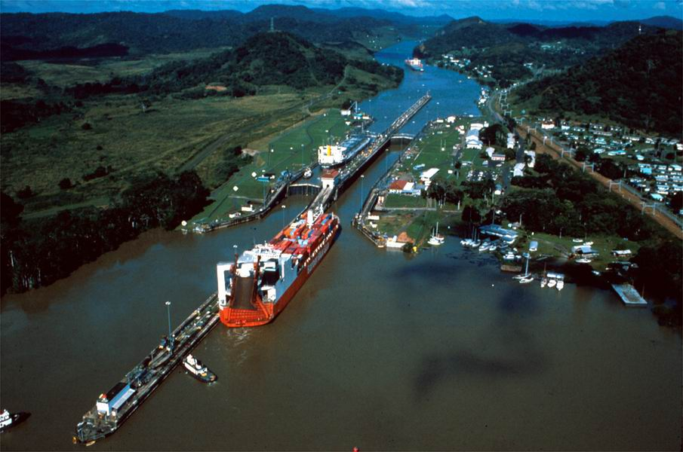

DATE: Tuesday, December 5, 2006
TIME: 2:00 PM CST
LOCATION: Your personal computer
COST: FREE!

For more information or to register, click on the link below or contact Danielle Caltabiano at Danielle.Caltabiano@mail.doc.gov or (817) 310-3744.

http://www.buyusa.gov/tradeamericas/panamacanal.html
International Trade Publication – November 2006

MAKING GREAT COMMUNITIES HAPPEN…IN CHINA
The American Planning Association (APA), with an assist from the U.S. Dept. of Commerce, is helping its members penetrate the Chinese market.

Much of the recent news on U.S.–China relations focuses on things that aren’t working well, such as trade deficits, intellectual property rights violations, and currency imbalances. However, a little-known fact is that as recently as 2004 the United States realized a trade surplus with China in services of $1.6 billion. Also, the recent successes of member companies of the American Planning Association (APA) in selling their services to China prove that U.S. firms can and do compete in this market.

About the APA
The APA is a professional organization with 40,000 members who work in community design, architecture, civil engineering, and environmental land use. Its motto is “Making Great Communities Happen.” In 2005, the APA set its sight on China by creating its China Initiative.

Economic Growth Fuels Demand for Services
The age-old law of supply and demand was behind the APA’s drive to promote sales to China. China’s economy has exploded at a blistering pace, with double-digit growth in gross domestic product over the past several years. Along with an unprecedented pace of urbanization and rural migration, a strong and sustained demand for urban planning and design expertise has developed.
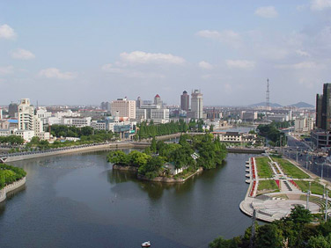

Since 1996, the APA has run a China program that has linked U.S. urban design firms and experts with hundreds of Chinese mayors and provincial leaders. These contacts have led directly to many U.S. business sales. In October 2005, the APA won a three-year Market Development Cooperator Program (MDCP) award from the U.S. Department of Commerce to support its China Initiative. The MDCP – operated by the International Trade Administration (ITA) – provides federal assistance to nonprofit export multipliers that serve small businesses.
(Continued on following page)
(Continued from previous page) – Making Great Communities Happen…in China

Partnership with Commerce Department Experts
The Commerce Department quickly assembled a team to work closely with the APA on its China Initiative. Team members were drawn from many parts of the agency. Specialists from the U.S. and Foreign Commercial Service—who are located both in the United States and in key in-country posts such as Beijing, Chengdu, Guangzhou, Hong Kong, Shanghai, and Shenyang—were especially important, bringing a strong knowledge of industry sectors important to the APA and an understanding of the Chinese market and the strengths that U.S. companies offer.

Building on Existing Initiatives
Within the China Initiative, one hallmark is a program that provides training and exchanges for U.S. planning companies and senior Chinese planning officials and mayors. Since 2002, the APA has already brought more than 100 Chinese mayors to the United States, where they visited several cities, met with U.S. companies, and learned about U.S. planning and design concepts.

Expanded Marketing Efforts
With its China Initiative, the APA is continuing to promote U.S. urban planning, urban design services, and planning philosophies. The APA’s five-part strategy includes (1) establishing a fully staffed APA office in Shanghai, (2) preparing promotion material for the China market in English and Mandarin, (3) providing training and exchanges for APA members and Chinese customers, (4) organizing business trips to
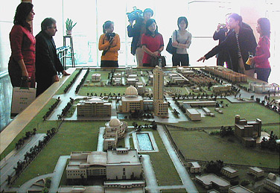

China for U.S. planning companies, and (5) cultivating long-term relationships with Chinese clients. Shanghai will be the center of the APA’s China operations because it is the economic hub of the Yangtze River delta. During the term of the MDCP award, the APA expects the Shanghai office to provide marketing and training for APA professionals in China and to facilitate collaboration between urban planners and members of related industries.

Successful Efforts Bring Sales
The first year of the MDCP award has been a success for the APA’s efforts in China. Seven U.S. firms have already signed contracts worth almost $500,000. The services they are exporting to China include design and engineering, transportation planning, urban development, and architectural services. The combination of market strength and a strong partnership with the Commerce Department has given U.S. firms a leg up in succeeding in the Chinese market. Jeff Soule, the APA’s policy director, echoes that sentiment, noting, “It’s a great partnership, and we all recognize that the service sector is the fastest-growing sector in China and that U.S. firms are the leaders in planning, design, and development services.” Please visit www.planning.org/APAinChina for more information on the APA’s China Initiative.
International Trade Publication – November 2006

“COMPLYING WITH U.S. EXPORT CONTROLS”
Presented by The Bureau of Industry and Security and the Utah District Export Council
December 6-7, 2006

This is a valuable opportunity to gain important information that every exporter needs to know. The two-day conference is being held in Salt Lake City, which provides an easy and convenient way to obtain information from trade and export experts. We encourage everyone to attend!
This two-day program is led by BIS's professional counseling staff and provides an in-depth examination of the Export Administration Regulations (EAR). The program will cover the information exporters need to know to comply with U.S. export control requirements on commercial goods. We will focus on what items and activities are subject to the EAR; steps to take to determine the export licensing requirements for your item; how to determine your export control classification number (ECCN); when you can export or re-export without applying for a license; export clearance procedures and record keeping requirements; Export Management and Compliance Program (EMCP) concepts; and real life examples that apply this information. Presenters will conduct a number of "hands-on" exercises that will prepare you to apply the regulations to your own company's export activities.

This program is well suited for all companies and individuals who need a comprehensive understanding of how to comply with U.S. Export Controls and is a unique opportunity to receive such in-depth training without traveling out-of-state.

Location

Hilton Hotel, Salt Lake City Center

255 South West Temple

Salt Lake City, Utah 84103

Time
Registration will begin at 7:30 am on December 6, 2006. The program will begin at 8:30 am on December 6, 2006, and end at 4:30 pm on December
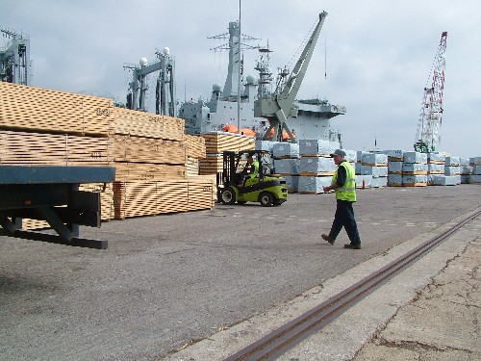

7, 2006.
(Continued on following page)
(Continued from previous page) – Complying With U.S. Export Controls

Accommodations
Please make your room reservations directly with the Hilton Hotel Salt Lake City Center by calling (801) 328-2000. Please mention “Complying with U.S. Export Controls”, as a select number of sleeping rooms are available December 5-6, 2006, at the special conference rate of $90. Parking is available at the hotel at the special conference rate of $2.00 each day. Hotel Website: http://www.hilton.com/.
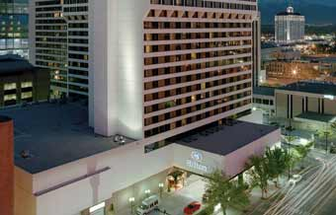

Registration
Advance registration is required and space is limited. Registration will begin at 7:30 am on December 6, 2006. The registration fee is $320 per person and includes continental breakfast, breaks, lunch, and training materials both days. All registrations must be received by November 30, 2006. No refunds for cancellations made after December 1, 2006.

To register, visit http://www.buyusa.gov/utah/exportcontrolsform.html or contact either:
- David Fiscus – (801) 255-1873, David.Fiscus@mail.doc.gov
or
- Chris Quinlivan – (801) 255-1872, Chris.Quinlivan@mail.doc.gov.

You may also fax your registration (include your name, telephone number, and e-mail address) to (801) 255-3147.

Payment
Make checks payable to Utah District Export Council and mail them to:

U.S. Department of Commerce
9690 S 300 W, Suite 331
Sandy, Utah 84070


Other Questions?
For more information or questions on the topics to be covered, please call BIS's Western Regional Office at (949) 660-0144 or (408) 351-3378.

International Trade Publication – November 2006

THE U.S.-CHINA LEGAL EXCHANGE & ROUNDTABLE
Seattle, WA - December 1 | Cleveland, OH - December 5 | Washington, DC - December 8

The U.S.-China Legal Exchange and Roundtable is an excellent way to learn about important changes to China's draft Anti-Monopoly Law and revisions to its Partnership Law. The Exchange features representatives from the General Counsel's office, China's Ministry of Commerce (MOFCOM), and local legal experts. It takes place as part of the annual high level bilateral exchange of the Joint Commission on Commerce and Trade.

Featuring:

- Vice Minister Zhang Qiong, SCLAO
- Vice Minister Ma Xiuhong, MOFCOM
- John Sullivan, General Counsel, U.S. Department of Commerce
- Other representatives of MOFCOM, SCLAO, U.S. Department of Commerce, U.S. Department of Justice, and the Federal Trade Commission
- Local legal experts from your community


The conference will address a range of topics:
- Proposed rules in the Chinese legal system that would affect U.S. firms or individuals selling, operating or investing in the Chinese market
- Review of the major differences between the U.S. and Chinese legal systems
- Sessions with Question and Answer discussion: Background on China’s AML and PL efforts; Monopoly Agreements and Cartels; Abuse of Dominant Position; Coverage of State Owned Enterprises; Merger Review; Legal Structures in China; Role & Liability of Partners and Limited Partners; and more

For more information, please contact:
Joel B. Blank, Attorney-Advisor; Office of the Chief Counsel for International Commerce, US DOC; Email: jblank@doc.gov; Tel. (202) 482-2510

For details on SEATTLE conference location and cost, click here.
Program supported by the China Business Information Center.

Registration is limited and will be accepted on a first-come first-serve basis. Register now at the regional conference you would like to attend!
Seattle, WA Registration | Washington, DC Registration | Cleveland, OH Registration
International Trade Publication – November 2006

INTELLECTUAL PROPERTY RIGHTS IN CHINA
An ongoing U.S. Commercial Service webinar series
December 14, 2006

Protecting and enforcing the intellectual property rights (IPR) of U.S. businesses in China is critical to the success of your industry. As an industry association, you can play a critical role in assisting your member companies on these issues. Keeping updated on the latest developments is integral to this effort. Therefore, the U.S. Commercial Service invites you and your member companies to participate in this new China IPR webinar series.

On December 14 at 2:00 pm – 3:30 pm EST, the U.S. Commercial Service will be offering the 9th webinar in this series – The Future of China’s IP Regime. Mark Cohen, Senior IP attaché at the U.S. Embassy in Beijing, will discuss priorities on the protection and enforcement of IP in China for 2007 and beyond. He will also share his views on the significant events of 2006. Most recently interviewed for CNBC, NPR, and featured in the Wall Street Journal, Mark Cohen is the U.S. government’s premiere expert on China's IP system.


The program is free. No special software or computer configuration is needed to participate; only a phone line and a computer with an Internet connection are necessary.

To register for the December program, please send your contact information to ChinaIPR@mail.doc.gov. A registration confirmation, and dial-in/log-in instructions will be sent to you a week before the program. To learn more about the webinar series, visit http://www.stopfakes.gov/events/china_webinar_series.asp.

International Trade Publication – November 2006

THE NATIONAL FORUM ON TRADE POLICY – TRADE & REGIONAL PROSPERITY
December 7-8, 2006

The National Forum on Trade Policy (NFTP) is an annual conference that brings together business leaders, federal and state policy makers, higher education practitioners and leading experts. NFTP 2006 will focus on pressing trade issues, draw from regional case studies, and examine the role of key industries in trade and regional prosperity throughout the United States.

These issues are particularly important in an emerging global economy, where company headquarters and production can take place anywhere in the world. There are no guarantees that a region will be able to attract business, or to keep and grow existing firms. Businesses will locate where there is a high quality of life, good schools, efficient transportation, supportive government policies, and good prospects for trade. A region must take steps to make itself competitive, or jobs will go elsewhere. Around the world, regions are marshalling public and private talent and money to pursue economic development and prosperity, and this conference will address how business and political leaders can position a region to do the same.

Location
NFTP 2006 will take place in Seattle's vibrant downtown area at The Westin. Participants will attend meetings within walking distance of Pike Place Market, the Seattle Waterfront, and a multitude of shopping districts. NFTP 2006 is hosted by UW Global Business Center & the Center for International Business & Research, San Diego State University.

Registration
Priority registration deadline is November 15, 2006. After November 15, 2006 the cost of registration will increase to $120. Register online. For more information, please visit http://bschool.washington.edu/ciber/nftp/.



International Trade Publication – November 2006

OTHER IMPORTANT EVENTS & INFORMATION

Canada Border Clearance / Customs Requirements Webinar November 29, 2006



Learn all you need to know about Canada Border Services Agency Clearance Procedures and Customs Requirements in Canada for Trade Show Booths and Supplies. To register for this free online webinar held on Wednesday, November 29, 2006 @ 2:00 p.m. EST, please visit http://www.buyusa.gov/canada/en/cbsaw.html.

2007 International Consumer Electronics Show January 7-11, 2007


If your business or interest lies in the consumer electronics industry, then the CES Show in Las Vegas on January 7-11, 2007, is an event you do not want to miss! The ICT Team will be offering Showtime presentations, appointments, and matchmaking at this premiere industry event. Approximately 20 Commercial Specialists will be leading delegations. To register for this event, please visit http://registration.expoexchange.com/ShowCES071/.

ONLINE RESOURCES
- Commercial News USA………………………….………...http://www.thinkglobal.us/
- Export.gov………………………………………………….……http://www.export.gov/
- International Trade Administration (ITA) International Trade Calendar……………. http://www.trade.gov/press/publications/newsletters/ita_1006/trade_calendar_1006.asp

For more information regarding the above events, or if you are a small business seriously interested in exporting, please contact Amy Benson, Director of the Boise Export Assistance Center, at (208) 364-7791. Please visit the Boise USEAC website to learn more about how the U.S. Commercial Service can assist your business.

