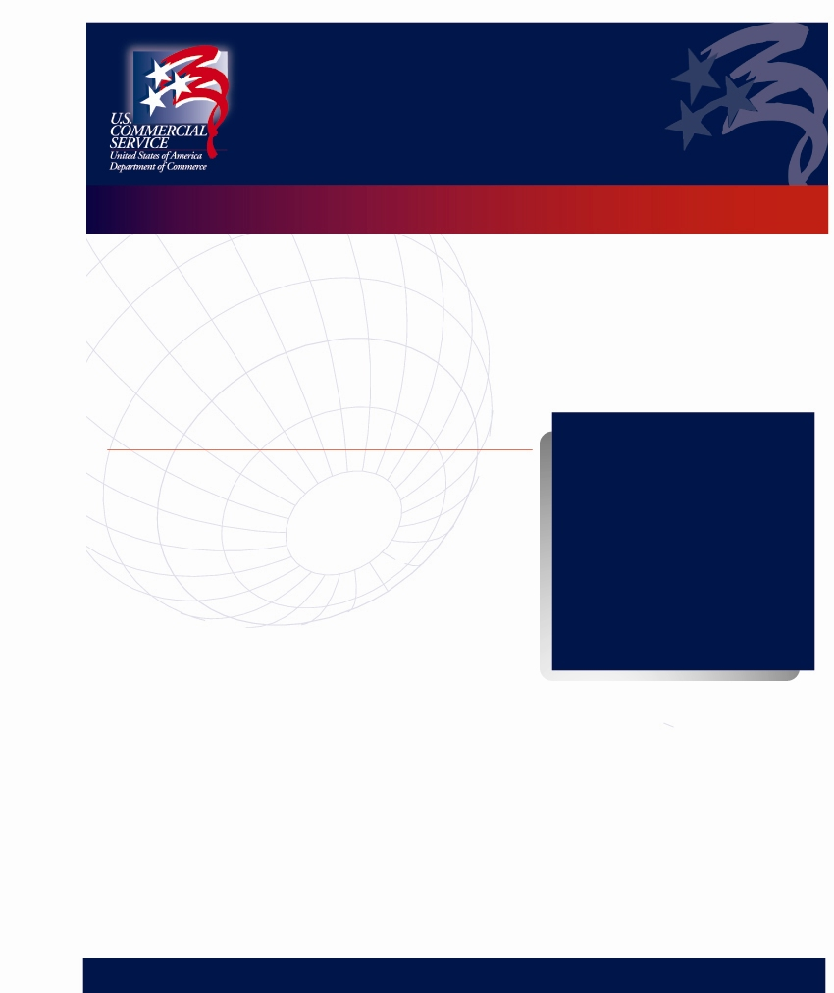
Business Opportunities in Singapore

Thursday, January 11, 2007

Don’t miss out on learning about sales opportunities for your company in Southeast Asia!

The U.S. Commercial Service provides you an opportunity to hear directly from the Commercial Attaché in Singapore in order to equip you with the latest market and industry intelligence required to help you succeed in Singapore.

Seminar Highlights:

- Discuss the prospects for your products or services in private counseling sessions with a U.S. Commercial Service Officer who represent and promote U.S. business interests at the U.S. Embassy in Singapore.
- Learn more about the U.S. Singapore Free Trade Agreement (USSFTA) that came into effect on January 1, 2004, and the new chapter it brings into the U.S.-Singapore partnership.
- The best prospects sectors for Singapore for Idaho firms include electronic components, aircraft and parts, electronics industry production/testing equipment, laboratory and scientific instruments, pollution control equipment, electric power systems, construction equipment and building products, pumps and valves, medical devices, telecommunication equipment and computer hardware and software, university education services and franchising.
- Hear the facts: Singapore is the 3rd largest U.S. trading partner in SE Asia and ranks 15th worldwide. In 2004, Singapore’s real GDP growth rate hit 8.4% (among the highest in the world)!

Event Details:
- Where:
Boise Metro Chamber
250 S. 5th Street, Basement
Boise, ID 83701
  - When:
    - Presentation: 9:30-11:00 am
    - One-on-one meetings available after 11:00 am
- Other:
    - $25 to attend; Make checks payable to Dept. of Commerce
    - Registration due by Jan. 5

RESERVATION FORM
Please respond by Fax to (208) 334-2783 by Friday, January 5, 2007.

Name(s) _________________________________ Title __________________________________________
Company ________________________________________________________________________________
Address __________________________________________________________________________________
Telephone _________________________________ Fax ___________________________________________
Credit Card #_____________________ Exp. Date_________

For more information or to schedule private consultations, contact Amy Benson at (208) 364-7791 or by email at Amy.Benson@mail.doc.gov.

This event is brought to you by the U.S. Commercial Service and the Boise Export Assistance Center.

http://www.export.gov or http://www.buyusa.gov/boise

International Trade Publication – December 2006

KIEV AGRIHORT 2007 & UKRPRODMASH 2007

Be a part of 2 major agribusiness trade shows in Kiev, Ukraine
February 13-15, 2007

Summary
The U.S. Commercial Service (USCS) Kiev, Ukraine, is pleased to announce to American companies the opportunity for marketing their products through catalogs at two Ukrainian trade shows in the agri-food sector. The site for the official USCS Business Information Office (BIO) and U.S. Product Literature Center (PLC) will be the Kiev AgriHort (February 13-15, 2007, exhibition for agricultural machinery and chemicals) and UkrProdMash (February 13-15, 2007, exhibition for food and drink processing and packaging technologies and equipment). This is an effective opportunity to test Ukraine’s agri-food market and to receive immediate trade leads without leaving your office. For a participation fee of $250.00, we will present your company's catalogs to visitors at the shows, and after the event we will send you a list of potential distributors or partners who have expressed interest in your products or services.

Background on Agricultural Sector
The agricultural sector plays a significant role in Ukraine’s economy. Possessing a large portion of the world's fertile black soil and being located in a temperate climate, Ukraine is a large agricultural producer. The agricultural sector accounts for 13-15% of the country’s Gross Domestic Product. Agricultural commodities account for 13% of the country’s total exports. According to industry experts,
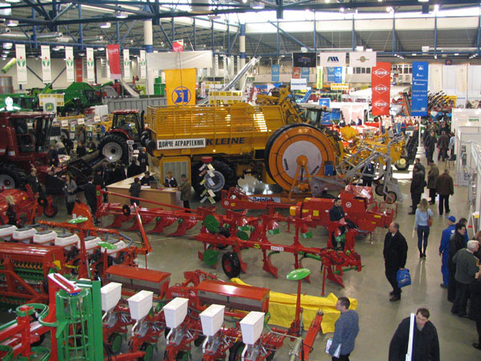

current depreciation of agricultural machinery and equipment is equal to 80-90% of total stock. Approximately 40% of all tractors in the field are 15-25 years old, so the need to replace basic farm machinery is becoming critical.

Background on Kiev AgriHort 2006 and UkrProdMash 2006
The international trade shows Kiev AgriHort 2006 and UkrProdMash 2006 took place February 15-17, 2006, in Kiev, at the International Exhibition Center. These annual events covered a broad range of products including: bakery equipment, bottling machinery, brewing technology, confectionery and dairy equipment, labeling and bar-
coding equipment, meat processing equipment, refrigeration equipment, beer and
(Continued on following page)

alcoholic beverages, mineral water and soft drinks, confectionery and dairy products, ice cream, seafood, fresh fruits and vegetables, agricultural machinery, tools, irrigation equipment, seeds and seedlings, fertilizers, agricultural commodities, processing technology, greenhouse technology, crop protection and control, crops and flowers, processing technology, veterinary products, and other products. In their ninth years, the shows built up a solid position as truly international shows, growing annually in size and number of exhibitors. They prove a steady development of the agribusiness sector and the attractiveness of the Ukraine’s market for international businesses. These trade shows attracted over 200
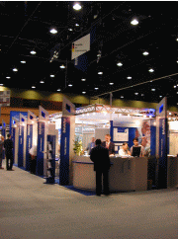

exhibitors from 20 countries, displaying in over 13,000 m² of exhibit space.

U.S. Product Literature Center at Kiev AgriHort 2007 & UkrProdMash 2007 shows
CS Kiev is organizing a Product Literature Center at Kiev AgriHort 2007 and UkrProdMash 2007. In addition to providing information on Commerce Department programs, the booth will exhibit catalogs and promotional information of U.S. firms and/or industry associations, and CS Kiev commercial specialists will distribute them to potential Ukrainian buyers for a fee of $250.00 per U.S. company or organization.
The $250.00 participation fee for the USCS Kiev catalog promotion will include:

- Inclusion in a U.S. Product Literature Center listing, to be prepared in Ukrainian, including summary information on your company;
- Product literature exposure at the CS Kiev Product Literature Center booth
- staffed by CS Kiev commercial specialists;
- Following the show, a list of potential Ukrainian buyers and/or business partners will be provided to each catalog display participant;
- One-year company profile display hosted at the American Embassy Commercial Service webpage for Ukrainian customers;
- One-year product literature reference exposure at the U.S. Commercial Service Kiev Business Commercial Library.

Interested American companies must register with CS Kiev before January 7th, 2007. Please contact:

Irina Dushnik
Commercial Specialist
U.S. Embassy Kiev Commercial Service
Telephone: (38044) 490-4096/490-4018, (38044) 490-4046
E-mail: Irina.Dushnik@mail.doc.gov
http://www.buyusa.gov/ukraine (CS Kiev programs/services)
http://www.export.gov
(Continued on following page)
Once registered and after paying the participation fee, U.S. companies and/or U.S. trade and industry associations should mail company catalogs and promotional materials to the CS office in Kiev.

Instructions for Sending Catalogs to CS Kiev
If you decide to ship materials to our U.S. address please plan that it will take up to 3 weeks before materials are delivered to the Embassy Kiev. In this case materials sent cannot exceed 40 brochures (maximum 30 pages each). The sum of three measurements of the package may not exceed 62 inches (length, width and height). The package/box may not weigh more than 40 lbs., and should be sent by U.S. mail to:

Richard Steffens
5850 Kiev Pl.
Dulles, VA 20189-5850

Materials also can be forwarded to CS Kiev by courier/delivery service. The customs value of the parcel should be zero to avoid customs clearance procedure (Note: The Embassy cannot clear any catalogs through the Ukrainian customs). In case you decide to send materials via courier/delivery, please use the following address:

U.S. Embassy
10, Yuriy Kotsyubinsky St.
Kiev 01901 Ukraine
Attn. Commercial Section


Please provide Irina Dushnik by e-mail (Irina.Dushnik@mail.doc.gov) with shipment date and reference number.

For additional information on the shows, please contact (please cc CS Kiev Irina Dushnik):

Kiev AgriHort 2007 UkrProdMash 2007
Show organizer – BTO Show organizer - Premier Expo
E-mail: kuno.jacobs@bto-exhibitions.nl E-mail: Ekomolova@pe.com.ua
Website: www.bto-exhibitions.nl Website: www.pe.com.ua

International Trade Publication – December 2006

COMMERCIAL SERVICE’S TOP 10 EXPORTING TIPS

With its network of offices across the United States and in more than 80 countries around the world, the U.S. Commercial Service utilizes its global presence and international marketing expertise to help U.S. companies sell their products and services worldwide. Exporting Tips from the U.S. Commercial Service include:

- Dedicate top-level management and develop a clear export strategy;

- Identify potential market(s) and conduct research and a risk/reward assessment;

- Be patient and realistic when going international (take a long-term approach and allow sufficient time for due diligence);

- Seek professional help from the U.S. Commercial Service, District Export Council, bankers, international legal firms, or freight forwarders;

- Make sure the product is export-ready (standards compliance, regulations, labeling, licensing, etc.);

- Understand and select the best distribution channel for each country (research all potential distribution partners);

- Identify sources of finance before beginning negotiations to ensure you are not caught flat-footed in business meetings (trade financing is crucial to success overseas);

- Create payment terms & conditions that meet the market’s needs/standards (you can offer terms to foreign buyers and meet competitors head-on by using the Export-Import Bank and the Small Business Administration’s export programs);

- Design your company’s Web site to be attractive and responsive to foreign buyers; and

- Take advantage of U.S. government export promotion services – everything from export counseling, financing, and market research to advocating for your products in overseas markets (they are affordable and effective, regardless of the size of the company).

International Trade Publication – December 2006

EXPO AGRO SINALOA 2007

February 7-10, 2007

Dear Agricultural Exporters,
The U.S. Commercial Service in Fresno and the North Bay, in collaboration with the Center for International Trade Development in Fresno, are organizing the US PAVILION at Expo Agro Sinaloa 2007, the premier agricultural trade show in Mexico. This event will take place in Culiacan, Sinaloa, on FEBRUARY 7-10, 2007. Abundant water and fertile soil make Sinaloa one of Mexico’s top agricultural producers. The main crops are grains and vegetables, which are used in local processing plants. Expo Agro Sinaloa only takes place once a year – do not miss this opportunity!

- FULL BOOTH EXHIBITION is $2,640
- There are only 2 booths remaining!



If you are interested in participating, please click on the following link to complete your on-line registration and/or to find additional information on the show: https://www.buyusa.gov/fresno/expoagrosinaloa2007.html.



The following link will take you to the Expo Agro Sinaloa 2007 home page, where you will find information about the show and the location of the booths still available in the U.S. Pavilion, as well as other important details: http://www.expoagro.org.mx.

International Trade Publication – December 2006

SEMICON CHINA 2007
March 21-23, 2007

The Commercial Section of the U.S. Consulate in Shanghai is pleased to support the Semicon China 2007 show. The goal is to promote the export of American products and services, and the Chinese semiconductor market holds great promise. The exposition, with a track record of over ten years, is one of the most established events of its kind in Asia, showcasing an extensive array of companies dealing in semiconductor equipment and materials, semiconductor manufacturing services, and electronic design automation (EDA). SEMICON China 2007 will be held at the Shanghai New International Expo Center (SNIEC) from March 21-23, 2007. The show is expected to draw more than 1,100 exhibitors, including foreign firms from the United States, Japan, South Korea, and Europe, and over 25,500 business visitors. For more information, please visit http://www.semi.org/semiconchina.

China’s semiconductor industry is growing quickly, and recent industry updates include the following:

- According to SEMI China, it is expected that China’s total capital investment in the semiconductor industry will reach $9.8 billion from 2006 to 2008.
- At present, China’s semiconductor production meets only about 10% of China’s domestic needs – primarily low and mid-level consumer products.

The U.S. Commercial Service will have a booth space close to the IC Manufacturing & Design Automation Pavilion and will provide the following on-site services to American exhibitors:

- Pre-show region-wide marketing campaign to buyers
- One-on-one briefing from a U.S. Consulate commercial representative
- On-site counseling throughout the show
- Gold Key Service (GKS) designed to help you find distributors, agents, or business partners in China
- A number of other tailored services provided by the U.S. Commercial Service (http://www.buyusa.gov/china/en/programs.html)

For more information, please contact Lisa Tang, Commercial Specialist in Shanghai:
Telephone: (86-21) 6279-7630, ext. 6226 Fax: (86-21) 6279-7639
Email: Lisa.Tang@mail.doc.gov
International Trade Publication – December 2006

LASER.WORLD OF PHOTONICS CHINA 2007
Commerce Department partners with Munich Trade Fairs to showcase U.S. companies at the Laser.World of Photonics China 2007 trade show
March 21-23, 2007

U.S. companies in the laser, photonics, and optics industry can expand their business in China by exhibiting at the Laser.World of Photonics China 2007 trade show in Shanghai, China. The show, held at the Shanghai New International Centre on March 21-23, 2007, is the leading laser, photonics, and optics industry exhibition, attracting over 6,000 visitors from over 18 countries. In China, the market opportunities in the area of photonics are developing at a very rapid rate. Over the past five years, the Chinese market for optoelectronic products grew by an average of 30%.

China is the “gateway to Asia”, and Laser.World of Photonics China 2007 offers U.S. companies excellent opportunities to sell laser, photonics, and optics products and service technologies in a market that is forecasted to grow at enormous rates. One important advantage for U.S. exhibitors is that Laser.World of Photonics China is held simultaneously with Electronica & ProductronicaChina 2007 and SEMICON China 2007. This offers U.S. companies more exposure to key buyers and greater opportunities to make sales and meet potential business partners.

With this in mind, the U.S. Commercial Service has granted Laser.World of China 2007 its Trade Fair Certification status, establishing a U.S. Pavilion for small and medium-sized exporters. Trade Fair Certification assures the Laser.World of Photonics 2007 exhibition of U.S. Commercial Service support in both the U.S. and in Asia. Companies exhibiting in the U.S. Pavilion have an excellent venue to establish or expand overseas distribution, generate sales leads, meet with existing clients, and work with Commerce trade experts to find the right buyers and partners.

For additional information about exhibiting or attending Laser.World of Photonics China 2007, contact Silke Eidam at (646) 437-1012 or by email at seidam@munich-tradefairs.com. You can also visit the show's official website at http://www.global-electronics.net/?id=45532.

For more information about the Trade Fair Certification Program, contact Mark Wells at (202) 482-0904 or by e-mail at Mark.Wells@mail.doc.gov.

International Trade Publication – December 2006

MAKING GREAT COMMUNITIES HAPPEN…IN CHINA
The American Planning Association (APA), with an assist from the U.S. Dept. of Commerce, is helping its members penetrate the Chinese market.

Much of the recent news on U.S.–China relations focuses on things that aren’t working well, such as trade deficits, intellectual property rights violations, and currency imbalances. However, a little-known fact is that as recently as 2004 the United States realized a trade surplus with China in services of $1.6 billion. Also, the recent successes of member companies of the American Planning Association (APA) in selling their services to China prove that U.S. firms can and do compete in this market.

About the APA
The APA is a professional organization with 40,000 members who work in community design, architecture, civil engineering, and environmental land use. Its motto is “Making Great Communities Happen.” In 2005, the APA set its sight on China by creating its China Initiative.

Economic Growth Fuels Demand for Services
The age-old law of supply and demand was behind the APA’s drive to promote sales to China. China’s economy has exploded at a blistering pace, with double-digit growth in gross domestic product over the past several years. Along with an unprecedented pace of urbanization and rural migration, a strong and sustained demand for urban planning and design expertise has developed.


Since 1996, the APA has run a China program that has linked U.S. urban design firms and experts with hundreds of Chinese mayors and provincial leaders. These contacts have led directly to many U.S. business sales. In October 2005, the APA won a three-year Market Development Cooperator Program (MDCP) award from the U.S. Department of Commerce to support its China Initiative. The MDCP – operated by the International Trade Administration (ITA) – provides federal assistance to nonprofit export multipliers that serve small businesses.
(Continued on following page)
Partnership with Commerce Department Experts
The Commerce Department quickly assembled a team to work closely with the APA on its China Initiative. Team members were drawn from many parts of the agency. Specialists from the U.S. and Foreign Commercial Service—who are located both in the United States and in key in-country posts such as Beijing, Chengdu, Guangzhou, Hong Kong, Shanghai, and Shenyang—were especially important, bringing a strong knowledge of industry sectors important to the APA and an understanding of the Chinese market and the strengths that U.S. companies offer.

Building on Existing Initiatives
Within the China Initiative, one hallmark is a program that provides training and exchanges for U.S. planning companies and senior Chinese planning officials and mayors. Since 2002, the APA has already brought more than 100 Chinese mayors to the United States, where they visited several cities, met with U.S. companies, and learned about U.S. planning and design concepts.

Expanded Marketing Efforts
With its China Initiative, the APA is continuing to promote U.S. urban planning, urban design services, and planning philosophies. The APA’s five-part strategy includes (1) establishing a fully staffed APA office in Shanghai, (2) preparing promotion material for the China market in English and Mandarin, (3) providing training and exchanges for APA members and Chinese customers, (4) organizing business trips to
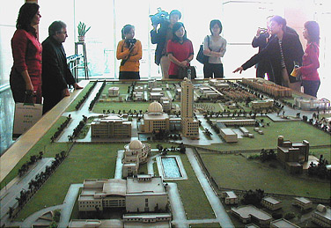

China for U.S. planning companies, and (5) cultivating long-term relationships with Chinese clients. Shanghai will be the center of the APA’s China operations because it is the economic hub of the Yangtze River delta. During the term of the MDCP award, the APA expects the Shanghai office to provide marketing and training for APA professionals in China and to facilitate collaboration between urban planners and members of related industries.

Successful Efforts Bring Sales
The first year of the MDCP award has been a success for the APA’s efforts in China. Seven U.S. firms have already signed contracts worth almost $500,000. The services they are exporting to China include design and engineering, transportation planning, urban development, and architectural services. The combination of market strength and a strong partnership with the Commerce Department has given U.S. firms a leg up in succeeding in the Chinese market. Jeff Soule, the APA’s policy director, echoes that sentiment, noting, “It’s a great partnership, and we all recognize that the service sector is the fastest-growing sector in China and that U.S. firms are the leaders in planning, design, and development services.”

Please visit www.planning.org/APAinChina for more on the APA’s China Initiative.

International Trade Publication – December 2006

OTHER IMPORTANT EVENTS & INFORMATION

2007 International Consumer Electronics Show January 7-11, 2007

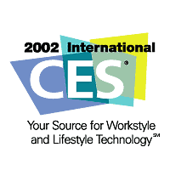
If your business or interest lies in the consumer electronics industry, then the CES Show in Las Vegas on January 7-11, 2007, is an event you do not want to miss! The ICT Team will be offering Showtime presentations, appointments, and matchmaking at this premiere industry event. Approximately 20 Commercial Specialists will be leading delegations. To register for this event, please visit http://registration.expoexchange.com/ShowCES071/.

Webinar on China RoHS January 11, 2007


On March 1, 2007, China's Administrative Measures on the Control of Pollution Caused by Electronic Information Products (also known as China RoHS) will go into effect. Products covered by the scope of these regulations which are sold or imported into China will need to comply with marking and material disclosure requirements at that time.
China's RoHS (Reduction on the use of Hazardous Substances) regulations will impact many of the companies selling or looking to sell their products in China. In an effort to bring exporters up to speed on how to comply with these regulations, the Department of Commerce has organized a “China RoHS: Overview and Best Practices” webinar to be held on January 11 (2:00 EDT). This free webinar will feature both private sector and Department of Commerce specialists who have been closely monitoring China's developments in this area. Participants will receive an overview of these regulations and insight on what they must do in order to comply. Further details as well as registration information can be found at: http://www.export.gov/china/trade_events/China_RoHS_webinar.pdf.

ONLINE RESOURCES
- Commercial News USA………………………….………...http://www.thinkglobal.us/
- Export.gov………………………………………………….……http://www.export.gov/
- International Trade Administration (ITA) International Trade Calendar……………. http://www.trade.gov/press/publications/newsletters/ita_1006/trade_calendar_1006.asp

For more information regarding the above events, or if you are a small business seriously interested in exporting, please contact Amy Benson, Director of the Boise Export Assistance Center, at (208) 364-7791 or by email at Amy.Benson@mail.doc.gov. Please visit the Boise USEAC website to learn more about how the U.S. Commercial Service can assist your business.

