
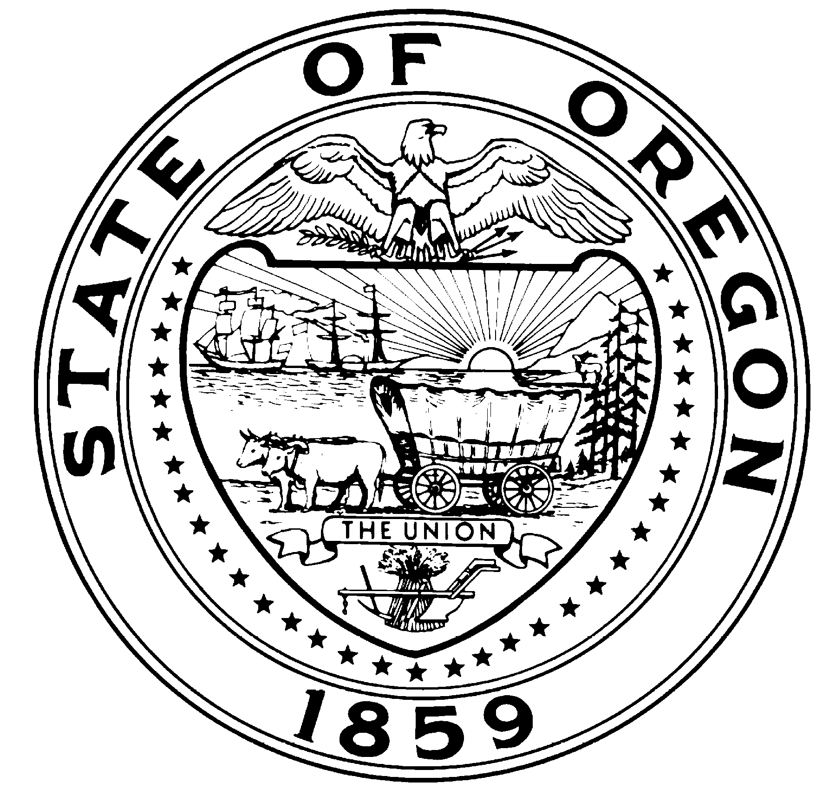
Theodore R. Kulongoski, Governor

State Library
250 Winter St. NE
Salem, OR 97301-3950
(503) 378-4243
FAX (503) 588-7119
TTY (503) 378-4334

ANNUAL PERFORMANCE REPORT: 2002-03

Introduction

Performance Accomplishments

The State Library’s Annual Performance Report for 2002-03 reports on 16 performance measures that serve to evaluate the extent to which the agency is advancing toward its long range goals, adopted by the State Library Board of Trustees. These goals were developed to influence three Oregon Benchmarks and four other high level outcomes for improved library services in the state. In 2002-03, five of the 16 measures showed improvement, eight did not, one was unchanged, and two are new, and cannot be assessed. The following table summarizes our performance accomplishments:

-14% | Number of research assistance transactions for state employees.
+5%  +7% | Percent of state agency customers rating service “very good” or “excellent.”
 | Percent of state employees registered to use SmartORgov.
-10% | Average number of daily visits to SmartORgov.
-2%  -1% | Number of individuals registered to receive Talking Book and Braille Services.
 | Number of talking books and Braille books checked out per year.
+1% | Percentage of Talking Book and Braille Services customers rating service “very good” or “excellent.”
+54% | Total donations to Talking Book and Braille Services.
+33% | Percentage increase [rate of growth] in local library services to children.
-32% | Percentage increase [rate of growth] in interlibrary lending.
NEW | Average daily visits to the FindOR government information locator system.

-50% | Number of public libraries making improvements to achieve OBM #38 minimum service criteria.
NEW | Number of schools making improvements to achieve Oregon Quality Education standards for school libraries.
-31% | Average number of hours of training per FTE staff member.
-30% | Number of FTE below affirmative action parity goal for women, disabled persons, and persons of color.
-4% | Number of hours worked by State Library volunteers.

Degree and Type of Agency Influence on Their Chosen Benchmarks and High-Level Outcomes

The following table summarizes the extent to which the State Library was able to influence Oregon Benchmarks and other high-level outcomes in 2002-03:

Oregon Benchmark or Other High-Level Outcome | State Library Influence in 2002-03
OBM #38 Percent of Oregonians served by a public library that meets minimum service criteria. | Two percent fewer Oregonians were served by an adequate public library in 2002-03 than in the previous year. Staff reductions at the Clackamas County Library caused that library to fail to meet the Benchmark standards which accounted for the bulk of the decrease statewide. The State Library was not able to influence the Benchmark significantly in 2002-03.
OBM #18 Percent of Oregon children entering school ready-to-learn. | Oregon public libraries were able to increase growth in library services to children (book check-outs and program participation) in 2002-03 from 6% to 8%. Research shows that use of a public library contributes significantly to early literacy development. The State Library’s Ready to Read Grant program encourages and assists local libraries to improve their services to children.
OBM #19/20 Percent of third/eight graders who achieve established skill levels: a. reading | As reported above, services to children continued to grow in 2002-03. Since the Ready to Read Grant program began in 1993, library service to children in Oregon has increased 91%.
HLO a. Percent of Oregon state government employees who use information provided by the State Library for planning, decision-making, and service delivery. | Research information provided by State Library staff to state government employees dropped 14% due mostly to staff reductions, but registration to use the Library’s SmartORgov information portal reached an all-time high of 15% of all state employees.
HLO b. Percent of Oregonians with print-related disabilities who have the same access to reading materials as other Oregonians. | Registration to use the Library’s Talking Book and Braille Services dropped slightly, as did book circulation, despite a growing number of Oregonians eligible for this service.
HLO c. Percent of Oregonians who are able to access information from any Oregon library. | Growth in interlibrary lending has slowed, but is still very strong at 12% for the year. State Library grant support for shared automated resource sharing systems continues to contribute to the increase.
HLO d. Percent of Oregon students who are served by a school library that meets Oregon Quality Education Model standards. | This is a new HLO. The State Library will begin collecting data in cooperation with the Oregon Department of Education in 2004-05. The Library hopes to be able to influence this by disseminating data and recognizing best practices.

Future Challenges

In order to meet the State Library Board’s long range goals and positively influence the Oregon Benchmarks and other high-level outcomes, the following challenges will have to be met:

- How to continue to provide more information services to state agency employees during a period of limited resources?

- How to effectively market the information services of the State Library to state agency employees so that they take advantage of the services that are available?

- How to ensure permanent public access to state agency publications and information when many publications are no longer printed?

- How to reach and serve the increasing number of blind and print-disabled Oregonians with Talking Book and Braille Services?

- How to continue to effectively leverage local public library efforts to improve library services to children, especially preschool children from low-income families?

- How to more effectively leverage local efforts to provide adequate public library services for every Oregonian?

- How to reverse the trend of disinvestment in public school library services in the state and begin to build back quality school libraries in every school?

- How to increase cooperation among all types of libraries and begin to make progress on developing a statewide library catalog that makes library materials from every library accessible to every Oregonian?

- Annual Performance Progress Report
Part I, Managing for Results
Agency: Oregon State Library
Contact: Jim Scheppke | Phone: 503 378-4367 ext 243
Alternate: Keith Adams | Phone: 503 378-4243 ext 226

The following questions shed light on how well performance measures and performance data are leveraged within your agency for process improvement and results-based management.
- How were staff and stakeholders involved in the development of the agency’s performance measures? | The State Library’s performance measures were developed by the State Library Board Budget Committee in 2002. The Budget Committee consisted of three board members, five managers and two classified staff. In addition, feedback from all of the teams at the library was solicited. The measures were disseminated to stakeholders as part of the 2003-05 Agency Request Budget and adopted in a public meeting in June, 2002.
- How are performance measures used for management of the agency? | Most of the measures are collected and reported quarterly and reviewed in a Management Team meeting and by all staff at Team Meetings. They are then reported and discussed with the State Library Board at bi-monthly State Library Board meetings.
- What training has staff had in the use performance measurement? | All of the managers at the state library have has some training in the use of performance measurement. Some of the staff have had training. The State Library will look for opportunities for agency-wide training on effective use of performance measurement.
- How does the agency communicate performance results and for what purpose? (Please include your agency’s URL for Performance Measures and this Annual Report) | The Annual Performance Report will be posted to the State Library website:  http://www.osl.state.or.us/home/  The posting will be announced to library stakeholders through library newsletters for the purpose of informing stakeholders about our performance.
- What important changes have occurred in the past year? | - SB 12 passed the Legislative Assembly, setting new priorities for the Library’s federally funded library development program.  - SB 238 authorized the library to begin to analyze and report data on school libraries.  - One third of the Library reference staff (2 FTE) was eliminated in the Legislatively Approved Budget for 2003-05, but a new librarian position was created to coordinate the FindOR search engine for Oregon.gov.

Annual Performance Progress Report
Part II, Key Measure Analysis of Progress

Performance measure with number.
54300-1. Number of research assistance transactions for state employees. The number of times that information is delivered to a state employee in response to a request for information.

Data |  |  |  |  |  | Target
1999 | 2000 | 2001 | 2002 | 2003 | 2004 | 2005
15,414 | 11,573 | 14,209 | 12,831 | 11,018 |  | 13,500

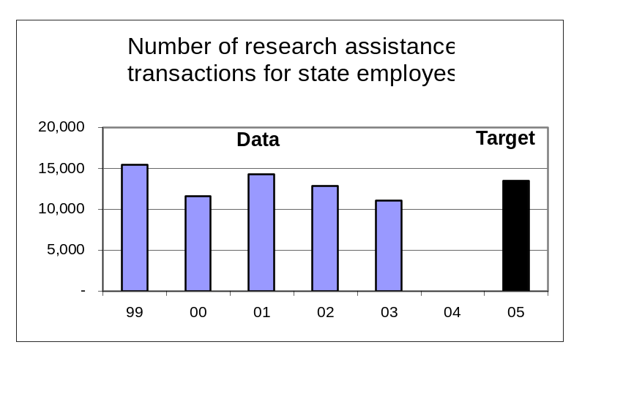To what goal or goals is this performance measure linked?
Goal: Improve library services to state government; increase usage and user satisfaction.

What does the performance measure demonstrate about the goal?
The measure tracks the State Library’s success in delivering information services to agency employees.
What does the data reveal?
The data shows a 14% decrease in information transactions from 2002 to 2003. The variance is caused in part by the loss of 2 FTE librarians, a reduction of one third of the professional staff assigned as the main research contact for state agency employees. It also shows the results of the Library’s adoption of new Web-based services and unmediated information provision via our SmartORgov website. As a result of intensive customer-training efforts, library customers are now able to directly access many online databases and other electronic information services, thus bypassing contact with library staff.

What is an example of a department activity related to the measure?
Library activities relating to this measure include: 1) significant marketing of services to agencies and state employees; 2) onsite presentations to agency managers and employees; 3) an active and popular “Desktop Learning Workshop” training program for state employees, which concentrates on teaching personal use of online information services; 4) adoption of Web and e-mail information delivery systems, resulting in fast and efficient information access and delivery.

What needs to be done as a result of your analysis?
We are in process of installing the “One Search” database portal. This is a “single-search” portal which can simultaneously search multiple databases and other topical electronic information resources. The system quickly returns grouped search result displays from the various information sources, with links for instant access to full text results. It also features automatic online ordering and delivery of publication photocopies or electronic text , direct from the search results display. We believe this and other improvements to SmartORgov will result in increased research assistance transactions.

What is the data source?
Internal count recorded by Government Research and Electronic Services (GRES) staff and compiled quarterly.
Annual Performance Progress Report
Part II, Key Measure Analysis of Progress

Performance measure with number.
54300-2. Percent of state agency customers rating service “very good” or “excellent.” The percentage of all state agency customers surveyed who rate the Library’s information services as “very good” or “excellent.”

Data |  |  |  |  |  | Target
1999 | 2000 | 2001 | 2002 | 2003 | 2004 | 2005
72% |  | 84% |  | 88% |  | 80%

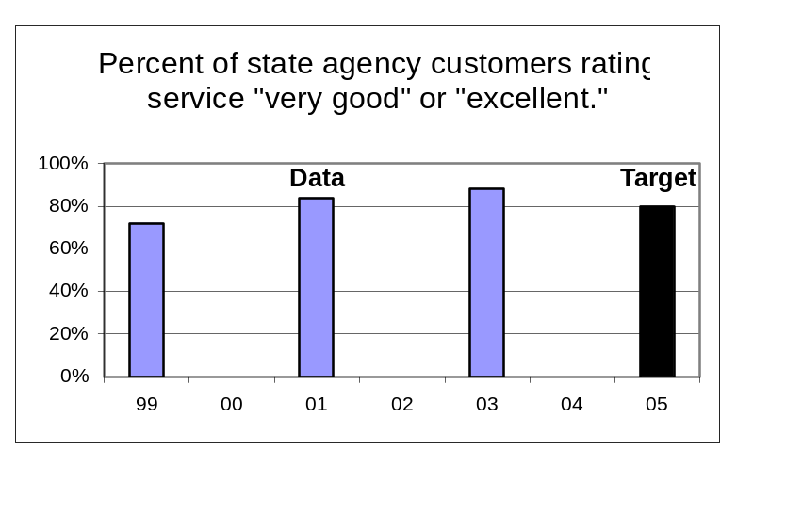
To what goal or goals is this performance measure linked?
Goal: Improve library services to state government; increase usage and user satisfaction.

What does the performance measure demonstrate about the goal?

This measure provides evidence of high user satisfaction with library information services.

What does the data reveal?
The 2003 survey shows a 4% increase in customers giving high marks to library services, despite the loss of professional and support staff.

What is an example of a department activity related to the measure?
The increase in satisfaction is related to the library’s leading-edge implementation of automated and Web-based information services via our SmartORgov website. These include: 1) addition of multiple direct user online databases; 2) fast and efficient Web delivery of customer-requested print copy images and electronic text; 3) library staff marketing and training efforts, introducing customers to online Web-based information services and supplementary library services.

What needs to be done as a result of your analysis?
We continue to improve Web information services and information-request delivery methods. We are adding the “One Search” portal, to give agency customers the ability to perform single-point global searches across numerous relevant databases and online services. We continue to customize the Web information search interfaces to provide easy and uncomplicated access to sophisticated information systems.

What is the data source?
Biennial customer satisfaction survey conducted by GRES staff.
Annual Performance Progress Report
Part II, Key Measure Analysis of Progress

Performance measure with number.
54300-3. Percent of state employees registered to use SmartORgov. The percentage of state employees who have registered to use the State Library’s Web-based information portal.

Data |  |  |  |  |  | Target
1999 | 2000 | 2001 | 2002 | 2003 | 2004 | 2005
8% | 9% | 12% | 14% | 15% |  | 20%

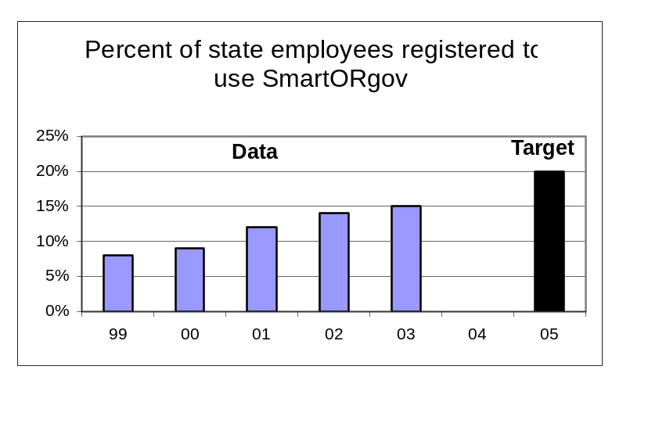
To what goal or goals is this performance measure linked?
Goal: Improve library services to state government; increase usage and user satisfaction.

What does the performance measure demonstrate about the goal?
This measure demonstrates the library’s penetration or “market share” of agency employees, those who have actively registered to use library services.

What does the data reveal?
The data shows a steady increase in the percentage of state employee registration. The percentage has nearly doubled in the five years. It demonstrates the success of the library’s commitment to “self-service” online information transactions, and to the results of our investment in marketing and user-education.

What is an example of a department activity related to the measure?
Related library activities include: 1) intensive marketing and training efforts; 2) conversion of library information resources from printed materials to public-domain and licensed online information services; 3) good results from efforts to integrate and add value to specialized online information services via the library’s Web portal, and of providing instant and transparent individual user access to these resources.

What needs to be done as a result of your analysis?
The library intends to continue the intensive marketing and training efforts, and, in addition, to work collaboratively with agencies and intra-agency groups to increase our visibility and relevance to the state’s “information workers.”

What is the data source?
Internal count recorded by GRES divided by an adjusted count of state employees obtained from DAS HRSD; calculated quarterly.
Annual Performance Progress Report
Part II, Key Measure Analysis of Progress

Performance measure with number.
54300-4. Average number of daily visits to SmartORgov. The average number of times in a day that state employees access the library’s Web-based information portal.

Data |  |  |  |  |  | Target
1999 | 2000 | 2001 | 2002 | 2003 | 2004 | 2005
 |  |  | 200 | 180 |  | 400

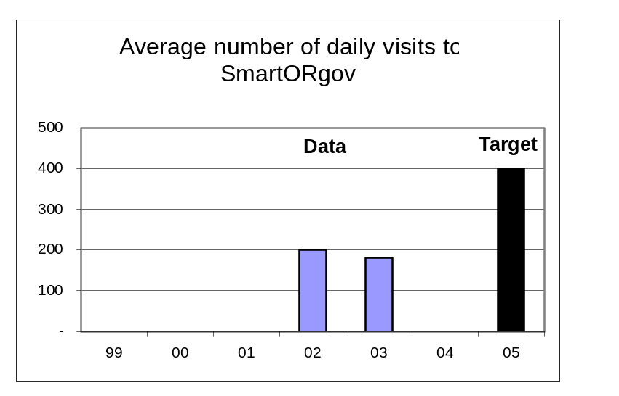
To what goal or goals is this performance measure linked?
Goal: Improve library services to state government; increase usage and user satisfaction.

What does the performance measure demonstrate about the goal?
This measure tracks and shows agency use of the library’s Web portal, by state agency employees.
[New]

What does the data reveal?
Data shows an apparent 10% decrease in usage from 2002-2003. This is explained by our development and integration of separate servers and outside information service vendors into our product inventory. The use of the separate servers means that many customers are going directly to the Web addresses for these services. These transactions are not being counted, since they are no longer “visits to the Web information portal.” Examples of these high-activity servers include: Illiad, our Web-based document request and delivery system, our proxy server, used to provide agency users with transparent interface to licensed/passworded online databases, and our LISTsmart (electronic mailing list) server, currently providing agencies with over 250 mailing lists, with 45,000+ list subscribers.

What is an example of a department activity related to the measure?
Implementation of the Illiad Web-based system for online request and delivery of print images and electronic text; of the STATEtrak system, for automatic e-mail reporting of a simplified legislative tracking service; etc.

What needs to be done as a result of your analysis?
The library is developing systems to cumulate transactions from all the various independent services not hosted on the SmartORgov Web portal. These can then be added to the reporting to give a more accurate picture of the library’s transaction flow via the Internet.

What is the data source?
Counted by SmartORgov system software.
Annual Performance Progress Report
Part II, Key Measure Analysis of Progress

Performance measure with number.
54300-5. Number of individuals registered to receive Talking Book and Braille Services. The number of Oregonians who have individually registered to receive services from Talking Book and Braille Services. Does not include people who use deposit collections.

Data |  |  |  |  |  | Target
1999 | 2000 | 2001 | 2002 | 2003 | 2004 | 2005
6,978 | 6,588 | 6,574 | 6,328 | 6,174 |  | 7,000

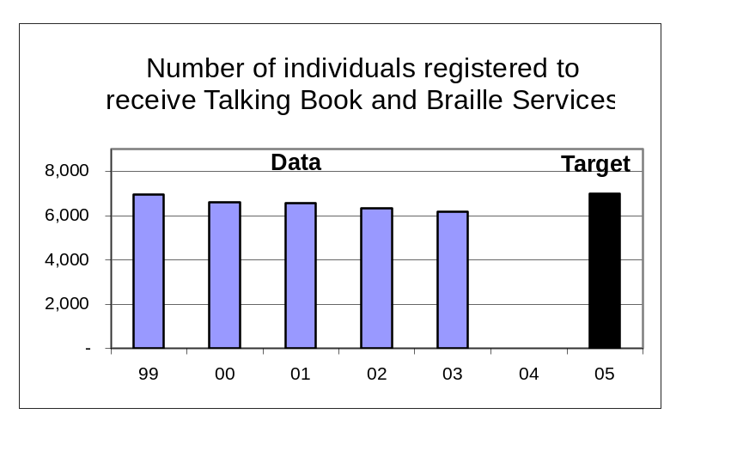
To what goal or goals is this performance measure linked?
Goal: Improve, adapt, and market talking book and Braille services to a growing user population.

What does the performance measure demonstrate about the goal?
TBABS needs to more effectively market its services to those who can take advantage of them.

What does the data reveal?
- For the last three years, regional libraries for the blind and print-disabled across the country have seen user numbers decrease for a number of reasons. The 11% reduction in registration in Oregon since 1999 is close to the national trend of 10% for the same period. There is a changing older population, many of whom are living a more active lifestyle than the previous generation. Medical advances have provided better vision opportunities for older persons. In addition, it is necessary now to pay for previously free advertising (PSAs, etc.) to promote the services to the relevant population.
- In recent years TBABS has been inadequately staffed. This has resulted in lack of ability to actively market the service, such as contacting agencies and individuals who also serve the same populations.

What is an example of a department activity related to the measure?
Recently, TBABS has actively promoted its services through public libraries, retirement facilities, health care facilities, and assisted care residences.

What needs to be done as a result of your analysis?
TBABS needs to promote its services to a targeted market with the aid of a long-range plan, paid advertising, and services that appeal to potential users.

What is the data source?
Internal count recorded by Talking Book and Braille Services (TBABS) staff; calculated quarterly.
Annual Performance Progress Report
Part II, Key Measure Analysis of Progress

Performance measure with number.
54300-6. Number of talking books and Braille books checked out per year. The total number of talking books and Braille books checked out to registered borrowers in a year. Does not include books checked out from deposit collections.

Data |  |  |  |  |  | Target
1999 | 2000 | 2001 | 2002 | 2003 | 2004 | 2005
368,465 | 369,234 | 358,827 | 348,224 | 345,833 |  | 375,000

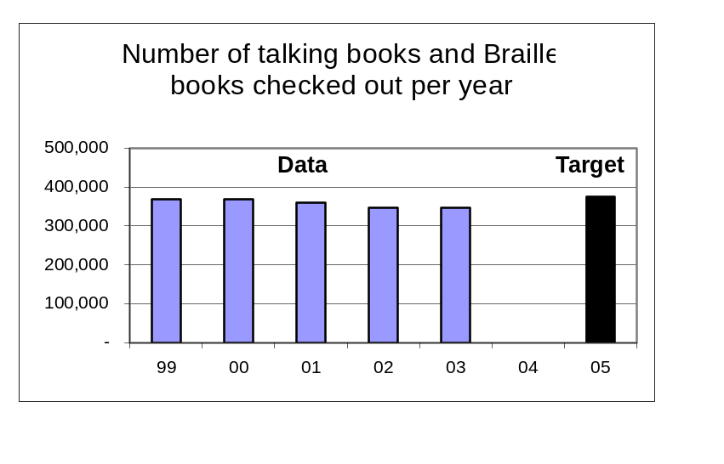
To what goal or goals is this performance measure linked?
Goal: Improve, adapt, and market talking book and Braille services to a growing user population.

What does the performance measure demonstrate about the goal?
The more books checked out, the more successfully we are meeting the needs of our clients. It also means that we are meeting the standards of 1-day turnaround for book requests.

What does the data reveal?
- TBABS has not been meeting our turnaround standard on a consistent basis. A decrease in registered customers also has a direct affect on circulation.
- Staff shortages, a decrease in volunteer hours, and budget cuts have limited the team’s ability to maintain our standards and meet goals set. Inadequacies in our outdated automation system sometimes make service more complicated than it should be.
- Staff hours have been lost due to disability and to illness. DAS rules necessitated wait times before hiring to fill empty position. New staff have to be trained.

What is an example of a department activity related to the measure?
In recent months we have hired two new staff members and have worked with the Volunteer Coordinator to recruit new volunteers.

What needs to be done as a result of your analysis?
The team needs to provide training for new team members and new volunteers so that production standards can be met and maintained. A new automated circulation and catalog system, which we recently purchased with donated funds, needs to be implemented as soon as possible.

What is the data source?
Counted by TBABS circulation system software.
Annual Performance Progress Report
Part II, Key Measure Analysis of Progress

Performance measure with number.
54300-7. Percentage of Talking Book and Braille Services customers rating service “very good” or “excellent.” The percentage of all customers surveyed who rate the overall service they receive from Talking Book and Braille Services as “very good” or “excellent.”

Data |  |  |  |  |  | Target
1999 | 2000 | 2001 | 2002 | 2003 | 2004 | 2005
 | 92% |  |  | 93% |  | 92%

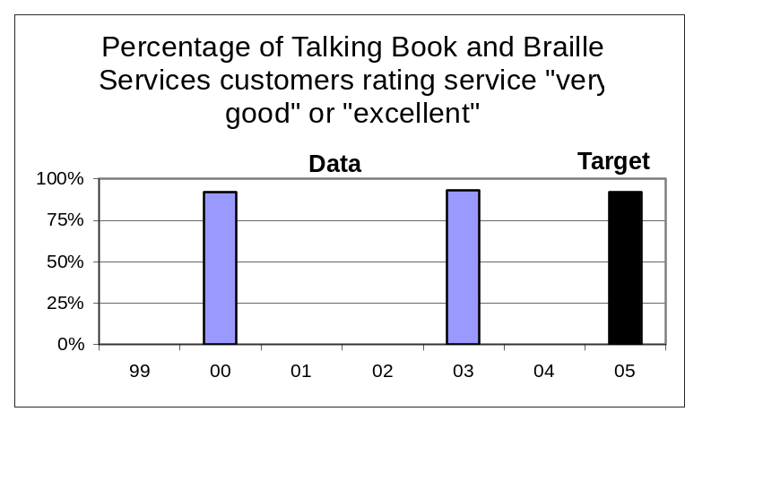
To what goal or goals is this performance measure linked?
Goal: Improve, adapt, and market talking book and Braille services to a growing user population.

What does the performance measure demonstrate about the goal?

TBABS has maintained the high satisfaction rating of its customers.

What does the data reveal?
The target was met.

What is an example of a department activity related to the measure?
Staff makes personal contact with customers as much as possible.

What needs to be done as a result of your analysis?
TBABS staff will be increasing our contact with customers via a plan to personally contact each customer at least once a year to verify recorded information and inquire if any changes in service are needed.

What is the data source?
Biennial customer satisfaction survey conducted by TBABS staff.

Annual Performance Progress Report
Part II, Key Measure Analysis of Progress

Performance measure with number.
54300-8. Total donations to Talking Book and Braille Services. The total amount of all donations to Talking Book and Braille Services received in a year.

Data |  |  |  |  |  | Targets
1999 | 2000 | 2001 | 2002 | 2003 | 2004 | 2005
$68,225 | $102,016 | $138,309 | $77,609 | $119,777 |  | $95,000

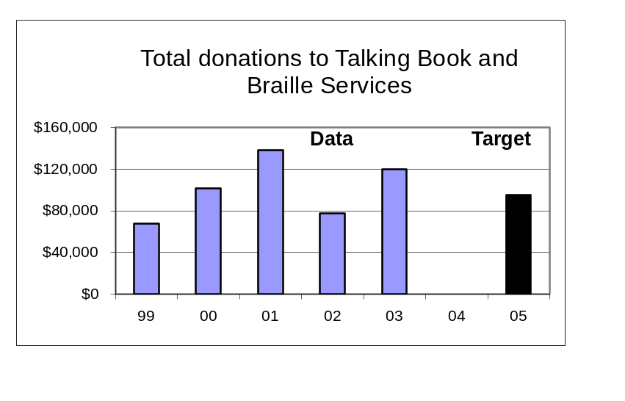
To what goal or goals is this performance measure linked?
Goal: Improve, adapt, and market talking book and Braille services to a growing user population.

What does the performance measure demonstrate about the goal?
TBABS has improved its marketing of its services.

What does the data reveal?
- Money raised was beyond expectations.
- TBABS made a special plea for help in financing a new automation system to provide better service and our customers responded generously.
- There was also one substantial bequest that finally cleared all the legal requirements and helped boost the total for this year.

What is an example of a department activity related to the measure?
Regular solicitation and careful recording of the results.

What needs to be done as a result of your analysis?
Continued efforts on the part of the Fund Development Officer, the Fund Development Committee, and the staff to maintain contact with customers and their families should be a priority. In addition TBABS should continue to make improvements in our services that are paid for with these funds.
What is the data source?
Internal count recorded by the State Library Business Office.
Annual Performance Progress Report
Part II, Key Measure Analysis of Progress
Performance measure with number.
54300-9. Percentage increase in local public library services to children. The percentage increase, compared to the previous year, of the sum of all public library circulation of children’s materials and attendance at children’s programs.

Data |  |  |  |  |  | Target
1999 | 2000 | 2001 | 2002 | 2003 | 2004 | 2005
0% | 10% | 9% | 6% | 8% |  | 10%

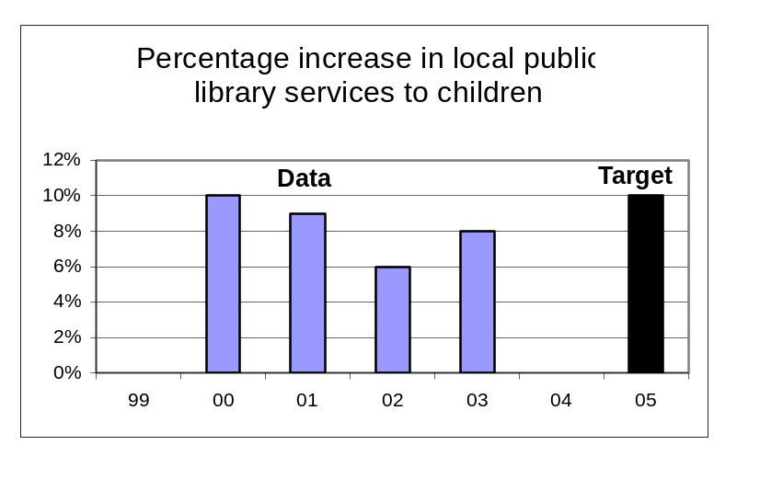
To what goal or goals is this performance measure linked?
Goal: Lead public libraries to achieve excellence in services to children.

What does the performance measure demonstrate about the goal?
Use of local and state funding to improve programming and collection development leading to increased use of public libraries by children.

What does the data reveal?
State funds provided by the State Library through the Ready to Read Grant program continue to leverage strong commitment and effort in local libraries that result in increased services to children. This occurred despite funding reductions to the program in 2002. Funding reductions may make it difficult to meet the target for 2005.

What is an example of a department activity related to the measure?
The State Library made 124 Ready to Read Grants to local public libraries in 2003-04 totaling $574,532. Funding was reduced by 18% from the prior year. The State Library staff also conducted an internal program evaluation in 2003-04, and provided training for youth services staff in small and rural libraries.

What needs to be done as a result of your analysis?
- Restore Ready to Read grant funding levels to return to higher annual growth in library service to children
- Use the results of the program evaluation to consider improvements to the program in the future.

What is the data source?
Derived from annual survey conducted by the State Library of all Oregon public libraries. “Services to children” is operationally defined as the sum of circulation of children’s materials and attendance at library programs for children.
Annual Performance Progress Report
Part II, Key Measure Analysis of Progress

Performance measure with number.
54300-10. Percentage increase in interlibrary lending. The percentage increase, compared to the previous year, of interlibrary loan materials received in all Oregon public and academic libraries.

Data |  |  |  |  |  | Target
1999 | 2000 | 2001 | 2002 | 2003 | 2004 | 2005
-1% | 28% | 19% | 19% | 13% |  | 15%

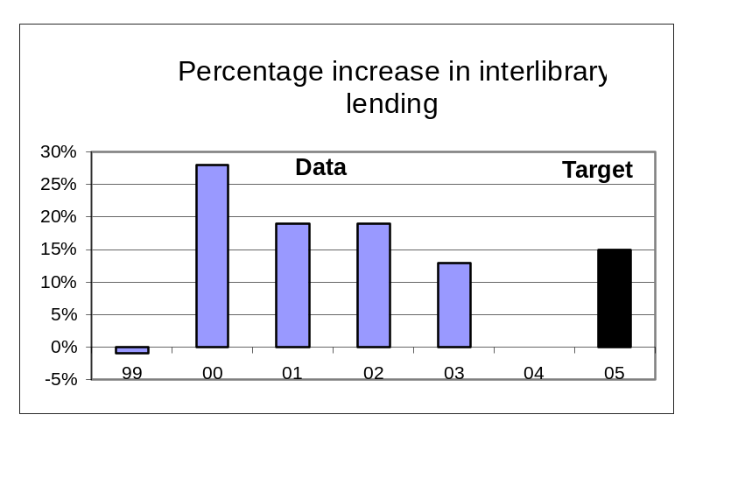
To what goal or goals is this performance measure linked?
Goal: Take a leadership role in developing a comprehensive statewide library resource sharing network, including improved citizen access to government information.

What does the performance measure demonstrate about the goal?
The measure demonstrates the extent to which public and academic libraries are sharing their resources via interlibrary loan of library materials (books, AV materials, and articles).

What does the data reveal?
- Data collected between 2001 and 2003 reflect an average improvement that exceeds the 2005 target.
- Net lender reimbursement to libraries from the State Library facilitated interlibrary lending of materials by reducing the financial impact to lending libraries.
- With the passage of SB 12 in the 2003 Legislative Assembly, the net lender reimbursement program has been replaced by a statewide database licensing program. However SB 12 still requires Oregon libraries to freely lend materials as a condition of participation in the database licensing program.

What is an example of a department activity related to the measure?
Training and outreach to libraries, collecting reports of interlibrary lending activities, federally funded grants to improve automated resource sharing systems and provide net lender reimbursement.

What needs to be done as a result of your analysis?
Continue current activities with the exception of the net lender reimbursement program.

What is the data source?
Derived from annual survey conducted by State Library staff of all public and academic libraries.
Annual Performance Progress Report
Part II, Key Measure Analysis of Progress

Performance measure with number.
54300-11. Average daily visits to the FindOR government information locator system. The average number of times in a day that anyone accesses the FindOR search engine for Oregon.gov, computed annually.

Data |  |  |  |  |  | Target
1999 | 2000 | 2001 | 2002 | 2003 | 2004 | 2005
 |  |  | 1,110 |  |  | 2,220

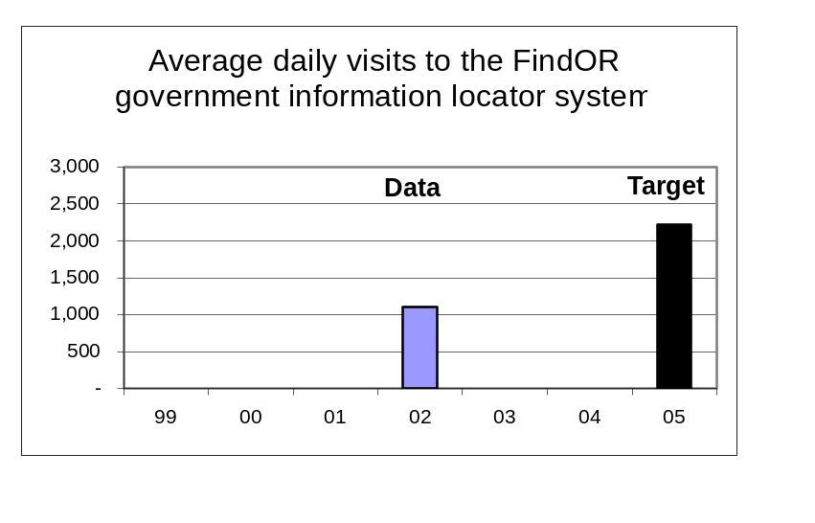
To what goal or goals is this performance measure linked?
Goal: Take a leadership role in developing a comprehensive statewide library resource sharing network, including improved citizen access to government information.
[New]

What does the performance measure demonstrate about the goal?
FindOR is the Web search engine for Oregon.gov, administered by the Library. This measure records the visitor traffic to the search engine, giving evidence of citizen and agency employee use of state agency websites.

What does the data reveal?
The data shows the number of visitor sessions to the search engine. The 2005 target is a 100% increase to the reported 2002 traffic. We anticipate much higher usage as the state moves towards implementation of the E-Government Program. The search engine currently provides global search of state Web sites. We will be adding separate indexes or catalogs that will add “Search this site” or “Search this collection” features to the service. This should result in higher use, as citizens use the search engine targeted to and linked from a specific area.

What is an example of a department activity related to the measure?
The library actively monitors Web addresses and special conditions within agency sites, for the purpose of accurately directing the search engine. We also provide training to agency personnel in metatag enrichment of agency Web sites, and in effectively using the search engine. We are actively collaborating with the E-Government Program, in designing and customizing the search engine implementation, and in providing search engine presentations as part of their training program.

What needs to be done as a result of your analysis?
Monitoring and implementing search engine software evolution; developing the various specialized site-search indexing implementations; continue working with E-Government Program team for development.

What is the data source?
Counted by FindOR system software.
Annual Performance Progress Report
Part II, Key Measure Analysis of Progress

Performance measure with number.
54300-12. Number of public libraries making improvements to achieve OBM #38 minimum service criteria. The number of libraries that failed to meet the OBM #38 minimum service criteria in the prior year that met them in the current year.

Data |  |  |  |  |  | Target
1999 | 2000 | 2001 | 2002 | 2003 | 2004 | 2005
4 | 10 | 10 | 2 | 1 |  | 3

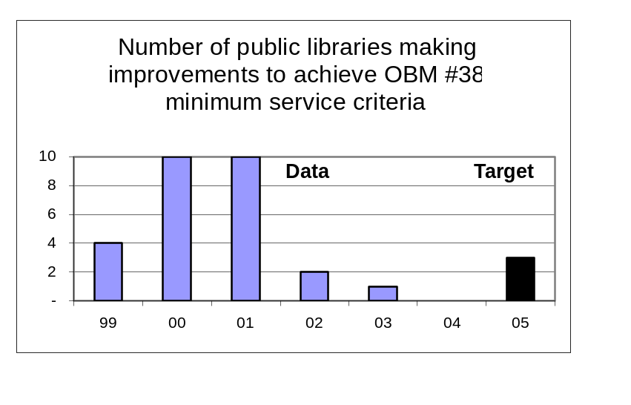
To what goal or goals is this performance measure linked?
Goal: Assist local communities to develop school and public library services for unserved and underserved Oregonians.

What does the performance measure demonstrate about the goal?
Continuous improvement in public libraries having paid staff, increased hours open, and increased services to children.
What does the data reveal?
- Libraries ability to improve services to the unserved and underserved is heavily impacted by funding and governance structures.
- Due to fluctuations in funding and staffing, libraries may not sustain minimum service criteria from year to year.
What is an example of a department activity related to the measure?
- Educating public library staff, governing boards, and local government officials on the value of maintaining and improving services.
- Providing competitive grants to develop or model existing programs to improve services.
What needs to be done as a result of your analysis?
- Continued education of library staff, governing boards, etc.
- Increased competitive grant funding to developing sustainable funding models for public libraries.
What is the data source?
Derived from annual survey conducted by the State Library of all Oregon public libraries.
Annual Performance Progress Report
Part II, Key Measure Analysis of Progress

Performance measure with number.
54300-13. Number of schools making improvements to achieve Oregon Quality Education Model standards for school libraries. The number of K-12 schools that did not meet the QEM standards for school libraries that in the prior year that did meet the standards in the current year.

Data |  |  |  |  |  | Target
1999 | 2000 | 2001 | 2002 | 2003 | 2004 | 2005
 |  |  |  |  |  | 10

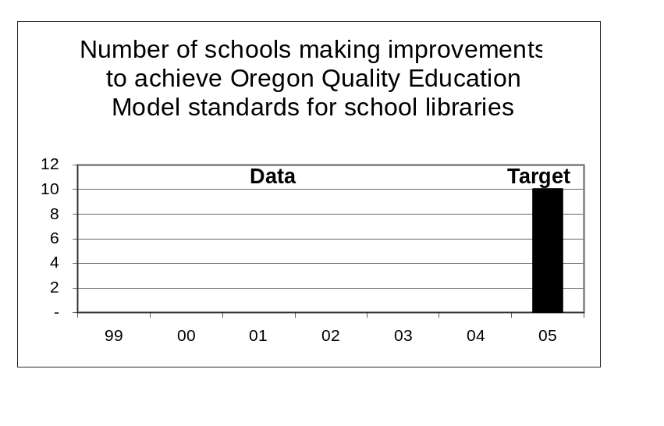
To what goal or goals is this performance measure linked?
Goal: Assist local communities to develop school and public library services for unserved and underserved Oregonians.

What does the performance measure demonstrate about the goal?
[New]
Performance measures are in development and will be tested by August 2004.
What does the data reveal?
—
What is an example of a department activity related to the measure?
The State Library is working with the Oregon Department of Education to improve the presentation and distribution of school library statistics to the K-12 community. Access to these data will assist schools in determining how well they are meeting OQEM standards and for making improvements.
What needs to be done as a result of your analysis?
—
What is the data source?
Derived from annual data collection from school districts conducted by the Oregon Department of Education.

Annual Performance Progress Report
Part II, Key Measure Analysis of Progress

Performance measure with number.
54300-14. Average number of hours of training per FTE staff member. The total number of hours of staff training in a year divided by the approved staff FTE.

Data |  |  |  |  |  | Targets
1999 | 2000 | 2001 | 2002 | 2003 | 2004 | 2005
21 | 22 | 28 | 16 | 11 |  | 25

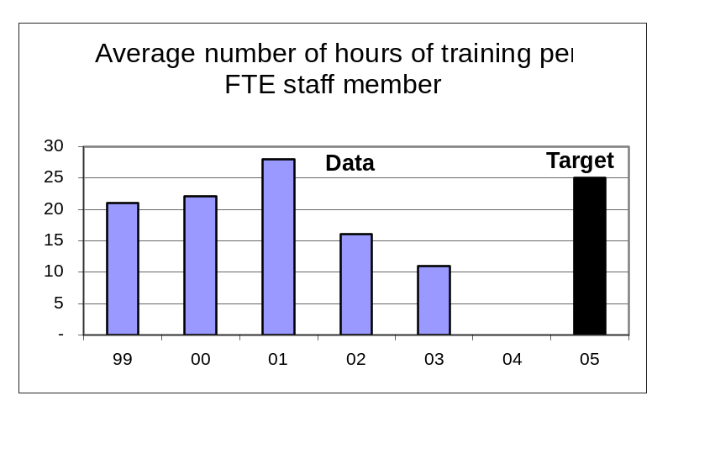
To what goal or goals is this performance measure linked?
Goal: Support staff development, participation, and innovation to achieve continuous quality improvement.

What does the performance measure demonstrate about the goal?
This measure demonstrates resources spent and team focus on team and skill development.
What does the data reveal?
- The data reveals significant reduction in training hours beginning in 2002 and continuing through 2003.
- The down trend in training hours is a result of several factors:
- The end of contracted new employee and team development training.
- A period of re-assessment of training needs and training delivery options.
- Overall discretionary spending was reduced pending legislative budget decisions.
- Training for our higher level technical and consulting staff is available only on a national level and was limited due to out of state travel restrictions and budget uncertainty.
  - Training required to transition the State Library to a team based organization was completed in 2001. A new process for maintaining team development and re-focusing training on technical skills, project management and innovation is being implemented through individual performance reviews and employee training and development plans.
What is an example of a department activity related to the measure?
Delivery of Project Management training to all agency staff along with training in project management web-based software.

What needs to be done as a result of your analysis?
- Implement 360º Performance Review and Training and Development Plan for all staff.
- Utilize new training tracking system to improve data collection.
- Improve accountability for registration and attendance at appropriate technical and professional skill training programs.

What is the data source?
Internal count recorded by Library Administrative Services.
Annual Performance Progress Report
Part II, Key Measure Analysis of Progress

Performance measure with number.
54300-15. Number of FTE below affirmative action parity goal for women, disabled persons, and persons of color. The sum of the numbers of staff FTE below the parity goals in these three categories according to the Department of Administrative Services 6/30 quarterly report.

Data |  |  |  |  |  | Targets
1999 | 2000 | 2001 | 2002 | 2003 | 2004 | 2005
7.5 | 6.9 | 4.7 | 6.0 | 4.2 |  | 4.0

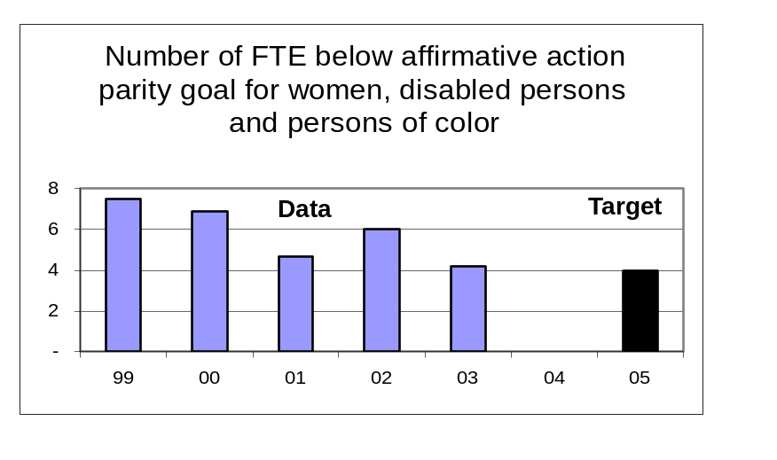To what goal or goals is this performance measure linked?
Goal: Support staff development, participation, and innovation to achieve continuous quality improvement.

What does the performance measure demonstrate about the goal?
This measure demonstrates agency progress in hiring to meet affirmative action parity goals as established by Department of Administrative Services.
What does the data reveal?
- The data indicates that the state library has made steady progress towards achieving parity goals.
- It has continued to be very difficult to recruit qualified minority or disabled applicants for professional librarian positions. Very few persons with disabilities or people of color have in the past graduated with MLS degrees leaving a small target population in the United States to recruit from.
- Recent experience among small state agencies with the current data formulas has shown that the method of establishing parity goals is statistically designed for large agencies and does not provide accurate goals or data for use by smaller agencies. The current system is under review with the goal of improving the usefulness and accuracy of the reports and goals for smaller agencies.
What is an example of a department activity related to the measure?
Extensive recruiting among minority groups for vacant positions at the state library.

What needs to be done as a result of your analysis?
- Participate in the revision of the state Affirmative Action data reporting and parity setting system.
- Work with the Governor’s Office of Affirmative Action to continue improving creative recruitment methods.
- Actively participate in the state-wide task group to develop best practices for training state workers in cultural competence, and implement those practices at the state library.

What is the data source?
Reported to the Library quarterly by DAS HRSD.
Annual Performance Progress Report
Part II, Key Measure Analysis of Progress

Performance measure with number.
54300-16. Number of hours worked by State Library volunteers. The total number of hours worked by all volunteers at the State Library as collected monthly by the Volunteer Coordinator.

Data |  |  |  |  |  | Targets
1999 | 2000 | 2001 | 2002 | 2003 | 2004 | 2005
13,607 | 15,634 | 19,361 | 17,469 | 16,837 |  | 18,000

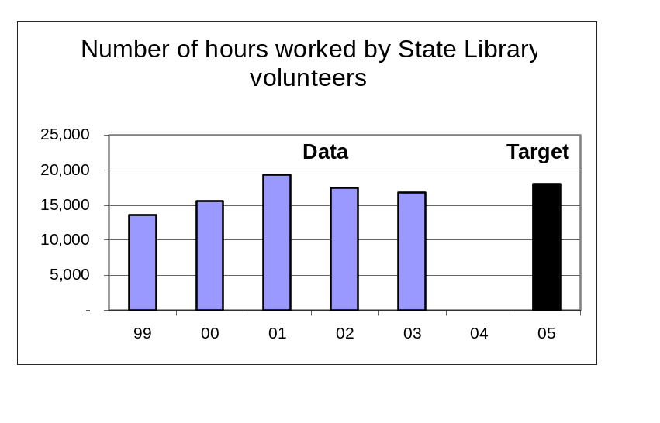To what goal or goals is this performance measure linked?
Goal: Support staff development, participation, and innovation to achieve continuous quality improvement.

What does the performance measure demonstrate about the goal?
This measure demonstrates that the state library relies heavily on volunteers to support staff in providing innovative, quality services.
What does the data reveal?
- Volunteer service is directly influenced by the economic political and social conditions in Oregon at any given time.
- Volunteer hours have declined as the economic recession and related social stresses have continued in Oregon. Many of our volunteers are referred through social programs that have been cut or reduced due to budget reductions.
- As we have improved staff productivity through hiring and innovation, we have implemented a modified volunteer plan to better utilize fewer volunteers. It is important that we reduce our reliance on volunteer time in Talking Book and Braille Services to deliver mandated library services to blind and vision impaired Oregonians.
What is an example of a department activity related to the measure?
- Working with the American Association of Retired People to bring senior citizens to the state library as volunteers for job experience.
What needs to be done as a result of your analysis?
- Implement our revised volunteer recruitment and assignment plan.
- Modify our performance measure to focus on volunteer productivity vs. hours.
What is the data source?
Internal count recorded by Library Administrative Services.

