Annual Performance Progress Report - Executive Summary
Time Period: Fiscal Year 2004 – 2005
Performance Accomplishments
Performance Target Achievement | Number
Total Number of Key Performance Measures (KPMs) | 16
Number of KPMs at target for most current reporting period | 7
Number of KPMs not at target for most current reporting period | 4
Number of KPMs – data not available | 5

The State Library’s Annual Performance Report for 2004-05 reports on 16 performance measures that serve to evaluate the extent to which the agency is advancing toward its long range goals, adopted by the State Library Board of Trustees. These goals were developed to influence three Oregon Benchmarks and four other high level outcomes for improved library services in the state. In 2004-05, six of the 16 measures showed improvement, five did not, and five are not available (see notes on pp. 13, 15, 16, 18, 19 for details). The following table summarizes our performance accomplishments relative to last year:

+4% | Number of research assistance transactions for state employees.
-2% | Percent of state agency customers rating service “very good” or “excellent.”
+20% | Percent of state employees registered to use State Employee Information Center.
+139% | Average number of daily visits to State Employee Information Center.
+6%  +9% | Number of individuals registered to receive Talking Book and Braille Services.
 | Number of talking books and Braille books checked out per year.
Not available | Percentage of Talking Book and Braille Services customers rating service “very good” or “excellent.”
-31% | Total donations to Talking Book and Braille Services.
Not available | Percentage increase [rate of growth] in local library services to children.
Not available | Percentage increase [rate of growth] in interlibrary lending.
+321% | Average daily visits to the search engine for Oregon.gov.
Not available | Number of public libraries making improvements to achieve OBM #38 minimum service criteria.
Not available | Number of schools making improvements to achieve Oregon Quality Education standards for school libraries.
-7% | Average number of hours of training per FTE staff member.
+8% | Number of FTE below affirmative action parity goal for women, disabled persons, and persons of color.
-14% | Number of hours worked by State Library volunteers.

Degree and Type of Agency Influence on Their Chosen Benchmarks and High-Level Outcomes

The following table summarizes the extent to which the State Library was able to influence Oregon Benchmarks and other high-level outcomes in 2004-05:

Oregon Benchmark or Other High-Level Outcome | State Library Influence in 2004-05
OBM #38 Percent of Oregonians served by a public library that meets minimum service criteria. | As of the date of this report, data for 2004-05 was still being collected from local public libraries. We plan to be able to make this analysis by January 1, 2006.
OBM #18 Percent of Oregon children entering school ready-to-learn. | As of the date of this report, data for 2004-05 was still being collected from local public libraries. We plan to be able to make this analysis by January 1, 2006.
OBM #19/20 Percent of third/eighth graders who achieve established skill levels: a. reading | As of the date of this report, data for 2004-05 was still being collected from local public libraries. We plan to be able to make this analysis by January 1, 2006.

HLO a. Percent of Oregon state government employees who use information provided by the State Library for planning, decision-making, and service delivery. | More state government employees are turning to the State Library to meet their high-level information needs, as evidenced by increases in research assistance transactions (+4%) and use of the State Employee Information Center website (+20%).
HLO b. Percent of Oregonians with print-related disabilities who have the same access to reading materials as other Oregonians. | Registration to use the Library’s Talking Book and Braille Services increased (+6%), as did book circulation (+9%), maintaining a trend in the past several years.
HLO c. Percent of Oregonians who are able to access information from any Oregon library. | As of the date of this report, data for 2004-05 was still being collected from local public and academic libraries. We plan to be able to make this analysis by January 1, 2006.
HLO d. Percent of Oregon students who are served by a school library that meets Oregon Quality Education Model standards. | This is a new HLO. The State Library has developed baseline data, for the 2002-03 school year, in cooperation with the Oregon Department of Education.

Future Challenges

In order to meet the State Library Board’s long range goals and positively influence the Oregon Benchmarks and other high-level outcomes, the following challenges will have to be met:

- How to continue to provide more information services to state agency employees during a period of limited resources?

- How to effectively market the information services of the State Library to state agency employees so that they take advantage of the services that are available?

- How to ensure permanent public access to state agency publications and information when many publications are no longer printed?

- How to reach and serve the increasing number of blind and print-disabled Oregonians with Talking Book and Braille Services?

- How to continue to effectively leverage local public library efforts to improve library services to children, especially preschool children from low-income families?

- How to more effectively leverage local efforts to provide adequate public library services for every Oregonian?

- How to reverse the trend of disinvestment in public school library services in the state and begin to build back quality school libraries in every school?

- How to increase cooperation among all types of libraries and begin to make progress on developing a statewide library catalog that makes library materials from every library accessible to every Oregonian?
Annual Performance Progress Report - Part I, Managing for Results
Time Period: Fiscal Year 2004 – 2005
Agency: State Library | Date Submitted: September 30, 2005 | Version No.:
Contact: Jim Scheppke | Phone: 503-378-4367
Alternate: Keith Adams | Phone: 503-378-4243

Agency Name: State Library |  | Agency No.: 54300

The following questions shed light on how well performance measures and performance data are leveraged within your agency for process improvement and results-based management.
- How were staff and stakeholders involved in the development of the agency’s performance measures? | The State Library’s performance measures were developed by the State Library Board Budget Committee in 2002. The Budget Committee consisted of three board members, five managers and two classified staff. In addition, feedback from all of the teams at the library was solicited. The measures were disseminated to stakeholders as part of the 2003-05 Agency Request Budget and adopted in a public meeting in June, 2002.
- How are performance measures used for management of the agency? | Most of the measures are collected and reported quarterly and reviewed in a Management Team meeting and by all staff at Team Meetings. They are then reported and discussed with the State Library Board at bi-monthly State Library Board meetings.
- What training has staff had in the use performance measurement? | All of the managers at the state library have had some training in the use of performance measurement. Some of the staff have had training. The State Library will look for opportunities for agency-wide training on effective use of performance measurement.
- How does the agency communicate performance results and for what purpose? (Please include your agency’s URL for Performance Measures and this Annual Report) | The Annual Performance Report will be posted to the State Library website:  http://oregon.gov/OSL/  The posting will be announced to library stakeholders through library newsletters for the purpose of informing stakeholders about our performance.
- What important changes have occurred in the past year? | - HB 2118 passed the Legislative Assembly, creating a digital state documents repository and reducing the requirement for the deposit of printed copies of state documents with the State Library.  - HB 2674 passed, which allows libraries operated by the nine federally-recognized tribes to benefit from State Library resource sharing programs.  - HB 2916 passed, which repeals the statutory requirement that public libraries maintain local support to qualify for Ready to Read Grants.  - HB 5115 passed, which appropriates $14.2 million for the State Library’s operations in the 2005-07 biennium and supports the continuation of all State Library programs.
Annual Performance Report- Part II, Key Measure Analysis
Time Period: Fiscal Year 2004 – 2005

Agency Name: State Library |  |  |  |  | Agency No.: 54300
Key Performance Measure (KPM) |  | 1999 | 2000 | 2001 |  | 2002 | 2003 | 2004 | 2005 | 2006 |  | 2007
# 54300-1. Number of research assistance transactions for state employees. | Target |  |  |  |  |  |  |  | 13,500
 | Data | 15,414 | 11,573 | 14,209 |  | 12,831 | 11,018 | 14,948 | 15,559
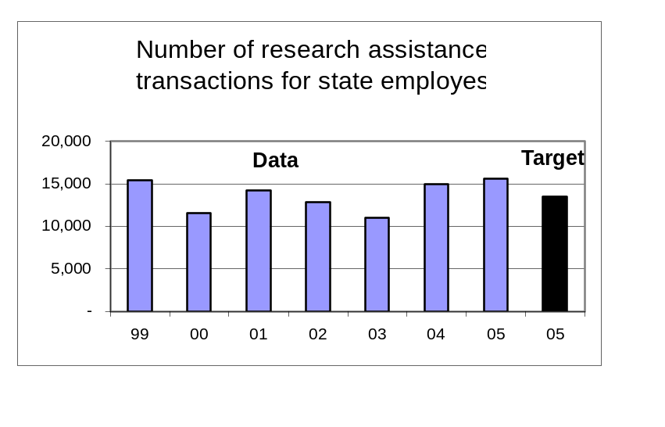Data Source: Internal count recorded by Library staff compiled quarterly.
Key Performance Measure Analysis

To what goal(s) is this performance measure linked?
Goal: Improve library services to state government; increase usage and user satisfaction.

What do benchmark (or other high-level outcome) data say about Oregon relative to the goal(s)? What is the impact of your agency?
More state government employees are turning to the State Library to meet their high-level information needs.

How does the performance measure demonstrate agency progress toward the goal?
The data shows a 4% increase in information transactions.

Compare actual performance to target and explain any variance.
The target was exceeded by 15%. This is attributed to improved information products, more effective marketing and training of state agency customers, and improved tracking of research assistance transactions using a new automated tracking system.

Summarize how actual performance compares to any relevant public or private industry standards.
There are no standards for research assistance transactions for state employees from state library agencies.

What is an example of a department activity related to the measure?
In 2004-05, library staff made 77 presentations throughout the state to increase the awareness of state employees about the information services that the Library can provide. This was more than double the number of presentations made in 2003-04.

What needs to be done as a result of this analysis?
Our State Employee Information Center website is now accessible from the new Govnet intranet for state agencies. As more agencies utilize Govnet as their agency intranet, and as more state employees find value in what Govnet has to offer, we hope to further increase the visibility of Library services
Annual Performance Report- Part II, Key Measure Analysis
Time Period: Fiscal Year 2004 – 2005

Agency Name: State Library |  |  |  |  | Agency No.: 54300
Key Performance Measure (KPM) |  | 1999 | 2000 | 2001 |  | 2002 | 2003 | 2004 | 2005 | 2006 |  | 2007
# 54300-2. Percent of state agency customers rating service “very good” or “excellent.” | Target |  |  |  |  |  |  |  | 80%
 | Data | 74% |  | 85% |  | 88% | 89% |  | 87%
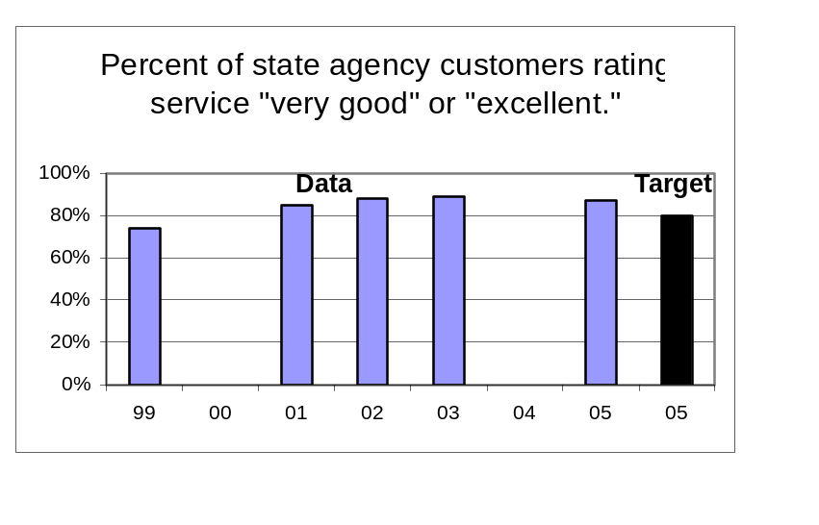Data Source: Annual customer satisfaction survey conducted by Library staff.

Key Performance Measure Analysis

To what goal(s) is this performance measure linked?
Goal: Improve library services to state government; increase usage and user satisfaction.

What do benchmark (or other high-level outcome) data say about Oregon relative to the goal(s)? What is the impact of your agency?
More state government employees are turning to the State Library to meet their high-level information needs, and are satisfied with the service they receive.

How does the performance measure demonstrate agency progress toward the goal?
The 2005 survey shows a 2% decrease in customers giving high marks to State Library services.

Compare actual performance to target and explain any variance.
The target was exceeded by 10%. We anticipated that satisfaction would drop as we continue to serve more state employees, but this has not happened to a significant extent.

Summarize how actual performance compares to any relevant public or private industry standards.
There are no standards for customer satisfaction with state library information service to state government employees.

What is an example of a department activity related to the measure?
The State Library’s State Employee Information Center website (library.state.or.us) has been totally redesigned to conform to match the look and feel of the Govnet intranet system and to be easier to navigate and find needed information resources.

What needs to be done as a result of this analysis?
We will attempt to continue to maintain the high quality of our customer service as we continue to try to serve more state employees with new and improved services.
Annual Performance Report- Part II, Key Measure Analysis
Time Period: Fiscal Year 2004 – 2005

Agency Name: State Library |  |  |  |  | Agency No.: 54300
Key Performance Measure (KPM) |  | 1999 | 2000 | 2001 |  | 2002 | 2003 | 2004 | 2005 | 2006 |  | 2007
#54300-3. Percent of state employees registered to use State Employee Information Center | Target |  |  |  |  |  |  |  | 20%
 | Data | 8% | 9% | 12% |  | 14% | 15% | 15% | 18%
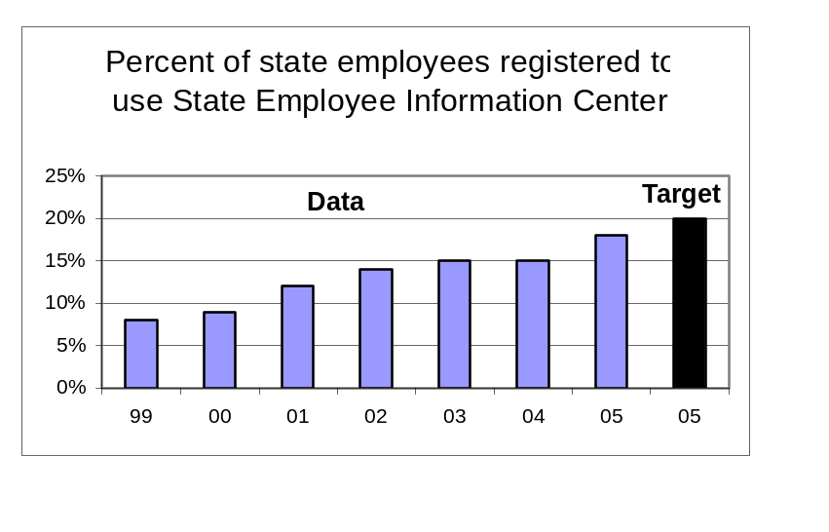Data Source: Internal count recorded by Library staff divided by an adjusted count of state employees obtained from DAS HRSD; calculated quarterly.

Key Performance Measure Analysis

To what goal(s) is this performance measure linked?
Goal: Improve library services to state government; increase usage and user satisfaction.

What do benchmark (or other high-level outcome) data say about Oregon relative to the goal(s)? What is the impact of your agency?
We were able to increase the percentage of state employees registered by 20% in the past year, after several years of flat performance.

How does the performance measure demonstrate agency progress toward the goal?
We undertook more aggressive marketing of our services in 2004-05 and our efforts paid off.

Compare actual performance to target and explain any variance.
Despite the increase, we still failed to meet the biennial target by 2%. We need to continue to develop new and improved services that will be of value to more state employees.

Summarize how actual performance compares to any relevant public or private industry standards.
There are no standards for the percentage of state employees registered to use an advanced Web-based information system at a state library agency.

What is an example of a department activity related to the measure?
In the past year we have conducted 77 marketing and training sessions for state agency employees, including the popular “Desktop Learning” trainings that instruct agency employees on how to use the State Employee Information Center and other State Library services.

What needs to be done as a result of this analysis?
As more agencies begin to use the new Govnet intranet system, and as more state employees use Govnet frequently to access needed information from their agency or the Department of Administrative Services, we believe our prominent presence as a tab in Govnet will lead to increased use of our website.

Annual Performance Report- Part II, Key Measure Analysis
Time Period: Fiscal Year 2004 – 2005

Agency Name: State Library |  |  |  |  | Agency No.: 54300
Key Performance Measure (KPM) |  | 1999 | 2000 | 2001 |  | 2002 | 2003 | 2004 | 2005 | 2006 |  | 2007
#54300-4. Average number of daily visits to State Employee Information Center | Target |  |  |  |  |  |  |  | 400
 | Data |  |  |  |  | 200 | 180 | 316 | 754
Data Source: Counted by SmartORgov system software.
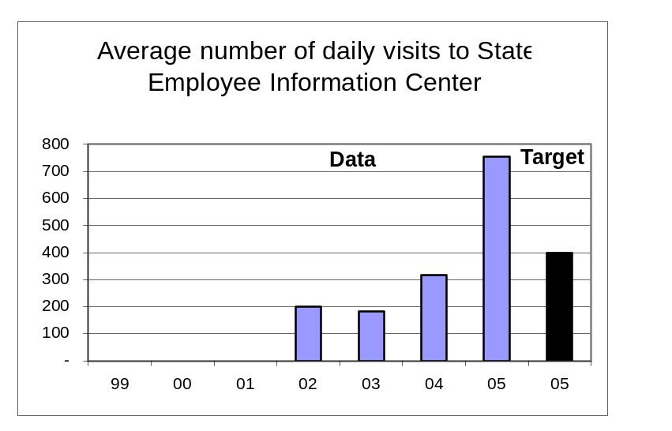

Key Performance Measure Analysis

To what goal(s) is this performance measure linked?
Goal: Improve library services to state government; increase usage and user satisfaction.

What do benchmark (or other high-level outcome) data say about Oregon relative to the goal(s)? What is the impact of your agency?
We saw a big increase in the use of our website this year that we attribute to a redesign and increased promotion and training.

How does the performance measure demonstrate agency progress toward the goal?
Use of the State Employee Information Center more than doubled from the previous year.

Compare actual performance to target and explain any variance.
The target was exceeded by 89%. The popularity of our website with state employees has exceeded our expectations.

Summarize how actual performance compares to any relevant public or private industry standards.
There are no standards for the average number of daily visits to an advanced Web-based information system at a state library agency.

What is an example of a department activity related to the measure?
The State Employee Information System now has a new name, a new, more simple URL, a better look and feel and is easier to navigate than our old website.

What needs to be done as a result of this analysis?
We need to continue to aggressively promote the use of the State Employee Information Center and train select groups of state employees throughout the state to access its rich information resources.
Annual Performance Report- Part II, Key Measure Analysis
Time Period: Fiscal Year 2004 – 2005

Agency Name: State Library |  |  |  |  | Agency No.: 54300
Key Performance Measure (KPM) |  | 1999 | 2000 | 2001 |  | 2002 | 2003 | 2004 | 2005 | 2006 |  | 2007
#54300-5. Number of individuals registered to receive Talking Book and Braille Services | Target |  |  |  |  |  |  |  | 7,000
 | Data | 6,978 | 6,588 | 6,574 |  | 6,328 | 6,174 | 6,726 | 7,156
Data Source: Internal count recorded by Talking Book and Braille Services staff; calculated quarterly.
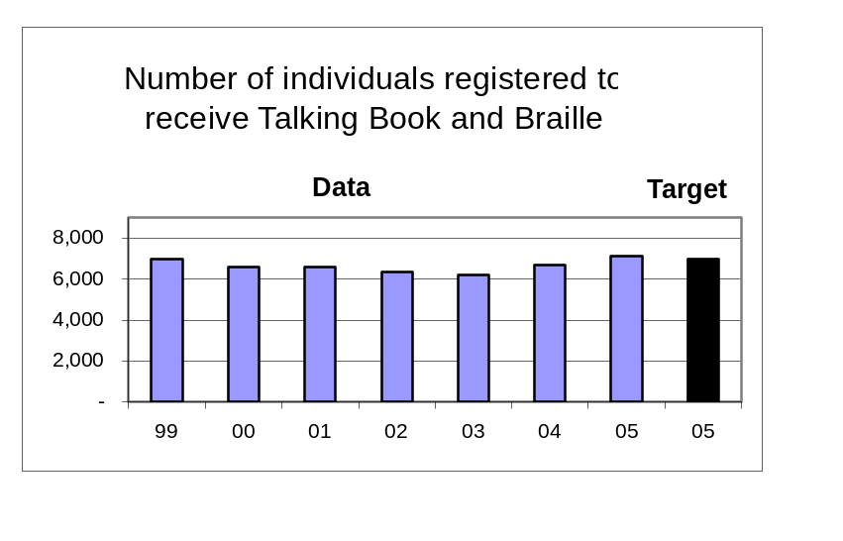

Key Performance Measure Analysis
To what goal(s) is this performance measure linked?
Goal: Improve, adapt, and market talking book and Braille services to a growing user population.

What do benchmark (or other high-level outcome) data say about Oregon relative to the goal(s)? What is the impact of your agency?
This year we continued to see more print-disabled Oregonians take advantage of Talking Book and Braille Services.

How does the performance measure demonstrate agency progress toward the goal?
The performance measure is a 6% increase over the prior year. Some of the increase may be aberrant, because we installed a new automated circulation in early 2004 that may track registrations somewhat differently. Also, because of staff shortages, we have not kept up with purging our registration files of inactive users.

Compare actual performance to target and explain any variance.
The number indicates we exceeded the target, but because of the reasons cited above, we cannot claim this with certainty.

Summarize how actual performance compares to any relevant public or private industry standards.
There are no standards for this performance measure. A 2002 study showed that Talking Book and Braille Services served 13% of the eligible population in Oregon as compared to an average of 12% for seven comparable state programs (AZ, CO, IA, MN, OR, WA, WI).

What is an example of a department activity related to the measure?
Since the beginning of 2005, we are collaborating with four other state libraries for the blind on a pilot project to test the popularity of downloadable audiobooks. We think it important to begin to experiment with new book formats beyond cassettes and Braille to maintain our customer base.
What needs to be done as a result of this analysis?
TBABS needs to promote its services to a targeted market with the aid of a long-range plan, paid advertising, and services that appeal to potential users, such as digital talking books.
Annual Performance Report- Part II, Key Measure Analysis
Time Period: Fiscal Year 2004 – 2005

Agency Name: State Library |  |  |  |  | Agency No.: 54300
Key Performance Measure (KPM) |  | 1999 | 2000 | 2001 |  | 2002 | 2003 | 2004 | 2005 | 2006 |  | 2007
#54300-6. Number of talking books and Braille books checked out per year. | Target |  |  |  |  |  |  |  | 375,000
 | Data | 368,465 | 369,234 | 358,827 |  | 348,224 | 345,833 | 354,410 | 387,644
Data Source: Counted by the Talking Book and Braille Services check-out system software.
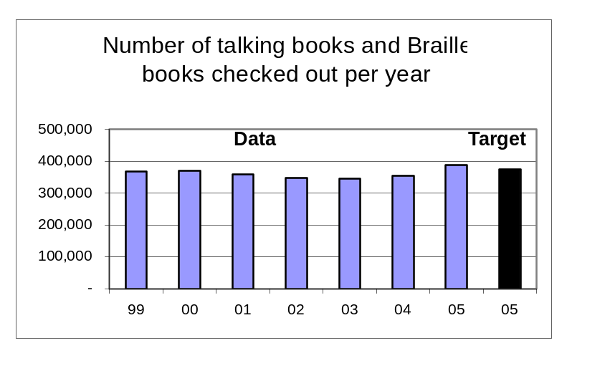

Key Performance Measure Analysis

To what goal(s) is this performance measure linked?
Goal: Improve, adapt, and market talking book and Braille services to a growing user population.

What do benchmark (or other high-level outcome) data say about Oregon relative to the goal(s)? What is the impact of your agency?
More print-disabled Oregonians are taking advantage of Talking Book and Braille Services.

How does the performance measure demonstrate agency progress toward the goal?
The 9.4% increase in check-outs in 2004-05 can be attributed to some successful marketing efforts and to the fact that the staff is very productive and highly motivated to provide excellent services to our customers.

Compare actual performance to target and explain any variance.
The target was exceeded by 3.4% which we attribute to the reasons cited above.

Summarize how actual performance compares to any relevant public or private industry standards.
There are no standards for this performance measure. A 2002 study showed that Talking Book and Braille Services had the highest annual checkouts per registered borrower (53) of seven comparable state programs (AZ, CO, IA, MN, OR, WA, WI).

What is an example of a department activity related to the measure?
In early 2004 we installed a new automated check-out and catalog system purchased entirely with funds donated to Talking Book and Braille Services, mostly by customers. This has helped our staff become more productive and help maintain an accurate count of checkouts, something that was occasionally a problem in the past.
What needs to be done as a result of this analysis?
Work on personalizing book services to customers through reader account customization and contact customers who have not been active users. Hire a marketing firm using donation funds to begin a marketing campaign to recruit new customers. Continue to promote downloadable audiobooks, particularly to younger readers.

Annual Performance Report- Part II, Key Measure Analysis
Time Period: Fiscal Year 2004 – 2005

Agency Name: State Library |  |  |  |  | Agency No.: 54300
Key Performance Measure (KPM) |  | 1999 | 2000 | 2001 |  | 2002 | 2003 | 2004 | 2005 | 2006 |  | 2007
#54300-7. Percent of Talking Book and Braille services customers rating service “very good” or "excellent” | Target |  |  |  |  |  |  |  | 92%
 | Data |  | 92% |  |  |  | 93% |  | 99.7%*
Data Source: Biennial customer satisfaction survey conducted by Talking Book and Braille Services staff.
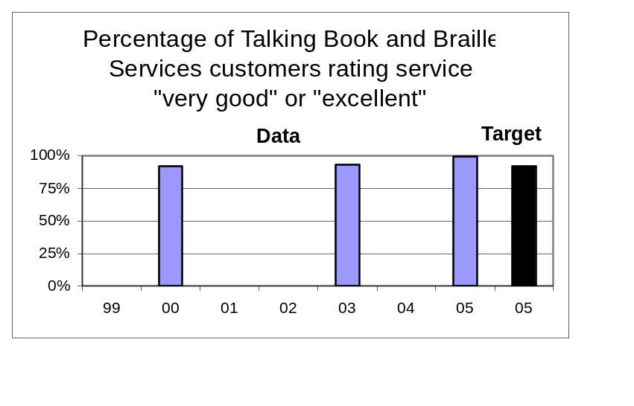*NOTE: The FY 2005 customer satisfaction survey used a draft Oregon Progress Board methodology that used new different rating scale with different terminology. The 99.7% figure represents customers who rated Talking Book and Braille Services “above average” or “excellent.” This result should not be compared to earlier results or the target.

Key Performance Measure Analysis
To what goal(s) is this performance measure linked?
Goal: Improve, adapt, and market talking book and Braille services to a growing user population.

What do benchmark (or other high-level outcome) data say about Oregon relative to the goal(s)? What is the impact of your agency?
Talking Book and Braille Services has maintained the high satisfaction rating by its customers.

How does the performance measure demonstrate agency progress toward the goal?
The 2005 result is not comparable to earlier surveys (see note above).

Compare actual performance to target and explain any variance.
The 2005 result is not comparable to the target (see note above).

Summarize how actual performance compares to any relevant public or private industry standards.
There are no standards for this performance measure.

What is an example of a department activity related to the measure?
We strive to maintain a 24 hour turnaround on book orders and we inspect every cassette book that is returned to insure that they are rewound and not damaged.

What needs to be done as a result of this analysis?
As our registration and circulation grows we will need to continue to increase staff productivity in order to maintain this high level of customer service.

Annual Performance Report- Part II, Key Measure Analysis
Time Period: Fiscal Year 2004 – 2005

Agency Name: State Library |  |  |  |  | Agency No.: 54300
Key Performance Measure (KPM) |  | 1999 | 2000 | 2001 |  | 2002 | 2003 | 2004 | 2005 | 2006 |  | 2007
#54300-8. Total donations to Talking Book and Braille Services. | Target |  |  |  |  |  |  |  | $95,000
 | Data | $68,225 | $102,016 | $138,309 |  | $77,609 | $119,777 | $168,287 | $115,672
Data Source: Internal accounting by the State Library Business Office.
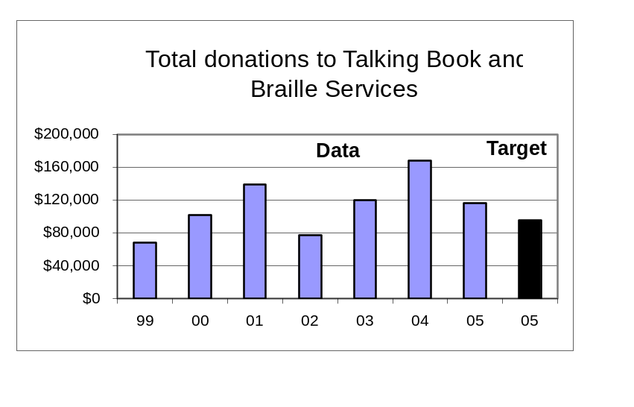
Key Performance Measure Analysis
To what goal(s) is this performance measure linked?
Goal: Improve, adapt, and market talking book and Braille services to a growing user population.

What do benchmark (or other high-level outcome) data say about Oregon relative to the goal(s)? What is the impact of your agency?
With continued support for our fund development efforts such as we saw in 2005 we will have a better chance of reaching our goal of serving more eligible Oregonians with Talking Book and Braille Services.

How does the performance measure demonstrate agency progress toward the goal?
Total donations were down compared to recent years, mostly because we only received $5,700 in bequests as compared to $50,358 last year.
Compare actual performance to target and explain any variance.
We exceeded our target by 22%.

Summarize how actual performance compares to any relevant public or private industry standards.
There are no standards for this performance measure.

What is an example of a department activity related to the measure?
We conduct two annual solicitations and also encourage memorial gifts and planned giving.
What needs to be done as a result of this analysis?
Increase giving through refinement of direct mail solicitation, with greater focus on individual/major gifts and increased planned giving marketing.

Annual Performance Report- Part II, Key Measure Analysis
Time Period: Fiscal Year 2004 – 2005

Agency Name: State Library |  |  |  |  | Agency No.: 54300
Key Performance Measure (KPM) |  | 1999 | 2000 | 2001 |  | 2002 | 2003 | 2004 | 2005 | 2006 |  | 2007
#54300-9. Percentage increase in local public library services to children. | Target |  |  |  |  |  |  |  | 10%
 | Data | 0% | 10% | 9% |  | 6% | 8% | 9% | *
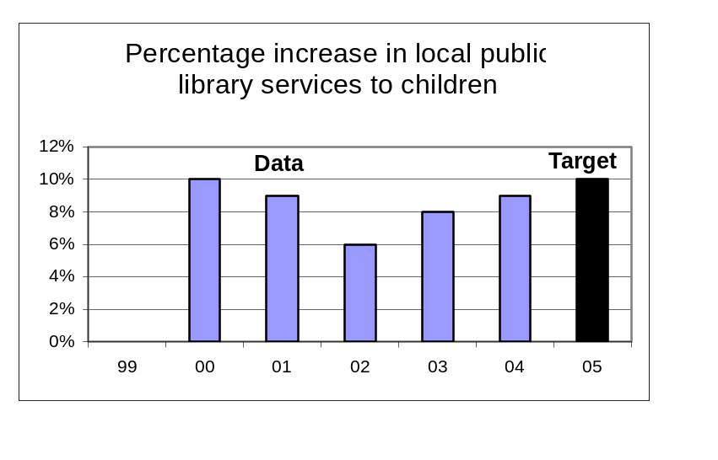Data Source: Internal accounting by the State Library Business Office.

*NOTE: Libraries are reporting their data for 2004-05. We will use the data to compute the performance measure by January 1, 2006.

Key Performance Measure Analysis

To what goal(s) is this performance measure linked?
Goal: Lead public libraries to achieve excellence in services to children.

What do benchmark (or other high-level outcome) data say about Oregon relative to the goal(s)? What is the impact of your agency?
Oregon public libraries were able to increase growth in library services to children (book check-outs and program participation) in 2002-03 from 6% to 8%. Research shows this will impact the percentage of Oregon children entering school ready-to-learn.

How does the performance measure demonstrate agency progress toward the goal?
State funds provided by the State Library through the Ready to Read Grant program continue to leverage strong commitment and effort in local libraries that result in increased services to children.
Compare actual performance to target and explain any variance.
[See note above.]

Summarize how actual performance compares to any relevant public or private industry standards.
There are no standards for this performance measure.

What is an example of a department activity related to the measure?
The State Library made 124 Ready to Read Grants to local public libraries in 2004-05 totaling $597,310. The Multnomah County Library is leading a statewide planning effort in 2005 to improve the contribution that public libraries make to early childhood development in the state, funded with a grant from the State Library.
What needs to be done as a result of this analysis?
The results of this planning effort should be considered in planning for the future of the grant program.
Annual Performance Report- Part II, Key Measure Analysis
Time Period: Fiscal Year 2004 – 2005

Agency Name: State Library |  |  |  |  | Agency No.: 54300
Key Performance Measure (KPM) |  | 1999 | 2000 | 2001 |  | 2002 | 2003 | 2004 | 2005 | 2006 |  | 2007
#54300-10. Percentage increase in interlibrary lending. | Target |  |  |  |  |  |  |  | 15%
#54300-10. Percentage increase in interlibrary lending. | Data | -1% | 28% | 19% |  | 19% | 13% | 8% | *
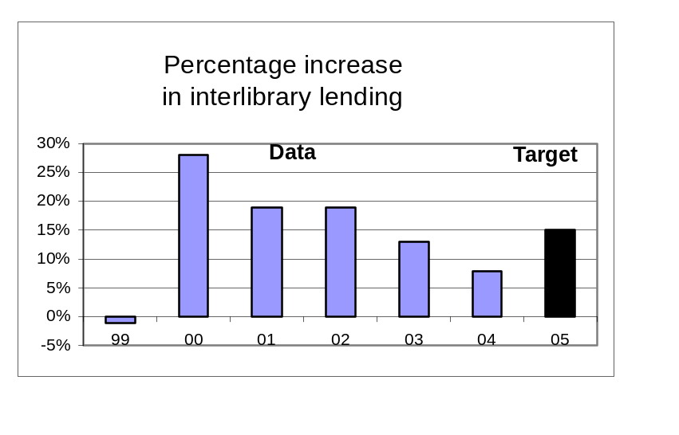Data Source: Derived from annual survey conducted by State Library staff of all public and academic libraries.

*NOTE: Libraries are reporting their data for 2004-05. We will use the data to compute the performance measure by January 1, 2006.

Key Performance Measure Analysis

To what goal(s) is this performance measure linked?
Goal: Take a leadership role in developing a comprehensive statewide library resource sharing network, including improved citizen access to government information.
What do benchmark (or other high-level outcome) data say about Oregon relative to the goal(s)? What is the impact of your agency?
The State Library is impacting the percentage of Oregonians who are able to access information from any Oregon library through grant support for various library resource sharing projects

How does the performance measure demonstrate agency progress toward the goal?
The growth in interlibrary lending that we saw several years ago is moderating. In 2000 and 2001 there was rapid growth in library consortia like the Orbis academic library consortium and the Southern Oregon Library Information System.

Compare actual performance to target and explain any variance.
The State Library Board did not set a target for 2004, but the Library is on track to meet the goal for 2005.

Summarize how actual performance compares to any relevant public or private industry standards.
There are no standards for this performance measure.

What is an example of a department activity related to the measure?
A grant was made to the Pioneer Library System to help them develop affordable courier delivery service throughout Eastern Oregon, and to the Jefferson County Library to establish a new regional library resource sharing system with the Deschutes Public Library and Confederated Tribes of Warm Springs
What needs to be done as a result of this analysis? Continue to look for opportunities to provide grant support to improve the ability of libraries to share resources.
Annual Performance Report- Part II, Key Measure Analysis
Time Period: Fiscal Year 2004 – 2005

Agency Name: State Library |  |  |  |  | Agency No.: 54300
Key Performance Measure (KPM) |  | 1999 | 2000 | 2001 |  | 2002 | 2003 | 2004 | 2005 | 2006 |  | 2007
#54300-11. Average daily visits to the search engine for Oregon.gov. | Target |  |  |  |  |  |  |  | 2,220
 | Data |  |  |  |  | 568 | 1,745 | 1,185 | 4,983
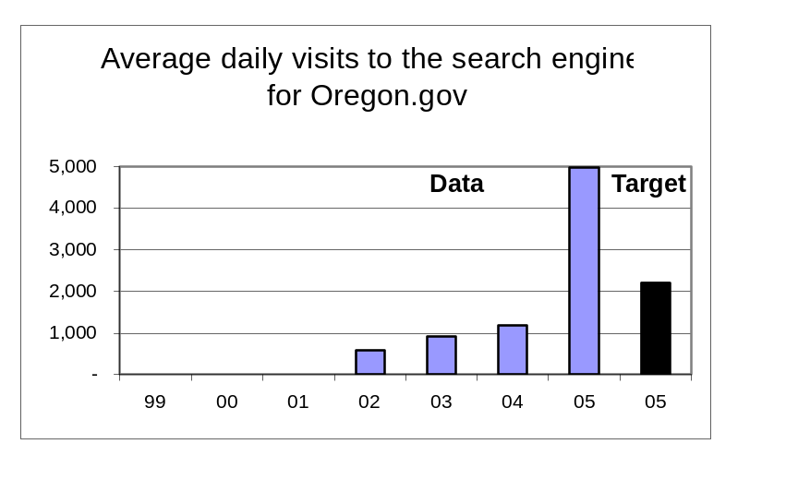Data Source: Counted by FindOR system software.

Key Performance Measure Analysis

To what goal(s) is this performance measure linked?
Goal: Take a leadership role in developing a comprehensive statewide library resource sharing network, including improved citizen access to government information.
What do benchmark (or other high-level outcome) data say about Oregon relative to the goal(s)? What is the impact of your agency?
The State Library is improving the ability of Oregonians to access information about state government on Oregon.gov.

How does the performance measure demonstrate agency progress toward the goal?
The average daily use of the search engine more than quadrupled in 2004-05 which means that many more Oregonians are using it to access government information.

Compare actual performance to target and explain any variance.
The target was exceeded by 124%.

Summarize how actual performance compares to any relevant public or private industry standards.
There are no standards for this performance measure.

What is an example of a department activity related to the measure?
Library staff regularly check the log of searches to see if users are finding what they are looking for, and changes are made to metatags to improve results for users.

What needs to be done as a result of this analysis?
Continue working with agencies to improve search engine performance to make it the most efficient way to access information on Oregon.gov.

Annual Performance Report- Part II, Key Measure Analysis
Time Period: Fiscal Year 2004 – 2005

Agency Name: State Library |  |  |  |  | Agency No.: 54300
Key Performance Measure (KPM) |  | 1999 | 2000 | 2001 |  | 2002 | 2003 | 2004 | 2005 | 2006 |  | 2007
#54300-12. Number of public libraries making improvements to achieve OBM #38 minimum service criteria. | Target |  |  |  |  |  |  |  | 3
 | Data | 4 | 10 | 10 |  | 2 | 1 | 3 | *
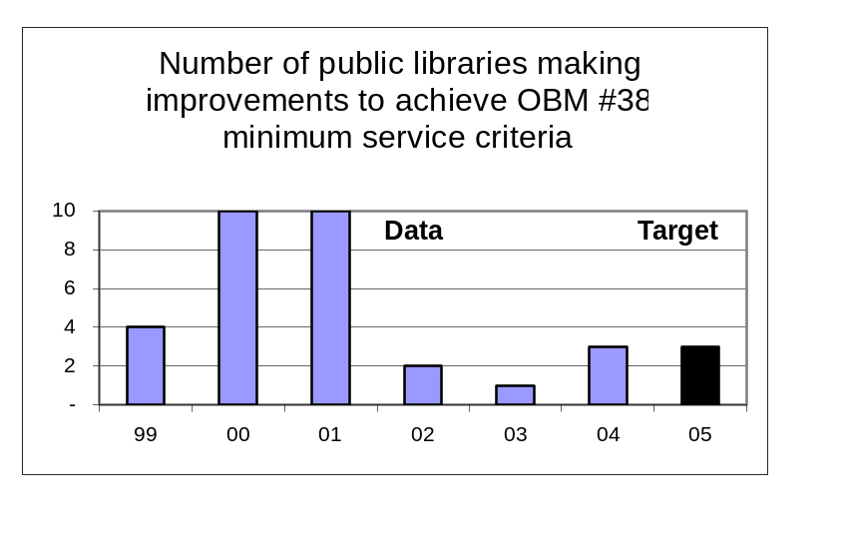Data Source: Derived from annual survey conducted by the State Library of all Oregon public libraries.

*NOTE: Libraries are reporting their data for 2004-05. We will use the data to compute the performance measure by January 1, 2006.

Key Performance Measure Analysis

To what goal(s) is this performance measure linked?
Goal: Assist local communities to develop school and public library services for unserved and underserved Oregonians.
What do benchmark (or other high-level outcome) data say about Oregon relative to the goal(s)? What is the impact of your agency?
The State Library was unable to have much impact on the percent of Oregonians served by a public library that meets minimum service criteria in 2003.

How does the performance measure demonstrate agency progress toward the goal?
In 2000 and 2001 the State Library offered incentive grants to public libraries not meeting the minimum standards. But most libraries could not sustain the improvements when the grant funds ran out, so the strategy was changed to support grassroots organizations working for sustainable improvement.
Compare actual performance to target and explain any variance.
The State Library Board did not set a target for 2004. We are still hoping to meet our biennial goal for 2005.

Summarize how actual performance compares to any relevant public or private industry standards.
There are no standards for this performance measure.

What is an example of a department activity related to the measure?
In recent years we have funded the Lane Library League, the Linn Library League and other grassroots organizations and efforts to plan for permanent and sustainable improvement in local library services, usually involving the creation of a library taxing district. We expect to see these efforts achieve results beginning in 2005.
What needs to be done as a result of this analysis?
Continue with the current strategy of making federal Library Services and Technology Act Grants and providing other assistance to grassroots organizations working to improve libraries.
Annual Performance Report- Part II, Key Measure Analysis
Time Period: Fiscal Year 2004 – 2005

Agency Name: State Library |  |  |  |  | Agency No.: 54300
Key Performance Measure (KPM) |  | 1999 | 2000 | 2001 |  | 2002 | 2003 | 2004 | 2005 | 2006 |  | 2007
#54300-13. Number of schools making improvements to achieve Oregon Quality Education Model standards for school libraries. | Target |  |  |  |  |  |  |  | 10
 | Data
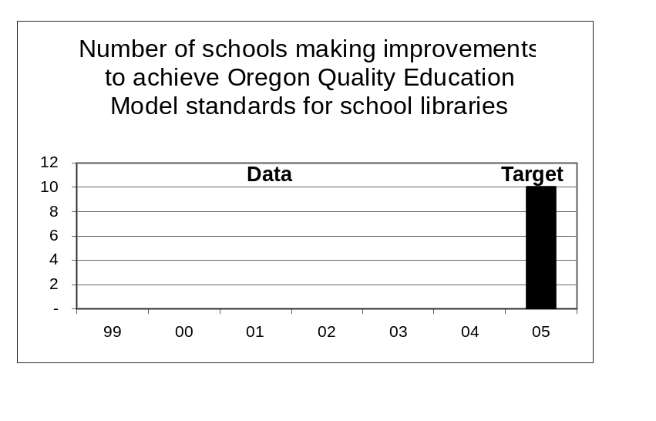Data Source: Derived from annual data collection from school districts conducted by the Oregon Department of Education.

Key Performance Measure Analysis

To what goal(s) is this performance measure linked?
Goal: Assist local communities to develop school and public library services for unserved and underserved Oregonians.
What do benchmark (or other high-level outcome) data say about Oregon relative to the goal(s)? What is the impact of your agency?
[New]
Performance measure is still in development.
How does the performance measure demonstrate agency progress toward the goal?
We cannot assess agency progress at this time.
Compare actual performance to target and explain any variance.
We cannot assess agency progress at this time.

Summarize how actual performance compares to any relevant public or private industry standards.
There are no standards for this performance measure.

What is an example of a department activity related to the measure?
The State Library conducted the baseline analysis of the number of schools meeting QEM standards for school libraries in 2002-03 using data from the Oregon Department of Education. The analysis showed that only two schools in the state met the QEM standards in 2002-03
What needs to be done as a result of this analysis?
We are planning to analyze data for 2003-04 school year in the second quarter of 2005-06.

. Annual Performance Report- Part II, Key Measure Analysis
Time Period: Fiscal Year 2004 – 2005

Agency Name: State Library |  |  |  |  | Agency No.: 54300
Key Performance Measure (KPM) |  | 1999 | 2000 | 2001 |  | 2002 | 2003 | 2004 | 2005 | 2006 |  | 2007
#54300-14. Average number of hours of training per FTE staff member. | Target |  |  |  |  |  |  |  | 25
 | Data | 21 | 22 | 28 |  | 16 | 11 | 29 | 27
Data Source: Internal count recorded by Library Administrative Services.
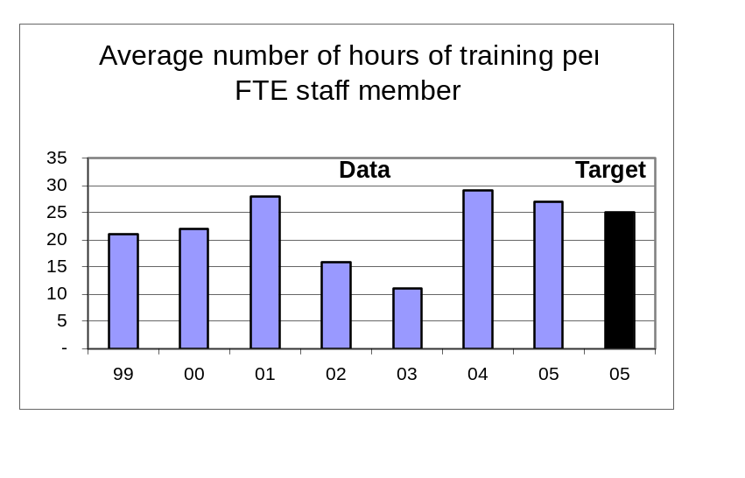

Key Performance Measure Analysis

To what goal(s) is this performance measure linked?
Goal: Support staff development, participation, and innovation to achieve continuous quality improvement.
What do benchmark (or other high-level outcome) data say about Oregon relative to the goal(s)? What is the impact of your agency?
This is an internal organizational development goal that does not directly impact a benchmark or high level outcome.
How does the performance measure demonstrate agency progress toward the goal?
The data reveals a significant increase in training hours beginning in 2003 and continuing through 2005. The increase is the result of several factors, including implementation of a new performance review and developmental planning process, increased attention to job-related training opportunities.
Compare actual performance to target and explain any variance.
The target was exceeded.

Summarize how actual performance compares to any relevant public or private industry standards.
There are no standards for this performance measure.

What is an example of a department activity related to the measure?
We completed current training and development plans for all employees and made improvements to the system we use to track training hours
What needs to be done as a result of this analysis?
We need to continue the use of training plans and quarterly training reports to teams. We also need to offer additional in-house training on team development and cultural competency.
Annual Performance Report- Part II, Key Measure Analysis
Time Period: Fiscal Year 2004 – 2005

Agency Name: State Library |  |  |  |  | Agency No.: 54300
Key Performance Measure (KPM) |  | 1999 | 2000 | 2001 |  | 2002 | 2003 | 2004 | 2005 | 2006 |  | 2007
#54300-15. Number of FTE below affirmative action parity goal for women, disabled persons, and persons of color. | Target |  |  |  |  |  |  |  | 4.0
 | Data | 7.5 | 6.9 | 4.7 |  | 6.0 | 4.2 | 5.1 | 5.5
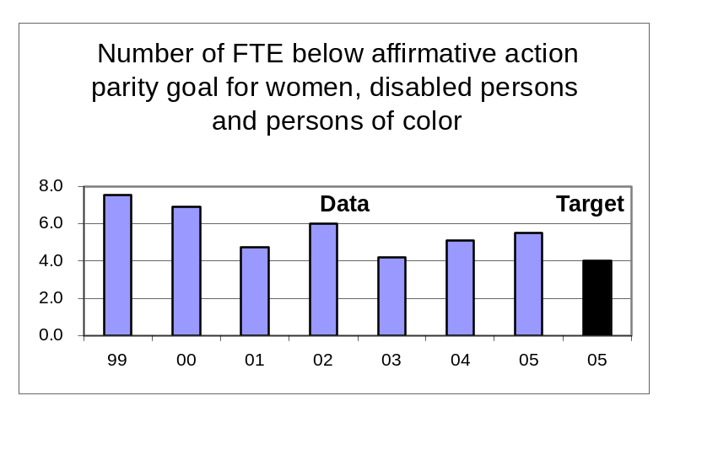Data Source: Reported to the Library quarterly by the Department of Administrative Services.

Key Performance Measure Analysis

To what goal(s) is this performance measure linked?
Goal: Support staff development, participation, and innovation to achieve continuous quality improvement.
What do benchmark (or other high-level outcome) data say about Oregon relative to the goal(s)? What is the impact of your agency?
This is an internal organizational development goal that does not directly impact a benchmark or high level outcome.
How does the performance measure demonstrate agency progress toward the goal?
The State Library has made long-term progress on meeting our affirmative action goals, but more recently we have made little progress. In FY 2005 the library lost one Hispanic employee, Two positions were offered to minority candidates who declined our offer for salary and location reasons.
Compare actual performance to target and explain any variance.
The Library is 1.5 FTE below the target that we set for 2005 due to the reasons described above.

Summarize how actual performance compares to any relevant public or private industry standards.
The parity goals for women, disabled persons, and persons of color constitute standards that we strive to meet.

What is an example of a department activity related to the measure?
Extensive recruiting among minority groups for vacant positions at the State Library.
What needs to be done as a result of this analysis?
Continue to focus on minority recruitment for Librarian and State Library Specialist positions. Develop a paid internship position in collaboration with tribal and minority advocacy groups to attract potential qualified applicants.
Annual Performance Report- Part II, Key Measure Analysis
Time Period: Fiscal Year 2004 – 2005

Agency Name: State Library |  |  |  |  | Agency No.: 54300
Key Performance Measure (KPM) |  | 1999 | 2000 | 2001 |  | 2002 | 2003 | 2004 | 2005 | 2006 |  | 2007
#54300-16. Number of hours worked by State Library volunteers. | Target |  |  |  |  |  |  |  | 18,000
 | Data | 13,607 | 15,634 | 19,361 |  | 17,469 | 16,837 | 13,167 | 11,329
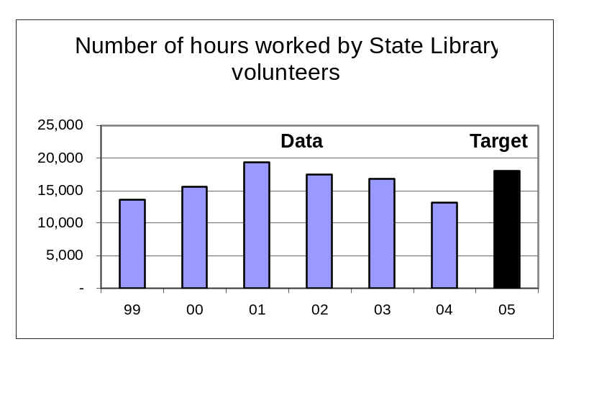Data Source: Internal count recorded by Library Administrative Services.

Key Performance Measure Analysis

To what goal(s) is this performance measure linked?
Goal: Support staff development, participation, and innovation to achieve continuous quality improvement.
What do benchmark (or other high-level outcome) data say about Oregon relative to the goal(s)? What is the impact of your agency?
This is an internal organizational development goal that does not directly impact a benchmark or high level outcome.
How does the performance measure demonstrate agency progress toward the goal?
As we have improved staff productivity through better hiring and new technology, we have improved our volunteer recruitment system by better defining the best use of volunteers, developing volunteer position descriptions and schedules needed to complete the volunteer work. We have ended our reliance on community service workers in Talking Book and Braille Services by increasing staff productivity, utilizing a new automated library check-out and catalog system.
Compare actual performance to target and explain any variance.
The target was not met, but the State Library Board supports our new direction to use fewer volunteers more effectively.

Summarize how actual performance compares to any relevant public or private industry standards.
There are no standards for this performance measure.

What is an example of a department activity related to the measure?
Work experience programs with AARP, Winema Job and Career Center Workforce Integration Program, Confederated Tribes of the Siletz and our business partner, Parrish Middle School.
What needs to be done as a result of this analysis?
To achieve the number of volunteers needed we must recruit from a broad population group that includes citizens who choose to volunteer, work experience volunteers and student volunteers.

