APPLICATION FOR FREE BOOK AND NFB-NEWSLINE SERVICE

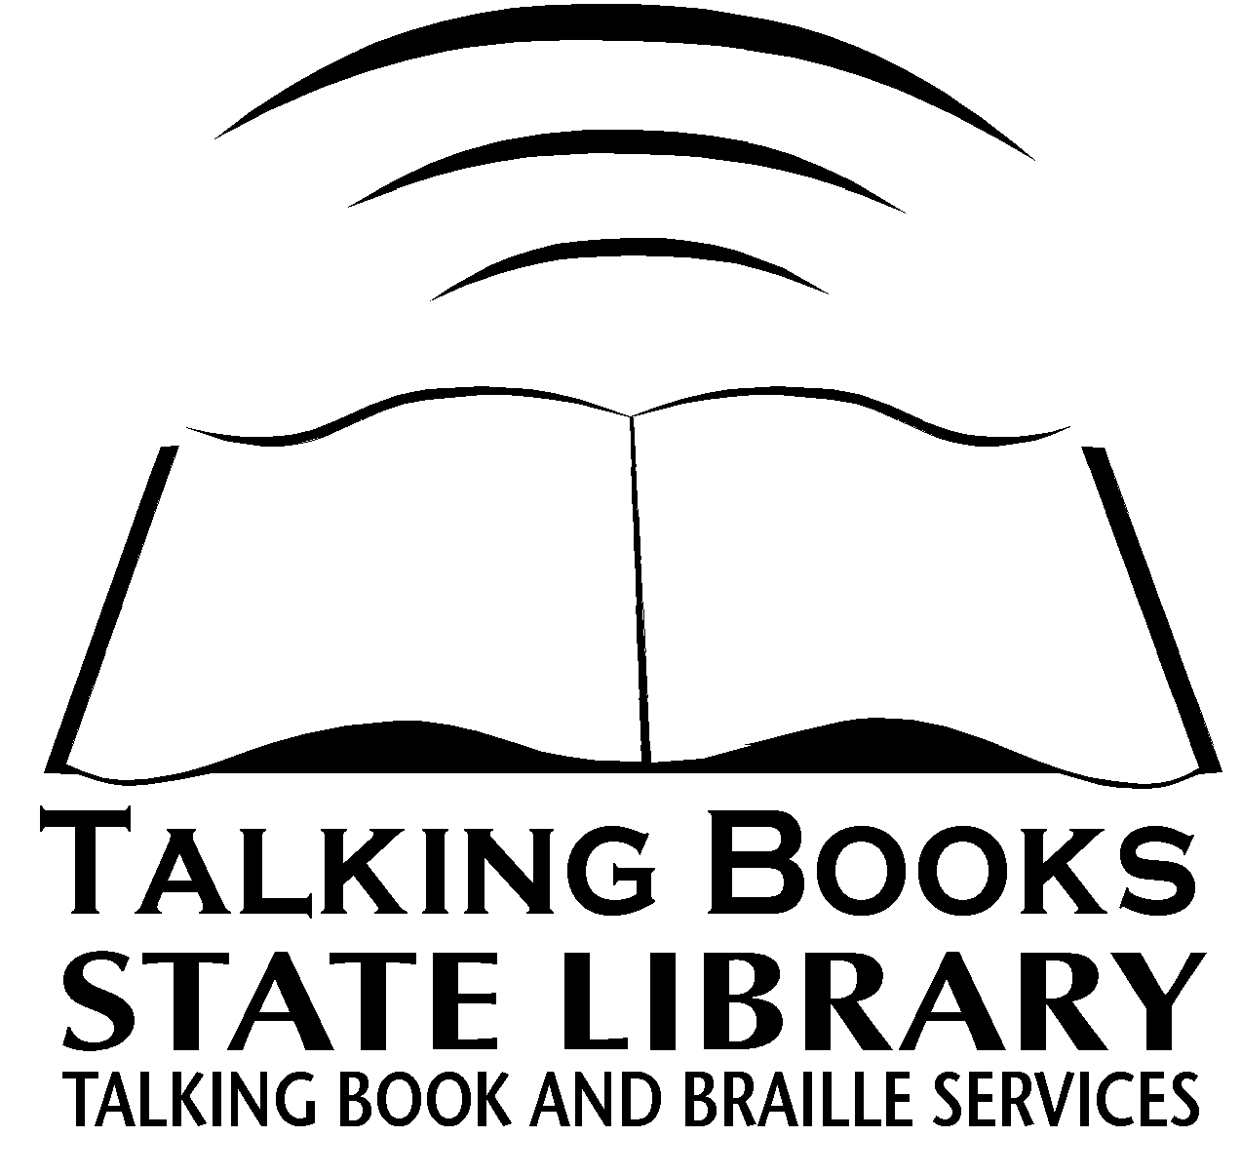

Mailing address

Talking Book and Braille Services
Oregon State Library
250 Winter Street NE
Salem OR
97301-3950

Phones

Toll Free:
1-800-452-0292

Salem:
503-378-3849

TTY Relay:
1-800-735-2900

e-mail
tbabs.info@state.or.us

Website
www.tbabs.org

Revised 7/06
Name______________________________________

C/O_______________________________________
(If applicable)

Mailing Address______________________________

___________________________________________
City County State ZIP

Telephone (___)_____________________________

E-mail _____________________________________

Date of Birth________________Female____Male___

Alternate Contact ____________________________ Relationship ___________Telephone______________

Check here if you have been honorably discharged from

the Armed Forces of the United States.

Check Service(s) Desired

____Books – Please select books for me based on the
topics checked on the next page.

____Request Only Books – I will call or submit book lists
as desired.

____NFB-NEWSLINE – Please refer to insert.

____NFB-NEWSLINE only – Please skip to page 4 for
certification.

____Downloadable Audio Books – Please refer to insert.

____Non-Partisan Voter's Guide:
___Cassette ___CD ___Large Print ___Braille

Page 2

Book Service Options

Reading level(s) preferred: ___Adult
___Young Adult
___Juvenile (Grade Level______________)

Areas of Interests ( Check as many as you wish ):

___Adventures ___Family stories ___Spy stories ___Nature ___Short stories ___Gothics
___Folklore/Myths ___Animal stories ___Travel ___Historical novels ___History ___Self-help
___Mysteries ___Career/Business ___Science
___Philosophy ___Bestsellers ___Westerns
___Poetry ___Classics ___Biographies ___Politics ___Inspirational/ Religion ___War
___Romances ___Oregoniana ___Humor
___Science fiction ___Parenting ___Sports
Gardening ___Crafts ___Cooking

Do you have special interests or favorite authors?

If you wish to receive books in languages other than English, please list those
languages here:
_______________________________________________

Check only if you do not wish to receive books that contain:

___Accented narrators ___Violence
___Explicit descriptions of sex ___Strong language

I prefer the bi-monthly Talking Book Topics catalog in:

___Large Print ___Cassette ___Computer Diskette

For Braille Readers Only:

I prefer the bi-monthly Braille Book Review in:

___Large Print ___Braille ___Computer Diskette
Page 3

Media, Accessories, and Other Services:

Equipment and accessories are available on extended loan. The cassette machine is needed to play National Library Service 4-track recorded material.
Please check as many of the following items as you would like to use so we can send the proper equipment:

____Cassette Books ____Cassette Magazines

Braille Books ____Braille Magazines

Descriptive Videos ____Web-Braille
(Please refer to insert) (Please refer to insert)

Headphones for readers who must have them to use the program,
such as readers in nursing homes, hospitals, and schools.

Pillow speaker for readers confined to bed.

Extension Lever ___Breath Switch

Amplifier for use by readers with profound hearing loss. **

Remote control for use by readers confined to bed or those with difficulty in
mobility. Turns machine on and off only. **

** Requires an additional application which will be sent by the State Library after registration.

Where did you hear about Talking Books?

Return of Equipment and Accessories
Playback equipment and accessories are supplied to eligible persons on extended loan. If this equipment is not being used in conjunction with recorded reading material provided by the National Library Service and its co-operating libraries, it must be returned to the issuing agency. One recorded cassette or one recorded magazine must be borrowed annually from NLS to retain use of equipment and accessories.

Page 4

Certification of Eligibility

Please have a doctor of medicine, doctor of osteopathy, ophthalmologist, optometrist, librarian, nurse, therapist, or other professional staff of a hospital, institution, or social welfare agency certify your eligibility in the space provided below. Qualified library users must be residents of the United States or United States citizens living abroad.

Photocopies and faxes of certification signature not accepted.
Family members or self-certification not accepted.

___1. Legally Blind—persons whose visual acuity, as determined by competent authority, is 20/200 or less in the better eye with correcting glasses, or whose widest diameter of visual field subtends an angular distance no greater than 20 degrees.

___2. Visually Disabled—persons who need aids other than regular glasses for reading standard printed materials.

___3. Physically Disabled—persons unable to read or unable to use standard printed material as a result of physical limitations.

___4. Deaf-Blindness

Please Note: in category 5 only - Reading Disabled - eligibility must be certified by a doctor of medicine (MD) or osteopathy (DO)

___5. Reading Disabled—persons having a reading disability resulting from an organic dysfunction and of sufficient severity to prevent them from reading printed matter in a normal manner.

In addition to 1, 2, 3, or 5 above, is there also a hearing impairment? Yes____ No____

I certify that the applicant is unable to read or use standard printed material for the reason indicated above.

__________________________________________________________________________
Certifier’s Printed Name

__________________________________________________________________________
Certifiers Signature Telephone

_________________________________________________________________________
Title/Occupation

__________________________________________________________________________
Street City State ZIP

