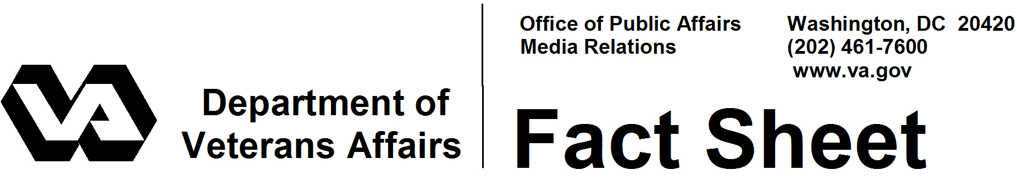

February 2008

VA Voluntary Service

VA's Voluntary Service is the largest volunteer program in the federal government. Men and women from their teens to their nineties become volunteer partners on the Department of Veterans Affairs (VA) health care team. Some bring special skills and knowledge, while others have a desire to explore and learn. Many come with a gift for working directly with patients, while others bring dependability to assignments behind the scenes. Voluntary Service matches the volunteer to the assignment, provides orientation and training for volunteers and maintains an awards program to recognize volunteer service.

Over the past 60 years, VA volunteers have donated more than 689 million hours of service worth an estimated $12.9 billion. In fiscal year 2007, 85,428 active volunteers contributed a total of more than 11.6 million hours of service -- equal to 5,574 full-time employees worth $218 million. Volunteers and their organizations generated another $59 million last year in direct gifts and donations.

Volunteer Activities
VA volunteers perform a variety of duties at VA medical centers, national cemeteries, regional offices and regional counsel offices. At medical centers, their roles range from traditional ones, such as escorting patients and administrative duties, to creative activities, such as teaching arts and crafts and developing newsletters. As VA has expanded its care of patients into the community, volunteers now assist VA staff in hospice programs, outpatient clinics, home-based primary care and outreach centers.

At cemeteries, volunteers provide military honors at burial services, create memorials, plant trees and flowers, build historical trails and place flags on graves for Memorial Day and Veterans Day.

Volunteers have been particularly active in supporting community programs aimed at reaching and serving the homeless in one- to three-day events offering a variety of services. Volunteers also have become an integral part of national and local "showcase events" aimed at introducing people with disabilities back to mainstream activities. These include the National Disabled Veterans Winter Sports Clinic, the National Veterans Wheelchair Games (the largest wheelchair athletic meet in the world), the National Veterans Golden Age Games and the National Veterans Creative Arts Festival.

- More -

Voluntary Service 2/2/2/2

Corporate volunteers play a strong role in these events, setting the pace for the future of VA Voluntary Service, along with a strong and growing youth volunteer program that is introducing teenagers and college students to careers and community service. In VA medical centers, young volunteers work in such areas as audiology, speech pathology, dietetics and physical therapy. Scout groups assist in landscaping and decorating at VA national cemeteries.

History
On April 8, 1946, General Omar Bradley, then head of the Veterans Administration, established a Voluntary Service National Advisory Committee to assist hospital administrators in organizing the spontaneous volunteer movements that developed in communities near military and VA hospitals. A national advisory committee was established, made up of representatives of the American Legion and its Auxiliary; American Red Cross; Disabled American Veterans and its Auxiliary; United Service Organizations Inc.; and Veterans of Foreign Wars of the United States and its Auxiliary. The committee recommended a plan for community volunteer participation in activities for hospitalized veterans, including the establishment of advisory committees at local hospitals. The committee has grown from six to 65 major veterans, civic and service organizations and more than 350 local organizations. The committee gives direction for the recruitment, training and placement of volunteers in medical centers.

# # #

