 |  | Chronic Care Initiative Update  March 15, 2007

Chronic Care Initiative (CCI) News:
- IHI International Forum on Redesigning the Clinical Office Practice on March 25-27 in Nashville, Tennessee. Terry Cullen and Bruce Finke will present on “Beading the Necklace: Innovation through Health Information Technology in the Indian Health System.”
- The CCI is adapting the Care Model: The Care Model, developed by Dr. Ed Wagner with Improving Chronic Illness Care, is the model of care for chronic conditions that the CCI is using. The Care Model is being adapted with the help of the IPC-Expert Panel and the extensive the experience shared by South Central Foundation (SCF). The main changes to the model are, “productive interactions through effective asset based partnering over time” can result in “improved achievement of patient and community goals.”

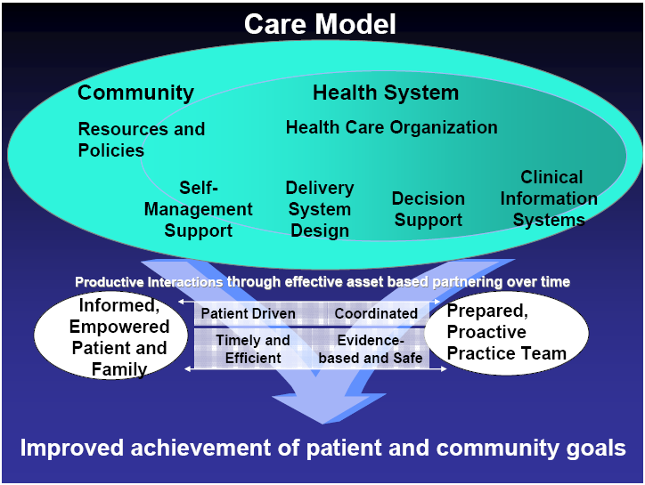

IPC-IHS News:
- The first Learning Session (LS1): A successful LS1 was held in Dallas, TX on March 15-16 with representatives from each pilot site attending.
  - Participants learned improvement techniques, explored the Care Model in depth, and worked on Team Aims and next steps.
- The second Learning Session (LS2): LS2, a working meeting for Pilot Site participants only, will be held in Boulder, CO on May 15-17.

