Oregon Business Energy Tax Credit

Application for
Preliminary Certification
for Solar Photovoltaic (PV) Projects

Oregon businesses and others that invest in solar photovoltaic projects can get a state tax credit. The tax credit for Solar Photovoltaic Projects is 50 percent of eligible project costs. You file the credit over five years: 10 percent each year. For projects with eligible costs of $20,000 or less, the tax credit may be taken in one year. Unused credits can be carried forward up to eight years.

Eligible Applicants
An eligible applicant (a project owner) must meet the following three requirements:
- Be a trade, business or rental property owner of a business site in Oregon or
Be an Oregon non-profit organization, tribe, or public entity that partners with an Oregon business or resident;
- Own or be the contract buyer of the project; and
- Use the equipment yourself or lease it to another person or business in Oregon.

Pass-through Option
Non-profit organizations, schools and other public entities that do not have an Oregon tax liability may participate in the Business Energy Tax Credit Program by using the Pass-through Option. Project owners may “pass-through” or transfer their 50 percent tax credit project eligibility to a pass-through partner in exchange for a lump-sum cash payment. The Oregon Department of Energy determines the rate that is used to calculate the cash payment. Both the project owner and pass-through partner must sign the Application for Final Certification for Pass-through Projects before a Final Certification is issued to the pass-through partner. The same review, rules and standards apply to projects approved under the Pass-through Option as those using the regular Business Energy Tax Credit Program. Please note: The Pass-through Option is also available to a project owner with an Oregon tax liability who chooses to transfer his or her tax credit. There may be tax implications to using the Pass-through Option. Please consult your tax preparer.

Timing
The Oregon Department of Energy must receive the Application for Preliminary Certification for Solar Photovoltaic Projects BEFORE the project owner financially commits to start the energy project. For example, an owner must apply before purchasing equipment or signing a contract. If a project owner starts a project and then decides to apply for the tax credit, the owner must submit a written request for a waiver with the application. The waiver request and application must be sent within 90 days of the project start date and must demonstrate an extenuating business circumstance that caused the delay in the application. Under extraordinary circumstances, the Director of the Department of Energy may extend the waiver period.

The eligible cost for solar projects is equal to the lesser of the project cost or the maximum eligible cost calculated. The Oregon Department of Energy will periodically determine and adjust, if necessary, the maximum eligible cost to reflect changes in the marketplace. The pre-certified eligible costs will be recognized for 12 months, after which time the applicant would need to reapply for a new preliminary certification. Publicly owned facilities will be allowed 36 months to
complete the project before being required to re-apply. A project owner must receive a Final Certificate before the credit can be claimed on an Oregon tax return.

OVER
Confidential Information and Disclosure
The State of Oregon's Public Records Law (ORS 192.410 et seq.) (PRL) applies to tax credit applications submitted to the Oregon Department of Energy. The law states every person has a right to inspect any public record of a public body, subject to certain exceptions.

Trade secrets and confidential business records information may be exempt from disclosure. Certain information, including trade secrets (ORS 192.501(2) and confidential submissions (ORS 192.502(4)), may be exempt from disclosure under exemptions to the PRL. Please consult your legal counsel to determine whether these or other exemptions could apply to your application.

Mark on each page any information that you believe are trade secrets, business records or that is otherwise protected under the PRL and that you request to be kept confidential. Marking information does not guarantee that it will be kept confidential. The Director of the Oregon Department of Energy will make any decisions regarding public disclosure of information contained in this application in accordance with the Oregon Public Records Law.

Under certain circumstances, as set out in ORS 192.445 (1), the personal safety exemption to the PRL, the Oregon Department of Energy is authorized to withhold your address, phone number and electronic mail address. If you want to claim this exemption under the PRL, please contact the Oregon Department of Energy prior to sending in your application for a Business Energy Tax Credit. Please consult your legal counsel to determine whether this exemption applies to you.

The Oregon Department of Energy does not endorse any company that requests application information and does not sell this information as a mailing list.

Before the project begins:

- A project owner must complete the Application for Preliminary Certification for Solar Photovoltaic Projects. He or she must send the signed form, supporting documentation, and payment of the review charge to the Oregon Department of Energy before the project begins. Incomplete applications will not be accepted. Note: If using Microsoft WORD version of the application, check the Web site to ensure the latest version is being used. (Dates are in the lower right-hand corner.)

- A project owner may start the project when he or she receives a Preliminary Certificate. The Oregon Department of Energy usually takes four to six weeks to review an application provided all necessary information is submitted. Incomplete or inadequate information may result in a delay in approval or in denial of the application. Please note: A project owner may begin the project before receiving a Preliminary Certificate, however, there is no guarantee the project will be approved.

- If vital characteristics of the project change after receiving the Preliminary Certificate, the project owner should submit a signed, written, detailed description of the changes to the project and energy savings estimates. An increase in cost only does not qualify as a project change. If the Department of Energy approves a project change, a project owner may be required to pay an additional review charge.

After the project is complete:

- A project owner should apply to the Oregon Department of Energy for final certification when the project is completed. If project costs are $50,000 or more, an owner must send a letter from a certified public accountant (not employed by the project owner) stating that he or she has reviewed the project costs. If project costs are less than $50,000, the project owner should send copies of the dated invoices, canceled checks or receipts that are marked “paid.”

- The Oregon Department of Energy will review the final application and may issue a Final Certificate. Under no circumstances can the Oregon Department of Energy approve more than
10 percent above the amount of Eligible Project Costs shown on the Preliminary Certificate unless the project was amended in writing and received approval before completion. The sum of all financial incentives and the tax credit may not exceed the Eligible Project Costs.

- A tax credit recipient may file the tax credit over five years (10 percent per year). If the Eligible Project Costs are $20,000 or less, a tax credit recipient may file for the tax credit in one year. A tax credit recipient may begin claiming the tax credit the year the project is finished or the year the Oregon Department of Energy issues the Final Certificate.

Questions? For questions on claiming the tax credit, contact the Oregon Department of Revenue (www.oregon.gov/DOR) or call 1-800-356-4222. For questions concerning the project, call the Oregon Department of Energy at 1-800-221-8035 (toll-free in Oregon) or (503) 378-4040 (Salem) or visit our Web site (www.oregon.gov/energy).

Business Energy Tax Credit

Application for Preliminary Certification

Solar Photovoltaic Project

This application is for solar photovoltaic systems only. If the project contains additional conservation measures, they should be applied for separately using the Application for Preliminary Certification of Conservation Projects.

Are you eligible? |  |  |  |  | For office use only
Yes No |  |  |  |  | Application #:
Have you submitted this application before financially committing to start this energy project? (e.g. signing a contract, ordering equipment, etc.)  If no, have you attached a request for a waiver? |  |  |  |  | Date received:
Are you interested in using the Pass-through Option?*

*The Pass-through Option will allow you to transfer your tax credit project eligibility to another business or individual (a pass-through partner) in exchange for a lump-sum payment. The payment amount is calculated using the pass-through rate. To use the Pass-through Option, check the Yes box above, complete this application form and send the form to the Oregon Department of Energy. There may be tax implications to using the Pass-through Option. Please consult your tax preparer.
1. Project owner information (We will send all correspondence to this person.)
Project owner’s name:
Tax I.D. # or SSN*:
Phone: |  | E-mail:
Business name:
Mailing address:
City/state/zip:
Principal business activity (or SIC, if known):
Contact person for project (Who can
answer technical questions about the project?)
Title: | Phone: |  |  | E-mail:
Company/organization CPA or CFO:
(If interested in Pass-through Option)
Title: | Phone: |  |  | E-mail:
*OAR 330-090-0130 authorizes the Oregon Department of Energy to use your federal tax identification or social security number as an identification number in maintaining internal records and may be shared with the Oregon Department of Revenue to establish the identity of an individual in order to administer state tax law.

2. Architect, engineer, vendor or contractor for project
Firm name of architect, engineer, vendor or contractor:
Address: | Phone:
City/state/zip:
Contact person: | E-mail:

3. Project site
Site owner: |  |  | Phone:
Site address:
City: | County: |  |  | Zip:
Total square footage affected by this project:
4. Estimated construction or installation dates
Estimated start date: |  | Estimated completion date:

5. May the Oregon Department of Energy publicize your project to promote efficiency to other businesses?
Yes No
6. How did you learn of the Business Energy Tax Credit Program?
Associate Advertisement Workshop Utility Vendor Other:

OVER

7. System Description
►Attach the following additional information:
□ Technical data sheet(s) for PV module(s).

a. System Type
type modifier
□ DC, a pump or other direct current application, no battery storage 1.0
□ Grid, utility interactive system without battery backup 1.0
□ Grid w/Bat, utility interactive system that includes batter backup 0.9
□ Off-Grid, Remote or non-utility connected application with battery storage 0.8

b. PV Array(s)
Total array rated power: Watts_{Total}____________ Watts DC at Standard Test Conditions (STC)
where,
Watts_{Total} = Watts₁ + Watts₂ + Watts₃ + Watts₄ + . . . .

Sub Array 1
Rated power (Watts₁): ____________ Watts DC at STC
Number of modules: ____________ Module output: ____________ Watts DC at STC
Module power tolerance: ____________ % (enter the +/- rating of the module @ STC)
Module manufacturer: ____________ Module model: __________________________
Inverter manufacturer: ____________ Inverter model: __________________________

Sub Array 2
Rated power (Watts₂): ____________ Watts DC at STC
Number of modules: ____________ Module output: ____________ Watts DC at STC
Module power tolerance: ____________ % (enter the +/- rating of the module @ STC)
Module manufacturer: ____________ Module model: __________________________
Inverter manufacturer: ____________ Inverter model: __________________________

Sub Array 3
Rated power (Watts₃): ____________ Watts DC at STC
Number of modules: ____________ Module output: ____________ Watts DC at STC
Module power tolerance: ____________ % (enter the +/- rating of the module @ STC)
Module manufacturer: ____________ Module model: __________________________
Inverter manufacturer: ____________ Inverter model: __________________________

Sub Array 4
Rated power (Watts₄): ____________ Watts DC at STC
Number of modules: ____________ Module output: ____________ Watts DC at STC
Module power tolerance: ____________ % (enter the +/- rating of the module @ STC)
Module manufacturer: ____________ Module model: __________________________
Inverter manufacturer: ____________ Inverter model: __________________________

c. Mounting
annual output modifier
□ 1-Axis, single axis tracking system 1.20
□ 2-Axis, dual axis tracking system 1.25
□ BIPV, building integrated system, fixed axis 1.00
□ Ground, ground mount, fixed axis 1.00
□ Roof, on building either rack or rail mounted 1.00
□ Other, _______________________________ 0.90

OVER
8. Site Assessment Conduct Site Survey
►Attach the following additional information:
□ Sun charts used to determine TSRF of array(s) and/or sub arrays

Use one or more sun charts for each sub-array. Sun charts must be taken from a location on the array which best characterizes the annual shading impact. Shading of PV modules is very sensitive to shading so evaluate the worst case location on each sub array. Projects must have a TSRF greater than 75% to be eligible for a tax credit.

a. Site Diagram

Draw or attach simple plan view of site/buildings/trees that shows where the array will be located.
b. Total Solar Resource Fraction (TSRF)
Tilt is the collector tilt from horizontal. Orientation is the direction the sub array faces where 180 equals true south. TOF is the tilt and orientation factor taken from the Oregon Department of Energy or Energy Trust of Oregon PV sun charts. The Shading Fraction lost annual due to external shading. The system TSRF is the power weighted average TSRF of each sub array as calculated below.

TSRF = (Watts₁ x TSRF₁ + Watts₂ x TSRF₂ + Watts₃ x TSRF₃ + Watts₄ x TSRF₄) ÷ Watts_{Total}

= ____________

Sub Array 1
Tilt: ________° Orientation: _________° TOF: ____________° Shading: _________
TSRF₁ = TOF x (1 – Shading Fraction) = ____________

Sub Array 2
Tilt: ________° Orientation: _________° TOF: ____________° Shading: _________
TSRF₁ = TOF x (1 – Shading Fraction) = ____________

Sub Array 3
Tilt: ________° Orientation: _________° TOF: ____________° Shading: _________
TSRF₁ = TOF x (1 – Shading Fraction) = ____________

Sub Array 4
Tilt: ________° Orientation: _________° TOF: ____________° Shading: _________
TSRF₁ = TOF x (1 – Shading Fraction) = ____________

OVER

9. Estimated Annual Energy Production
a. Solar Resource
Choose the city with the most similar solar resource (kWh/yr-W)
Solar Resource
□ Astoria, Seaside, Cannon Beach, Warrenton 1.03
□ Burns, John Day, Canyon City, Hines 1.39
□ Eugene, Roseburg, Springfield, Sweet Home 1.14
□ Medford, Klamath Falls, Grant's Pass, Ashland 1.32
□ North Bend, Coos Bay, Coquille, Bandon 1.26
□ Pendleton, Enterprise, La Grande 1.31
□ Portland, Hood River, Hillsboro, Oregon City 1.08
□ Redmond, Bend, Prineville, Madras, Lakeview 1.43
□ Salem, Lincoln City, Corvallis, Silverton 1.14

b. Estimated annual energy produced by entire array:
Total rated output (Watt_{Total}, from 7b) = __________
Total Solar Resource Fraction (TSRF, from 8b) = x __________
System Type Modifier (from 7a) = x __________
Mounting Type Modifier (from 7c) = x __________
Solar Resource (from 9a) = x __________
Annual useful energy produced = __________ kWh/yr

10. Energy use without project (for building or facility)
Gather this information from historical energy bills. If the project is new construction, then estimate the energy use that would have been present without the PV array.
Energy use for the past 12 months:
a. Electricity ______ kwh x 0.003414 = MMBTU
b. Natural Gas ______ therms x 0.100 = MMBTU
c. Diesel ______ gallons x 0.014 = MMBTU
d. Other (enter units) ______ x _______ = MMBTU
TOTAL energy use = ________ MMBTU per year
e. Utilities (Electric, Gas, Oil, Other):
f. Fraction of electrical energy supplied by PV system (9b / 10a) = _________ % (check units)

OVER

11. Estimated Project Cost
Materials: | Estimated cost:
Labor: | Estimated cost:
Engineering: | Estimated cost:
Other: (Do not include Business Energy Tax Credit review costs.) | Estimated cost:
Total of Estimated Costs from above: | A. $
Deduct any federal grants:  Note: OAR 330-090-0110 (19) (n) The sum of any rebates or cash payments under ORS 469.631 to 469.645, 469.649 to 469.659, 469.673 to 469.683, or 757.612(5)(a), or from a public purpose organization and the Business Energy Tax Credit may not exceed eligible costs. | B. $
Estimated Project Cost  Take A and subtract B to get the Estimated Project Cost (C) | C. $

12. Eligible Project Cost
The Eligible Project Cost is the lesser of the Maximum Eligible Cost and the Estimated Project Cost. The Maximum Eligible Cost is calculated using a spreadsheet that can be downloaded from the Oregon Department of Energy Web site. The Maximum Eligible Cost will decline as more systems are granted preliminary certifications. Applicants should use the spreadsheet on line to ensure they are using the most recent version.
a. System size (from 7b, Watts_{Total} ÷ 1000) kW
b. Total Solar Resource Fraction (from 8b, TSRF) %
c. Module warranty tolerance (from module technical data sheet): %
This is the +/- percentage on the module manufacturer warranty that
the module will deliver initially under standard test conditions.
d. Is this project going to be placed on/serve a publicly owned facility (Yes/No)?
e. Maximum Eligible Cost (calculated from MEC spreadsheet): $ .00
f. Eligible Project Cost (lesser of 11c and 12e): $ .00

13. Business Energy Tax Credit review charge
Applications will not be reviewed until the review charge is paid in full.
Eligible Project Cost (See 12f) ___________________x .0060 = $______________________

Minimum payment required is $30; the maximum payment required is $35,000. Make check payable to the Oregon Department of Energy and include with this application. You may also pay by Visa or MasterCard.
 I want to pay by Visa/MasterCard. Please contact me at this phone number: __________________.

If all or a portion of your application is denied, or if a change in your project results in lower costs, a portion up to 75 percent of this payment may be refunded within two years of pre-certification. If you add to your approved project, you must send a written description of the additions and the costs to be eligible for a tax credit. If the Oregon Department of Energy approves the additional eligible costs, an additional payment may be required. For more information, see Oregon Administrative Rule
330-90-0150(2).

OVER

14. Project Owner Preliminary Statement
- I understand that Oregon Department of Energy approval and certification of my project is for
tax credit purposes only. The Oregon Department of Energy does not guarantee or in any way ensure the performance of any equipment, the quality of any system or the reliability of any dealer.
- I agree that the project will comply with all local, state and federal requirements. I will obtain all necessary permits. I will comply with the technical requirements for the project listed in the BETC Technical Requirement Guidelines (attached).
- I will permit the Oregon Department of Energy or its agents to inspect the project at its discretion to make sure the project qualifies for the tax credit. I understand that if I give false information about the project, or if I refuse to permit the Oregon Department of Energy to inspect the project, I will not get the tax credit.
- I understand that this tax credit application is a public record and that Oregon Department of Energy may be required by law to disclose information in this tax credit application to the public on request. I have marked any information that I request be kept confidential. I understand that marking information does not guarantee that it will be kept confidential and that the Director of the Oregon Department of Energy will make any decisions regarding public disclosure of information contained in this application in accordance with the Oregon Public Records Law.
- I understand that the Oregon Department of Energy does not endorse any company that requests information on this application and does not sell information as a mailing list.
- I hereby release the State of Oregon and its commissions, agencies, officers, employees, contractors, and agents, and agree to defend and indemnify the foregoing from and against any claims, demands, or costs (including attorney and expert witness fees at trial and on appeal) arising from or in any way related to the Oregon Department of Energy’s issuance or failure to issue any pre-certification or final certification for a Business Energy Tax Credit, or any party’s inability to obtain a Business Energy Tax Credit.
- I understand that the sum of all financial incentives and the tax credit can not exceed the total eligible project cost.
- I have enclosed a check to the Oregon Department of Energy or will pay by Visa or MasterCard for the review charge.
- I verify that the project owner does not restrict membership, sales, or services on the basis of race, color, creed, religion, national origin, sexual preference or gender.
- I have completed this form to the best of my knowledge.
- I certify that I am the project owner or the authorized agent.
£ I have read and agree with the terms, conditions of the Project Owner Preliminary Statement.

Signature: ____________________________________________Title: ____________________
Print Name:___________________________________________ Date: ___________________

Send completed application with payment to: Oregon Department of Energy, 625 Marion St. NE
Salem, OR 97301-3737. If you have questions, call: 1-800-221-8035 (toll-free in Oregon)



Solar Site Assessment

A tool for estimating the impact of collector tilt, orientation and shading

To estimate the performance of a solar energy system we need to know how much solar energy is available for your collector. This worksheet is used to estimate the impact of tilt, orientation and external shading on how much solar energy your solar collectors can collect. The Total Solar Resource Fraction (TSRF) represents the fraction of energy a particular collector would receive when compared to one in the same city, but that has optimal tilt, orientation and no external shading. For example, a collector with a TSRF of 80 percent indicates that 80 percent of the solar energy at your location over a year will be available to the solar collector.

For simplicity we have separated calculating the TSRF into two parts. The first part is to determine the impact of collector tilt and orientation. This Tilt and Orientation Factor (TOF) is estimated using one of the following plots. The second part is to uses a sun chart to estimate how much energy is lost on an annual basis from external shading from plants, buildings or other obstructions. The combination of these two effects will provide your collector’s TSRF.
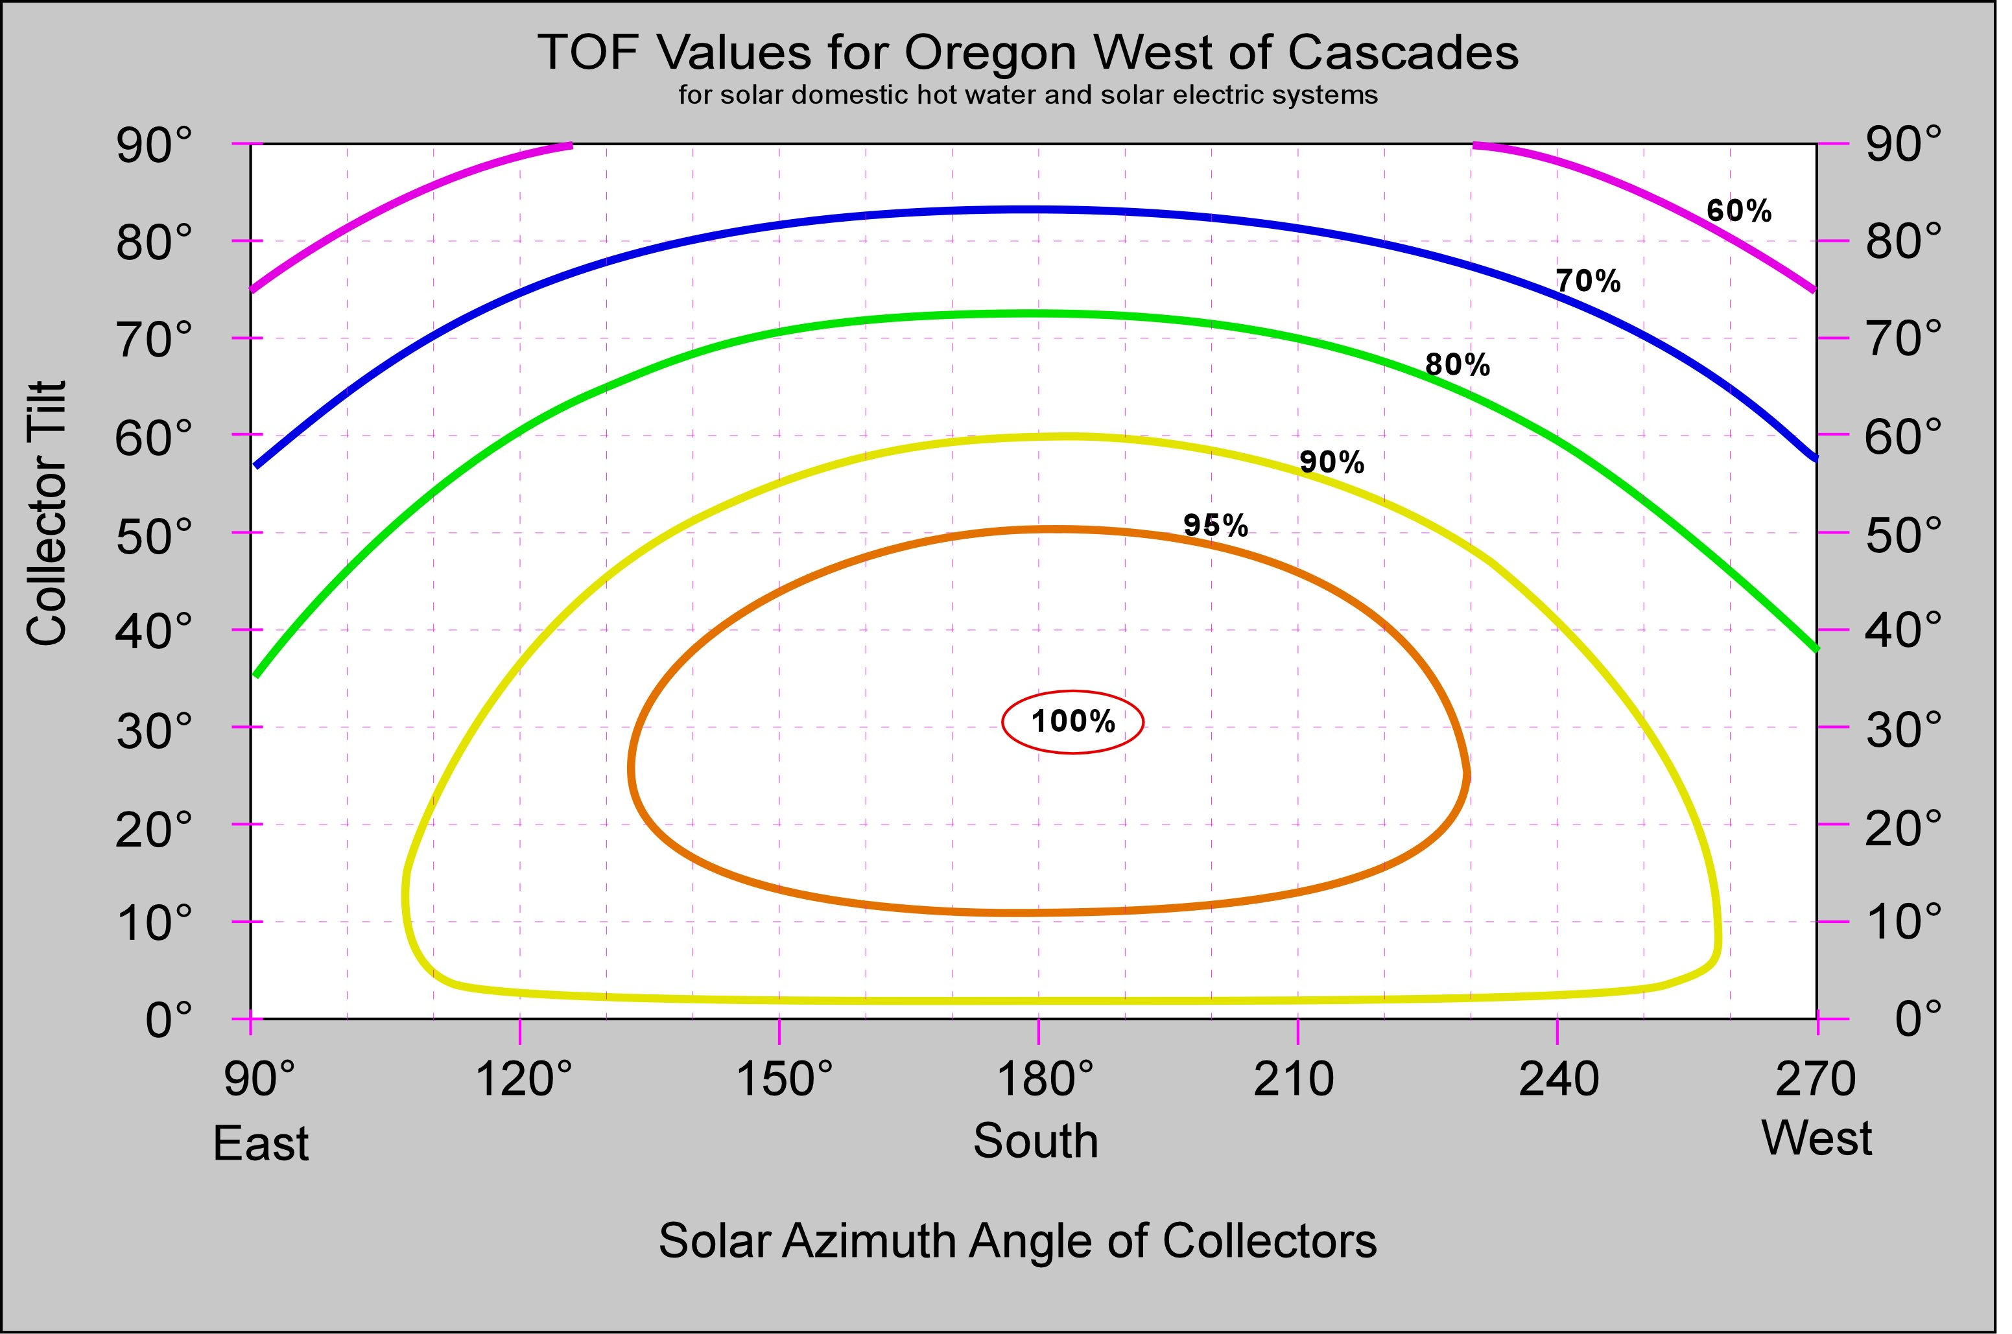
TOF graphs (right) show the impact of tilt, and orientation on annual performance of a solar collector. TOF values range from 100% (no loss) at the center of the inner circle to less than 60% (40% or more loss) in the upper left and right corners.

Azimuth angles are based on true polar orientation, adjusted for magnetic declination (16-20 degrees for most of Oregon)

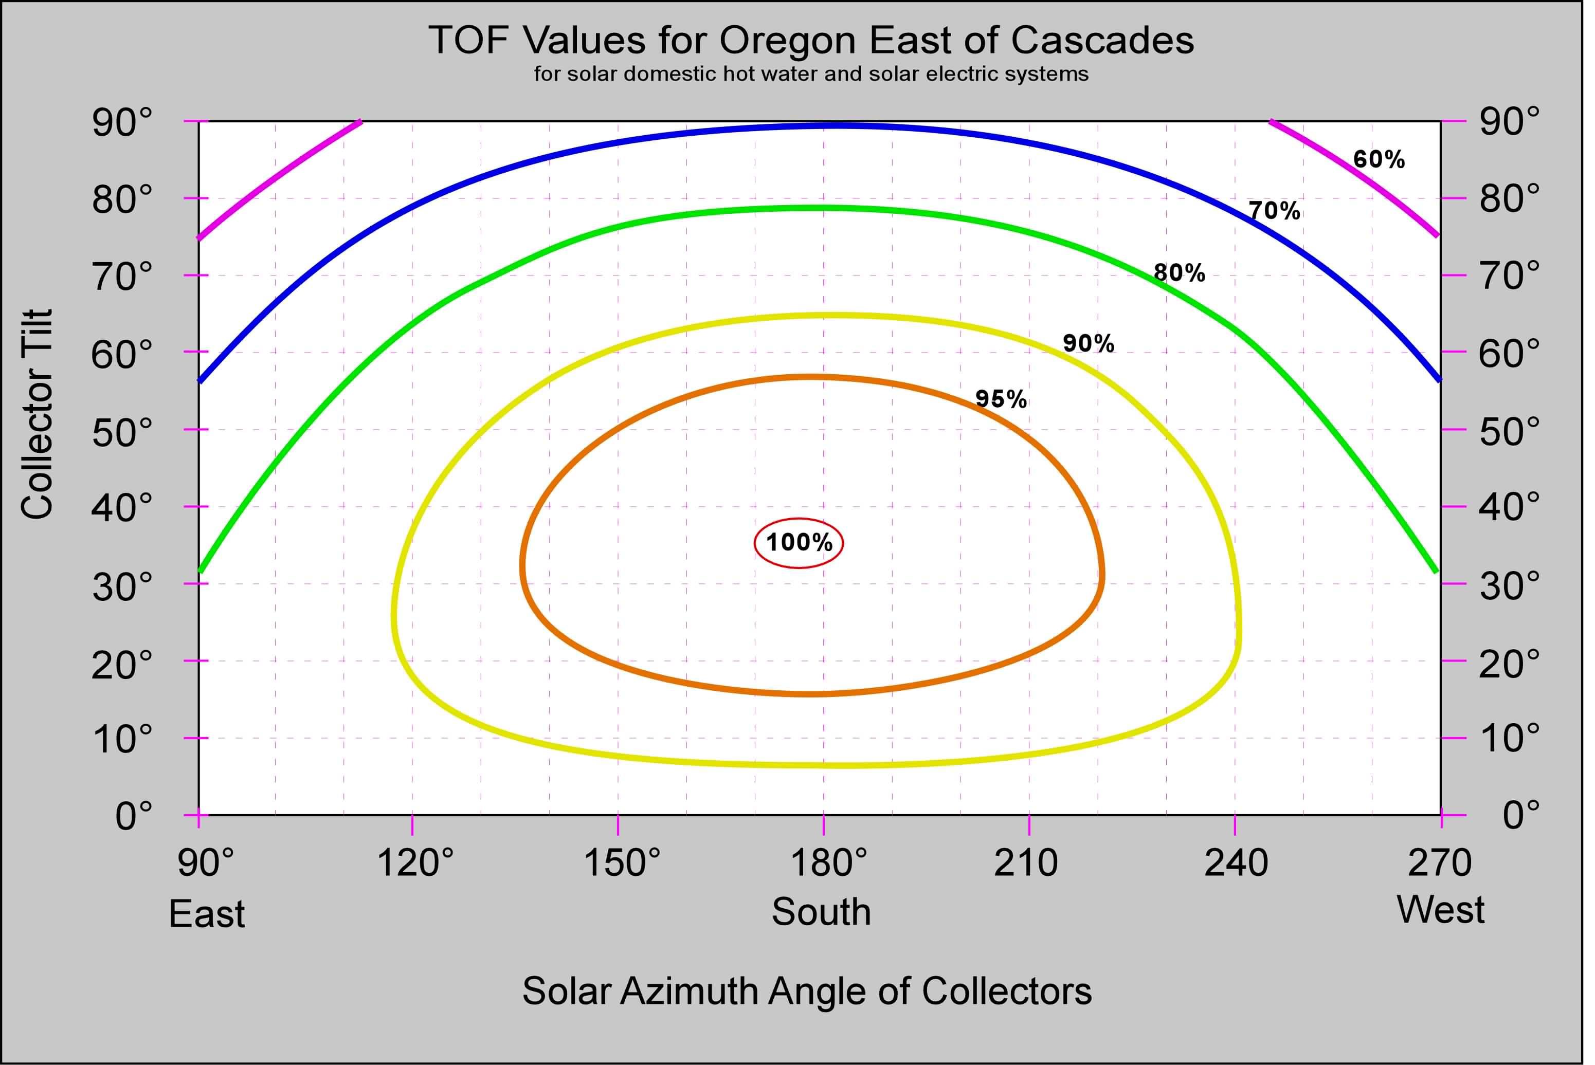
Use the upper graph if your system is installed West of the Cascades. Use the lower graph if your system is installed East of the Cascades.

Draw a dark X mark the graph for your collector’s tilt and azimuth angle. Interpolate between the nearest two lines to estimate the TOF value to the nearest 1%.

Collector Tilt = __________ °
(angle from horizontal)

Solar Azimuth =________ °
(collector orientation)

TOF = ___________ %
(estimated from graph)

Sun Chart

For solar water heating and solar electric systems

Step 1 – From the midpoint of the solar array, draw the skyline on the graph below. Use the elevation angles and solar azimuth angles to determine the location of the obstructions. A solar site assessment tool such as the Pathfinder™, or Solmetric Suneye is recommended for increased accuracy. Energy Trust of Oregon sun charts can be used in lieu of the sun chart below. Draw deciduous trees with a dotted outline and fill with light shading. Year-round obstructions like buildings, or evergreen trees should be drawn with solid outlines and filled with heavy shading.

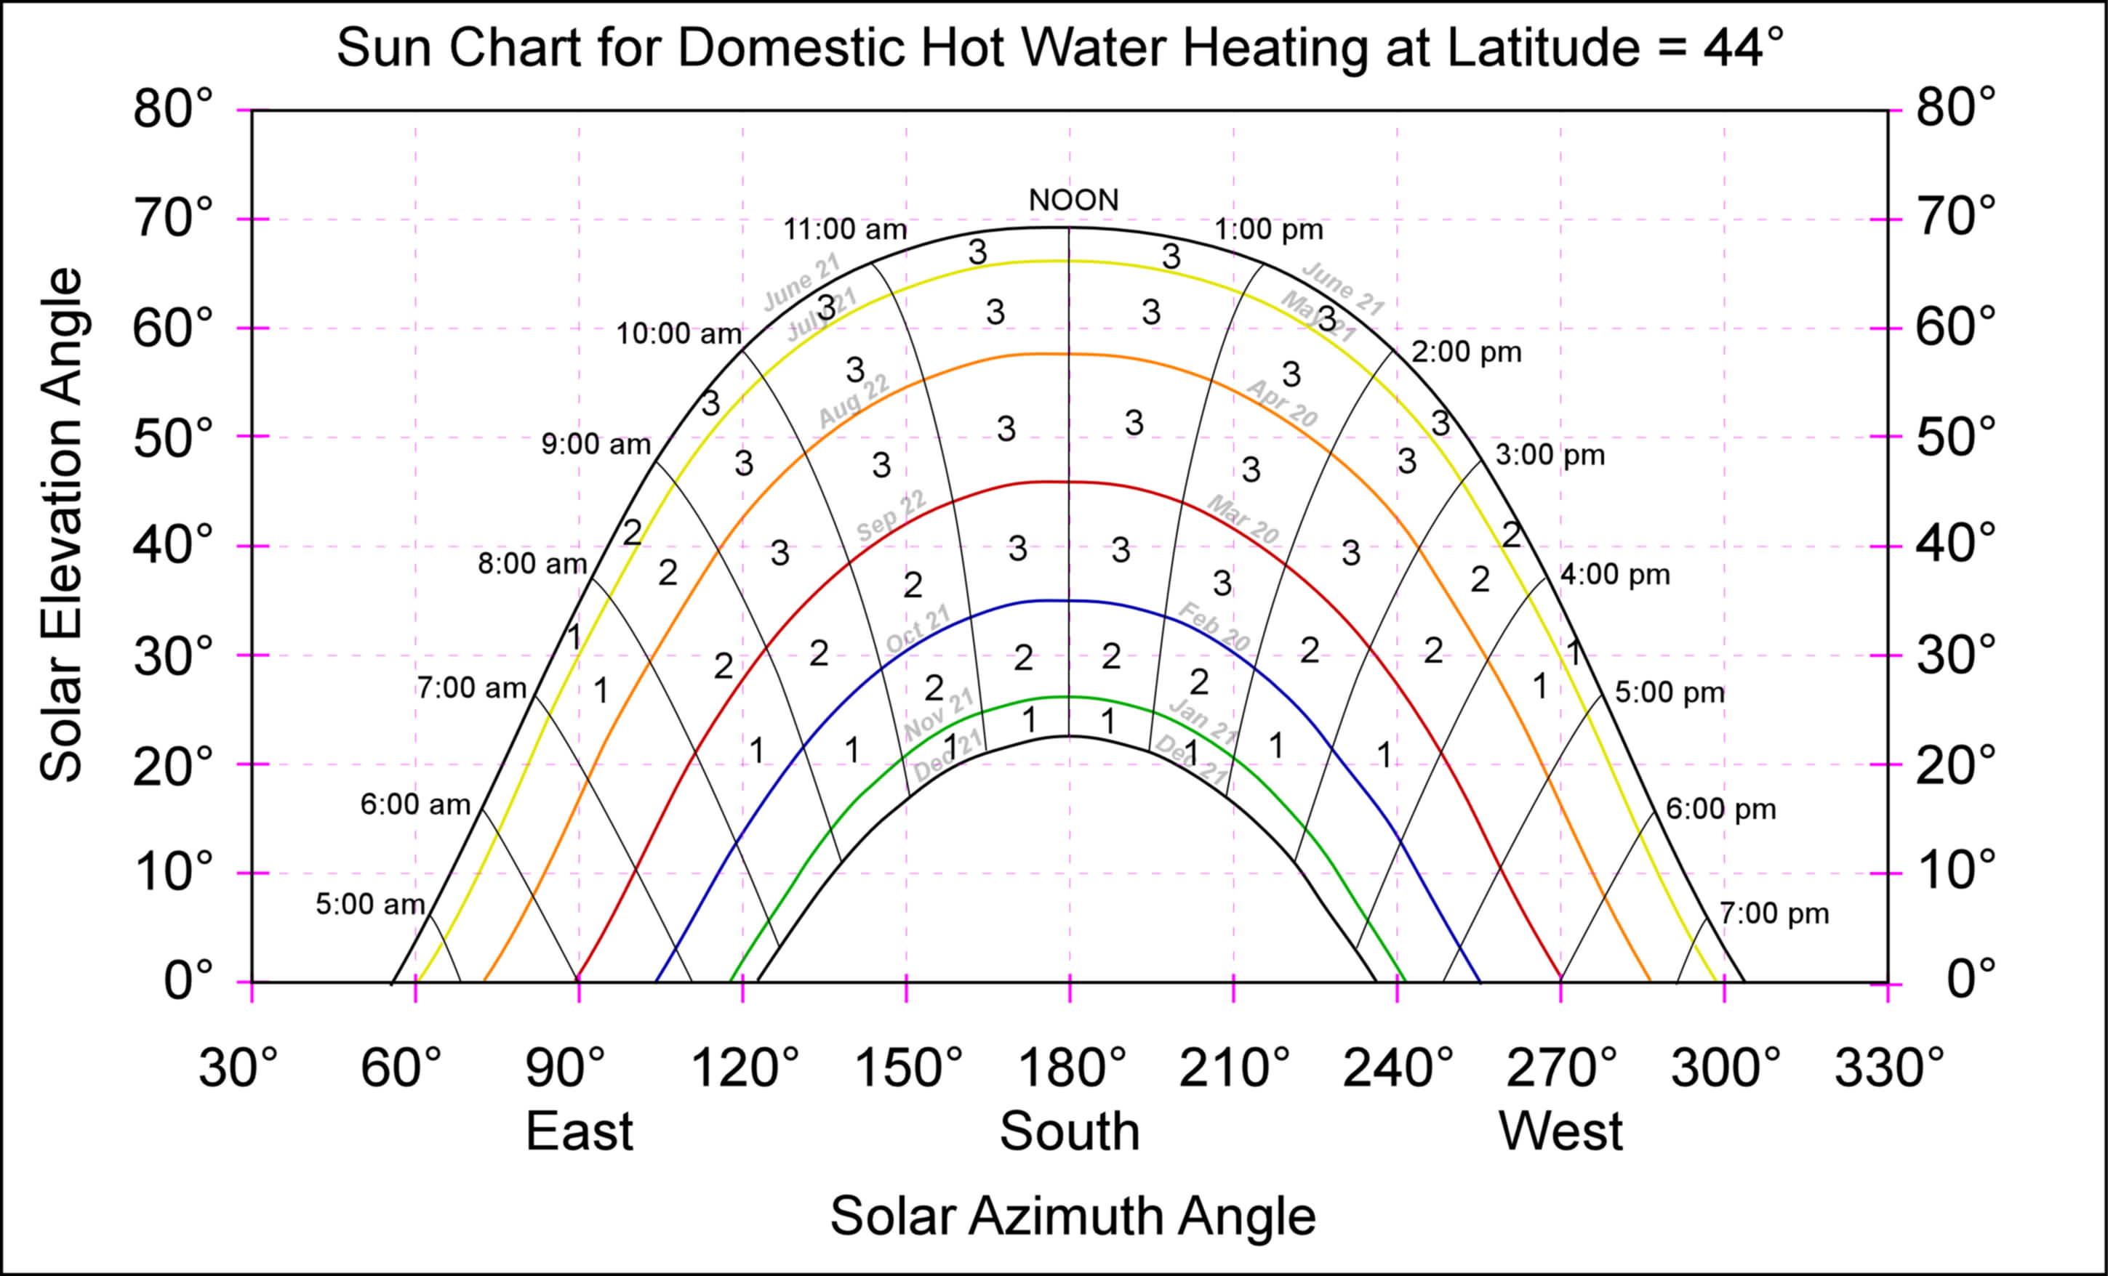
Step 2 – Add up the solar fraction numbers in the sections that have shading. For solar electric systems, partial shading in one section must be counted fully (no fractional amounts). Any deciduous tree shading below the Sept 22/March 20 line can be counted at half value to account for the fact that some light will get through these obstructions when the trees lose their leaves. This sum of all these values divided by 100 is the “Shading Fraction”. It represents the percent of energy lost to external shading.

Shading Fraction = sum of obstructed areas ÷ 100 = ______________

Step 3 – Calculate the Total Solar Resource Fraction using the following equation:

Total Solar Resource Fraction = TOF x (1 – Shading Fraction) = ______________

BETC Technical Requirements for PV Systems

All qualifying installations must meet the following minimum PV system specifications:
- The facility must be designed to last at least 25 years (with minimal maintenance) and deliver or exceed performance expectations of a well designed facility.
- Installation must meet industry standards.
- Facility must be permitted and in compliance with all applicable building and electrical codes.
- All facility equipment must be rated for the temperature and exposure conditions in which it will operate continuously for 25 years or more.
- All facility components must be new (modules, inverter, batteries, mounting hardware).
- Array mounting must not reduce the expected life or durability of the structure on which it is located.
- The facility must be designed for optimal performance without sacrificing good aesthetics.
- The facility must include all code required signage and a customer manual.
- A customer manual must contains the following information:
  - Facility documentation
    - As-built drawings that accurately describe the components installed and the wiring design, including wire sizes, and estimated length of wire runs
    - Facility site plan that indicates array, inverter, and all disconnect locations
    - The sun chart used to determine facility total solar resource fraction
    - Operation and maintenance requirements including the name and phone number of person(s) or company to call in the case of a facility failure
  - Warranties and installation documentation
    - Minimum two-year contractor warranty for materials and workmanship
    - Manufacturer’s warranty for PV modules and inverter
    - Permit documentation
  - Manuals and data sheets
    - Bill of material listing all primary facility components including part model numbers or designation
    - Inverter owner’s manual
    - Manufacturer data sheets for major components, including but not limited to: inverters, modules, charge controller.
- All facilities must include one or more meters that are capable of recording the facility’s total energy production. Meters must be equivalent to American National Standards Institute (ANSI) certified revenue meters with a 0.5 or better accuracy class and, if digital, it must have non-volatile data memory.
- Array must be sized to operate within the current, voltage and power limits approved and warranted by the inverter manufacturer. The temperature-adjusted voltage must remain within the inverter limits at the historical record low temperature for the location in which it is installed.
- Wires must be sized to keep the total voltage drop below 2 percent on the DC conductors from the array to the inverter including the existing wire whips on the PV modules, and/or 2 percent on the AC conductors from the inverter to the point of interconnection (total not to exceed 4 percent).
- Voltage mismatch caused by practical shading of the array, different orientations of string and localized shading events are minimized.
- Installing contractor must provide a minimum 24-month full warranty on parts and labor to the facility owner.
- System Total Solar Resource Fraction (TSRF) must be greater than 75%.

Express TSRF as a fraction (e.g. 88% = 0.88)

