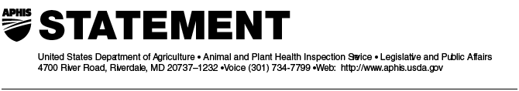

Suzan Holl (301) 734-6464
Jerry Redding (202) 720-6959

STATEMENT BY JOHN CLIFFORD, DEPUTY ADMINSTRATOR
ANIMAL AND PLANT HEALTH INSPECTION SERVICE
Regarding the Opening of the Philippine Market to Live U.S. Breeder Cattle

January 11, 2006

“I am pleased to announce that the Philippines Department of Agriculture recently agreed to allow live U.S. breeder cattle imports into the country under the terms and conditions of the Philippines Import Health Protocol for Live Cattle from the United States.

As with meat and meat products destined for the Philippines, importers are required to obtain a veterinary quarantine clearance (VQC) from the Philippine Department of Agriculture’s Bureau of Animal Industry (BAI) prior to the shipment of animals. Specific import terms and conditions for the import of live breeder cattle are outlined in the health protocol.

The opening of the Philippines market to live U.S. breeder cattle and the completion of the health protocol is the result of negotiations between USDA’s Animal and Plant Health Inspection Service and the BAI.

This agreement is another example of our trading partner’s confidence in the effectiveness of the United States’ interlocking measures to safeguard U.S. beef from bovine spongiform encephalopathy.”

#

