ARC Guide for Educators and Students

http://www.archives.gov/research/arc/education/

The guide introduces educators and students to the National Archives’ Archival Research Catalog (ARC). Searching in ARC to learn more about National Archives’ historical documents could enrich a classroom activity, a homework assignment, or a research project.

- Part 1: ARC in the Classroom

Dorothy E. Davis, et. al. vs. County School Board of Prince Edward County, Virginia, 1951? (ARC ID 279100)
  - Handouts for Classroom Use
  - ARC and NARA's Teaching With Documents Lesson Plans
    - Continue Your Research in ARC
    - Research a Specific Topic: Example: Civil Rights
  - Anatomy of an ARC Series Description
- Part 2: Search Tips for Educators and Students
  - Anatomy of the ARC Basic Search Screen
  - Keyword
  - Digital Copies
  - Dates
  - Location (where the records are located)
- Part 3: Printing, Downloading, and Ordering Records Found in ARC
  - Printing from ARC
  - Downloading Digital Images
  - Citing Records
  - Ordering Records Found in ARC
    - Ordering Copies
    - Contacting NARA
    - Visiting NARA for Research
    - Visiting NARA with Your Students

Part 1: ARC in the Classroom


ARC: A Work in Progress
Currently over 54% of our records are described in ARC. Every two weeks new descriptions are placed in ARC. If you do not find the records you are seeking, please contact the NARA office that holds those records. Read more about: Why aren’t all Federal Archived Records Online?

Bring variety to your classroom by teaching with primary documents – the raw materials of history. Your students can learn about history firsthand using the primary sources held by the National Archives and Records Administration (NARA). NARA has billions of pieces of paper and millions of photographs that document the working of the Federal Government and U.S. history.

ARC is NARA's online door to the Archives. Educators and students can use ARC to locate records found in our various facilities nationwide and view digital images of some of these records. ARC contains descriptions of records created by Federal agencies, Congress, and Presidential administrations as well as records created by people and sent to the government.

Handouts for Classroom Use

For Educators | For Students
- ARC Brochure for Educators and Students (PDF)  - ARC Web Tips (PDF or Word)  - (Printable version of this guide): ARC Guide for Educators and Students (PDF or Word) | - ARC Brochure for Educators and Students (PDF)  - Anatomy of the ARC Basic Search Screen (PDF or Word)  - Anatomy of an ARC Series Description (PDF or Word)

ARC and NARA's Teaching With Documents Lesson Plans
Did you know?
You can type just an ARC ID number into the ARC keywords box to retrieve that one ARC description.

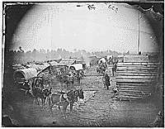

For example, ARC ID: 524642 (Camp scene. Showing winter huts and corduroy roads, ca. 1860 - ca. 1865) is featured in Teaching With Documents: The Civil War as Photographed by Mathew Brady. <http://www.archives.gov/education/lessons/brady-photos/>
You can search in ARC for copies of documents used in NARA's Teaching With Documents lesson plans. Lesson plans are available on various topics, arranged by period in U.S. history. Please note that not all documents used in the lesson plans have been entered into ARC. “Teaching With Documents” is just one part of NARA’s online resources for Educators and Students.

- Continue Your Research in ARC: The records you find in the Teaching With Documents lesson plans can be a starting point for both educators and students. Students can search in ARC to find historical records for a special research paper or a National History Day project.

- Example: Civil Rights: You plan to use the Teaching With Documents lesson plan
Court Documents Related to Martin Luther King, Jr., and Memphis Sanitation Workers in your classroom. Introduce your students to ARC with the following tasks. (Review the Search Tips in Part 2 of this guide on ARC’s search options.)
  - Show the class how to look up the lesson plan’s first document in ARC by typing the ARC ID number 279325 into the keywords box.
  - Search broadly in ARC with the keywords Civil Rights and browse through the results. (Always set your search hit limit to 2,000 to see the maximum number of hits.)
  - Search more narrowly in ARC with the keywords Civil Rights Act and browse.
  - Refine your search by again searching with the keywords Civil Rights Act and adding the Digital Objects Filter to retrieve only ARC descriptions that have digital images attached. Selected pages from the Civil Rights Act of 1964 are available as digital images attached to ARC ID 299891.

Anatomy of an ARC Series Description
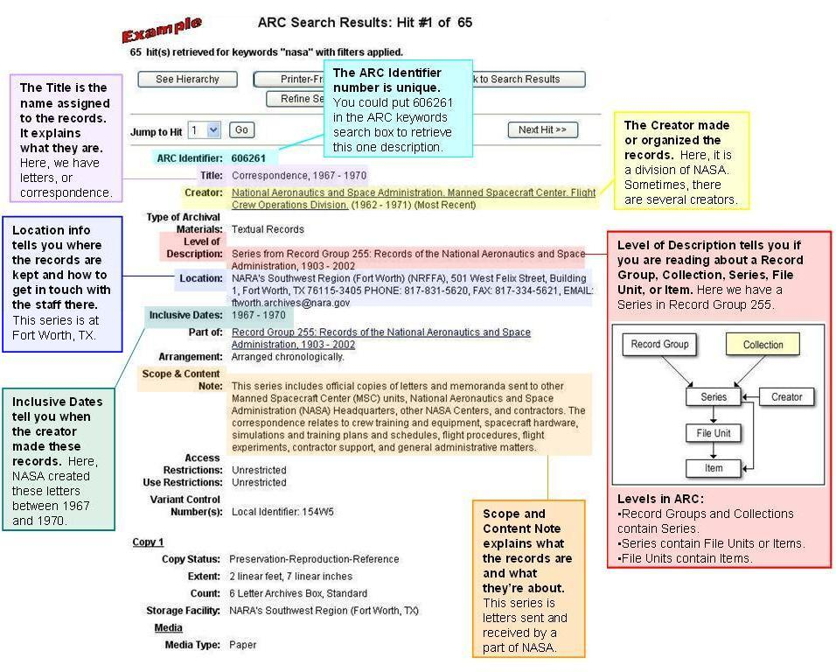

- Read more about the Record Group and Series concepts.

Part 2: Search Tips for Educators and Students

Anatomy of the ARC Basic Search Screen

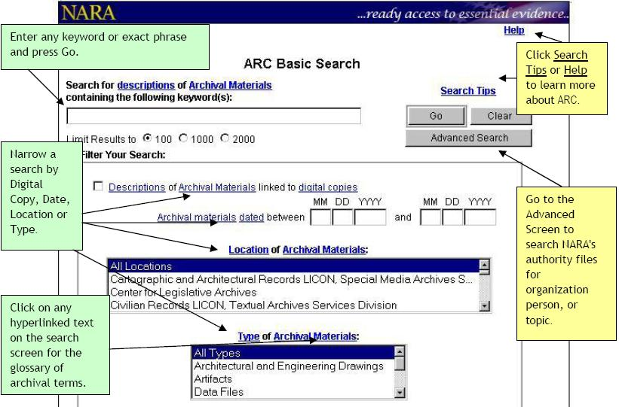

ARC allows you to search in various ways for federal records.

Keyword
The keyword search in ARC searches most fields in the archival descriptions. Search for multiple keywords at the same time by using the words:
- AND
- OR
- NOT
For example, search for baseball or softball to find descriptions with either keyword in them.

Digital Copies
ARC has thousands of digital copies (or digital images) in the catalog. To search only for descriptions linked to digital images, check the box next to "Descriptions of Archival Materials linked to digital copies.”

See ARC Galleries for highlights or ARC Galleries A to Z for a list of all topics featured. For more details on how to view and print digital copies in ARC, see Illustrated Search Steps and Hints: Viewing Digital Copies of Buffalo Bill Materials.

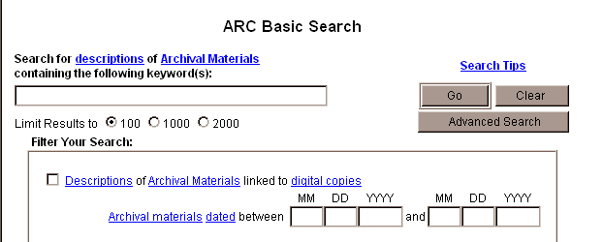

Dates
This filter allows you to narrow your search by means of the dates associated with the archival materials.
The Date Range consists of two sets of date boxes. You may enter a date to search for in either or both. ARC will find descriptions of materials that fall within that range.

Inclusive v. Coverage Dates
Often you will see descriptions with two sets of dates: inclusive dates and coverage dates. Inclusive dates are the dates that the records were created. Coverage dates are the dates of the time period that the records document.
For example, the War Department began creating individual service files for Revolutionary War soldiers in 1890. The inclusive or creation dates for these records are 1890-1913, the dates that the War Department was creating the records. The coverage dates are 1775-1781, the dates of the Revolutionary War.

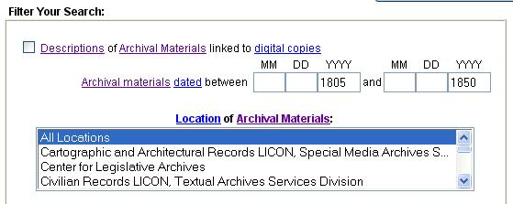

Location
You can filter a keywords search to only return descriptions of records available at a specific National Archives location. Type your keywords into the box and select any location from the filter list. In the example below, we searched for records related to the Apollo space missions held by NARA’s Southwest Region in Fort Worth, Texas. (If, instead, you are interested in finding records about a particular state or region, try putting the name into the keywords box.)

- Press the Yellow Search button in the upper left corner of this page to go to the Basic search screen.  - Type the words Apollo in the Keywords box.  - Select the limit results radio button for 2000.  - Select the locations filter marked NARA's Southwest Region (Fort Worth).  - Press the Go button.  - When hits are returned for your search, view the full result of your hit by selecting the Title link. |  | 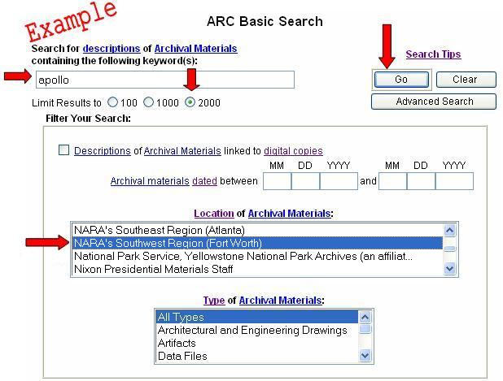

- More Search Tips: How to Search in ARC
Part 3: Printing, Downloading, and Ordering Records Found in ARC

Printing from ARC

Descriptions and images found in ARC can be printed. You can also print out your list of search results; this is very useful for viewing hundreds of thumbnail image search results on one page. Click on the Print Friendly Version Button at the top of the screen and then use the print function on your computer.

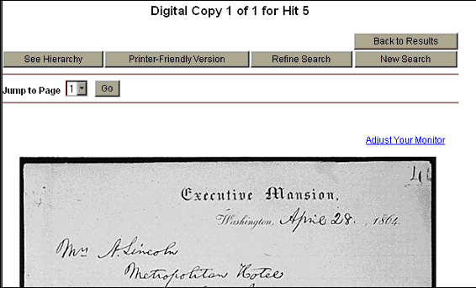
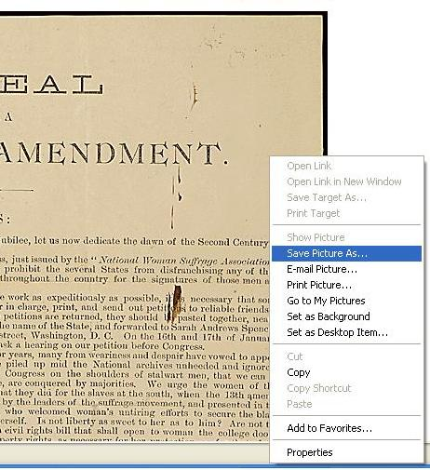
Downloading Images

Both the thumbnail (small) and larger images in ARC can be saved to your computer or onto a disc or CD-rom.

1. Right Click on the image.
2. Click on Save Picture As.
3. A window with options for where you would like to save the image on your computer will appear. (You may assign a new filename to the image. We recommend changing the file name to the ARC ID number so you can match it up with the description later.)
4. Click OK.
5. Open the file folder or drive where you saved the file and double click on the file.
6. Or open a photo editor or an Internet browser and select Open from the File menu. Browse for the file and double click on it to open it in the viewer.
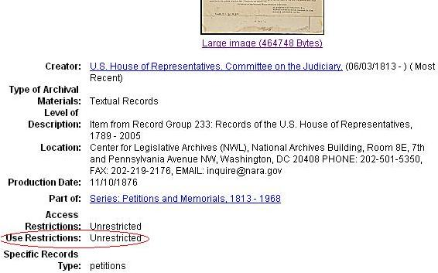
Check under the Use Restrictions listed in the ARC description. Restrictions may apply to the materials, based on copyright or other use restrictions. Read information about Publication of Photographs Furnished by Still Pictures, particularly the section on Crediting the National Archives.

Citing Records

NARA’s General Information Leaflet 17: Citing Records in the National Archives of the United States covers how to cite NARA records of various levels of description and various media formats. Your students should refer to the leaflet when citing NARA records in their papers.

Ordering Records Found in ARC
If you would like to receive copies of any records you find described in ARC you can either request copies for a fee or visit NARA.
- Ordering Copies: For more information on ordering photocopies please go to our Obtaining Copies of Records page.
- Contacting NARA: If you have further questions about records you find in ARC, the location and contact information is available in the ARC description in the location field. The unit’s name, address, phone number, fax number, and preferred email address appear. You may send an email to inquire@nara.gov with general questions about NARA.
- Visiting NARA for Research: You can visit the location listed in each description to see the records. Instead, you can contact that location to arrange for copies of the records. Allow at least 48 hours for offices to retrieve records that are stored off site. For more information on visiting our facilities please go to our Planning Your Research Visit page.
- Visiting NARA with Your Students: See more information about visiting the National Archives Experience and bringing your class to visit the National Archives in Washington, DC. No chance of making a trip to Washington, DC, anytime soon? NARA’s Regional Archives and Presidential Libraries, located around the country, welcome school groups.

(August 2007)

Endnotes (URLs) ? http://www.archives.gov/education/lessons/
http://www.archives.gov/education/
http://www.nationalhistoryday.org/
http://www.archives.gov/education/lessons/memphis-v-mlk/
http://www.archives.gov/research/guide-fed-records/index-numeric/concept.html
http://www.archives.gov/research/start/how-records-grouped.html
http://www.archives.gov/research/arc/topics/index.html
http://www.archives.gov/research/arc/topics/gallery-a-to-z.html
http://www.archives.gov/research/arc/topics/buffalo-bill/index.html
http://www.archives.gov/research/arc/how-to-search.html
http://www.archives.gov/research/order/restrictions.html
http://www.archives.gov/research/formats/publication-of-photos.html
http://www.archives.gov/research/formats/publication-of-photos.html#credit
http://www.archives.gov/publications/general-info-leaflets/17.html
http://www.archives.gov/national-archives-experience/visit/visit.html
http://www.archives.gov/national-archives-experience/visit/visit_groups.html
http://www.archives.gov/locations/regional-archives.html
http://www.archives.gov/presidential-libraries/visit/

