Hospital Survey on
Patient Safety Culture

Prepared for:
Agency for Healthcare Research and Quality
U.S. Department of Health and Human Services
540 Gaither Road
Rockville, MD 20850
http://www.ahrq.gov

Contract No. 290-96-0004

Prepared by:
Westat, Rockville, MD

Joann Sorra, Ph.D.
Veronica Nieva, Ph.D.

Principal Investigators

AHRQ Publication No. 04-0041
September 2004
This document is in the public domain and may be used and reprinted without permission except those copyrighted materials noted for which further reproduction is prohibited without the specific permission of the copyright holders.

Suggested Citation:
Sorra JS, Nieva VF. Hospital Survey on Patient Safety Culture. (Prepared by Westat, under Contract No. 290-96-0004). AHRQ Publication No. 04-0041. Rockville, MD: Agency for Healthcare Research and Quality. September 2004.
Preface

The Agency for Healthcare Research and Quality (AHRQ) is the lead Federal agency charged with conducting and supporting research to improve patient safety and health care quality for all Americans. AHRQ’s goal is to support a culture of safety and quality improvement in the Nation’s healthcare system that will help speed the adoption of research findings into practice and policy.

To that end, AHRQ has sponsored the development of this survey on patient safety culture. This tool is useful for assessing the safety culture of a hospital as a whole, or for specific units within hospitals. Moreover, the survey can be used to track changes in patient safety over time and to evaluate the impact of patient safety interventions.

In addition, since 2001, AHRQ has supported a wide range of other patient safety research to develop innovative approaches to collecting, analyzing, and reporting patient safety data; understanding the impact of working conditions on patient safety, including the sciences of ergonomics and human factors; and fostering the use of information technology to reduce medical errors.

As a result, many other patient safety products and tools also are available from the Agency. These can be found on AHRQ’s Website, at http://www.ahrq.gov, or by calling AHRQ’s publications clearinghouse, at 1-800-358-9295.

I hope that this survey, as well as AHRQ’s other patient safety tools, will be useful in helping you to ensure that your hospital or health care facility is as safe as possible and, as a result, will help us to achieve the vision that we all share—a health care system in which patients are never harmed in the course of receiving care.

Carolyn M. Clancy, M.D.
Director
Agency for Healthcare Research and Quality

Contents

Part One: Survey User’s Guide
Chapter 1. Introduction 1
Development of the Hospital Survey on Patient Safety Culture 1
Who Should Complete the Survey 2
Safety Culture Dimensions Measured in the Survey 2
Modifying or Customizing the Survey 3
Contents of This Survey User’s Guide 4
Chapter 2. Getting Started 7
Determine Available Resources, Project Scope, and Schedule 7
Plan Your Project 8
Decide Whether To Use an Outside Vendor 8
Form a Project Team 9
Chapter 3. Selecting a Sample 11
Determine Whom To Survey 11
Determine Your Sample Size 12
Compile Your Sample List 12
Review and Fine-Tune Your Sample 13
Chapter 4. Determining Your Data Collection Methods 15
Decide How Surveys Will Be Distributed and Returned 15
Establish Points-of-Contact Within the Hospital 16
Chapter 5. Establishing Data Collection Procedures 17
Maximize Your Response Rate 17
Track Responses With or Without Identifiers 18
Assemble Survey Materials 20
Track Responses and Response Rates 22
Chapter 6. Conducting a Web-based Survey 25
Consider the Pros and Cons of Web-based Surveys 25
Design and Pretest the Web-based Survey 26
Develop a Web-based Data Collection Plan 28
Chapter 7. Preparing and Analyzing Data, and Producing Reports 31
Identify Complete and Incomplete Surveys 31
Code and Enter the Data 32
Check and Electronically Clean the Data 33
Analyze the Data and Produce Reports of the Results 33
References 37

Part Two: Survey Materials
The Survey Form (taken from electronic file) 41
Safety Culture Dimensions and Reliabilities 45
Sample Page from Survey Feedback Report (taken from electronic file) 49

Appendixes
Appendix A. Pilot Study for the Hospital Survey on Patient Safety Culture:
A Summary of Reliability and Validity Findings 53
Appendix B. Safety Culture Assessment: A Tool for Improving Patient Safety in
Healthcare Organizations 67

Chapter 1. Introduction

Patient safety is a critical component of health care quality. As health care organizations continually strive to improve, there is a growing recognition of the importance of establishing a culture of safety. Achieving a culture of safety requires an understanding of the values, beliefs, and norms about what is important in an organization and what attitudes and behaviors related to patient safety are expected and appropriate. A definition of safety culture is provided below.

Development of the Hospital Survey on
Patient Safety Culture

Recognizing the need for a measurement tool to assess the culture of patient safety in health care organizations, the Medical Errors Workgroup of the Quality Interagency Coordination Task Force (QuIC) sponsored the development of a hospital survey focusing on patient safety culture. Funded by the Agency for Healthcare Research and Quality (AHRQ), the Hospital Survey on Patient Safety Culture was developed by a private research organization under contract with AHRQ.

To develop this survey, the researchers conducted a review of the literature pertaining to safety, accidents, medical error, error reporting, safety climate and culture, and organizational climate and culture. In addition, the researchers reviewed existing published and unpublished safety culture surveys and conducted in-person and telephone interviews with hospital staff. The survey was pretested with hospital staff to ensure the items were easily understood and relevant to patient safety in a hospital setting. Finally, the survey was pilot tested with more than 1,400 hospital employees from 21 hospitals across the United States. The pilot data were analyzed, examining item statistics and the reliability and validity of the safety culture scales, as well as the factor structure of the survey through exploratory and confirmatory factor analyses. Based on the analysis of the pilot data, the survey was revised by retaining only the best items and scales. The resulting Hospital Survey on Patient Safety Culture has sound psychometric properties for the included items and scales.

The survey and its accompanying toolkit materials are designed to provide hospital officials with the basic knowledge and tools needed to conduct a safety culture assessment, along with ideas for using the data. Part One of the Hospital Survey presents issues inherent to the data collection process and the overall project organization. Part Two includes the survey form, followed by a separate overview of the included items, grouped according to the safety culture dimensions they are intended to measure and the reliability findings derived from the pilot data. A sample page from the Survey Feedback Report also is provided. Appendix A summarizes the development of the pilot survey. Appendix B is a journal article on the uses of safety culture assessments and their place in the clinical treatment environment.

Who Should Complete the Survey

The Hospital Survey on Patient Safety Culture examines patient safety culture from a hospital staff perspective. The survey can be completed by all types of hospital staff—from housekeeping and security to nurses and physicians. The survey is best suited for the following, however:

- Hospital staff who have direct contact or interaction with patients (clinical staff, such as nurses, or nonclinical staff, such as unit clerks);

- Hospital staff who may not have direct contact or interaction with patients but whose work directly affects patient care (staff in units such as pharmacy, laboratory/pathology);

- Hospital-employed physicians who spend most of their work hours in the hospital (emergency department physicians, hospitalists, pathologists); and

- Hospital supervisors, managers, and administrators.

Note that some physicians have privileges at hospitals but are not hospital employees and may spend the majority of their work time in nonhospital, outpatient settings. Consequently, these types of physicians may not be fully aware of the safety culture of the hospital and generally should not be asked to complete the survey. Careful consideration should be given when deciding which physicians to include or exclude from taking the survey.
Safety Culture Dimensions Measured in the Survey

The survey places an emphasis on patient safety issues and on error and event reporting. The survey measures seven unit-level aspects of safety culture:
- Supervisor/Manager Expectations & Actions Promoting Safety (4 items),
- Organizational Learning—Continuous Improvement (3 items),
- Teamwork Within Units (4 items),
- Communication Openness (3 items),
- Feedback and Communication About Error (3 items),
- Nonpunitive Response to Error (3 items), and
- Staffing (4 items).

In addition, the survey measures three hospital-level aspects of safety culture:
- Hospital Management Support for Patient Safety (3 items),
- Teamwork Across Hospital Units (4 items), and
- Hospital Handoffs and Transitions (4 items).

Finally, four outcome variables are included:
- Overall Perceptions of Safety (4 items),
- Frequency of Event Reporting (3 items),
- Patient Safety Grade (of the Hospital Unit) (1 item), and
- Number of Events Reported (1 item).

Modifying or Customizing the Survey

The survey was developed to be general enough for use in most hospitals. You may find, however, that the survey uses terms that are different from those used in your hospital, or that your hospital’s management would like to ask hospital staff additional questions about patient safety. Anticipating the need for some modification or customization of the survey, the survey form and feedback report templates are available as modifiable electronic files at the AHRQ Website (www.ahrq.gov/qual/hospculture/). We recommend making only those changes to the survey that are absolutely necessary, because changes may affect the reliability and overall validity of the survey, and may make comparisons with other hospitals difficult.

Here are some suggestions regarding modifications to the survey:

- Modifying background items. The survey begins with a background question about the respondent’s primary work area or unit. The survey ends with some additional background questions about such topics as staff position, tenure in the organization, and work hours. Your hospital may wish to modify the responses to these background questions so they are tailored to reflect the names of your hospital’s work units, staff position titles, and the like.

- Use of the term “unit.” The survey places most of its emphasis on safety culture at the unit level, because staff will be most familiar with safety culture at this level. There also is a section that pertains to safety culture across the hospital as a whole. If you work in a smaller hospital that does not have differentiated units with multiple staff members in each unit, you may want to consider modifying some of the instructions and/or items in the survey from a focus on the “unit” to a focus on the hospital as a whole. The term “unit” also may be replaced by an equivalent term, such as “department,” if it suits your hospital (just be sure to make this replacement everywhere it applies in the survey).

- Adding items. If your hospital would like to add additional items to the survey, we recommend adding these items toward the end of the survey (after “Section G: Number of Events Reported”).

- Making the survey shorter or removing items. Although the survey takes only about 10 to 15 minutes to complete, your hospital may want to administer a shorter survey with fewer items. Part Two of the Hospital Survey on Patient Safety Culture includes an overview of the safety culture dimensions assessed in the survey and the reliability figures for each dimension. Delete the dimensions that your hospital is not interested in assessing (be sure to delete all of the items associated with those dimensions). In this way, your hospital’s results on the remaining safety culture dimensions still can be compared to other hospitals that use the survey.

- Adapting the survey for Web-based data collection. We recommend using a paper-based survey data collection methodology to make sure you obtain the highest possible response rates. Despite the probability of lower response rates, however, your hospital may decide that it is more feasible and logistically advantageous to do data collection with a web-based survey. Web-based surveys have a wide range of design features and can involve different data collection procedures, so please be sure to read Chapter 6: Conducting a Web-based Survey, for guidelines on how to adapt the Hospital Survey for this type of data collection.

Contents of This Survey User’s Guide

This Survey User’s Guide is designed to assist you in conducting your own hospital survey on patient safety. This guide provides a general overview of the issues and major decisions involved in conducting a survey and reporting the results. The guide includes the following chapters:
- Chapter 2—Getting Started. Chapter 2 provides information on planning the project, outlines major decisions and tasks in a task timeline, and discusses hiring a vendor and forming a project team.
- Chapter 3—Selecting a Sample. Chapter 3 describes the process of selecting a suitable sample group from your staff.
- Chapter 4—Determining Your Data Collection Methods. Chapter 4 outlines decisions about how surveys will be sent and returned and discusses the importance of establishing points-of-contact within the hospital.
- Chapter 5—Establishing Data Collection Procedures. Chapter 5 suggests techniques for maximizing your response rate, discusses the importance of protecting confidentiality, and outlines survey materials to be assembled.
- Chapter 6—Conducting a Web-based Survey. Chapter 6 presents the pros and cons of using a Web-based survey approach to data collection and outlines special considerations that must be taken into account.
- Chapter 7—Preparing and Analyzing Data, and Producing Reports. Chapter 6 discusses the steps needed to prepare the data and analyze the responses and provides suggestions for producing feedback reports.

Chapter 2. Getting Started

Before you begin, it is important to understand the basic tasks involved in a survey data collection process and decide who will manage the project. This chapter is designed to guide you through the planning stage of your project.

Determine Available Resources, Project Scope, and Schedule

Two of the most important elements of an effective project are a clear budget to determine the scope of your data collection effort and a realistic schedule. Therefore, to plan the scope of the project, you need to think about your available resources. You may want to ask yourself the following questions:

- How much money and/or resources are available to conduct this project?

- Who within the hospital is available to work on this project?

- When do I need to have the survey results completed and available?

- Do we have the technical capabilities to conduct this project in the hospital, or do we need to consider using an outside company or vendor for some or all of the tasks?

You should read this entire Survey User’s Guide before deciding on a budget and the project’s scope, because this document outlines the tasks that need to be accomplished. Each task has interrelated cost and scheduling implications to consider. Use the following guidelines to determine your budget and plan:

- Consider all of the project tasks and whether the tasks will be performed in-house or through an outside company or vendor.

- Develop initial budget and scheduling estimates and revise as needed given your available resources, existing deadlines, and project implementation decisions.

- Include a cushion for unexpected expenses, and account for tasks that may take longer than expected.
Plan Your Project

Use the timeline below as a guideline in planning the tasks to be completed. Plan for at least 10 weeks from the beginning of the project to the end of data collection. Add a few more weeks for data cleaning, analysis, and report preparation. If you are conducting a web survey, add several weeks to the beginning of the timeline to allow time for adapting the survey to a web-based format, and pretesting to ensure that the web version works properly before beginning data collection.

Table 1. Task Timeline for Project Planning

EEnd of
ddata ccollection
}

Decide Whether to Use an Outside Vendor

You may want to consider using an outside company or vendor either to handle your survey data collection tasks or to analyze the data and produce reports of the results. Hiring a vendor may be a good idea for several reasons. Working with an outside vendor may help ensure neutrality and the credibility of your results. In addition, since confidentiality of survey responses is a typical concern, staff may feel their responses will be more confidential when they are returned to an outside vendor. Vendors typically also have experienced staff to perform all of the necessary activities and the facilities and equipment to handle the tasks. A professional and experienced firm may be able to provide your hospital with better quality results in a more timely manner than if you were to do the tasks yourself.

On the other hand, the use of a vendor may add too much additional expense to your project. If your hospital system has a corporate headquarters, you may want to find out if the headquarters staff is capable of and interested in conducting a survey of your hospital and analyzing the data for you. Your hospital system may be interested in conducting a system-wide survey effort; not just in your hospital. Moreover, your hospital’s staff may feel more comfortable about the confidentiality of their responses if surveys can be returned to a corporate headquarters address.

If you are considering hiring an outside vendor, the following guidelines may help you to select the right one:
- Look for a vendor with expertise in survey research. Local universities may have their own survey research centers or be able to refer you to vendors. You also may inquire within your hospital or hospital system to find out if particular vendors have been used before for survey data collection, analysis, and reporting.
- Gain an understanding of the vendor’s capabilities and strengths, so you can match them to the needs of your project. Determine whether the vendor can conduct all of the project components you want them to handle. Some vendors will be able to handle your feedback report needs; others will not.
- Provide potential vendors with a written, clear outline of work requirements. Make tasks, expectations, deadlines, and deliverables clear and specific—mention all documentation, files, data sets, and other deliverables you expect to receive. Then, ask each vendor to submit a short proposal describing the work they plan to conduct, the qualifications of their company and staff, and details regarding methods and costs.
- Meet with the vendor to make sure you will be able to work well together.
- Once you have chosen a vendor, institute monitoring, supervision, and problem-resolution procedures.

Form a Project Team

Whether you conduct the survey in-house or through an outside vendor, you will need to establish a project team responsible for planning and managing the project. Your project team may consist of one or more individuals from your own hospital staff, outsourced vendor staff, or a combination.

The Project Team’s Responsibilities

The project team is responsible for a variety of duties—either for conducting them in-house or for monitoring them if an outside vendor is hired. Highlights of some of these project duties include:
- Planning and budgeting—Determining the scope of the project based on available resources, planning project tasks, and monitoring the budget.
- Selecting a sample—Determining how many and which staff to survey.

- Establishing department-level contact persons—Contacting department- and unit-level points-of-contact in the hospital to support survey administration, maintain open communication throughout the project, and provide assistance.

- Preparing survey materials—Printing surveys, preparing postage-paid return envelopes and mailing labels, and compiling these components for your survey mailout.

- Distributing and receiving survey materials—Distributing prenotification letters, surveys, and nonresponse postcards; and handling receipt of completed surveys.

- Tracking survey responses and response rates—Monitoring who has returned the survey and who should receive followup materials.

- Handling data entry, analysis, and report preparation—Reviewing survey data for respondent errors and data entry errors in electronic data files, conducting data analysis, and preparing a report of the results.

- Coordinating with and monitoring an outside vendor (optional)—Outlining the requirements of the project to solicit bids from outside vendors, selecting a vendor, coordinating tasks to be completed in-house versus by the vendor, and monitoring progress to ensure that the necessary work is completed and deadlines are met.

The remainder of this Survey User’s Guide contains the information necessary to collect survey data using an in-house project team. If you decide to hire a vendor, you may use the information as a resource to facilitate communication with your vendor about the various project tasks and decisions that will be required.

Chapter 3. Selecting a Sample

The population from which you select your sample will be staff in your hospital or hospital system. You either can administer surveys to everyone in your population of hospital staff, or you can administer surveys to a subset or sample of your population. Although surveying all staff may seem simple or most desirable, the additional time and resources required may eliminate that option. If you decide to administer surveys to all hospital staff, this chapter is not applicable. If you are uncertain or have decided that you will administer surveys to a sample of hospital staff, however, this chapter tells you how to select your sample.

When you select a sample, you are selecting a group of people that closely represents the population so that you can generalize your sample’s results to the broader population. To select your sample, you need to determine which hospital staff you want to survey and the number of staff that need to be surveyed.

Determine Whom To Survey

All staff in your hospital or hospital system represent your population. From this population, you may want to survey staff from every area of the hospital, or you may want to focus on specific units, staffing categories, or staffing levels. There are several ways to select a sample from a population. Several types of samples are described below. Select the type that best matches your needs, taking into account what is practical given your available resources.

- Staff in particular staffing categories. You may be interested only in surveying staff in specific staffing categories, such as nursing. With this approach, you may select all staff within a staffing category or select a subset of the staff. This approach alone, however, may not be sufficient to represent the views of all staff in the hospital.

- Staff in particular areas/units. You may want to survey staff in particular hospital areas or units, such as OB/GYN, Emergency, Pharmacy, etc. The list below presents three examples of ways staff can be selected using this approach, listed in order from most to least representative of the entire hospital population:
- A subset of staff from all areas/units (most representative).
- All staff from some areas/units.
- A subset of staff from some areas/units (least representative).

- A combined approach. If possible, we recommend surveying staff using a combination of the two sample types just described. For example, you may be interested in surveying all nurses (a staffing category), but only a subset of staff from every hospital area (excluding nursing). Using a combination of sample types allows you either to oversample or selectively sample certain types of staff in an attempt to thoroughly represent the diversity of hospital staff.

Determine Your Sample Size

The size of your sample will depend on whom you want to survey and your available resources. While your resources may limit the number of staff you can survey, the more staff you survey, the more likely you are to adequately represent your population.

To determine your sample size, think about your budget and how many responses you want to receive (i.e., your response goal). Because not everyone will respond, you can expect to receive completed surveys from about 30 percent to 50 percent of your sample. Therefore, to reach your response goal, your sample size should be at least twice the number of responses you want to receive. If the number of responses you eventually want to achieve is 200 completed surveys, be prepared to administer surveys to at least 400 staff members (an example of sample selection is presented at the end of this chapter).

Budget Considerations

Your budget may determine the number of staff you can sample. To reach an adequate number of responses, you will need to send initial surveys as well as followup surveys to those who do not respond to the first survey. Your budget also should take into consideration additional costs for materials such as envelopes and postage, if you are mailing surveys.

Compile Your Sample List

After you determine whom you want to survey and your sample size, compile a list of the staff from which to select your sample. When compiling your sample list, include several items of information for each staff member:

- First and last name,
- Internal hospital mailing address, or home or office addresses if surveys will be mailed,
- E-mail address (if conducting a Web-based survey or using e-mail to send prenotification letters, web survey hyperlinks, or reminders),
- Hospital area/unit, and
- Staffing category or job title.

If you are selecting ALL staff in a particular staffing category, hospital area, or unit, no sampling is needed; so simply compile a list of all these staff. If you are selecting a subset or sample of staff from a particular staffing category, hospital area, or unit, you will need to use a method such as simple random sampling or systematic sampling.

Simple Random vs. Systematic Sampling

Simple random sampling involves selecting staff randomly, such that each staff member has an equal chance of being selected. Systematic sampling essentially involves selecting every N^{th} person from a population list. For example, if you have a list of 100 names in a particular group and need to select 25 to include in your sample, you would choose to begin at a random point on the list and then select every 4th staff member to compile your sample list. Thus, if you began with the first person on the list, you would select the 4th, 8th, 12th, 16th, etc. staff member, up to the 100th staff member, compiling a total of 25 names in your sample list.

Review and Fine-tune Your Sample

Once you have compiled your sample list, review the list to make sure it is appropriate to survey each staff member on the list. To the extent possible, ensure that this information is complete, up-to-date, and accurate. Points to check for include:
- Staff on administrative or extended sick leave,
- Staff who appear in more than one staffing category or hospital area/unit,
- Staff who have moved to another hospital area/unit,
- Staff who no longer work at the hospital, and
- Other changes that may affect the accuracy of your list of names or mailing addresses.

If you believe there are certain staff who should not receive the survey or that your records are not complete, selectively remove people from the list. If you remove someone from the list, add another staff member in her/his place.

Revising Your Sample

You may review your list and realize that you would like to survey an additional staffing category or hospital area that was not part of your initial sample. In this case, you will need to add to your list.

Selecting a Sample—An Example

Suppose you work in a 200-bed hospital with 1,400 staff members. Nursing is the single
largest staffing category, with 1,000 staff. Smaller hospital areas or units have a combined
total of 100 non-nursing staff, and larger hospital areas or units have a combined total of 300
non-nursing staff.

- Determine Whom To Survey. You decide to survey a sample of nurses, all non-nursing
staff from smaller hospital areas or units, and all non-nursing staff from the larger hospital
areas or units. You therefore choose a combination approach to select your sample.

- Determine Your Sample Size. Your response goal is 450 completed surveys, and this goal
fits within your budget. Therefore, your sample size will be 900 staff members (expecting a
50% response rate).

- Compile Your Sample List. Your final sample list of 900 staff members consists of:

1. Nursing—From the total of 1,000 nurses, a sample of 500 nurses is selected (250 expected completes). The sample was selected as follows:
a) A list of the 1,000 nurses was produced.
b) Using systematic sampling, every other nurse on the list was selected to be included in the sample until 500 names were selected (1,000 total nurses divided by 500 nurses needed = every 2nd nurse).

2. Smaller hospital areas or units—All 100 non-nursing staff (50 expected completes).

3. Larger hospital areas or units—All 300 non-nursing staff (150 expected completes).

- Review and Fine-Tune Your Sample. When verifying the contact information for the initial sample of 900 staff, you found that 25 staff no longer work for the hospital and should be
dropped from the list. You may or may not want to replace these names. To replace the names, randomly select additional staff from the same staffing categories or hospital areas as the staff who were dropped.

Chapter 4. Determining Your Data Collection Methods

Once you have determined your available resources, project scope, and timeline; established a project team; and selected your sample (or populations to include), you need to decide how to collect the data. This chapter guides you through decisions about data collection methods. The methods you choose for sending and returning surveys affect how your staff views the confidentiality of their responses, and this will impact your overall survey response rate. To achieve maximum response rates among all hospital staff, we recommend using a paper-based data collection method. Current research and evidence shows that Web-based surveys have lower response rates than paper surveys (Groves, 2002), so the procedures outlined in Chapters 4 and 5 assume a paper-based approach. If your hospital is considering a web survey, Chapter 6 presents the pros and cons and outlines special considerations that need to be taken into account.

Decide How Surveys will be Distributed and Returned

When deciding how surveys will be distributed and returned, consider any previous experience your hospital has had with surveys. Have previous hospital surveys been mailed to staff home addresses or administered through the internal mail system at work? Were surveys returned through contact persons, the internal mail system, to “drop box” locations in the hospital, or by mail using postage-paid return envelopes? Were surveys returned to a location within the hospital or to an outside vendor? What were employee survey response rates? If possible, it is best to use methods that previously were successful in your hospital.

Distributing Surveys

Surveys can be mailed directly to staff home addresses or administered through an internal mail system at work. If surveys are mailed to homes, you need to verify that you have correct, updated home addresses of staff members and account for outgoing and return postage in your budget. If surveys are administered to staff at work, we recommend that you provide explicit instructions and allow staff to complete the survey during work time to emphasize hospital administration’s support for the data collection effort.

Returning Surveys

If your budget is limited, completed surveys can be returned to a designated hospital contact person through the internal mail system or to survey drop-off locations within the hospital. This method of returning surveys, however, may raise staff concerns about the confidentiality of their responses. Rely on your hospital’s past experience with these methods if they have been successful.

If your hospital has had little experience administering employee surveys or you feel there are confidentiality concerns, it is best to have staff mail their completed surveys directly to an outside vendor or an address outside the hospital via postage-paid return envelopes. If you do not use a vendor, consider having the surveys returned to a corporate headquarters address so staff will be assured that no one at their hospital will see the completed surveys. Remember, if surveys are returned through the mail, you will need to account for return postage in your budget.

Establish Points-of-Contact Within the Hospital

You will want to establish people in the hospital to serve as points-of-contact for the survey. Points-of-contact increase the visibility of the survey by showing their support for the effort and by helping to answer questions about the survey. Decide how many points-of-contact are needed by taking into account the number of staff and hospital areas or units taking the survey. We recommend using at least two types of points-of-contact.

A Main Hospital Point-of-Contact

At least one main hospital point-of-contact should be appointed from the project team so that staff will have one central source for their questions or concerns about the survey. We recommend including contact information for the main hospital point-of-contact in the prenotification letter or survey cover letter sent to staff (i.e., phone number, e-mail address, office number). The main hospital point-of-contact has several duties, including:

- Answering questions about survey items, instructions, or processes,
- Responding to staff comments and concerns,
- Helping to coordinate survey mailing and receipt of completed surveys,
- Communicating with outside vendors as needed, and
- Communicating with other points-of-contact as necessary.

Additional Points-of-Contact

You may decide to recruit points-of-contact for each hospital area, unit, or staffing category included in your sample. A unit-level point-of-contact is responsible for promoting and administering the survey within his/her unit and for reminding unit staff to complete the survey, without coercing them in any way. An informational letter describing these duties and the overall survey process should be sent to potential contacts before you begin survey administration. Unit-level contacts typically are at the management or supervisory level, such as nurse managers, department managers, or shift supervisors.
Chapter 5. Establishing Data Collection Procedures

Once you have decided how you want the surveys distributed and returned, and have established at least one main hospital point-of-contact, you need to make several decisions regarding your data collection procedures. This chapter describes strategies for maximizing your response rate and outlines methods for tracking responses and collecting data.

Maximize Your Response Rate

The response rate is the total number of complete returned surveys divided by the total number of eligible staff sampled. Achieving a high response rate is very important for making valid generalizations about your hospital, based on your survey data collection effort. Surveys are used to infer something about a particular population. There must be enough survey respondents to accurately represent the hospital or larger population, before you can legitimately present your survey results as a reflection of your hospital’s safety culture.

If your response rate is low, there is a danger that the large number of staff who did not respond to the survey would have answered very differently from those who did respond. Therefore, an overall response rate of 50 percent or more should be your minimal goal. The higher the response rate, the more confident you can be that you have an adequate representation of the staff’s views. To achieve high response rates, we recommend a basic data collection approach that involves sending a paper survey and the following items, in the order presented:

- Prenotification letter. Before administering the survey, create a letter signed by your hospital’s CEO or president on hospital letterhead. The letter will inform all the staff in your sample that they will be receiving a survey and that hospital administration is in full support of the survey effort. If an outside vendor is handling the data collection duties, use the letter as an opportunity to introduce the vendor.

- First survey. About 1 week later, send the survey to all staff in your sample group. Include a supporting cover letter similar in content to the prenotification letter and instructions for completing and returning the survey. Include preaddressed postage-paid envelopes to make it easy for respondents to return their surveys.

In the cover letter, or on the survey form, ask staff to complete the survey within 7 days, but do not print an actual deadline date on the letter or survey. Sometimes data collection schedules get delayed, and you do not want to reprint letters or surveys because they are outdated. In addition, sometimes people will not complete a survey if they notice that it is beyond the deadline date.

- First reminder postcard or letter. Approximately 2 weeks after sending the survey, send a reminder postcard or letter to the sample group thanking those who have already responded and reminding others to please respond. The reminders can be sent to everyone, or only to those who have not responded.

- Second survey. Two weeks after sending the first reminder, send a second survey to nonrespondents, including a cover letter thanking those who have already responded and reminding others to please complete the second survey. If you are not using identifiers to track responses, it may be necessary to send a second survey to everyone in your sample.

- Second reminder postcard or letter (optional). Approximately 1 week after sending the followup survey, you may choose to send a second and final reminder.

Track Responses With or Without Identifiers

To ensure confidentiality, respondents are asked not to provide their names on the completed survey forms. It is sometimes helpful, however, to include a number or code known as an identifier, on your surveys. Identifiers typically are used to track whether individuals have responded to the survey and/or to track the particular unit or hospital associated with a completed survey. The advantage of using identifiers is that they allow you to track responses so you:

  - Send reminders and followup materials only to nonrespondents, saving on costs;
  - Eliminate the possibility of someone completing more than one survey; and
  - Calculate response rates at the unit or hospital level (hospital-level response rates are important when administering the survey in several hospitals at the same time).

On the other hand, there are a number of disadvantages to using identifiers. Some respondents will be so concerned about the confidentiality of their responses that they will de-identify their own surveys by removing or marking out their identification number or code. Respondents also may refuse to complete the survey if they are concerned that their response will be tracked, especially if the data will be collected and analyzed within the hospital (rather than by an outside vendor). Furthermore, the inclusion of any type of identifier on surveys mandates a very strict adherence to procedures protecting the confidentiality of the information linking individual staff to the identification numbers or codes.

Reply Postcards with Identifiers

An alternative to using identifiers printed on surveys is to include in the survey materials a postage-paid reply postcard that has an identifying number or code (with no identifiers on the actual surveys). In the sample reply postcard, the number “155” is one respondent’s individual identification number. When respondents return their completed surveys, they are instructed to return the reply postcard separately, which notifies you that the staff member with the particular individual identification number has returned the survey and therefore does not need to be sent reminder materials. Using a separate postcard ensures the anonymity of survey responses because there is no way to link any completed survey answers to a particular individual. The main obstacle to this approach is that it is not an exact means of tracking responses, because there may be people who send in their surveys but not their postcard, and vice versa.
Sample Reply Postcard with an Identifier:

No Identifiers

If you decide it is best not to use any identifiers, reminder letters and followup surveys must be sent to all staff with instructions to disregard the second survey if the first survey was completed and mailed. You may receive phone calls from respondents who completed and returned their survey, wondering why they received followup materials, but you can instruct them to disregard the materials and remove their names from further followup mailings.

Assemble Survey Materials

The following materials will need to be assembled in preparation for the survey mailing. To improve response rates, it is advantageous to personalize outer envelopes and letters (e.g., addressed to “Dear John Doe”). Care should be taken, however, to prevent names from appearing on the actual survey forms.

- Publicity materials (optional). Depending on how extensively you survey your staff, you may want to post informational flyers or send e-mail notices publicizing the survey.

- Unit-level point-of-contact letter (optional). You may want to send a letter to unit-level contact persons describing the purposes of the survey and explaining their role in the survey effort. The letter should be printed on official hospital letterhead, dated with month/year, signed by the hospital CEO, and should provide background information and instructions regarding the survey.

- Prenotification letter. The prenotification letter should describe the purposes of the survey and it should contain the completion instructions. This letter also should be on official hospital letterhead, signed by the hospital CEO or president.

- Cover letter. The cover letter should be on official hospital letterhead and is to be included with the first packet of survey materials. Include the following points:
  - Why the hospital is conducting the survey and how staff responses will be used,
  - Which hospital staff were selected to be surveyed (e.g., all staff, nursing staff, all clinical staff, a random sample of staff, etc.),
  - How much time is needed to complete the survey,
  - Confidentiality or anonymity assurances,
  - Suggested reply timeframe and how to return completed surveys,
  - Incentives for which staff will be eligible, if they respond (Optional), and
  - Contact information for the main hospital point-of-contact.

These points can be summarized in a few short paragraphs. For example:
“The enclosed survey is part of our hospital’s efforts to better address patient safety. The survey is being distributed to (sample description). It will take about 10 to 15 minutes to complete and your individual responses will be kept confidential. Only group statistics will be prepared from the survey results.

Please complete your survey and return it WITHIN THE NEXT 7 DAYS. (Do not provide a specific date) When you have completed your survey, please (provide return instructions). (Optional incentive) As a way of thanking staff members for their participation, respondents will receive (describe incentive).

Please contact [contact name and job position] if you have any questions [provide phone number and email address]. Thank you in advance for your participation in this important effort.”

- Reminder postcards or letters. A reminder postcard or letter is sent to nonrespondents after the first survey administration, asking them to please complete and return their survey.

- Surveys. If you are not tracking responses and plan to send second surveys to everyone in your sample, print at least twice the number of surveys as staff in your sample. If you are tracking responses and will send only second surveys to nonrespondents, you may print fewer surveys. For example, if your hospital’s survey response history typically results in a 20 percent response to the first survey, you could print 80 percent more surveys than were distributed initially, to prepare for the followup survey mailing—800 staff multiplied by .80 equals 640, for a total estimate of 1,440 printed surveys needed.

- Labels. You will need labels for the outside of each survey mailing envelope, addressed either to the home address or internal hospital mailing address of each staff member in your sample. Return address labels may be used on return envelopes. Labels also may be used to place identifiers onto surveys.

- Envelopes. You will need a set of outer envelopes to send the surveys and a set of return envelopes for the return of completed surveys. Preprint the return address on the return envelopes (or use labels). To make sure that the cover letter, survey, and return envelope fit without folding or bending, use slightly larger outer envelopes. Calculate the number of envelopes based on the number of initial and followup surveys to be sent.

- Postage. If surveys are to be sent through the mail, weigh the outgoing packet of survey materials to ensure you have adequate postage. If surveys are to be returned through the mail, weigh the survey and the return envelope to ensure you have adequate postage on the return envelopes. Calculate the total amount of postage based on the number of initial and followup surveys to be mailed.

Track Responses and Response Rates

You, or your vendor, will need to follow survey response rates by tracking completed surveys as they are returned. Tracking returned surveys can be done very simply with a spreadsheet software program. If you are planning to use survey identifiers, create a separate row for each individual identifier. Create columns across the top of your spreadsheet for the date the initial survey is distributed, the date the returned survey is received (so respondents can be excluded from followup reminders), as well as the distribution dates for any first reminders, second surveys, or second reminders. Compile response rates for each round of followup contacts—at the time of the first reminder, the second survey, and the final reminder—to track your response progress.

Closing Out Data Collection

To ensure you receive as many responses as possible, plan to hold open data collection for at least 2 weeks after the second survey or second followup reminder is sent. Referring back to the project timeline on page 8, allow 8 weeks or more from the prenotification letter to the your data collection period closeout. There always will be a few respondents who return the survey very late, so you may want to take this into consideration and hold the data collection period open longer. Once the established cutoff date arrives, close out data collection and begin preparing the data for analysis as described in the following chapter.

Calculating Your Response Rate

To calculate your survey response rate, divide the number of completed and returned surveys (numerator) by the number of surveys sent (denominator). This equation often needs adjusting, however. The number of surveys “returned” depends on the criteria you use to define a “completed” survey. The number of surveys “sent” depends on how many staff actually receive their survey. If a survey is returned due to a bad address or because a selected staff member no longer works at the hospital, the case is ineligible for inclusion and would be subtracted from the denominator. We recommend using the following formula for an adjusted response rate:

Number of complete, returned surveys
Number of surveys distributed – (ineligibles + incomplete surveys)
(minus) (plus)

Chapter 6. Conducting a Web-based Survey

As mentioned earlier in this guide, current research and evidence shows that Web-based surveys have typically lower response rates than paper-based surveys (Groves, 2002). It is important to reiterate that low response rates will limit your ability to generalize your results. However, because Web-based surveys do have certain advantages, your hospital may be considering this type of approach. To help you decide which approach is best suited to your situation, or if a combination approach is warranted, this chapter presents the pros and cons of conducting a Web-based survey. The chapter also outlines special considerations that need to be taken into account and presents guidelines that will help you make the most of a Web-based survey, should you decide to take that approach.

A major factor, of course, is cost. While the costs of a Web-based survey may seem less because there are no printing, postage or data entry expenses, do not overlook the labor costs associated with Web survey programming and testing. At the same time, a Web-based approach generally tends to be more economical as the survey sample size becomes larger. Surveys sampling only a few hundred individuals are likely to be more cost-effective using a paper-based survey approach. Cost, however, is but one of the many factors that need to be considered in deciding which approach to take.

Consider the Pros and Cons of Web-based Surveys

There are a number of pros and cons to conducting Web-based surveys. The relative weight given to each of these advantages and disadvantages, and the final decision on whether to conduct a web survey, will be determined by your hospital’s specific circumstances, capabilities, resources, and goals.

The primary advantages to Web-based surveys are:
- Simpler logistics. Web-based surveys can be virtually paperless, making them easier in some ways to manage. There are no surveys to print; no handling of letters, labels, envelopes, or postage; and there are no completed paper surveys to manage.
- No need for data entry and minimal need for data cleaning. Web-based surveys typically are programmed to prevent invalid responses. Moreover, the responses are automatically copied to a database, so the need for separate data entry is eliminated and the need for data cleaning is greatly reduced.
- Potential for faster data collection. While not always the case, Web-based surveys can facilitate shorter data collection periods. Web-based surveys involving e-mail notification and follow-up correspondence are received immediately after being sent, so the time interval between survey administration steps often is reduced.

There also are several disadvantages to web surveys:
- Time and resources needed for development and testing. Time and resources are needed to program a Web-based survey so that it meets acceptable standards of functionality including: usability requirements, log-in usernames and/or passwords, and the convenience of allowing respondents the option of saving their responses and returning later to finish the survey. Of equal importance are security safeguards for protecting the data. In addition, the Web-based survey must be pretested thoroughly to ensure that it works properly and that the resulting data set is established correctly.
- Limited access to the internet or e-mail. A Web-based survey should be accessible to all the individuals in your sample group. Barriers to internet service and e-mail accessibility issues will lead to poor response rates. Many hospitals have only a limited number of internet-connected computers. If computers are located centrally, staff may be concerned about the privacy of their responses. In addition, all staff may not have e-mail access or may not access their e-mail regularly. In such cases, e-mail notification or e-mail messages with hyperlinks to the survey website may not be effective instruments for getting respondents to complete the survey.
- Individual differences in computer and internet use. The intensity of computer and internet usage is the most important predictor of cooperation in a Web-based survey (Groves, 2002). There are likely to be staff among your sample group who are not computer or internet savvy, and, therefore, may not respond to the survey if this is their only means of accessing the survey.

Design and Pretest the Web-based Survey

If you decide after weighing the pros and cons of conducting a Web-based survey that this is the approach your hospital will take, there are a number of web survey design aspects to consider. If your hospital plans to use off-the-shelf commercial software, rather than having a vendor design and develop a custom Web-administered survey, assess the various software applications available to you and make your selection on the basis of capabilities and which product best handles the many features and recommendations we outline below.

Web-based Survey Design Features

While research on the best ways to design internet-administered surveys continues to evolve, current knowledge suggests that the following are elements of a good Web-based survey:
- Do not force respondents to answer every question. Permit respondents to continue completing the survey after choosing not to answer a particular question. Forcing respondents to answer each question before being allowed to move on to the next question is something that not only annoys respondents, but is not advisable on the Hospital Survey on Patient Safety Culture because some respondents may have legitimate reasons for not answering an item. Forcing a response would cause them to make a wild guess, rather than an informed answer.

It may be desirable, however, to establish a minimum number or percentage of completed items in judging a survey “complete.” You may not want respondents to start the Web-administered survey and submit their final survey answers after completing only a few items, particularly if you have promised an incentive of some type for “completing” the survey. Program a certain number of responses or a percentage of the total items as a minimum number to be completed, before allowing respondents to submit their final answers (50% complete would be a good starting point, but you could set your cutoff higher). If the number of completed items falls below your cutoff minimum when respondents try to submit their data, have a message inform them that they must complete at least “XX %” of the items to be eligible for the incentive. They can then choose to “save and exit” (if you provide the option for respondents to reenter the survey) and complete the minimum required number of items at a later time, or they can choose to go ahead and “submit” their data with the knowledge they not be eligible for the incentive. In either case, respondents should be given the option of submitting the incomplete data.

- Provide respondents with a means to assess their survey progress. Because it is difficult to know the length of a Web-based survey, it is helpful for respondents to have some type of indicator showing their overall progress in the survey, particularly for a relatively short instrument like the Hospital Survey on Patient Safety Culture. For example, there could be a graphical progress bar that indicates completion percentages at various points, for example “Survey is 50% complete.” Other options include programming the survey as one scrolling page, or allowing respondents to move forward and backward through a multiple-page format at their convenience, so they may view the entire length of the survey. If a multiple-page format is used, however, avoid using an extreme one-question-per-page design.

- Include username and/or password protection (Optional). Unless access is restricted in some way, websites are accessible to the public. Your survey website can be restricted through the use of a password that is common to all users or groups of users, or through the use of individual usernames and/or passwords (which requires the use of confidential identifiers to link individuals to usernames/passwords). While the survey may be published to part of a restricted company or organization intranet, respondents will be able to complete the survey more than once unless individual passwords and/or usernames are established. Screening questions also can be developed to prevent individuals from participating in the survey multiple times, in the event usernames and/or passwords are not used. The use of usernames and/or passwords is best accomplished in conjunction with e-mail survey notifications using hyperlinks to the survey website. This enables respondents to easily copy and paste their username and/or password directly from the e-mail. Linking individuals to usernames and/or passwords will complicate the web development and administrative aspects of the project.

- Allow respondents to interrupt their session, save their answers, and complete the survey at a later time (Optional). Although it takes only 10 to 15 minutes to complete the Hospital Survey on Patient Safety Culture, respondents may get interrupted while in the middle the survey and they will not want to readdress parts of the survey they have already completed. If they choose to leave their internet browser open and the survey idle until they can come back to it, the respondent may get “timed-out” of their internet connection and their responses will be lost. To encourage the respondent to complete the survey at a later time, the stopping point in the survey must be bookmarked and the completed items have to be stored in computer memory. Provisions must be made in the programming to allow an individual to re-use the same identification username and/or password that was established at the initial login to again access the site at a later time for the purpose of completing the survey. The “save and exit” feature should be accessible at any point in the survey, but the “submit responses” option should be available only at the end of the survey.

- Allow respondents to print a hard-copy version of the survey and complete it on paper (Optional). Some respondents will prefer to complete a paper version of the survey, and providing this option may boost your response rate. It is possible to design your Web-based survey so it can be printed in paper form, but this functionality must be tested thoroughly to ensure that it prints properly on different printers. Attention must be given to line lengths and page lengths in the design of the survey page template. Moreover, instructions must be provided so the respondents will know where to return the completed paper surveys, and designated personnel then must enter the responses into your data set (paper survey data can be entered via the website).

- Thoroughly pretest the survey (Essential and Mandatory). Conduct thorough pretests of the survey using low-end computers with slower internet connections, with various internet browsers (different iterations of Netscape and Internet Explorer), and with different display settings (screen resolutions set at 800 x 600 pixels versus 1152 x 864 pixels), etc. This must be done to ensure the survey appears and performs as it should, despite the different settings and personal preferences selected on individual computers.

Develop a Web-based Data Collection Plan

A Web-based survey data collection plan is very similar to a paper-based data collection plan in its basic steps. Refer back to Chapters 4 and 5 to identify those elements central to your data collection methods, and for those collection procedures common to Web-based and paper-based surveys. Rather than reiterate all the necessary data collection steps in this section, we have chosen to highlight various steps and identify strategies for conducting those steps that are unique to Web-based surveys, while offering advice on the best approaches.
If you desire to use a combination of Web-based and paper survey approaches, it is most economical to first implement the Web-based survey. Later, you can distribute paper surveys to those members of the sample group who did not respond to the Web-based instrument.
A Combination of Web- and Paper-based Survey Methods

Prenotification

Prenotification is correspondence used to notify staff that they have been included in a sample and are being asked to complete a Web-based survey. Prenotification letters can be sent electronically, via e-mail, which requires an up-to-date list of the e-mail addresses for those individuals in your sample group. Alternatively, printed letters can be distributed through internal hospital mail on letterhead signed by the hospital CEO or president. The main criterion in deciding which prenotification method to use is staff e-mail use (e.g., whether staff in your hospital sample all have access to e-mail and read it regularly). If e-mail use is uneven, it is best to distribute a hard copy prenotification letter through the internal hospital mail. Overall, we recommend doing prenotification with a hard copy letter—even in conjunction with Web-based survey data collection—because it is another tool for capturing the respondents’ attention. E-mail is then used to direct the sample group to the survey instrument. The message should contain a hyperlink to the website containing the survey form and individual usernames/passwords, if applicable.

To further boost response rates, it is advisable to personalize the prenotification letters or e-mails (i.e., addressed to each respondent, using their first and last name). If e-mail notification is used, the name or e-mail address in the “From” line should be easily recognizable to staff to prevent them from mistaking your e-mail for spam and deleting it. For example, you might use the title and name of the hospital CEO, or another recognized staff executive, to ensure the e-mail gets opened and read (FROM: “CEO Joe Smith, with Hospital X”).

Follow-up

Follow-up steps improve response rates for Web-based surveys in the same way they help with paper surveys (Groves, 2002). It is important to follow up with nonrespondents in a timely manner to ensure the data collection period does not drag on for too long.

If you have the means to conduct all contact steps via e-mail, time intervals between follow-up steps can be reduced. Consider sending the first e-mail reminder one week after the survey website link has been e-mailed (rather than using a two-week reminder, as is recommended with a paper survey). Include the hyperlink to the survey website in each e-mail reminder, along with the individual’s username and/or password, if applicable. Then send a second e-mail reminder, one week after the first reminder. A third e-mail reminder can be sent the following week. Send e-mail reminders only to those who have not responded, or to those who chose to “save and exit” the survey, but have not returned to the website to complete the survey. Use a larger, colored font to make the heading of the reminder e-mail more noticeable, and ensure the text of the first and second reminder messages is slightly different, to capture the recipients’ attention. If you have not used identifiers and have no way to determine which members of the sample group have completed the survey, then e-mail reminders must be sent to everyone. It is important in such cases to include a sentence thanking those who have already completed their surveys and asking them to disregard the reminder.

We are recommending a combination of printed reminders and electronic reminders—even for those with the capabilities to conduct all contact steps through e-mail—to ensure that at least one of the messages reaches each respondent, since individuals respond differently to various forms of communication. You may decide to send the first and second reminders via e-mail, followed by a final reminder postcard to be distributed to nonrespondents. The final reminder postcard could be printed on brightly colored card stock, thanking those who have responded for their help and asking those who have not responded to please complete the survey in the next 7 days.

If all follow-up reminders are printed on paper and sent through internal hospital mail, more distribution time will be needed between data collection steps. The follow-up steps for a Web-based survey are the same as those associated with a paper survey (see Chapter 5: Establishing Data Collection Procedures).

Chapter 7. Preparing and Analyzing Data, and Producing Reports

After closing out the data collection period, the collected survey data will need to be prepared for analysis. As mentioned in Chapter 2, you may want to hire a vendor to conduct data entry, data analysis, or to produce feedback reports for your hospital. If you elect to do your own data entry, analysis, and report preparation, this chapter will guide you through the various decisions and steps. If you choose to hire a vendor, use this chapter as a guide to establish data preparation protocols. Data coding and cleaning will be minimized, in the event you choose to conduct a Web-based survey, because the programming needed to make the survey form interactive and publish it to your website will perform some of these steps for you.

You or your vendor will need to accomplish a number of tasks to prepare the survey data for analysis. Several data files will need to be created during the data preparation process, however, it is important to maintain the original data file that is created when survey responses are entered. Any changes or corrections should be made to duplicate files, for two reasons:

  - Retaining the original file allows you to correct possible future errors made during the data cleaning or recoding processes, and
  - The original file is important should you ever want to go back and determine what changes were made to the data set or conduct other analyses or tests.

Identify Complete and Incomplete Surveys

Each survey needs to be examined for completeness, prior to entering the survey responses into the data set. A complete survey is one in which every item or at least many items have a response. If a few items throughout a survey form have been left blank, or if one or two entire sections of the survey have not been answered, you may still consider the survey to be sufficiently complete to warrant its inclusion in the data set.

At a minimum, we recommend including only those surveys in which the respondents complete at least one whole section of the survey. If a respondent has not answered most of the items in at least one section of the survey, you will be missing relevant data on too many items. This will become problematic when calculating the safety culture composite scores. Therefore, we recommend using the following criteria to identify incomplete surveys and exclude them from your data set.

Exclude the responses from a survey form if the respondent answered:
  - Less than one entire section of the survey.
  - Fewer than half of the items throughout the entire survey (in different sections).
  - Every item the same (e.g., all “4”s or all “5”s). If every answer is the same, the respondent did not give the survey their full attention. The survey includes reverse-worded items that exercise both the high/positive and low/negative ends of the response scale to provide consistent answers.

Code and Enter the Data

Some problematic answers may need to be coded before the data is entered into an electronic data file. Coding involves decision making with regard to the proper way to enter ambiguous responses. Potential coding issues are described below. These coding steps will not be necessary if you are using a Web-based platform or scannable forms.

Illegible, Mismarked, and Double-Marked Responses

Respondents may provide responses that cannot be read easily or, in some cases, their intended answer may be difficult to determine. For example, a respondent may write in an answer such as 3.5, when they have been instructed to circle only one numeric response. Or, they may circle two answers for one item. Develop coding rules for these situations and apply them consistently. Examples of coding rules are to mark all of these types of inappropriate responses as missing, or to use the highest response when two responses are provided (e.g., a response with both 2 and 3 would convert to a 3). Once surveys have been coded as necessary (most surveys will not need to be coded), the data can be entered into an electronic file using statistical software such as those manufactured by SAS® or SPSS®, a Microsoft Excel® spreadsheet, or by entering the data into a flat file or text file that can be easily imported into a data analysis software program.

Identifiers

If identifiers (identification numbers or codes) were used on surveys, once you close out data collection, destroy any information linking the identifiers to individual names, because you no longer need this information and you want to eliminate the possibility of linking responses on the electronic file to individuals. Once the linkage information is destroyed, you may enter the identification number in the electronic data file. If no identifiers were used on the surveys or if you wish to include a different identifier in the data file, create an identification number for each survey and write it on the surveys in addition to entering it into the electronic data file. This identifier can be as simple as numbering the returned surveys consecutively, beginning with the number one. This number will enable you to go back and check the electronic data file against the respondents’ original answers if there are values that look like they were entered incorrectly.

Open-Ended Comments

Respondents are given the opportunity to provide written comments at the end of the survey. Comments can be used to obtain direct quotes for feedback purposes. If you wish to analyze these data further, the responses will need to be coded according to the type of comment that was made. For example, staff may respond with positive comments about patient safety efforts in their unit. Or, they may comment on some negative aspects of patient safety that they think need to be addressed. You may assign code numbers to similar types of comments and later tally the frequency of each comment type. Open-ended comments may be coded either before or after the data has been entered electronically.

Check and Electronically Clean the Data

Once the surveys have been coded as necessary and entered electronically, it is necessary to check and clean the data file before you begin analyzing and reporting results. The data file may contain errors. You can check and clean the data file electronically by producing frequencies of responses to each item and looking for out-of-range values or values that are not valid responses. Most items in the survey require a response between 1 and 5. Check through the data file to ensure that all responses are within the valid range (e.g., that a response of “7” has not been entered for a question requiring a response between 1 and 5). If out-of-range values are found, return to the original survey and determine the response that should have been tallied.

Analyze the Data and Produce Reports of the Results

Feedback reports are the final step in a survey project and are critical for synthesizing the collected information. Ideally, feedback should be provided broadly—to hospital management, administrators, boards of directors, hospital committees, and to hospital staff, either through their units or through a centralized communications tool such as e-mail or newsletters. The more broadly the results are disseminated, the more useful the information is likely to become. The feedback also will serve to legitimize the collective effort of the respondents and their participation in the survey. It is gratifying and important for respondents to know that something worthwhile came out of the information they provided. Different types of feedback reports can be prepared for each different audience, from one- or two-page executive summaries to more complete reports that use statistics to draw conclusions or make comparisons.

Frequencies of Response

One of the simplest ways to present results is to calculate the frequency of response for each survey item. We developed a Microsoft PowerPoint® presentation to accompany this Survey User’s Guide, with modifiable feedback report templates that you may use to communicate results from the Hospital Survey on Patient Safety Culture. The feedback report template groups survey items according to the safety culture dimension each item is intended to measure. You can easily adapt the PowerPoint template by inserting your hospital’s survey findings in the charts to create a customized feedback report. You can also customize the report to display unit-level data, in addition to hospital-level data. To make the results easier to view in the report, the two lowest response categories have been combined (Strongly Disagree/Disagree and Never/Rarely) and the two highest response categories have been combined (Strongly Agree/Agree and Most of the time/Always). The midpoints of the scales are reported as a separate category (Neither or Sometimes). The percentage of answers corresponding with each of three response categories then are displayed graphically—see the example below.

Because each survey item most likely will have some missing data, missing responses are excluded from the total (or denominator) when calculating these percentages. In the example shown, assume there were 200 total survey respondents. Twenty people did not answer this particular item, however, so the total number of people who responded to the item was 180. The percentage of respondents who Strongly Agreed/Agreed was 50 percent or 90/180. The percentage of respondents who either Strongly Disagreed/Disagreed or responded “Neither” was 25 percent or 45/180. Excluding missing data from the total allows the percentages of responses within a graph to sum to 100 (actually 99 to 101, due to the rounding of decimals to whole numbers).

There are placeholder pages in the electronic feedback report template for highlighting your hospital’s strengths and areas needing improvement, respective of patient safety issues covered in the survey. We define patient safety strengths as those positively worded items that about 75 percent of respondents endorsed by answering “Strongly Agree/Agree” or “Always/Most of the time” (or those negatively worded items that about 75% of respondents disagreed with). The 75 percent cutoff is somewhat arbitrary, and your hospital may choose to report strengths using a higher or lower cutoff percentage. Similarly, areas needing improvement are identified as those items that 50 percent or fewer respondents did not answer positively (they either answered negatively or “Neither” to positively worded items, or they agreed with negatively worded items). The cutoff percentage for areas needing improvement is lower, because if half of the respondents are not expressing positive opinions with regard to a safety issue, there probably is room for improvement.

It also is important to present frequency information about the background characteristics of all the respondents as a whole—the units to which they belong, how long they have worked in the hospital or their unit, their staff position, etc. This information helps others to better understand whose opinions are being represented in the data. Be careful not to report frequencies in small categories (e.g., the number of hospital presidents who responded), where it may be possible to determine which employees fall into those categories.

Composite Frequencies of Response

The survey items can be grouped into dimensions of safety culture, and so it can be useful to calculate one overall frequency for each dimension. One way of doing this is to create a composite frequency of the total percentage of positive responses for each safety culture dimension. Composites can be computed for individual units or sections of a hospital, or for the hospital as a whole. For example, a composite frequency of 50 percent on Overall Perceptions of Safety would indicate that 50 percent of the responses reflected positive opinions regarding the overall safety in the unit or hospital.

To create an overall composite frequency on a safety culture dimension:
Step 1. Determine which items are related to the dimension in which you are interested, and which items related to that are reverse worded (negatively worded). Items are grouped by dimension in Appendix B, which also identifies the items that are reverse worded. There are three or four items per dimension.

Step 2. Count the number of positive responses to each item in the dimension—“Strongly Agree/Agree” or “Most of the time/Always” are positive responses for positively worded items. For reverse worded items, disagreement indicates a positive response, so count the number of “Strongly Disagree/Disagree” or “Never/Rarely” responses.

Step 3. Count the total number of responses for the items in the dimension (this excludes missing data).

Step 4. Divide the number of positive responses to the items (answer from step 2) by the total number of responses (answer from step 3).

Number of positive responses to the items in the dimension
Total number of responses to the items (positive, neutral, and negative)
in the dimension

The resulting number is the percentage of positive responses for that particular dimension.
Here is an example of computing a composite frequency percentage for the Overall Perceptions of Safety dimension:
- There are four items in this dimension—two are positively worded (A15) and (A18), and two are negatively worded (A10) and (A17). Keep in mind that disagreeing with the negatively worded items indicates a positive perception of safety.
- To count the total number of positive responses, complete Table 2:

Table 2. Example of composite frequency matrix

Items in  “Overall Perceptions  of Safety” | 1. For positively worded items, count the number of “Strongly Agree” or “Agree” responses. | 2. For reverse worded items, count the number of “Strongly Disagree” or “Disagree” responses. | 3. Total number of “positive” responses | 4. Total number of responses to the item  (excluding missing responses)
Item A15-positively worded  “Patient safety is never sacrificed to get more work done.” | 120 | NA* | 120 | 260
Item A18-positively worded  “Our procedures and systems are good at preventing errors from happening.” | 130 | NA* | 130 | 250
Item A10-reverse worded  “It is just by chance that more serious mistakes don’t happen around here.” | NA* | 110 | 110 | 240
Item A17-reverse worded  “We have patient safety problems in this unit.” | NA* | 140 | 140 | 250
 |  | TOTALS: | 500 | 1,000
*Not Applicable

The composite frequency percentage is calculated by dividing the total number of positive responses on all four questions (numerator) by the total number of responses to all four questions excluding missing responses (denominator). There were 500 positive responses, divided by 1,000 total responses, which results in a composite of 50 percent positive responses for Overall Perceptions of Safety.

While there are many other ways to analyze survey data, we have presented only basic options here. If you are working with an outside vendor, the vendor may suggest additional analyses that you may find useful.
References

Dillman, DA. Mail and internet surveys. New York, NY: John Wiley Company, 2000.

Fink A, Kosecoff J. How to conduct surveys: a step-by-step guide. Thousand Oaks, CA: Sage Publications, 1998.

Groves, R.M. Survey nonresponse. New York: Wiley, 2002.

Salant P, Dillman DA. How to conduct your own survey. New York, NY: John Wiley Company, 1994.

Details on the development, pilot testing, and psychometric properties of the Hospital Survey on Patient Safety Culture are contained in the following technical report:
Sorra, JS and Nieva, VF. Psychometric analysis of the Hospital Survey on Patient Safety. (Prepared by Westat, under contract to BearingPoint, and delivered to the Agency for Healthcare Research and Quality [AHRQ], under Contract No. 29-96-0004.)

The Hospital Survey form and the complete set of Survey Feedback Report templates are available as a free, downloadable Microsoft PowerPoint® presentation, at www.ahrq.gov/qual/hospculture/

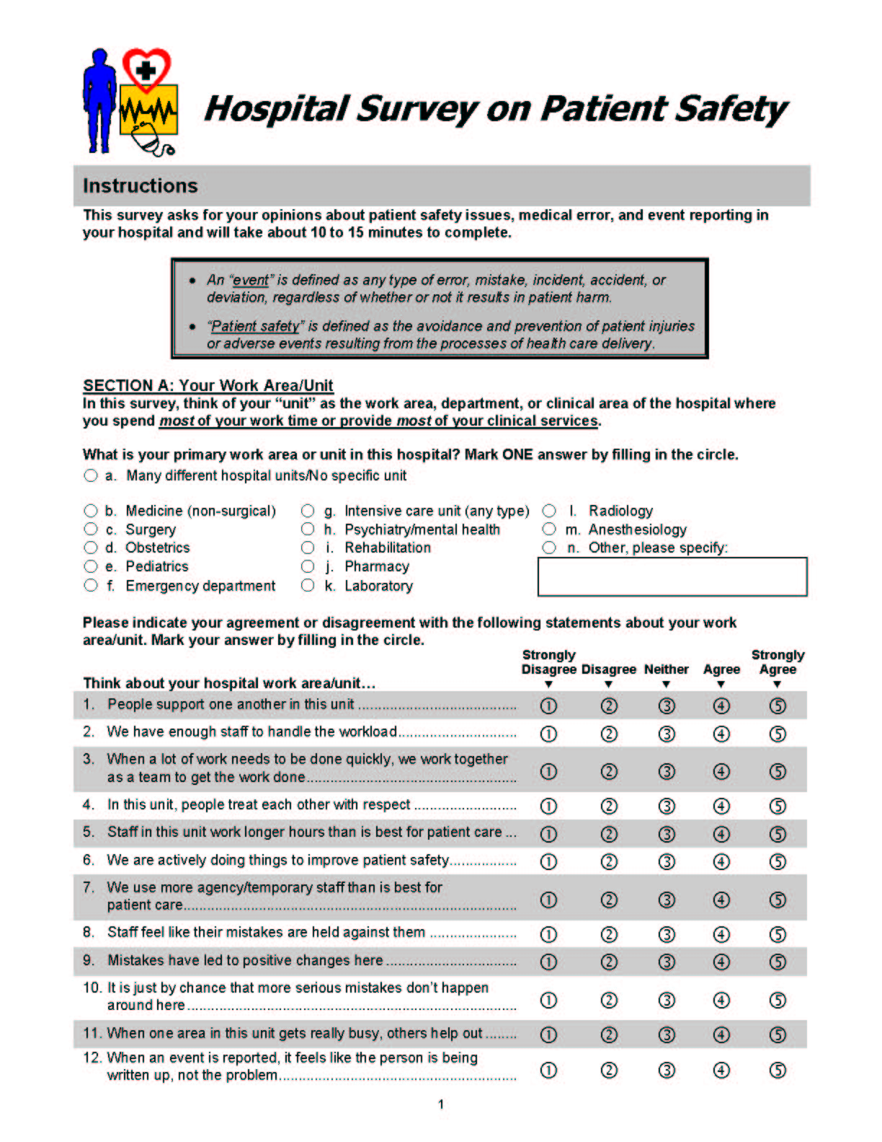
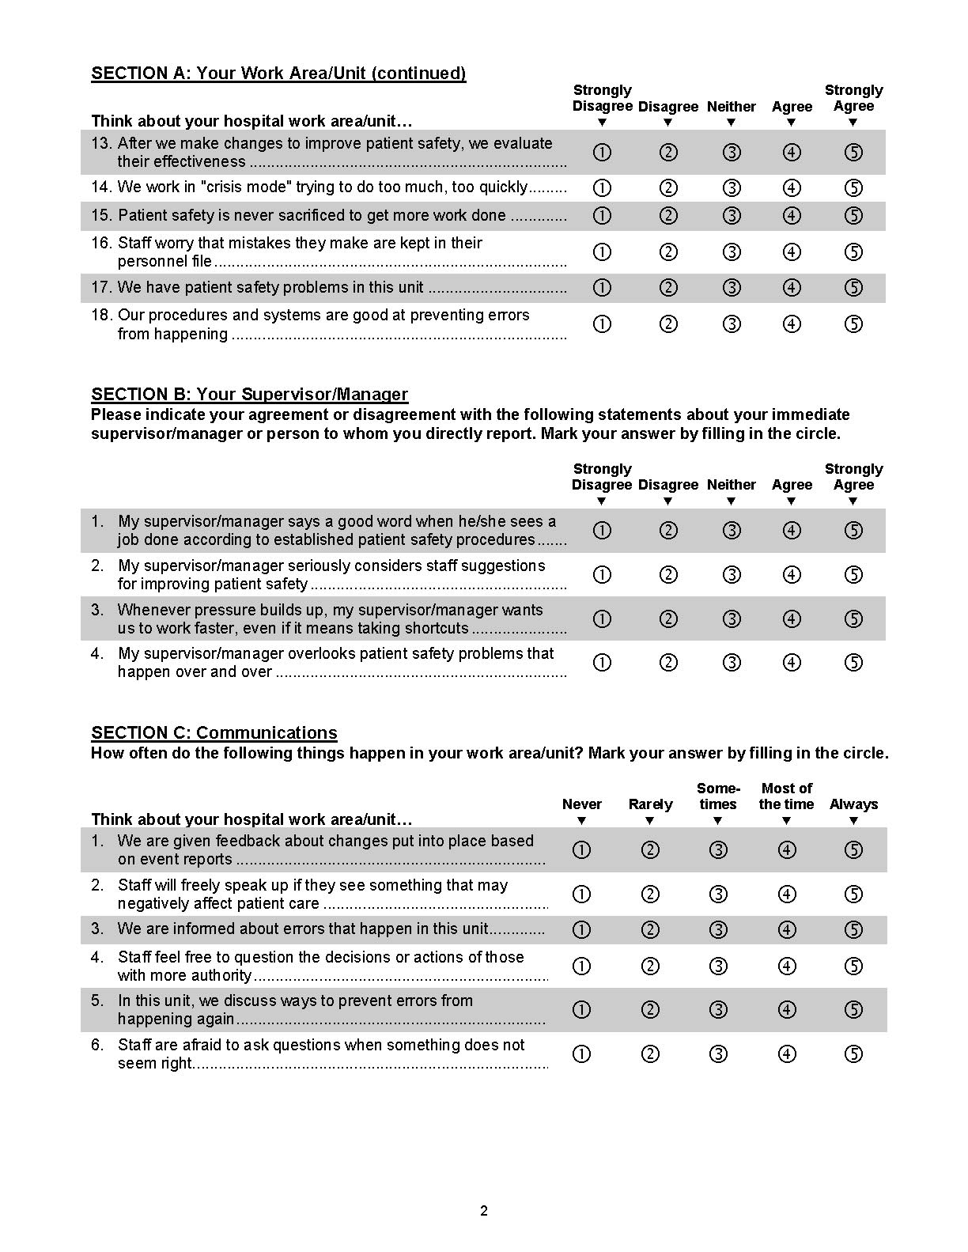

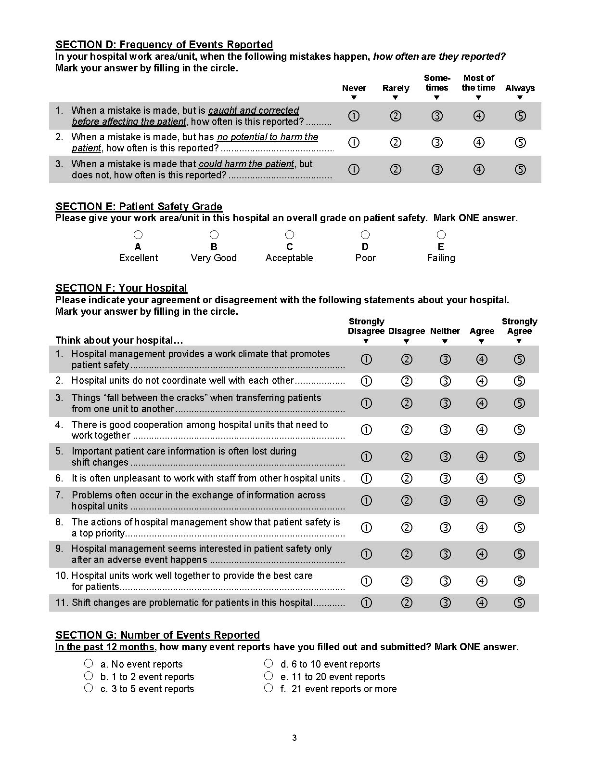
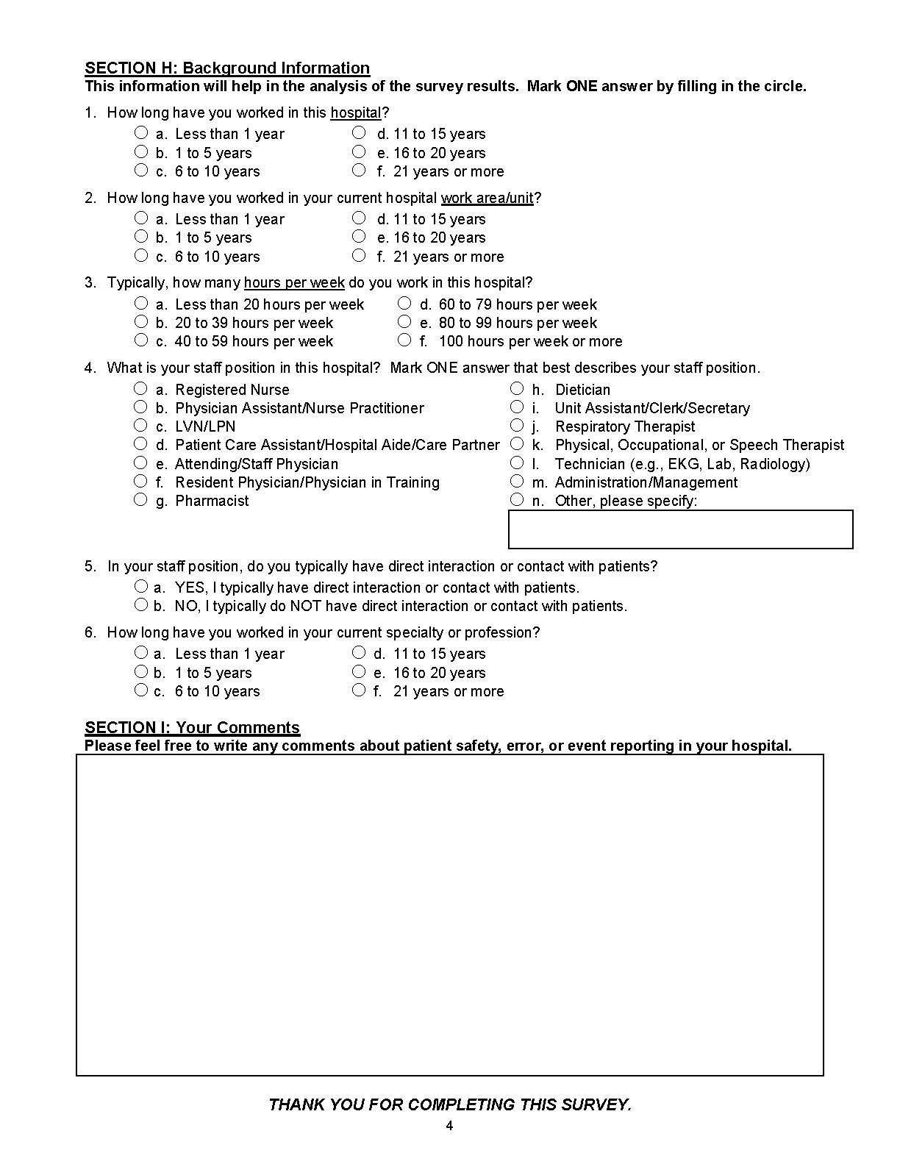
Safety Culture Dimensions and Reliabilities

I. Background Variables
A. What is your primary work area or unit in this hospital?
H1. How long have you worked in this hospital?
H2. How long have you worked in your current hospital work area/unit?
H3. Typically, how many hours per week do you work in this hospital?
H4. What is your staff position in this hospital?
H5. In your staff position, do you typically have direct interaction or contact with patients?
H6. How long have you worked in your current specialty or profession?

II. Outcome Measures

A. Frequency of Event Reporting
D1. When a mistake is made, but is caught and corrected before affecting the patient, how often is this reported?
D2. When a mistake is made, but has no potential to harm the patient, how often is this reported?
D3. When a mistake is made that could harm the patient, but does not, how often is this reported?
Reliability of this dimension—Cronbach’s alpha (3 items) = .84

B. Overall Perceptions of Safety
A15. Patient safety is never sacrificed to get more work done.
A18. Our procedures and systems are good at preventing errors from happening.
A10r. It is just by chance that more serious mistakes don’t happen around here. (reverse worded)
A17r. We have patient safety problems in this unit. (reverse worded)
Reliability of this dimension—Cronbach’s alpha (4 items) = .74

C. Patient Safety Grade
E1. Please give your work area/unit in this hospital an overall grade on patient safety.
Single-item measure—grades A through E as response categories.

D. Number of Events Reported
G1. In the past 12 months, how many event reports have you filled out and submitted?
Single-item measure—numeric response categories.
III. Safety Culture Dimensions (Unit level)

A. Supervisor/manager expectations & actions promoting safety
B1. My supervisor/manager says a good word when he/she sees a job done according to established patient safety procedures.
B2. My supervisor/manager seriously considers staff suggestions for improving patient safety.
B3r. Whenever pressure builds up, my supervisor/manager wants us to work faster, even if it means taking shortcuts. (reverse worded)
B4r. My supervisor/manager overlooks patient safety problems that happen over and over. (reverse worded)
Reliability of this dimension—Cronbach’s alpha (4 items) = .75

B. Organizational Learning—Continuous improvement
A6. We are actively doing things to improve patient safety.
A9. Mistakes have led to positive changes here.
A13. After we make changes to improve patient safety, we evaluate their effectiveness.
Reliability of this dimension—Cronbach’s alpha (3 items) = .76

C. Teamwork Within Hospital Units
A1. People support one another in this unit.
A3. When a lot of work needs to be done quickly, we work together as a team to get the work done.
A4. In this unit, people treat each other with respect.
A11. When one area in this unit gets really busy, others help out.
Reliability of this dimension—Cronbach’s alpha (4 items) = .83

D. Communication Openness
C2. Staff will freely speak up if they see something that may negatively affect patient care.
C4. Staff feel free to question the decisions or actions of those with more authority.
C6r. Staff are afraid to ask questions when something does not seem right. (reverse worded)
Reliability of this dimension—Cronbach’s alpha (3 items) = .72

E. Feedback and Communication About Error
C1. We are given feedback about changes put into place based on event reports.
C3. We are informed about errors that happen in this unit.
C5. In this unit, we discuss ways to prevent errors from happening again.
Reliability of this dimension—Cronbach’s alpha (3 items) = .78

F. Nonpunitive Response To Error
A8r. Staff feel like their mistakes are held against them. (reverse worded)
A12r. When an event is reported, it feels like the person is being written up, not the problem. (reverse worded)
A16r. Staff worry that mistakes they make are kept in their personnel file. (reverse worded)
Reliability of this dimension—Cronbach’s alpha (3 items) = .79

G. Staffing
A2. We have enough staff to handle the workload.
A5r. Staff in this unit work longer hours than is best for patient care. (reverse worded)
A7r. We use more agency/temporary staff than is best for patient care. (reverse worded)
A14r. We work in “crisis mode,” trying to do too much, too quickly. (reverse worded)
Reliability of this dimension—Cronbach’s alpha (4 items) = .63

H. Hospital Management Support for Patient Safety
F1. Hospital management provides a work climate that promotes patient safety.
F8. The actions of hospital management show that patient safety is a top priority.
F9r. Hospital management seems interested in patient safety only after an adverse event happens. (reverse worded)
Reliability of this dimension—Cronbach’s alpha (3 items) = .83

IV. Safety Culture Dimensions (Hospital-wide)

A. Teamwork Across Hospital Units
F4. There is good cooperation among hospital units that need to work together.
F10. Hospital units work well together to provide the best care for patients.
F2r. Hospital units do not coordinate well with each other. (reverse worded)
F6r. It is often unpleasant to work with staff from other hospital units. (reverse worded)
Reliability of this dimension—Cronbach’s alpha (4 items) = .80
B. Hospital Handoffs & Transitions
F3r. Things “fall between the cracks” when transferring patients from one unit to another. (reverse worded)
F5r. Important patient care information is often lost during shift changes. (reverse worded)
F7r. Problems often occur in the exchange of information across hospital units. (reverse worded)
F11r. Shift changes are problematic for patients in this hospital. (reverse worded)
Reliability of this dimension—Cronbach’s alpha (4 items) = .80
Sample Page from Survey Feedback Report Templates

The complete set of Survey Feedback Report templates and the Hospital Survey form are available free of charge, as a downloadable Microsoft PowerPoint® presentation, at www.ahrq.gov/qual/hospculture/

Appendix A. Pilot Study for the
Hospital Survey on Patient Safety Culture:
A Summary of Reliability and Validity Findings

Prepared for:
Agency for Healthcare Research and Quality
U.S. Department of Health and Human Services
540 Gaither Road
Rockville, MD 20850
http://www.ahrq.gov

Contract No. 290-96-0004

Prepared by:
Westat, Rockville, MD

Joann Sorra, Ph.D.
Veronica Nieva, Ph.D.

Principal Investigators

Acknowledgements

This survey development effort was sponsored by the Medical Errors Workgroup of the Quality Interagency Coordination Task Force (QuIC), and was funded by the Agency for Healthcare Research and Quality (AHRQ contract no. 290-96-0004). Westat conducted this work under a subcontract with BearingPoint. The authors wish to thank Matthew Mishkind, Ph.D., a former Westat staff member, who contributed to the development of the pilot instrument and conducted cognitive testing; Rose Windle for survey administration; and Theresa Famolaro for assisting with data cleaning and analysis. We are grateful to Dorothy B. “Vi” Naylor, MN, of the Georgia Hospital Association; and Tracy Scott, Ph.D., and Linda Schuessler, MS, of the Emory Center on Health Outcomes and Quality, Rollins School of Public Health, for sharing part of the data they collected in 10 Georgia hospitals using the pilot survey so we could include their data in this psychometric analysis. We also wish to thank a Risk Manager at a Veterans Health Administration (VHA) Hospital for administering the pilot survey to staff at a VHA hospital and sharing the data with Westat. In addition, we thank Eric Campbell, Ph.D., Barrett Kitch, M.D., M.P.H., and Minah Kim, Ph.D., of the Institute for Health Policy at Massachusetts General Hospital in Boston for their suggestions to improve the pilot survey and for recruiting four hospitals to participate in the pilot. Finally, we wish to thank our AHRQ project officer, James Battles, Ph.D., for his guidance and assistance.

Introduction and Background

Sponsored by the Medical Errors Workgroup of the Quality Interagency Coordination Task Force (QuIC) and funded by the Agency for Healthcare Research and Quality (AHRQ contract no. 290-96-0004), this summary describes the development of the Hospital Survey on Patient Safety Culture and presents the results of a psychometric analysis designed to determine the reliability and validity of the survey. The goal of this project was to develop a reliable, public-use safety culture instrument that hospitals could administer on their own to assess patient safety culture from the perspective of their employees and staff.

This summary presents survey pilot data gathered from 1,437 hospital staff in 21 United States hospitals. The goal of the psychometric analysis was a concise and refined survey instrument, based on an earlier draft instrument and revised through the identification of conceptually meaningful, independent, and reliable safety culture dimensions, with three to five survey items measuring each dimension. The psychometric analysis consisted of a number of analytic techniques, including: item analysis, content analysis, exploratory and confirmatory factor analyses, reliability analysis, composite score construction, correlational analysis, and analysis of variance.

Survey Development

The researchers conducted a number of preliminary activities to inform the development of the Hospital Survey on Patient Safety Culture. First, a review of the literature was conducted in areas related to safety management and accidents in the nuclear and manufacturing industries, employee health and safety, organizational climate and culture, safety climate and culture, and medical error and event reporting. The researchers also gathered examples of existing safety climate and culture instruments, including published and unpublished instruments and those available across the Internet.

Psychometric analyses also were conducted on two existing health care safety culture surveys: one developed and administered by Westat for the Medical Event Reporting System for Transfusion Medicine (MERS-TM) and another developed and administered by the Veterans Health Administration (VHA). The 100-item MERS-TM safety culture survey data set consisted of 945 staff from 53 hospital transfusion services across the United States and Canada. The 120-item VHA Patient Safety Questionnaire (FY 2000) data set consisted of 6,161 staff from 160 VHA hospitals nationwide. The data sets were analyzed independently, and the psychometric analyses were written as technical reports delivered to AHRQ (Burr, Sorra, Nieva & Famolaro, 2002; Sorra & Nieva, 2002). The results from these technical reports had a significant influence on the safety culture dimensions and types of items that were included in the pilot version of the Hospital Survey on Patient Safety Culture.

Key dimensions of hospital safety culture were identified for inclusion in the survey, based on the literature review, examination of existing published and unpublished safety culture instruments, and the psychometric analyses from the MERS-TM and VHA safety culture surveys. Items then were developed to measure those dimensions. The items were written with the goal of obtaining a staff-level perspective on patient safety in hospital settings. Respondents were asked to think about their own units because they would know the culture of their unit better than the hospital as a whole. The investigators, however, did include a short section at the end of the survey that focused specifically on hospital-wide safety issues.

Cognitive Testing and External Review of the Survey

Cognitive testing is a developmental procedure in which individuals similar to the targeted respondents are asked to complete a questionnaire and provide comments or “think aloud” while answering the questions. Frequently, the interviewer will ask respondents questions as they work through the questionnaire to better assess the respondents’ comprehension and interpretation of the terms used and the items they are being asked to consider, as a means of determining how they arrive at their answers, and to identify problems with the items or instructions. Cognitive interviews were conducted by telephone with diverse hospital staff, including a nurse manager, risk manager, department clerk, dietician, food services employee, respiratory therapist, pharmacist, and pathologist, as well as nurses, residents and physicians from different U.S. hospitals. The investigators also solicited reviews of the draft instrument from other researchers familiar with safety culture measurement, along with input from a hospital system administrator, a group of physicians, and the Joint Commission on Accreditation of Healthcare Organizations (JCAHO). Changes were made to the survey dimensions and items following cognitive testing and the external survey review, resulting in a revised pilot survey comprised of 79 items measuring 14 dimensions of safety culture.

Draft Pilot Survey

The draft pilot survey contained items that, for the most part, used 5-point Likert response scales of agreement (“Strongly disagree” to “Strongly agree”) or frequency (“Never” to “Always”). The items in the draft pilot survey included two single-item outcome measures used as validity checks and 14 multiple-item dimensions or scales of patient safety—two overall patient safety outcome scales designed to assess validity and 12 safety culture dimensions.

Methodology

The pilot survey administration sample included 21 hospitals across six U.S. states. The investigators collected their own data in 10 hospitals. Additional data from one Veterans Health Administration (VHA) hospital and 10 Georgia hospitals were forwarded to the researchers by the VHA and the Emory Center on Health Outcomes and Quality, in close cooperation with the Georgia Hospital Association. The sample of hospitals was selected to vary by geographic region, teaching status, and hospital size (Table 1), to ensure that the pilot survey administration contained a diverse sample. In addition, two facilities were for-profit hospitals, one facility was a veterans hospital, and one was a geriatric hospital.

Table 1. Teaching status and bed size of the 21 pilot hospitals

Hospital Type | Number of Beds
 | Small  (< 300 beds) | Medium/Large  (301 – 500 beds) | Large  (> 500 beds)
Teaching  Nonteaching | 5  5 | 3  1 | 6  1

For the 10 hospitals in which the investigators collected data, packets were delivered containing a cover letter, the survey, a postage-paid envelope for returning completed surveys directly to the investigators, and a reply postcard. Contact persons at each hospital distributed the survey packets through the internal hospital mail system (with the exception of one hospital in which the surveys were mailed to employees’ homes). The surveys were mailed to the homes of hospital employees included in the sample for the remaining 11 hospitals.

Data collection involved the following distribution steps to maximize response rates: a first survey, first reminder postcard, second survey, and a second reminder postcard. For six hospitals, a prenotification letter was sent on hospital letterhead, signed by the hospital president, COO, CEO, or equivalent.

Sample and Response Statistics

Criteria for sample selection varied somewhat from one hospital group to another. Six hospitals each selected a sample of about 100 staff, and purposive sampling was used (rather than random sampling) to ensure that an adequate variety of job classifications and hospital units would be represented. The selected hospital staff included those with direct patient contact, as well as those without patient contact. The researchers also recommended the inclusion of only those physicians who spend the majority of their work time in the hospital (e.g., emergency department physicians, radiologists, hospitalists, pathologists, etc.).

Only nurses and pharmacists were selected in four other hospitals, and these staff were randomly chosen. All staff were included in another hospital (a census). Staff in another group of 10 hospitals were selected from four specific departments—general medicine, general surgery, intensive/critical care, and ancillary services. A random sample of 100 staff from each unit was selected. For smaller hospitals in this group, all staff from these departments were selected (and may not have reached 100 staff per department).

A total of 4,983 surveys were administered across the 21 hospitals, with 1,437 responses received at the time the data set was compiled. This resulted in a 29% overall response rate. Response statistics are summarized below.
- Distribution through internal hospital mail systems (11 hospitals):
45% response rate (711 responses out of 1,575 surveys)
Note: One site in this group mailed the surveys to the employees’ home addresses.
- Distribution to employees’ homes through the U.S. Postal Service (10 hospitals):
21% response rate (726 responses out of 3,408 surveys)
- Average response rate within each hospital: 37%
- Average number of respondents per hospital: 68

In anticipation of confidentiality concerns and the privacy of each individual’s responses, the survey included few demographic questions. Most respondents were female (81%) and most (84%) typically had direct interaction or contact with patients. The average age of the respondents was 43 years old. They had worked an average of 10 years in their hospital, and the average tenure in their specific hospital unit or work area was 7 years. The largest percentage of respondents worked in intensive care units (18%), followed by surgery (15%), other (14%), and medicine (nonsurgical) (12%).

Analyses and Results

Several analyses were conducted on the responses to the items in the Hospital Survey on Patient Safety Culture. The goal of the combined analytic efforts was a shorter, revised survey instrument, based on conceptually meaningful, independent, and reliable safety culture dimensions, with three to five items measuring each dimension. Individual item analysis first was conducted, in an effort to identify and eliminate those items that were highly skewed or had high amounts of missing data.

Exploratory and Confirmatory Factor Analyses

Since it is possible that safety culture could simply be a single, unidimensional concept, an exploratory factor analysis was conducted initially to explore the dimensionality of the survey data. Principal components extraction was used, along with varimax rotation, to maximize the independence of the factors. The exploratory factor analysis results confirmed the existence of multiple factors or dimensions and provided evidence that suggested many of the a priori item groupings did, in fact, fall into distinct factors. The analysis results revealed 14 factors with eigenvalues greater than or equal to 1.0. The total variance explained by the 14 components or factors is 64.5 percent, with almost all items loading highly on only one factor (with a factor loading greater than or equal to .40).

To further examine the dimensionality of the survey, and taking into consideration the a priori safety culture dimensions, a confirmatory factor analysis (CFA) then was performed. CFA is used when an a priori factor structure is posited, because CFA tests the fit of a model that proposes a specific number of factors and specifies the items that measure or load onto each of the factors. Since the Hospital Survey on Patient Safety Culture was developed by first identifying safety culture dimensions and then creating items to measure those dimensions, an a priori factor structure was posited and a CFA was conducted to determine how well the posited structure conforms to the data. An initial confirmatory factor model then was created based on the exploratory factor analysis and a content analysis of the safety culture dimensions and items. The CFA work was done using the SAS Institute’s software for calculating covariance analysis of linear structural equations (CALIS), in conjunction with the maximum likelihood method of parameter estimation.

After analyzing several confirmatory factor models (and dropping items each time to eliminate problematic issues), the investigators arrived at a final confirmatory factor model with a good fit to the data. This was verified by a number of different model fit indices. The final confirmatory factor model features 12 dimensions—two outcome dimensions and 10 safety culture dimensions—with three or four items measuring each dimension, for a total of 42 items.

Overall model fit indices were examined closely. These model fit statistics—the comparative fit index (CFI), the goodness-of-fit index (GFI), the adjusted GFI (AGFI), the normalized fit index, and the non-normalized fit index (NNFI)—each met the criterion for good conformance with indices at .90 or above. The closer each of these indices is to 1.00, the better the fit of the model to the data. The root-mean-square error of approximation (RMSEA), a measure of the discrepancy per degree of freedom for the model or the degree of unexplained variance, was .04. An RMSEA of .05 or lower indicates a good model fit because the closer it is to zero, the better the fit of the model to the data.

Reliability Analysis

Internal consistency reliabilities were examined for each of the 12 final safety culture dimensions identified in the confirmatory factor model. Since items were worded in both positive and negative directions, negatively worded items first were reverse coded so that a higher score would indicate a more positive response in all cases. Each of the 12 safety culture dimensions that make up the survey was found to have an acceptable reliability (defined as a Cronbach’s alpha greater than or equal to .60), with reliability coefficients ranging from .63 to .84.

Validity Analysis: Composite Scores and Intercorrelations

Composite scores were created for the 12 safety culture dimensions by obtaining the mean of the responses to items in each dimension (after any necessary reverse coding). A composite score was calculated for each respondent, relative to each of the 12 safety culture dimensions. Since all the items used 5-point response scales, composite scores ranged from 1.0 to 5.0 (scored so that 1 = a low score and 5 = a high score). After calculating the composite scores, the safety culture dimensions then were correlated with one another.

The construct validity of each safety culture dimension would be reflected in composite scores moderately related to one another, indicated by correlations between .20 to .40. Correlations of less than .20 would indicate that two safety culture dimensions were related weakly. Exceptionally high correlations (.85 or above) would likely indicate that the dimensions measure essentially the same concept, and these dimensions possibly could be combined and some items eliminated. Correlations between the safety culture composites or scales ranged from .23 (between Nonpunitive Response to Error and Staffing or Frequency of Event Reporting) to .60 (between Hospital Management Support for Patient Safety and Overall Perceptions of Safety). These intercorrelations all fall within the expected moderate to high range. That none were exceptionally high indicates that no two safety culture dimensions appeared to measure the same construct.

Correlations were calculated for the 12 safety culture dimensions and the four outcome variables (two of the safety culture dimensions are considered outcome variables—Overall Perceptions of Safety and Patient Safety Grade). The highest intercorrelation was .66
(p < .001), calculated for the outcome measures of Overall Perceptions of Safety and Patient Safety Grade. This high correlation provides evidence of the Overall Perceptions scale validity, in that has a strong relation to the respondents’ single-item assessment of their unit’s grade on patient safety (A = Excellent, B = Very Good, C = Acceptable, D = Poor, and E = Failing). The second highest intercorrelation was between Overall Perceptions of Safety and Hospital Management Support for Patient Safety (r = .60, p < .001). This finding points to the important role that hospital management plays in the advancement of patient safety issues. Staff gave their units higher patient safety marks when they felt that hospital management actively supported safety.

The highest correlation associated with the Frequency of Event Reporting dimension was with Feedback and Communication About Error (r = .48, p < .001). Surprisingly, Nonpunitive Response to Error had the lowest relationship with the Frequency of Event Reporting (r = .23, p < .001). Hospital staff indicated that events are reported more frequently when there is an open line of communication involving errors, and when they are given feedback regarding changes implemented as a result of event reports. These correlations suggest that increased event reporting is more likely to be achieved through the advancement of communication and feedback—than through the creation of a nonpunitive culture.

Finally, all but two of the correlations between the Number of Events Reported within the last year and the safety culture dimensions were nonsignificant and very low—almost zero in most cases. One explanation for the lack of relationships with this one-item outcome variable is that more than half of all respondents reported no events in the last 12 months. Forty-five percent reported 10 or fewer events. The lack of variability and the highly skewed nature of the reported event numbers resulted in an absence of linear relationships with the other safety culture dimensions. For now, the best use for this one-item measure of reported events is as a change indicator, to see if staff report more events over time.

Analysis of Variance: Differences Across Hospitals

One final analysis—a one-way analysis of variance (ANOVA)—was conducted on each of the 12 safety culture dimensions, and on the two single-item outcome measures (Number of Events Reported and Patient Safety Grade), to determine the extent to which composite scores on these safety culture scales are differentiated across hospitals. An ANOVA by hospitals examines whether there is greater response variability on the safety culture dimensions between hospitals compared to within hospitals. In other words, it generally addresses the issue of whether hospitals differ on each of the safety culture dimensions. All ANOVAs on each of the 12 composites had statistical significance, supporting the hypothesis that hospitals have differentiated scores on each dimension—that different hospitals have different composite scores on the safety culture outcome variables and dimensions. Since hospitals have different actual levels of patient safety, some should score high and some should score low on the safety culture dimensions—which is what the results indicate and what good scales would reflect.

Conclusions

Westat was tasked with developing an employee survey to assess the culture of patient safety in hospital settings. The development of the survey was based on a literature review, examination of existing published and unpublished safety culture instruments, and psychometric analyses conducted on two existing safety culture surveys.

The draft survey was piloted in 21 hospitals, and the pilot data were analyzed to refine the instrument and determine its psychometric properties. In the process of refining the instrument, 26 of the originally piloted items were dropped. Based on the psychometric analyses, the final Hospital Survey on Patient Safety Culture includes 12 dimensions and 42 items, plus additional background questions. All of the psychometric analyses—from the CFA results and reliabilities to the intercorrelations among the dimensions and the analysis of variance results—provide solid evidence supporting the final dimensions and items that were retained.

All dimensions were shown to have acceptable levels of reliability (defined as Cronbach’s alpha equal to or greater than .60). The safety culture dimensions included in the final survey are shown below (reliabilities are in parentheses):

- Two outcome dimensions (multiple item scales):
1. Overall perceptions of safety (.74)
2. Frequency of event reporting (.84)

- Ten safety culture dimensions (multiple item scales):
1. Supervisor/manager expectations and actions promoting patient safety (.75)
2. Organizational learning—Continuous improvement (.76)
3. Teamwork within units (.83)
4. Communication openness (.72)
5. Feedback and communication about error (.78)
6. Nonpunitive response to error (.79)
7. Staffing (.63)
8. Hospital management support for patient safety (.83)
9. Teamwork across hospital units (.80)
10. Hospital handoffs and transitions (.80)
References

Burr M, Sorra J, Nieva VF, et al. Analysis of the Veterans Administration (VA) National Center for Patient Safety (NCPS) FY 2000 Patient Safety Questionnaire. Technical report. Westat: Rockville, MD; 2002.

McKnight S, Lee C. Patient safety attitudes. Paper presented at the Summit on Effective Practices to Improve Patient Safety, Washington, DC; September 5-7, 2001.

Nieva VF, Sorra J. Safety culture assessment: A tool for improving patient safety in health care organizations. Qual Saf Healthcare 2003;12(Suppl 2):17-23.

Sorra J, Nieva VF. Psychometric analysis of the MERS-TM Hospital Transfusion Service Safety Culture Survey. Technical report. Westat: Rockville, MD; 2002.

Sorra JS, Nieva VF, Schreiber G, et al. MERS-TM Hospital Transfusion Service Safety Culture Survey. Unpublished survey developed by Westat under contract to Columbia University, supported by a grant from the National Heart, Lung, and Blood Institute (NHLBI # R01 HL53772-06); 2001.

Appendix B. Safety Culture Assessment: A Tool for Improving Patient Safety in Healthcare Organizations

Reprinted with the permission of BMJ Publishing Group, London (UK) from:
Quality and Safe Health Care 2003; 12(Suppl II):ii17-ii23

The text of this article also is available in electronic form at:
http://qhc.bmjjournals.com/cgi/content/full/12/suppl_2/ii17

Adapted from Zohar (2000). A group-level model of safety climate: Testing the effect of group climate on microaccidents in manufacturing jobs. Journal of Applied Psychology, (85) 4, 587-596.

