UNITED STATES COAST GUARD

“THE GUARDIAN ETHOS”

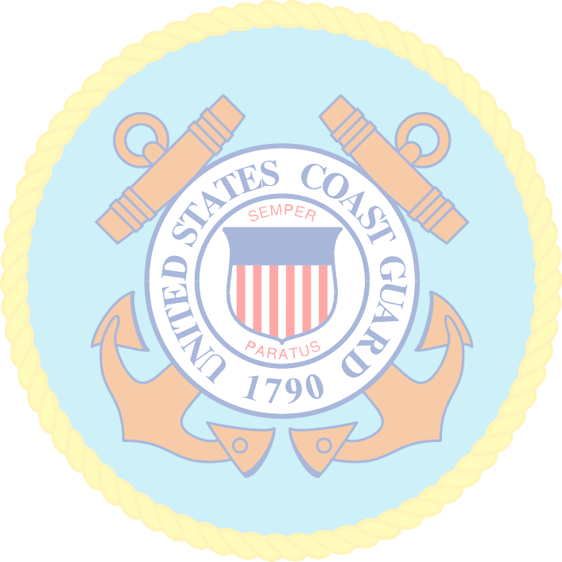

I am America’s Maritime Guardian.

I serve the citizens of the United States.

I will protect them.

I will defend them.

I will save them.

I am their Shield.

For them I am Semper Paratus.

I live the Coast Guard Core Values.

I am a Guardian.

We are the United States Coast Guard.

