Unit 1: Disaster Preparedness

In this unit you will learn about:

- Disasters and Disaster Workers: What defines a disaster, what defines an emergency, and who makes up the response workforce.
- The Impact on the Infrastructure: The potential effect of extreme emergencies and disasters on transportation; electrical service; telephone communication; fuel; food, water, and shelter; and emergency services.
- Structural and Nonstructural Hazards: Potentially hazardous conditions in various types of structures and their contents during a disaster.
- Hazard Mitigation: What to do to reduce the risk of damage from hazards that threaten your area.
- Home and Workplace Preparedness: How you can prepare in advance to reduce structural and nonstructural hazards and survive the initial period after a disaster.
- Community Preparedness: How a community can prepare in advance to respond.
- Protection for Disaster Workers: Laws that protect disaster workers from liability.

Unit 1: Disaster Preparedness
Objectives | At the conclusion of this unit, the participants will be able to:  - Describe the types of hazards that are most likely to affect their homes and community.  - Describe the functions of CERTs and their role in the immediate response to a disaster.  - Identify steps to prepare themselves for a disaster.
Scope | The scope of this unit will include:  - Welcome and Introductions.  - Recent Disasters and Emergencies.  - Course Preview.  - Disasters and Disaster Workers.  - Participant Introductions.  - Impact on the Infrastructure.  - Structural and Nonstructural Hazards.  - Disaster Hazard Mitigation.  - Unit Summary.
Estimated Completion Time | 2 hours 30 minutes
Training Methods | The Lead Instructor will begin by welcoming the participants to the course, introducing himself or herself and the other Instructor(s), and making any necessary administrative announcements. The Instructor will then briefly review a major disaster that recently affected the area or the State, stressing its aftermath, lessons learned (including the importance of preparedness), and the role that CERTs might have had in that disaster.  Next, the Instructor will briefly explain the course objectives and discuss the topics to be covered in the course.  The Instructor will then give a brief overview of the nature of disasters and extreme emergencies, stressing how CERTs fit into the response and recovery picture.  Then the Instructor will begin an introductory activity. The purpose of this activity is to introduce the participants to each other and illustrate the types of skills and abilities that CERTs require.

Training Methods (Continued) | During this activity, each participant will introduce himself or herself and provide a brief description of:  - Why he or she is attending the course.  - Where he or she lives or works in the community.  Following the introductions, the Instructor will review the collective distribution of participants and facilitate a brief discussion of how the skills demonstrated in the introductory activity might be useful in the immediate aftermath of a disaster. During the discussion, the Instructor will stress the importance of communication, trust, and teamwork (the whole being greater than the sum of the parts) as critical elements of effective CERTs.  Next, the Instructor will lead a discussion of the chief threat(s) for the community and the impact that the threat(s) is(are) likely to have on the community’s infrastructure and emergency services.  The Instructor will then lead a discussion of the types of structural and nonstructural hazards that the participants may face in the different types of structures located within the community and how those hazards can be mitigated through individual and community preparedness efforts both at home and in the workplace.  Finally, the Instructor will summarize the key points of the session while creating the linkage that, as CERT members, the participants will play a vital role in response.
Resources Required | - Community Emergency Response Team Instructor Guide  - Community Emergency Response Team Participant Manual  - Visuals 1.1 through 1.22  - Visuals for hazard modules selected from Appendix 1-A
Equipment | The following additional equipment is required for this unit:  - A computer with PowerPoint software  - A computer projector and screen  - Scissors (1 for every 5 participants)  - Tape (1 roll for every 5 participants)  - Two pieces of cardboard (approximately 8" X 10" ) (1 set for every 5 participants)  - Forty pieces of construction paper (8½" x 11") (1 set for every 5 participants)

Preparation | Prepare information on State and local laws that protect CERT members in your area.  Review this unit and the hazard modules that are included at the end of this unit, carefully. Select the hazards that present the greatest threat to your community, and incorporate them into the unit. If possible, tailor the hazard materials by including local examples and photographs.
Notes | A suggested time plan for this unit is as follows:  Welcome and Introductions 20 minutes  Introduction and Unit Overview 5 minutes  Recent Disasters and Emergencies 15 minutes  Course Preview 5 minutes  Disasters and Disaster Workers 5 minutes  (Disaster Threats) [From Appendix 1-A] (25 minutes)  Impact on the Infrastructure 10 minutes  Structural and Nonstructural Hazards 10 minutes  Hazard Mitigation 15 minutes  Home and Workplace Preparedness 15 minutes  Community Preparedness 10 minutes  Protection for Disaster Workers 5 minutes  Unit Summary 5 minutes  Total Time: 2 hours 30 minutes
Remarks | This unit includes information on a variety of hazards, some—but not all—of which may affect your community. Review this unit and the additional materials carefully before training to identify hazards that pose a threat to your community.  After determining which hazard presentations you wish to include, you will want to add the PowerPoint slides into the main file for Unit 1. To merge the slide presentations:  - Open the PowerPoint file for Unit 1.  - Open the PowerPoint file for the hazard you wish to include.  - While in the hazard presentation, click “Slide Sorter View” ( ) at the bottom left corner of the screen.  - Click “Edit” at the top of the screen.  - Click “Select All” from the edit pull-down menu.  - Click “Window” at the top of the screen and select the Unit 1 presentation.  - Click “Slide Sorter View” ( ).  - Place the cursor where the hazard insert should be by clicking between the slides at the appropriate place in the Unit 1 presentation.  - Right click, and select “paste” to pull in the hazard slides.  - Repeat steps 2 through 8 for each hazard presentation that you wish to include in this unit.

Unit 1: Disaster Preparedness

 |  |  | Welcome and Introductions
 | Introduce Course |  | Welcome the participants to Community Emergency Response Team training.  Introduce yourselves and provide some background information about your past experiences in emergency response.  Tell the participants that the introduction section in their Participant Manuals contains excellent information on:  - When a Disaster strikes.  - Community preparedness.  - How CERT teams operate.  - The CERT training program.  Encourage the participants to review this information after the training session is adjourned.
 |  |  | Participant Introductions
 | Introduce Unit |  | As the participants are arriving, develop a class roster by passing around a sheet of paper. Ask the participants to write down their name, address, and phone number.

 |  |  | Activity: Building a Tower
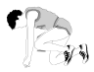 | Conduct Activity |  | Instructions: Follow the steps below to conduct this exercise:  - Assign the participants to groups of five.  - Distribute the following materials to each group:  - 1 pair of scissors  - 1 roll of scotch tape  - 2 pieces of cardboard (approximately 8” x 10”)  - 40 pieces of construction paper (8½” x 11”)  - Tell the group that they will spend the next 10 minutes planning and designing a free-standing tower that stands at least five feet tall from the bottom of the structure to the top. Explain that you will tell the groups when to begin and that they will have 5 minutes from that point to construct the tower.  - Tell the groups when to begin their work and when to end.  - At the end of the allotted time, facilitate a group discussion of what the groups have learned through the exercise. Be sure to cover the following points:  - Unfamiliar people. . .  - Can work on an unfamiliar problem. . .  - Using unfamiliar tools. . .  - In unfamiliar surroundings. . .  - In a time-compressed environment. . .  - To reach a common goal.  Stress that the skills and abilities that the groups used during the exercise are the same skills that they will use as CERT members.

 |  |  | Introduction and Unit Overview
 |  |  | Unit Objectives
 | Display Visual |  |  | Unit Objectives  - Describe the types of hazards to which your community is vulnerable.  - Describe the functions of CERTs.  - Identify preparedness steps.
At the end of this unit, the participants should be able to:

- Describe the types of hazards most likely to affect their homes and community.

- Describe the functions of CERTs and their role in immediate response.

- Identify steps to prepare for disasters.

 |  |  | Recent Disasters and Emergencies
 | Introduce Topic |  | Stress to the participants that:  - Emergency response personnel cooperate at many levels to provide immediate response capabilities.  - Emergency service capability can be greatly enhanced by well-organized, well-trained, and well-managed CERTs that are able to:  - Prepare in advance of a disaster event.  - Respond in their communities to address immediate needs brought about by the disaster.
 | Display Visual |  |  | Preparing for a Disaster  CERTs should prepare by:  - Identifying potential hazards in their homes and workplaces.  - Reducing hazards, where possible.  - Developing a disaster supply kit.
Tell the participants that, as CERT members, their role is to prepare for a disaster by:

- Identifying potential structural and nonstructural hazards in their homes and workplaces.

- Reducing the hazards to the degree possible before a disaster strikes.

- Developing a disaster supply kit.

 |  |  | Recent Disasters and Emergencies (Continued)
 | Instructor’s Note |  |  | Tell the participants that a complete list of items to include in a disaster supply kit is included later in this unit and in a FEMA publication titled, Are Your Ready?, which is available on FEMA’s website at: www.fema.gov/areyouready/ in either Word or PDF format.
 | Display Visual |  |  |  | Responding To a Disaster  CERTs should respond by:  - Locating and turning off utilities, if safe.  - Extinguishing small fires.  - Treating injuries.  - Conducting light search and rescue.  - Helping to relieve survivor stress.
CERTs respond after a disaster by:

- Locating and turning off utilities, if safe to do so.

- Extinguishing small fires.

- Treating life-threatening injuries until professional assistance can be obtained.

- Conducting light search and rescue operations.

- Helping disaster survivors cope with their emotional stressors.

Recent Disasters and Emergencies (Continued)
Briefly review a recent disaster or emergency in your area or State. Discuss:

- The event (e.g., Category 4 hurricane, earthquake measuring 6.3).

- The damage (e.g., lives lost, injuries, cost to rebuild).

- Lessons learned, especially as they relate to preparedness.

Then explain the role that CERTs might have had if they were operational during that disaster. Relate their role to the key CERT functions:

- Fire safety

- Medical operations

- Light search and rescue

- Disaster psychology

CERTs in Disaster Roles

Explain that there are many instances of CERT members’ participation in disaster response.

Point out that during the Northridge Earthquake, the following use of CERTs were recorded:

- Search: 203

- Rescue: 17

- Medical treatment: 57

- Patient transport: 4

- Fire suppression: 5

- Utility control: 156

Recent Disasters and Emergencies (Continued)
Tell the group that in Alachua County, FL, during Hurricane Floyd in 1999 and during Tropical Storm Gordon in 2000, CERTs were called by the EOC to contact special-needs residents to ensure that they were aware of the approaching storms and to ascertain whether they would use the county’s special needs shelters and transportation. The CERTs arranged transportation, as necessary.

About a dozen CERTs were used during the Hidden Lake and Lake Louise fires in 2000 to provide food for the firefighters, move supplies, and assist with preparation in the area.

Tell the group that the CERT concept has extended from its original purpose as a response operation following catastrophic disasters. CERTs are now activated for a wide range of emergencies. For example, in Whatcom County, WA, CERT members were used in the following situations:

- Whatcom Creek gasoline pipeline explosion (Olympic Pipeline)

- Explosion at the Georgia-Pacific Pulp & Paper Mill

- Y2K Emergency Operations Center (EOC) activation

- Sandy Point wind and flood event

- Nisqually earthquake

The CERT members who responded to the Whatcom Creek incident received The American Red Cross Real Heroes Award for their contributions. CERT members in the county have received Federal, State, and local recognition for their response efforts.

 |  |  | Recent Disasters and Emergencies (Continued)
 |  |  | CERTs in Nondisaster Roles
 | Display Visual |  |  | Nondisaster CERT Roles  CERT members can:  - Distribute preparedness materials.  - Staff first aid booths at special events.  - Assist with installation of smoke alarms.
Explain that CERT members also are a potential volunteer pool for the community. They can help with projects such as:

- Distributing preparedness materials.

- Staffing medical booths during special events.

- Assisting with the installation of smoke alarms for seniors and special-needs households.

 |  |  | Recent Disasters and Emergencies (Continued)
 | Display Visual |  |  |  | Citizen Corps  - The President has encouraged Americans to volunteer to improve and safeguard the nation.  - Areas of emphasis for volunteer efforts:  - Crime  - Natural Disasters  - Terrorism
 |  |  | Additionally, in his January 29, 2002, State of the Union address, the President asked that Americans volunteer their services to improve and safeguard our country. The three areas of emphasis for these volunteer efforts are crime, natural disasters, and terrorism. The Citizen Corps Program was created to help Americans meet this call to service. One of the volunteer opportunities offered to the American public under the Citizen Corps umbrella is the CERT program.
 | Instructor’s Note |  |  | If anyone asks, explain that other opportunities under Citizen Corps include Neighborhood Watch, Volunteers in Police Service, and the Medical Response Corps.

 |  |  | Recent Disasters and Emergencies (Continued)
 | Display Visual |  |  | Additional CERT Training Opportunities  - Shelter management  - Community relations  - Donations management  - Special needs concerns  - Debris removal  - Utilities control  - Advanced first aid  - Automated External Defibrillator use  - CPR skills
After completing initial CERT training, many CERT members seek to expand and improve their skills—through continuing CERT modules offered locally, courses offered through The American Red Cross, or programs from other sources. Some CERT members have sought additional training opportunities in:

- Shelter management.

- Community relations.

- Donations management.

- Special needs concerns.

- Debris removal.

- Utilities control.

- Advanced first aid.

- Automated External Defibrillator use.

- CPR skills.

Ask the participants if they have any questions about the use of CERTs in recent disasters.

Tell the participants that next, you will provide an overview of the course.

 |  |  | Course Preview
 |  |  | Explain that this unit will provide an overview of the course by establishing a context for CERTs within the specific hazards faced by the community.
 | Display Visual |  |  | Course Preview  The scope of this course includes:  - Fire safety.  - Disaster medical operations.  - Light search and rescue.  - CERT organization.  - Disaster psychology.  - CERTs and terrorism.
Tell the group that later units will cover:

- Fire safety.

- Disaster medical operations.

- Light search and rescue.

- CERT organization.

- Disaster psychology.

- CERTs and terrorism.

Make any administrative announcements that are necessary at this time. Include information about:

- The times for this and future sessions.

- Materials required.

- Building disaster preparedness kits.

- Emergency exits.

- Restroom locations, smoking policy, etc.

- Course completion requirements.

 |  |  | Disasters and Disaster Workers
 | Display Visual |  |  | Types of Disasters  - Natural  - Manmade  - Technological
 | Introduce Topic |  | Introduce this section by stating that disasters can be:  - Natural.  - Manmade.  - Technological.
 | Display Visual |  |  | Key Elements of Disasters  - They are relatively unexpected.  - Emergency personnel may be overwhelmed.  - Lives, health, and the environment are endangered.

 |  |  | Disasters and Disaster Workers (Continued)
Explain that, regardless of the event, disasters have several key elements in common:

- They are relatively unexpected, with little or no warning or opportunity to prepare.

- Available personnel and emergency services may be overwhelmed initially by demands for their services.

- Lives, health, and the environment are endangered.

Stress that, in the immediate aftermath of a disaster, needs will be greater than professional emergency services personnel can provide. In these instances, CERTs become a vital link in the emergency service chain.

 |  |  | Disaster Threats
 | Instructor’s Note |  |  | Present information about the hazards that present the greatest threat to your community here.
 |  |  | Impact on the Infrastructure
 | Introduce Topic |  | Ask the participants how many have been caught in a(n) [insert the type of event that is most common for your area]. Ask what types of problems they experienced with such things as their utilities and transportation.
 | PM, P. 1-6 |  | Refer the participants to the chart titled, Possible Effects of Damage to the Infrastructure, in their Participant Manuals. Summarize the participants’ responses to the discussion question by listing some of the effects on the infrastructure.

 | PM, P. 1-6 | Possible Effects of Damage on Infrastructure

Damage to . . . | Possible Effects
Transportation | - Inability to assess damage accurately  - Ambulances prevented from reaching victims  - Police prevented from reaching areas of civil unrest  - Fire departments prevented from getting to fires  - Flow of needed supplies is interrupted
Structures | - Damaged hospitals unable to function normally  - Increased risk of damage from falling debris
Communication Systems | - Victims unable to call for help  - Coordination of services is hampered
Utilities | - Loss of utilities  - Increased risk of fire or electrical shock  - Loss of contact between victims and service providers  - Inadequate water supply  - Increased risk to public health
Water Service | - Firefighting capabilities restricted  - Medical facilities hampered
Fuel Supplies | - Increased risk of fire or explosion from fuel line rupture  - Risk of asphyxiation

 |  |  | Impact on the Infrastructure (Continued)
 | Display Visual |  |  | Effects on Infrastructure  Damage to transportation:  - Inability to assess damage accurately  - Ambulances prevented from reaching victims  - Police prevented from reaching areas of civil unrest  - Fire departments prevented from getting to fires  - Interruption to the flow of needed supplies
Damage to transportation can:

- Cause inaccurate damage assessment.

- Prevent ambulances from reaching victims.

- Prevent police from reaching areas of civil unrest.

- Prevent fire departments from getting to fires.

- Interrupt the flow of needed supplies.

 |  |  | Impact on the Infrastructure (Continued)
 | Display Visual |  |  | Effects on Infrastructure  Damage to structures:  - Damaged hospitals unable to function normally  - Increased risk of damage from falling debris
Damage to structures can:

- Prevent damaged hospitals from receiving patients.

- Increase the risk of damage from falling debris.

 | Display Visual |  |  | Effects on Infrastructure  Disrupted communication:  - Victims unable to call for help  - Coordination of services hampered
Disrupted communication can:

- Prevent victims from calling for help.

- Hamper coordination of services.

 |  |  | Impact on the Infrastructure (Continued)
 | Display Visual |  |  | Effects on Infrastructure  Damage to utilities:  - Loss of utilities  - Increased risk of fire or electrical shock  - Loss of contact between victims and service providers  - Inadequate water supply  - Increased risk to public health
Damage to utilities can:

- Cause loss of service.

- Increase risk of fire and electrical shock.

- Cause loss of contact between victims and service providers.

- Cause an inadequate water supply for firefighting.

- Increase the risk to public health (if there is extensive damage to the water supply or if it becomes contaminated).

 |  |  | Impact on the Infrastructure (Continued)
 | Display Visual |  |  | Effects on Infrastructure  Damage to fuel supplies:  - Increased risk of fire or explosion from fuel line rupture  - Risk of asphyxiation
Damage to fuel supplies can:

- Increase the risk of fire or explosion from ruptured fuel lines.

- Pose a risk of asphyxiation from natural gas leaks in confined areas.

 |  |  | Draw the correlation that each instance of damage to the infrastructure may severely restrict the abilities of police, fire, and emergency medical services in that disaster.
 |  |  | Point out that, because emergency services personnel are likely to have inadequate resources to meet the public’s needs, those resources must be applied according to the highest-priority need.
- Police will address incidences of grave public safety.

- Firefighters will suppress major fires.

- EMS personnel will handle life-threatening injuries. (Stress, however, that CERTs will also handle life-threatening injuries until EMS units become available.)

Lower-priority needs will have to be met in other ways.

 |  |  | Structural and Nonstructural Hazards
 | Introduce Topic |  | Introduce this topic by asking the participants questions based on the hazards below.
 | Ask Question |  |  | How many of you know where your utility shutoffs are?
 |  |  | Use the participants’ responses to introduce the term hazard mitigation. Tell them that shutting off or raising utilities is one way to reduce—or mitigate—a hazard before a disaster occurs. Shutting off utilities is one way to mitigate a hazard immediately after a disaster.
 |  |  | Explain that the mitigation steps that one should take before and immediately after a disaster depend on the hazard and type of structure. This topic will deal with types of structures and the hazards related to each. Safety precautions, including hazard mitigation for structural and nonstructural hazards, will be covered next.
 |  |  | Hazards Related to Structure Type
 |  |  | Remind the participants that they might not have an opportunity to select the type of structure that they are in when a occurs. It is important to know what type of damage to expect from the main types of structures in the community.
Tell the participants that engineered buildings, such as most high-rise buildings, have performed well in most types of disasters. Stress that, during earthquakes and high-wind events (e.g., tornadoes, hurricanes), older high-rise buildings, however, are more susceptible to damage from:

- Broken glass.

- Falling panels.

- Collapsing walkways and stairways.

 |  |  | Structural and Nonstructural Hazards (Continued)
 | Ask Question |  |  | How many of you live in single-family homes? Do you know what types of damage to expect?
 |  |  | If not mentioned by the group, tell them that age, type of construction, and type of disaster are major factors in potential damage to detached homes and garages.
- Homes built before 1940 generally were not bolted to the foundation, making them subject to being shaken, blown, or floated off their foundations.

- Older homes constructed of unreinforced brick are less stable than newer construction.

Remind the participants that:

- Tornado and hurricane damage to single homes can range from little damage to total destruction.

- Following an event in which a structure has been damaged, there is a threat of additional damage, such as fire from ruptured gas lines.

 |  |  | Structural and Nonstructural Hazards (Continued)
 | Ask Question |  |  | How many of you live in mobile homes? Do you know what type of damage you can expect if a high-risk hazard occurs?
 |  |  | If not mentioned by the group, stress that mobile homes are most susceptible to damage because they are easily displaced. When displacement occurs, structural integrity becomes questionable, and utility connections are easily damaged, increasing the risk of fire and electric shock.
 |  |  | Point out that malls, sports arenas, airports, places of worship, and other places with long roof spans also may pose hazards in some types of disasters. For example:
- Strip shopping centers pose a threat from collapse and broken glass.

- Warehouse-type structures may also collapse.

 |  |  | Add that there is also a risk in all types of structures from nonstructural hazards.
 |  |  | Nonstructural Hazards
 | Ask Question |  |  | How many of you are aware of hazards in your own homes or workplaces?
 |  |  | If not mentioned by the group, stress that everyone has hazards in their homes or workplaces. Fixtures and items within a home, garage, or workplace can pose a hazard during or after a disaster.

 |  |  | Structural And Nonstructural Hazards (Continued)
 | Display Visual |  |  | Hazards From Home Fixtures  - Gas line ruptures from displaced water heaters or ranges  - Damage from falling books, dishes, and other cabinet contents  - Electric shock from displaced appliances  - Fire from faulty wiring, overloaded plugs, or frayed electric cords
Some of the hazards include:

- Gas line ruptures from water heaters or ranges displaced by shaking, water, or wind.

- Damage from falling books, dishes, or other cabinet contents.

- Risk of injury or electric shock from displaced appliances and office equipment.

- Fire from faulty wiring, overloaded plugs, frayed electrical cords.

Emphasize the importance of reducing hazards as part of personal preparedness. Stress that there are several relatively simple measures that individuals can take to alleviate many home and workplace hazards.

 |  |  | Hazard Mitigation
 | Introduce Topic |  | Stress the importance of becoming informed on the probable impacts of likely events, including the potential for terrorist activity. The more information the participants have, the better they will be able to plan adequately and respond reasonably.  Tell the group that, regardless of the event or the amount of warning offered, there are safety precautions that they can take to reduce or prevent injury. This section will deal with measures to ensure personal safety.  The next section will address:  - Home and worksite preparedness.  - Community preparedness.
 |  |  | Personal Safety
 | Ask Question |  |  | What would you do if you were caught outside during a(n) [identify the type of hazard that is most common in your area]?
 |  |  | Acknowledge the group’s responses. Then ask:
 | Ask Question |  |  | What would you do if you were caught outside during a(n) [identify a type of hazards that requires different personal safety measures?]

 |  |  | Hazard Mitigation (Continued)
 |  |  | Summarize the discussion using the next visual.
 | Display Visual |  |  | Personal Safety  Personal safety measures vary depending on:  - The type of event.  - The amount of warning available.  - Location during the event (i.e., inside, outside, driving).
If not mentioned by the group, remind them that the appropriate personal safety measures are determined by:

- The type of event.

- The amount of warning that they have.

- Whether they are inside, outside, or driving.

 |  |  | Remind the participants that protecting themselves during a disaster requires planning. There are measures that they should take to prevent or minimize the damage caused by most hazards. These measures can be taken long before a disaster occurs, during the time of the disaster, and after the disaster occurs.

 |  |  | Home and Workplace Preparedness
 |  |  | Remind the group that preparedness is the key to survival in a disaster. Individuals, families, and building managers can take steps that will help minimize structural and nonstructural hazards, facilitate escape, and promote survival during the period immediately following the event.
 | Display Visual |  |  | Home/Workplace Preparedness  - Structural and nonstructural hazard mitigation  - Individual preparations:  - Assemble disaster supplies.  - Develop a disaster plan.  - Develop a safe room.
Tell the group that home and worksite preparedness includes:

- Structural and nonstructural hazard mitigation.

- Individual preparations, such as:

- Assembling a disaster supply kit.
- Developing a disaster plan.
- Developing a safe room in a secure area of the home (in case authorities ask them to stay indoors during a disaster).

 |  |  | Home and Workplace Preparedness (Continued)
 |  |  | Structural and Nonstructural Mitigation
 | PM, P. 1-10 |  | Refer the participants to the chart titled, Precautions Against Structural and Nonstructural Hazards, in their Participant Manuals. Stress that many injuries from structural and nonstructural hazards are easily preventable.
 | Display Visual |  |  |  | Sample Structural Hazard Mitigation  - Bolt older houses to the foundations.  - Strap propane tanks.  - Raise utilities.  - Strap mobile homes to their slabs.  - Ask a professional to check foundation, roof connectors, chimney, etc.
Some steps that the participants can take include the following:

- Samples of structural hazards:

- Bolt older houses to the foundations.
- Strap propane tanks.
- Raise utilities (above the level of flood risk).
- Strap mobile homes to their slabs.
- Ask a professional to check the foundation, roof, chimney, etc.

 | Instructor’s Note |  |  | Please research the types of structural hazards in your area, and modify these hazard mitigation measures to make them appropriate to your area.

 | PM, P. 1-10 | Precautions Against Structural and Nonstructural Hazards

Type Of Hazard | Sample Precautions
Structural | - Bolt older houses to the foundation.  - Strap propane tanks.  - Raise utilities (above the level of flood risk).  - Strap mobile homes to their concrete pads.  - Ask a professional to check the foundation, roof connectors, chimney, etc.
Nonstructural | - Anchor such furniture as bookshelves, hutches, and grandfather clocks to the wall.  - Secure appliances and office equipment in place with industrial-strength Velcro®.  - Secure cabinet doors with childproof fasteners.  - Locate and label shutoffs for gas, electricity, and water before disasters occur. After a disaster, shut off the utilities as needed to prevent fires and other risks. Store a shutoff wrench where it will be immediately available.  - Secure water heaters to the wall to safeguard against a ruptured gas line or loose electrical wires.

 |  |  | Home and Workplace Preparedness (Continued)
 | Display Visual |  |  | Sample Nonstructural Hazard Mitigation  - Anchor heavy furniture.  - Secure appliances and office equipment.  - Secure cabinet doors with childproof fasteners.  - Locate and label gas, electricity, and water shutoffs.  - Secure water heaters and have flexible gas lines installed.
- Samples of nonstructural hazards:

- Anchor heavy furniture, such as bookshelves, hutches, and grandfather clocks, to the wall.
- Secure appliances and office equipment in place with commercial-strength Velcro®.
- Secure cabinet doors with childproof fasteners.
- Locate and label shutoffs for gas, electricity, and water before a disaster occurs. Shut off utilities as needed to prevent fires and other risks.
- Secure water heaters to the wall to safeguard against a ruptured gas line or loose electrical wires and have flexible gas lines installed.

 | PM, P. 1-11 |  | Refer the participants to the chart titled, Utility Shutoffs, in their Participant Manuals. Tell the group that they will practice shutting off utilities in a later section.
 |  |  | Explain that different nonstructural hazards pose different threats, depending on the disaster. Provide a few examples of preventive measures, and refer the participants to FEMA’s Talking About Disasters website for more in-depth discussion: www.fema.gov/rrr/talkdiz/.

 | PM, P. 1-11 | Utility Shutoffs

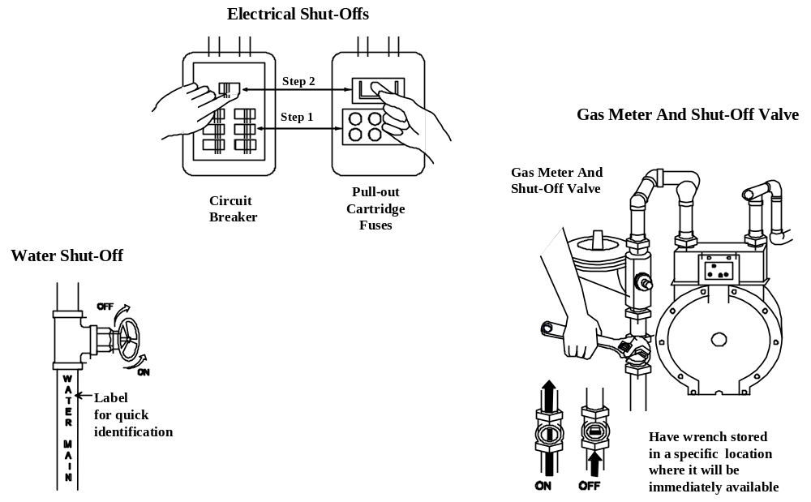
Utility shutoffs: Electrical, Water, Gas. The electrical shutoff procedure shows both a circuit box and a fuse box and shows two steps. Step 1 is to turn off all individual breakers (or unscrew fuses). Step 2 is to shut off the main circuit (or main fuse switch). The water shut-off indicates a clockwise turn of the valve to shut off and a counter-clockwise turn to turn on. The gas meter shut-off diagram indicates the shut-off valve location on the pipe that comes out of the ground. To turn off the valve, use a wrench to turn the valve clockwise one-quarter turn.

Home and Workplace Preparedness (Continued)
- Home Fires: Make sure that burglar bars and locks on outside window entries are easy to open.

- Landslides/Mudslide: Install flexible pipe fittings to avoid gas or water leaks. Flexible fittings are more resistant to breakage.

- Wildfires:

- Avoid using wooden shakes and shingles for roofing.
- Clear all flammable vegetation at least 30 feet from the home. Remove vines from the walls of the home.
- Place propane tanks at least 30 feet from the home or other structures.
- Stack firewood at least 30 feet away and uphill from the home.

Developing a Disaster Plan

Point out that an emergency plan can mean the difference between life and death in a disaster. For example:

- How will you escape your home?

- Where will you meet family members?

- What route will you take out of your neighborhood if evacuation becomes necessary? Do you have an alternate route in case your primary route is blocked or otherwise impassable?

- What will you take with you?

- Where will you go?

- What will you need to shelter in place? Do you have those items (or enough of those items)?

Suggest that the participants play the “What if?” game (What will I do if this happens?) for every hazard that presents a high risk to the community. Then begin within the home and work outward to answer each of the questions above.

 |  |  | Home and Workplace Preparedness (Continued)
 |  |  | Explain that the answers to these questions may be different depending on the hazard, and the participants probably will not be able to plan for every event that could happen. But stress that, by playing “What if?” with high-risk hazards, they will be better prepared for any hazard that might strike.
 |  |  | Ask the group:
 | Ask Question |  |  | How many of you have developed escape plans for your homes or workplaces?
Emphasize the importance of having an escape plan that:

- Includes escape from every room of the house or every area of the workplace.

- Considers the needs of children and physically challenged individuals.

 | PM, PP. 1-13 & 1-14 |  | Explain the Exit Drills in the Home plan. Tell the participants that a sample escape plan is in the Participant Manual. Explain that, in most cases, homeowners won’t have smoke alarm in every room, but it is important to have a smoke alarm at least on every level of the house.  Ask the participants if they have any questions about home and worksite preparations.  Urge the participants to practice their plans after they develop them. Suggest that they conduct family fire drills, follow the local evacuation routes, and locate the nearest shelter to ensure that, when a disaster occurs, they know what to do.

 | PM, P. 1-13 | Creating a Family Disaster Plan

Creating A Family Disaster Plan

To get started . . .

- Contact your local emergency management office and your local chapter of The American Red Cross.

- Find out which disasters are most likely to happen in your community.
- Ask how you would be warned.
- Find out how to prepare for each type of disaster.

- Meet with your family.

- Discuss the types of disasters that could occur.
- Explain how to prepare and respond.
- Discuss what to do if advised to evacuate.
- Practice what you have discussed.

- Plan how your family will stay in contact if separated by disaster.

- Pick two meeting places:
- A location a safe distance from your home in case of fire.
- A place outside your neighborhood in case you can’t return home.

- Choose an out-of-state friend as a “check-in contact” for everyone to call.

- Complete the following steps.

- Post emergency telephone numbers by every phone.
- Show responsible family members how and when to shut off water, gas, and electricity at main switches.
- Install a smoke alarm on each level of your home, especially near bedrooms; test them monthly and change the batteries two times each year. (Change batteries when you change your clocks in the spring and fall.)

- Contact your local fire department to learn about home fire hazards.

- Learn first aid and CPR. Contact your local chapter of The American Red Cross for information and training.

 | PM, P. 1-14 | Creating a Family Disaster Plan

- Meet with your neighbors.

- Plan how the neighborhood could work together after a disaster. Know your neighbors’ skills (medical, technical).
- Consider how you could help neighbors who have special needs, such as elderly or disabled persons.
- Make plans for child care in case parents can’t get home.

Escape Planning

Develop an escape plan that provides for escape from every room. As part of your escape plan:

- Consider the needs of children and physically challenged individuals.

- Inform all family members or office coworkers of the plan.

- Run practice escape drills.

An example of an escape plan is shown in the figure that follows.

Escape Plan

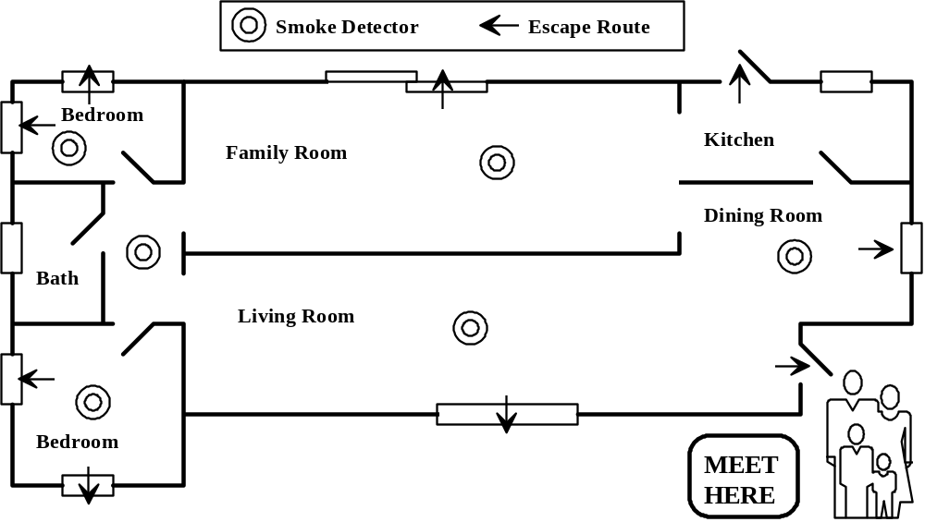
Sample family escape plan with arrows showing an escape route from every room in the home and a family meeting place outside the home.

 |  |  | Home and Workplace Preparedness (Continued)
 | PM, PP. 1-16 through 1-19 |  | Refer the participants to, Assembling and Storing a Disaster Supply Kit, in the Participant Manual. Tell the group that the list includes all disaster supplies recommended by FEMA.
Point out that the disaster supplies included on this list is fairly complete, and suggest that the participants determine the supplies that they will need for evacuation, those that they will need to shelter in place, and those that they will need for both.

- Evacuation-only supplies and supplies (e.g., prescription medications) that are required for evacuation and shelter in place should be stored where they can be accessed quickly in an evacuation situation.

- Shelter-in-place-only supplies (e.g., 3 days of water for each family member for a hurricane or earthquake) should be stored in an accessible location within the home or workplace.

 | Instructor’s Note |  |  | Safe room selection and preparation will be covered later in this unit.

 | PM, P. 1-16 | Assembling and Storing an Disaster Supply Kit

You can cope best by preparing for disaster before it strikes. One way to prepare is by assembling a Disaster Supply Kit. After disaster strikes, you won’t have time to shop or search for supplies. But if you’ve gathered supplies in advance, you and your family can endure an evacuation or home confinement.

To Prepare Your Kit

- Review the checklist on the next few pages (from FEMA L-189, ARC 4463, Your Family Disaster Supplies Kit).

- Gather the supplies from the list.

- Place the supplies you’re apt to need for an evacuation in an easy-to-carry container. These supplies are listed with an asterisk (*).

Water

Store water in plastic containers such as soft drink bottles. Avoid using containers that will decompose or break, such as milk cartons or glass bottles. A normally active person needs to drink at least two quarts of water each day. Hot environments and intense physical activity can double that requirement. Children, nursing mothers, and ill people will need more.

- Store 1 gallon of water per person per day (2 quarts for drinking, 2 quarts for food preparation/sanitation.)* |  | - Keep at least a 3-day supply of water for each person in your household.
If you have questions about the quality of the water, purify it before drinking. You can heat water to a rolling boil for 1 minute or use commercial purification tablets to purify the water. You can also use household liquid chlorine bleach if it is pure, unscented, 5.25% sodium hypochlorite. To purify water, use the table below as a guide:

Ratios for Purifying Water with Bleach

 | Water Quantity | Bleach Added
 | 1 Quart  1 Gallon  5 Gallons | 4 Drops  16 Drops  1 Teaspoon
Ratios for purifying water with bleach: Water quantity and bleach added

After adding bleach, shake or stir the water container and let it stand 30 minutes before drinking.

 | PM, P. 1-17 | Assembling and Storing an Disaster Supply Kit

Food

Store at least a 3-day supply of nonperishable food. Select foods that require no refrigeration, preparation, or cooking and little or no water. If you must heat food, pack a can of Sterno®. Select food items that are compact and lightweight. Include a selection of the following foods in your disaster supply kit:

- Ready-to-eat canned meats, fruits, and vegetables  - Canned juices, milk, soup (if powdered, store extra water)  - Staples⎯sugar, salt, pepper  - High-energy foods⎯peanut butter, jelly, crackers, granola bars, trail mix | - Foods for infants, elderly persons, or persons on special diets  - Comfort/stress foods⎯cookies, hard candy, sweetened cereals, lollipops, instant coffee, tea bags
Kitchen Items

- Manual can opener  - Mess kits or paper cups, plates, and plastic utensils  - All-purpose knife  - Household liquid bleach to treat drinking water | - Sugar, salt, pepper  - Aluminum foil and plastic wrap  - Re-sealing plastic bags  - If food must be cooked, small cooking stove and a can of cooking fuel

 | PM, P. 1-18 | Assembling and Storing an Disaster Supply Kit

First Aid Kit*

Assemble a first aid kit for your home and one for each car. A first aid kit should include:

- First aid manual  - Sterile adhesive bandages in assorted sizes  - 2-inch sterile gauze pads (4-6)  - 4-inch sterile gauze pads (4-6)  - Hypoallergenic adhesive tape  - Triangular bandages (3)  - Needle  - Moistened towelettes  - Antibacterial ointment  - Thermometer  - Tongue blades (2)  - Tube of petroleum jelly or other lubricant  - Assorted sizes of safety pins  - Cleaning agent/soap  - Latex gloves (2 pairs)  - Petroleum jelly  - Cotton balls | - Sunscreen  - 2-inch sterile roller bandages (3 rolls)  - 3-inch sterile roller bandages (3 rolls)  - Scissors  - Tweezers  Nonprescription Drugs  - Aspirin or nonaspirin pain reliever  - Antidiarrhea medication  - Antacid (for stomach upset)  - Syrup of Ipecac (used to induce vomiting if advised by the Poison Control Center)  - Laxative  - Vitamins  - Activated charcoal (used if advised by the Poison Control Center)
Tools and Supplies

- Mess kits, or paper cups, plates and plastic utensils*  - Emergency preparedness manual*  - Battery-operated radio and extra batteries*  - Flashlight and extra batteries*  - Fire extinguisher: small canister, ABC type  - Tube tent  - Pliers  - Duct tape  - Compass  - Matches in a waterproof container  - Aluminum foil  - Plastic storage containers  - Signal flare(s)  - Paper, pencil  - Needles, thread  - Work gloves | - Medicine dropper  - Shutoff wrench, to turn off household gas and water  - Whistle  - Plastic sheeting  Sanitation  - Toilet paper, towelettes*  - Soap, liquid detergent*  - Feminine supplies*  - Personal hygiene items*  - Plastic garbage bags, ties (for personal sanitation uses)  - Plastic bucket with tight lid  - Disinfectant  - Household chlorine bleach

 | PM, P. 1-19 | Assembling and Storing an Disaster Supply Kit

Clothing and Bedding

Include at least one complete change of clothing and footwear per person.

- Sturdy shoes or work boots*  - Rain gear*  - Blankets or sleeping bags* | - Hat and gloves*  - Thermal underwear*  - Sunglasses*
Household Documents and Contact Numbers

- Personal identification, cash (including change) or traveler’s checks, and a credit card  - Copies of important documents: birth certificates, marriage certificate, driver’s license, social security cards, passport, wills, deeds, inventory of household goods, insurance papers, immunizations records, bank and credit card account numbers, stocks and bonds. Be sure to store these in a watertight container. | - Emergency contact list and phone numbers  - Map of the area and phone numbers of places you could go  - An extra set of car keys and house keys
Special Items

Remember family members with special needs, such as infants and elderly or disabled persons.

For Baby*  - Formula  - Diapers  - Bottles  - Powdered milk  - Medications  For Adults*  - Heart and high blood pressure medication  - Insulin  - Prescription drugs  - Denture needs  - Contact lenses and supplies  - Extra eye glasses | - Entertainment⎯games and books  - Important Family Documents ⎯keep these records in a waterproof, portable container  - Will, insurance policies, contracts, deeds, stocks and bonds  - Passports, social security cards, immunization records  - Bank account numbers  - Credit card account numbers and companies  - Inventory of valuable household goods  - Important telephone numbers
*Items marked with an asterisk are recommended for evacuation.
 |  |  | Home and Workplace Preparedness (Continued)
 |  |  | Evacuate or Shelter-in-Place?
 |  |  | Point out that the decision of whether to evacuate or shelter in place is not always easy. If time and location allow, they should listen to the Emergency Alert System (EAS) for instructions from emergency management professionals who are evaluating the situation.
 | Instructor’s Note |  | Note: Review evacuation and shelter-in-place procedures for hazards in the local area. Insert slides to support your presentation.

 |  |  | Community Preparedness
 |  |  | Introduce community preparedness by explaining that citizen preparedness will be less effective if the community isn’t prepared. Representatives of all agencies that have a role in response work together to organize their agencies’ activities before an emergency or disaster. The product of their efforts is called an Emergency Operations Plan, or EOP.
 |  |  | The Emergency Operations Plan (EOP)
 | Display Visual |  |  | The EOP  - Assigns responsibility to organizations and individuals  - Sets forth lines of authority  - Describes how people and property will be protected  - Identifies personnel, equipment, facilities, supplies, and other resources
Explain that the EOP is a document that:

- Assigns responsibility to organizations and individuals for carrying out specific actions at projected times and places in an emergency that exceeds the capability or routine responsibility of any one agency (e.g., the fire department).
- Sets forth lines of authority and organizational relationships, and shows how all actions will be coordinated.
- Describes how people and property will be protected in emergencies and disasters.
- Identifies personnel, equipment, facilities, supplies, and other resources available—within the jurisdiction or by agreement with other jurisdictions—for use during response and recovery operations.

In short, the EOP describes how the community will do business in an emergency.

 |  |  | Community Preparedness (Continued)
 |  |  | Community Preparedness and CERTs
 | Display Visual |  |  | CERTs in a Disaster Setting  - Assist first responders when requested  - Initially assume many of the same functions as response personnel when necessary until help arrives:  - Fire safety  - Light search and rescue  - Disaster medical operations
Point out that communities also prepare for disasters when they establish Community Emergency Response Teams (CERTs) to respond in the period immediately after a disaster when response resources are overwhelmed or delayed. Explain that CERTs:

- Assist first responders when requested in accordance with standard operating procedures developed by the sponsoring agency

- Assume many of the same functions as response personnel following a disaster when emergency services are overwhelmed or delayed.

- Fire safety
- Light search and rescue
- Medical operations

 |  |  | Community Preparedness (Continued)
 |  |  | Community Preparedness and CERTs
 | PM, P. 1-23 |  | Refer the participants to the chart titled, CERT Organization, in the Participant Manual. Point out that in the later sessions, they will learn more about the major CERT functional areas.  Emphasize that no matter which function CERT members are assigned to, effective CERTs require teamwork.  Tell the group that there are checklists in the Additional Materials section at the back of Unit 1 in the Participant Manual, that will be of help in planning and organizing a CERT and assembling equipment and supplies for a CERT team.  Ask the participants if they have any questions about community preparations.

 | PM, P. 1-23 | CERT Organization

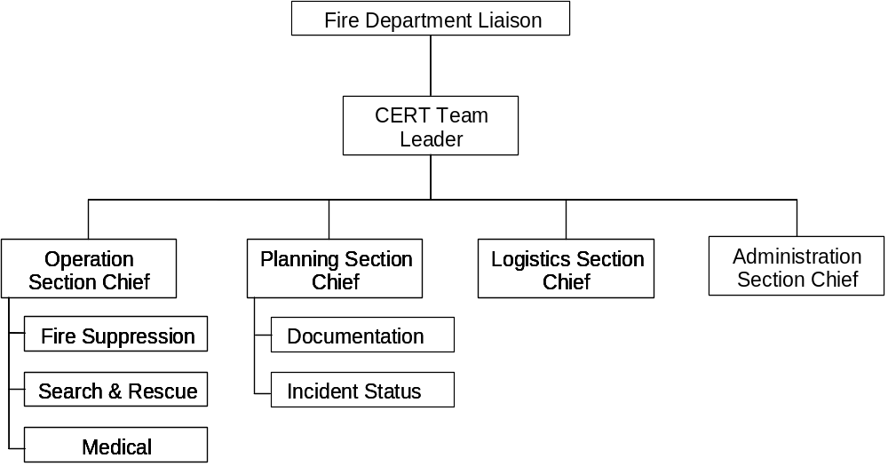

CERT Organization showing the Fire Department Liaison at the top. Underneath is the CERT Team Leader who directs the activities of four sections: Operations, Planning, Logistics, and Administration. Underneath the Operations Section are three response teams: Fire Suppression Search and Rescue, and Medical. Underneath the Planning Section are two sections: Documentation and Incident Status.

 |  |  | Protection for Disaster Workers
Explain that, as volunteers, CERT members are generally protected by “Good Samaritan” laws that protect people who provide care in a prudent and reasonable manner.

Point out that, in a disaster, CERT members are also protected by the Volunteer Protection Act of 1997, a Federal law that protects volunteers from liability as long as they are acting in accordance with the training that they have received.

 | PM, P. 1-24 |  | Tell the participants that there also is a chart titled, Applicable Laws and Key Points, in the Participant Manual, on which they should record applicable laws and key points for their State.  Explain the specific protection offered by the laws and point out the liabilities that extend beyond the protection of the laws.

 | PM, P. 1-24 | Applicable Laws and Key Points

Applicable Laws | Key Points

 |  |  | Unit Summary
 | Display Visual |  |  | Unit Summary  - CERTs are among a variety of agencies and personnel who cooperate to provide assistance in the aftermath of a disaster.  - CERTs have proven themselves invaluable in the areas in which they were tested.  - CERTs have become a key component of the Citizen Corps program.
 | Summarize Unit |  | Summarize the unit by making the following points:  - CERTs are among a variety of agencies and personnel who cooperate to provide assistance in the aftermath of a disaster. The keys to CERT effectiveness are in:  - Familiarity with the types of events that are high risk for the area and the types of damage that can occur as a result.  - Adequate preparation for each event and its aftermath.  - Training in the functional areas to which CERTs are assigned.  - Practice through refreshers and simulations.  - CERTs have proven themselves invaluable in the areas in which they were tested. They can be invaluable in this community as well.  - CERTs have become a key component of President Bush’s Citizen Corps.
 |  |  | Ask the participants if they have any questions about anything covered in this unit.

Unit Summary (Continued)

Homework Assignment

Tell the group that the next unit will cover fire safety. Then remind the group that, before the next session, they should:

- Read and familiarize themselves with Unit 2: Fire Safety in the Participant Manual.

- Bring a pair of leather gloves and safety goggles to use in the fire suppression unit, and to serve as a starting point for their disaster supply kits.

- Begin food and water storage for at least 3 days for themselves and their families.

- Establish an out-of-state contact.

- Locate the utility shutoffs in their homes.

Tell the group to wear appropriate clothes to the next session (no shorts or open-toed shoes), because they will practice putting out a small fire with an extinguisher.

Thank the participants for attending this session.

