Tropical Cyclone Report
Tropical Storm Beryl
(AL022006)
18-21 July 2006

Richard J. Pasch
National Hurricane Center
31 August 2006

Beryl passed over Nantucket, Massachusetts, but produced minimal impacts there or elsewhere.

- Synoptic History

The genesis of Beryl can be traced back to a frontal system that stalled off the coast of North Carolina around 16 July. Over the next day or two this system gradually decayed into a surface low pressure trough while remaining nearly stationary over sea surface temperatures of 26 to 27 degrees Celsius. By 1200 UTC 18 July, a low pressure center formed near the southwestern end of the trough with sufficient organized deep convection to designate the system as a tropical depression, centered about 250 n mi east-southeast of Wilmington, North Carolina. Six hours later, as convective banding features became more prominent over the eastern semicircle of the circulation, the cyclone became a tropical storm.

The “best track” chart of Beryl’s path is given in Fig. 1, with the wind and pressure histories shown in Figs. 2 and 3, respectively. The best track positions and intensities are listed in Table 1. From 18 to 20 July, the tropical storm moved mainly northward along the western periphery of a subtropical high pressure area, and paralleled the coast of the mid-Atlantic states. Vertical shear was not strong and upper-level anticyclonic outflow became established over the system, allowing Beryl to strengthen to its maximum intensity of 50 kt by 1800 UTC 19 July. This intensity was maintained for a little less than 24 hours. By 1800 UTC 20 July, as Beryl passed over cooler waters, a slow weakening trend began. Steering winds ahead of a mid-tropospheric trough moving through the Great Lakes caused the storm to turn toward the north-northeast and northeast with a gradual increase in forward speed. The center of Beryl passed over Nantucket, Massachusetts around 0645 UTC 21 July, at which time the maximum sustained winds were estimated to be 45 kt. Thereafter, the cyclone continued to accelerate northeastward. Beryl lost tropical characteristics shortly after 1200 UTC 21 July. The system crossed Nova Scotia and moved over Newfoundland where it merged with another extratropical cyclone after 1200 UTC 22 July.

- Meteorological Statistics

Observations in Beryl (Figs. 2 and 3) include satellite-based Dvorak technique intensity estimates from the Tropical Analysis and Forecast Branch (TAFB), the Satellite Analysis Branch (SAB) and the U. S. Air Force Weather Agency (AFWA), as well as flight-level and dropwindsonde observations from flights of the 53rd Weather Reconnaissance Squadron of the U. S. Air Force Reserve Command. Microwave satellite imagery from NOAA polar-orbiting satellites, the NASA Tropical Rainfall Measuring Mission (TRMM), the NASA QuikSCAT, and Defense Meteorological Satellite Program (DMSP) satellites were also useful in tracking Beryl.

The estimated peak intensity of the storm is based on maximum 850 mb flight-level winds of 64 kt, dropsonde data, and subjective surface wind estimates of 50-55 kt made on board the reconnaissance aircraft on 19-20 July. Although a reconnaissance plane measured 850 mb flight level winds of 67 kt at 0703 UTC 21 July, a comparison of the aircraft winds with surface data from Nantucket and nearby NOAA buoys suggested that only about 50 to 60 percent of the flight-level winds were occurring at the surface. Therefore, the storm’s intensity is estimated to have been only 45 kt around that time.

Ship reports of winds of tropical storm force associated with Beryl are given in Table 2, and selected surface observations from land stations and data buoys are given in Table 3. Wind gusts to tropical storm force were reported on Nantucket.

- Casualty and Damage Statistics

There are no reports of casualties associated with Beryl. The storm did not have a serious impact on Nantucket; the storm surge there was only about 1 ft, no wind damage was reported on the island, and the rainfall was relatively light. There were also no reports of damages elsewhere due to Beryl.

- Forecast and Warning Critique

About 45 h prior to genesis, the National Hurricane Center’s Tropical Weather Outlook (TWO) first noted the area of cloudiness and showers associated with a dissipating frontal system, from which Beryl eventually formed, and stated that gradual development was possible. Roughly 21 h before development, the TWO stated that a tropical depression could form in the area.

A verification of official and guidance model track forecasts is given in Table 4. Average official track errors for Beryl were 19, 45, 69, 107, and 440 n mi for the 12, 24, 36, 48, and 72 h forecasts, respectively. There were no forecasts to verify beyond 72 h. The number of forecasts ranged from 11 at 12 h to 1 at 72 h, so the numbers of cases are too small to make these average errors very meaningful.

Official and guidance model intensity forecasts for Beryl are given in Table 5. Average official intensity errors were 4, 4, 4, 6, and 15 kt for the 12, 24, 36, 48, and 72 h forecasts, respectively. Although these errors are smaller than the average long-term values, it should again be noted that there were too few cases to make this comparison very meaningful.

Table 6 lists the watches and warnings that were issued for Beryl. The tropical storm warning for Nantucket was issued about 22 h prior to landfall in that location.
Table 1. Best track for Tropical Storm Beryl, 18-21 July 2006.

Date/Time  (UTC) | Latitude  (°N) | Longitude  (°W) | Pressure  (mb) | Wind Speed  (kt) | Stage
18 / 1200 | 32.3 | 73.3 | 1010 | 30 | tropical depression
18 / 1800 | 33.0 | 73.3 | 1008 | 35 | tropical storm
19 / 0000 | 33.8 | 73.5 | 1006 | 35 | "
19 / 0600 | 34.5 | 73.7 | 1005 | 35 | "
19 / 1200 | 35.2 | 73.6 | 1004 | 40 | "
19 / 1800 | 35.9 | 73.5 | 1003 | 50 | "
20 / 0000 | 36.6 | 73.2 | 1002 | 50 | "
20 / 0600 | 37.4 | 73.2 | 1001 | 50 | "
20 / 1200 | 38.3 | 73.0 | 1002 | 50 | "
20 / 1800 | 39.1 | 72.5 | 1002 | 45 | "
21 / 0000 | 39.8 | 71.8 | 1003 | 45 | "
21 / 0600 | 41.0 | 70.5 | 1000 | 45 | "
21 / 1200 | 42.4 | 68.4 | 1002 | 40 | "
21 / 1800 | 43.8 | 66.3 | 1000 | 35 | extratropical
22 / 0000 | 45.5 | 63.3 | 1002 | 35 | "
22 / 0600 | 47.2 | 60.0 | 1003 | 35 | "
22 / 1200 | 48.5 | 56.5 | 1004 | 30 | "
22 / 1800 |  |  |  |  | merged with extratropical low
21 / 0645 | 41.3 | 70.1 | 1000 | 45 | landfall at Nantucket, Massachusetts
21 / 0600 | 41.0 | 70.5 | 1000 | 45 | minimum pressure
20 / 0600 | 37.4 | 73.2 | 1001 | 50 | maximum intensity

Table 2. Selected ship and buoy reports with winds of at least 34 kt for Tropical Storm Beryl, 18-21 July 2006.

Date/Time (UTC) | Ship call sign | Latitude  (°N) | Longitude  (°W) | Wind  dir/speed (kt) | Pressure  (mb)
19 / 0900 | 41630 | 32.6 | 76.3 | 260 / 39 | 1015.6
19 / 1600 | 41645 | 33.2 | 71.6 | 230 / 43 | 1020.8
19 / 2100 | DEDM | 37.8 | 72.2 | 090 / 39 | 1018.0
20 / 1500 | WMVF | 38.6 | 74.2 | 320 / 35 | 1014.2

Table 3. Selected surface observations for Tropical Storm Beryl, 18-21 July 2006.

Location | Minimum Sea Level Pressure |  | Maximum Surface  Wind Speed |  |  | Storm surge  (ft)^{c} | Storm  tide  (ft)^{d} | Total  rain  (in)
Location | Date/  time  (UTC) | Press.  (mb) | Date/  time  (UTC)ª | Sustained  (kt)^{b} | Gust  (kt) | Storm surge  (ft)^{c} | Storm  tide  (ft)^{d} | Total  rain  (in)
Massachusetts
Official
Chatham (CQX) | 21/0828 | 1003.1 | 21/0759 | 22 | 29 |  |  | 0.33
Hyannis (HYA) | 21/0806 | 1005.1 | 21/0658 | 20 | 26 |  |  | 0.21
Martha’s Vineyard (MVY) | 21/0705 | 1005.5 | 21/0425 | 23 | 30 |  |  | 0.07
Nantucket (ACK) | 21/0721 | 1000.4 | 21/0623 | 30 | 38 | 0.9 |  | 0.28
Unofficial
Nantucket NWS Skywarn Spotter | 21/0657 | 1000.4 | 21/0612 |  | 39
Nantucket Sound Cape Wind Buoy (Horseshoe Shoal) |  | 1006.0 | 21/0610 | 34e | 44
NOAA Buoys
Buoy 44008 (40.5ºN 69.4ºW, Nantucket Shoals) |  |  | 21/0550 | 35 | 49
Buoy 44018 (41.3ºN 69.3ºW, east of Nantucket) | 21/0900 | 1001.1 | 21/0800 | 33 | 43

ª Date/time is for sustained wind when both sustained and gust are listed.
^{b} Except as noted, sustained wind averaging periods for C-MAN and land-based ASOS reports are 2 min; buoy averaging periods are 10 min.
^{c} Storm surge is water height above normal astronomical tide level.
^{d} Storm tide is water height above National Geodetic Vertical Datum (1929 mean sea level).
^{e} Averaging period is unknown.

Table 4. Preliminary track forecast evaluation (heterogeneous sample) for Tropical Storm Beryl, 18-21 July 2006. Forecast errors (n mi) are followed by the number of forecasts in parentheses. Errors smaller than the NHC official forecast are shown in bold-face type. Verification includes the depression stage, but does not include the extratropical stage, if any.

Forecast Technique | Forecast Period (h)
Forecast Technique | 12 | 24 | 36 | 48 | 72 | 96 | 120
CLP5 | 33 (11) | 65 ( 9) | 102 ( 7) | 161 ( 5) | 289 ( 1)
GFNI | 20 ( 6) | 46 ( 4) | 66 ( 2)
GFDI | 31 (10) | 51 ( 8) | 75 ( 6) | 82 ( 4)
GFSI | 29 ( 9) | 55 ( 7) | 84 ( 5) | 182 ( 3)
AEMI | 25 (10) | 45 ( 8) | 77 ( 6) | 134 ( 4)
NGPI | 22 ( 8) | 39 ( 6) | 45 ( 4) | 28 ( 2)
UKMI | 25 ( 8) | 68 ( 6) | 117 ( 4) | 35 ( 2)
BAMD | 39 (11) | 81 ( 9) | 127 ( 7) | 194 ( 5) | 525 ( 1)
BAMM | 46 (11) | 95 ( 9) | 147 ( 7) | 216 ( 5) | 464 ( 1)
BAMS | 55 (11) | 112 ( 9) | 173 ( 7) | 245 ( 5) | 423 ( 1)
CONU | 17 ( 9) | 32 ( 7) | 49 ( 5) | 76 ( 3)
GUNA | 15 ( 8) | 28 ( 6) | 44 ( 4) | 68 ( 2)
FSSE | 24 ( 4) | 37 ( 4) | 49 ( 4) | 102 ( 3)
OFCL | 19 (11) | 45 ( 9) | 69 ( 7) | 107 ( 5) | 440 ( 1)
NHC Official  (2001-2005 mean) | 37 (1930) | 65 (1743) | 91 (1569) | 118 (1410) | 171 (1138) | 231 (913) | 303 (742)

Table 5. Preliminary intensity forecast evaluation (heterogeneous sample) for Tropical Storm Beryl, 18-21 July 2006. Forecast errors (kt) are followed by the number of forecasts in parentheses. Errors smaller than the NHC official forecast are shown in bold-face type. Verification includes the depression stage, but does not include the extratropical stage, if any.

Forecast Technique | Forecast Period (h)
Forecast Technique | 12 | 24 | 36 | 48 | 72 | 96 | 120
SHF5 | 5.8 (11) | 7.6 ( 9) | 10.0 ( 7) | 10.8 ( 5) | 17.0 ( 1)
GFDI | 4.3 (10) | 8.0 ( 8) | 10.3 ( 6) | 14.3 ( 4)
GFDL | 4.6 (11) | 9.3 ( 9) | 8.1 ( 7) | 13.5 ( 4) | 17.0 ( 1)
SHIP | 3.4 (11) | 5.6 ( 9) | 5.9 ( 7) | 5.4 ( 5) | 1.0 ( 1)
DSHP | 3.4 (11) | 5.6 ( 9) | 5.9 ( 7) | 6.2 ( 5) | 7.0 ( 1)
FSSE | 5.5 ( 4) | 5.5 ( 4) | 1.3 ( 4) | 3.7 ( 3)
ICON | 2.1 ( 9) | 4.6 ( 7) | 5.8 ( 5) | 5.0 ( 3)
OFCL | 3.6 (11) | 3.9 ( 9) | 3.6 ( 7) | 6.0 ( 5) | 15.0 ( 1)
NHC Official  (2001-2005 mean) | 6.3 (1930) | 9.8 (1743) | 12.1 (1569) | 14.3 (1410) | 18.4 (1138) | 19.8 (913) | 21.8 (742)

Table 6. Watch and warning summary for Tropical Storm Beryl, 18-21 July 2006.

Date/Time (UTC) | Action | Location
18 / 1500 | Tropical Storm Watch issued | North of Cape Lookout northward to south of Currituck Beach Light, North Carolina
19 / 1500 | Tropical Storm Watch discontinued | North of Cape Lookout northward to south of Currituck Beach Light, North Carolina
19 / 2100 | Tropical Storm Watch issued | Plymouth southward and westward to Woods Hole, Massachusetts, including Cape Cod, Nantucket Island, and Martha’s Vineyard
20 / 0900 | Tropical Storm Warning issued | Plymouth southward and westward to Woods Hole, Massachusetts, including Cape Cod, Nantucket Island, and Martha’s Vineyard
20 / 1500 | Tropical Storm Watch issued | West of Woods Hole, Massachusetts westward to New Haven, Connecticut, and for eastern Long Island, New York east of Fire Island and Port Jefferson
21 / 0600 | Tropical Storm Watch discontinued | West of Woods Hole, Massachusetts westward to New Haven, Connecticut, and for eastern Long Island, New York east of Fire Island and Port Jefferson
21 / 0900 | Tropical Storm Warning discontinued | Plymouth southward and westward to Woods Hole, Massachusetts, including Cape Cod, Nantucket Island, and Martha’s Vineyard

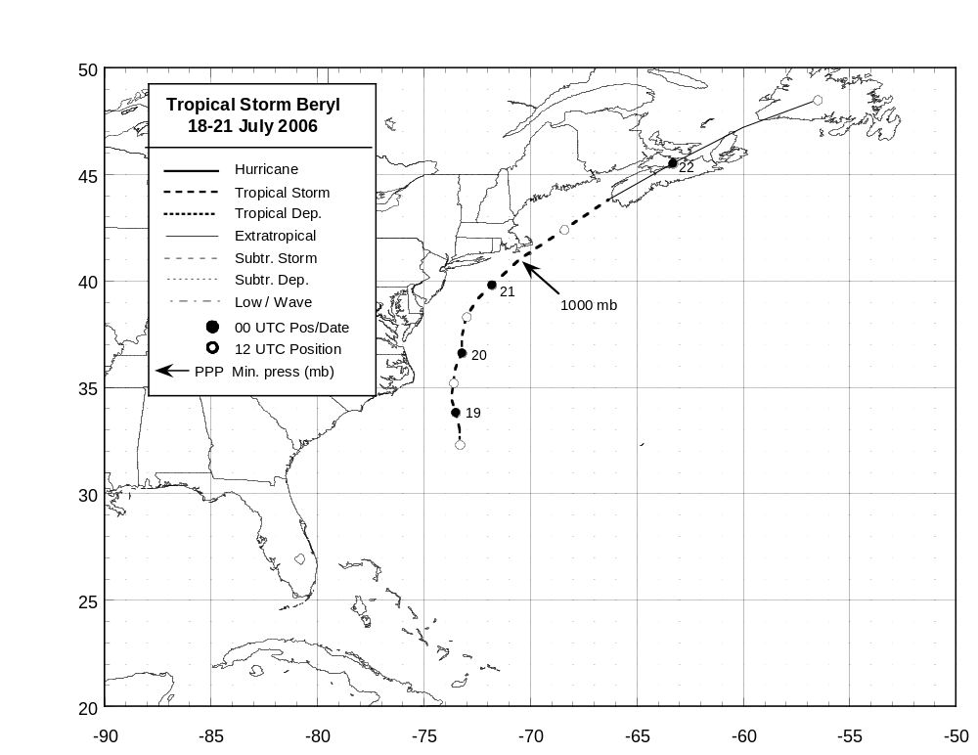
Figure 1. Best track positions for Tropical Storm Beryl, 18-21 July 2006. Track during the extratropical stage is based partially on analyses from the NOAA Ocean Prediction Center.
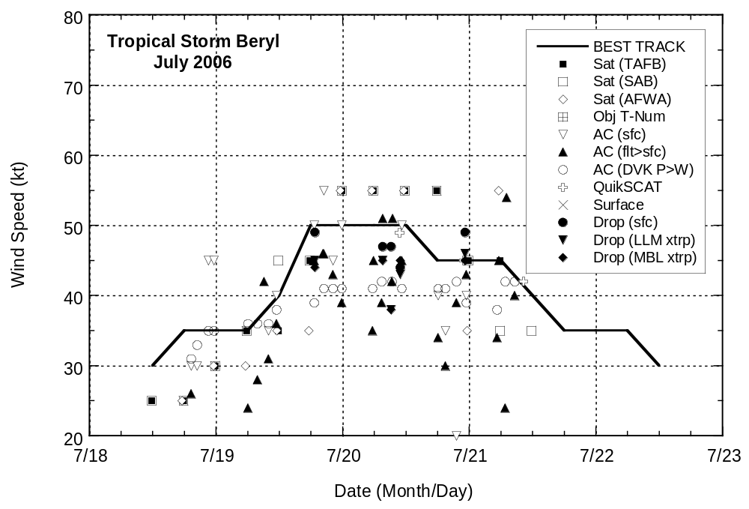
Figure 2. Selected wind observations and best track maximum sustained surface wind speed curve for Tropical Storm Beryl, 18-21 July 2006. Aircraft observations have been adjusted for elevation using 90%, 80%, and 80% reduction factors for observations from 700 mb, 850 mb, and 1500 ft, respectively. Dropwindsonde observations include actual 10 m winds (sfc), as well as surface estimates derived from the mean wind over the lowest 150 m of the wind sounding (LLM), and from the sounding boundary layer mean (MBL). Estimates during the extratropical stage are based partially on analyses from the NOAA Ocean Prediction Center.

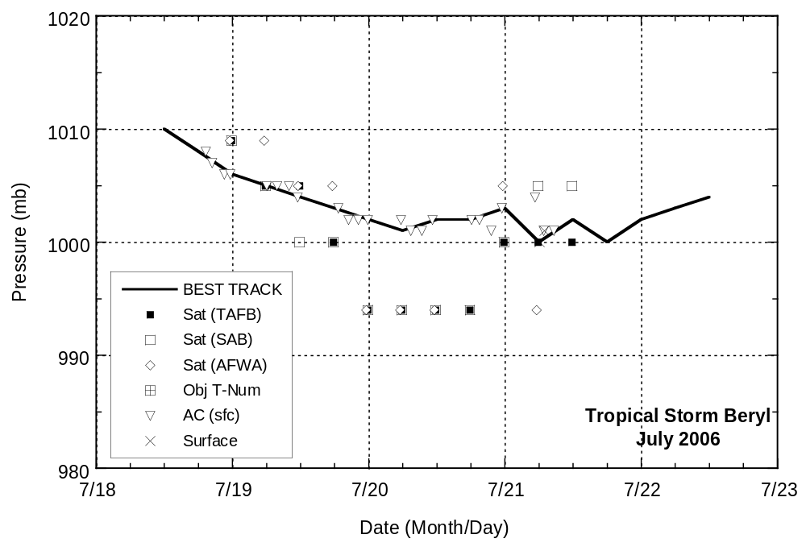

Figure 3. Selected pressure observations and best track minimum central pressure curve for Tropical Storm Beryl, 18-21 July 2006. Estimates during the extratropical stage are based partially on analyses from the NOAA Ocean Prediction Center.

