MeSH Database

Articles are indexed using a powerful vocabulary, called Medical Subject Headings (MeSH). The MeSH Database provides the option of identifying appropriate MeSH terms for searches.

Click on the MeSH Database link on the blue sidebar to search for a particular term or concept. After finding a term, click on the link to view and select subheadings and to refine aspects of the MeSH term. Check the terms desired, then click on the Send To Search Box feature. When finished adding terms, click Search PubMed to run the search.

Clinical Queries

PubMed’s Clinical Queries section makes it easier to find articles that report applied clinical research. Click on Clinical Queries on the blue sidebar. Select one of the three options.

To search by clinical study category, type search terms in the box provided. Then select one of the filter categories: “etiology,” “diagnosis,” “therapy,” “prognosis,” or “clinical prediction guides” and either “narrow, specific search” or “broad, sensitive search.”

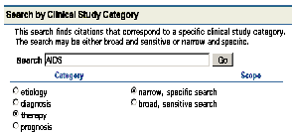

Select “Find Systematic Reviews” to locate systematic reviews, meta-analyses, reviews of clinical trials, evidence-based medicine, consensus development conferences, and guidelines.

Select “Medical Genetics Searches” to find citations and abstracts related to various topics in medical genetics. Choose one or more of the filter categories provided.

Printing & E-mailing

After selecting your citations and the display format, select Text, Printer, or E-mail from the Send To pull-down menu. Text will create a plain text version of the results. The Printer option creates a print-friendly version of the results. Email will ask for a selection of additional options and an email address.

Verifying a Citation

To search for a specific article of a journal issue, click on Single Citation Matcher on the blue sidebar. A form screen will appear. You do not need to fill out the entire form.

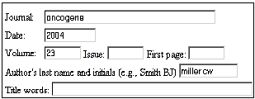

My NCBI

PubMed’s My NCBI feature stores search strategies, provides automatic e-mail updates, and stores search results. You must register for My NCBI by creating a User Name and Password. Click on My NCBI on the blue sidebar to sign on. My NCBI includes additional features for filtering search results. The tool icon to the right of the features tabs links to a list of commonly requested filters, e.g., “free full text” and “review”.

Saving Search Results
To save search results, select File from the Send To pull-down menu. You can use the Clipboard to collect citations from multiple searches. To save citations for citation management software, change the display format to MEDLINE before downloading or emailing.

Developed and updated by NN/LM staff. Funded by NLM. This brochure can be freely reproduced. It is on the internet at http://nnlm.gov/training/resources/pmtri.pdf. Revised: June 2008
PubMed
BASICS

PubMed® is the U.S. National Library of Medicine’s premiere search system for health information. It is available free on the Internet at http://pubmed.gov.

PubMed Content

- MEDLINE®, NLM’s database of millions of references to articles published in biomedical journals
- OLDMEDLINE®, journal article citations from 1949 through 1965
- in-process citations that have not yet been analyzed and indexed for MEDLINE
- publisher supplied citations that may not receive full indexing for MEDLINE because they are not biomedical in nature
- links to Entrez molecular biology databases.

PubMed Features

- sophisticated search capabilities, including spell checker and special tools for searching clinical topics
- assistance in finding search terms using the MeSH Database, a guide to MEDLINE’s controlled vocabulary
- ability to store and automatically receive email updates for saved searches using PubMed’s My NCBI.
- links to full-text articles and to information about library holdings
- links to other NLM search systems, such as ClinicalTrials.gov®, MedlinePlus®, NIH Clinical Alerts and Advisories, NLM Gateway® and PubMed Central.

Assistance and Training

Look at the top of the blue NCBI sidebar for links to Overview, Help, FAQs, and an online Tutorial.

The National Network of Libraries of Medicine® (NN/LM), an outreach program of NLM™, provides assistance and training nationwide. To find a local library, please call 800-338-7657 or go to http://nnlm.gov/members.

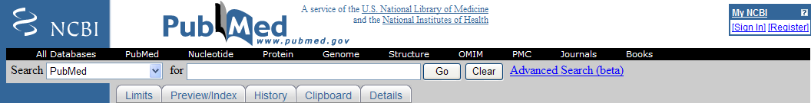
PubMed Searching

To Search PubMed, type a word or phrase into the query box, then click on the Go button or press the Enter key. Combine search terms with connector words: “AND”, “OR” or “NOT”. Type connector words in upper case letters.

Author Searching – Author names should be entered in the form gerberding jl, but initials are optional. Author names are automatically truncated to account for varying initials.

PubMed Features Tabs

Below the query box are the Features Tabs: Limits, Preview/Index, History, Clipboard, and Details.

Feature provides a table with checkboxes for Publication types, Languages, Subsets, Ages, Humans or Animals, Gender, and Publication Date. You can also restrict your search to items with abstracts or links to full text, and make multiple choices within a category. Click on Limits below the query box and make selections. After entering the search and choosing limits, click on the Go button to run the search. A checkmark in a box beside the word Limits indicates that limits are active.

Feature allows viewing and selecting of searchable fields and subject terms. Preview may be used in conjunction with the Index to construct and combine search statements before viewing the search results. Consult Help for more information.

Feature keeps track of search statements and numbers them as links. Clicking on the links provides a menu allowing search statements to be deleted, combined into a search with the AND, OR or NOT connectors, or saved in My NCBI.

Feature allows collecting of selected citations from one or more searches for printing, saving, e-mailing, ordering, or storing in My NCBI Collections. Click the check box beside the citations to select them. Then go to the Send To pull-down menu, and select Clipboard. To see the selected citations, click on the Clipboard features tab.

Feature provides information on how PubMed ran a search. PubMed looks first for the search words as MeSH terms, then journal titles, then authors and also searches “All Fields.” Details also shows how PubMed maps terms to MeSH headings.

PubMed Search Results

After clicking on the Go button, PubMed displays a list of results in summary format. To retrieve more information about the search results, use the menu next to Display to pick Abstract, Citation, or MEDLINE format.

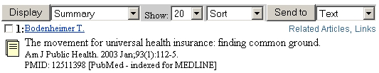

Ordering Journal Articles

Loansome Doc allows users to order copies of articles from a medical library. You must register with a library to use this service. To register, identify a library offering Loansome Doc service at http://nnlm.gov/members or call your Regional Medical Library at 800-338-7657 for a referral. Contact the library to register and learn about fees and policies.

After registering with a library that offers Loansome Doc service, PubMed can be used to place orders for copies of articles. Select articles of interest, and then select Order from the Send To pull-down menu.

Links to Full Text and Library Holdings

Many PubMed citations have links to the full-text of articles through PubMed Central (a digital archive of life sciences journal literature), through your library’s electronic and print holdings, or through the publisher (the latter may require a subscription or may make an article available by pay-per-view). Check with your library for details about your full text links or call your Regional Medical Library at 800-338-7657.

Related Articles

A helpful PubMed feature is the ability to find citations that are similar to those of interest. To retrieve Related Articles, click on the Related Articles link to the right of each citation.

