Sample Form

Header | Header | Header |  |  | Header
Item |  |  |  |  | 95
Item |  |  |  |  | 150
Item |  |  |  |  | 70
Item |  |  |  |  | 25
Item |  |  |  |  | 30
Item | Item:
Item | Item:
Item | Item :
Name
Address or room number
Phone
Signature

The Tables

To create a table, click Insert Table on the toolbar and drag to select the number of rows and columns. For the form panel, we created a table with 4 columns and 21 rows (don’t worry–you can always add or delete rows later if you guess wrong).

We selected options on the Formatting Palette to create the form:

- To delete the border outlining the cells, select the table, and then under Borders and Shading, click No Border . To add lines above or below rows, first select the row, and then click the desired border type.
  - To merge cells, select them, and then click Merge under Table.
- To change the alignment of the prices and order amounts, select the cells, and then click Align Right under Alignment and Spacing.
- To change the size of a cell, select it and drag the border in the desired direction.



For more information, contact:

Graduate Education Office
Uniformed Services University
4301 Jones Bridge Road
Bethesda, MD 20814-4799

301-295-3913
toll free 800-772-1747

e-mail: graduateprogram@usuhs.mil
web: www.usuhs.mil
(Click on “Graduate Education”)

Graduate Education
Medical & Clinical Psychology


Level 5. Clinical Psychology Program-

Military Track
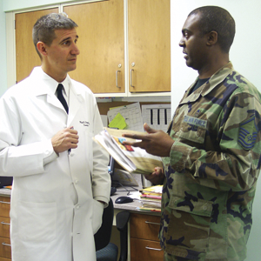 | 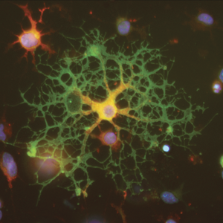
 | 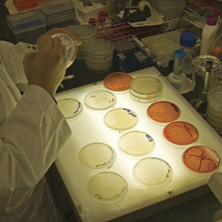
 | 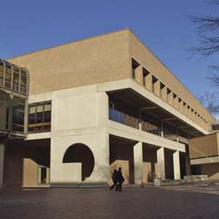




This Brochure

Our design is a tri-fold brochure, laid out on two U.S. letter-sized pages with a landscape orientation (click Page Setup on the File menu). The first page includes the three outer panels of the brochure, and the second page includes the three inner ones. It should be printed double-sided and folded in thirds.

Look at this brochure in page layout view (on the View menu) so that you can see all pictures and text boxes. Click Formatting Palette to easily see the formatting applied to the items on the page. Also, display nonprinting characters by making sure that Show/Hide ¶ is selected on the toolbar.

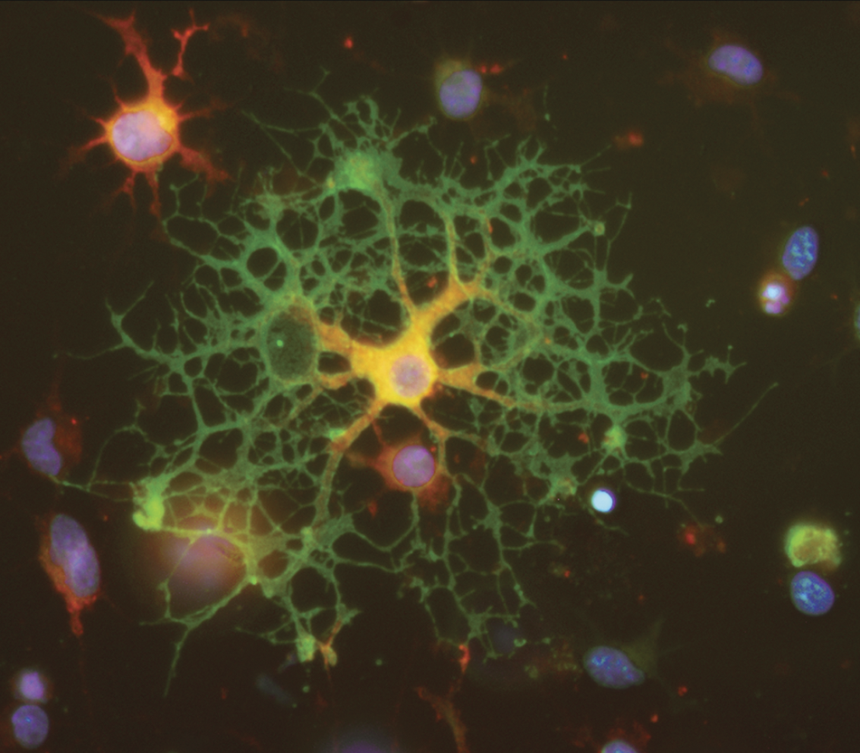

The Design Elements

Photos – We inserted the photos on the top of these columns and on the cover by clicking in the Insert menu, point to Picture, and then click From File. Find the file you want to insert. To make your photo fit across a column, make it 3.17 inches wide.

Cover Graphics – We placed photos in a table on top of the cover background. First click in the cell, and then insert the photo in the same way as described above.

Each photo in the cover grid is 1 inch square. For a level 1 brochure, the center-left photo is of the USU campus and the photos on the right represent aspects of USU. For levels 2 – 5, the center-left photo would represent the organization producing the brochure and the photos on the right would represent the departments and school the producers belong to. There should be one photo on the right representing the university (e.g. a campus photo).
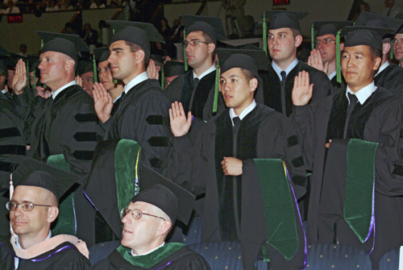

The Text

We’ve created character and paragraph styles for the brochure so that we can quickly and consistently apply formatting to the text. You can see the names and attributes of the styles we’ve used by placing your insertion point in a paragraph or selecting text and then looking under Styles on the Formatting Palette.

Styles
Paragraph styles – We created paragraph styles for headings, body text, and bullets. The bullets are a customized style.

- To create a customized bullet style, click Bullets and Numbering on the Format menu. On the Bulleted tab, click Customize. Click Font and/or Bullet to create the bullet you want. Once you’ve created a bullet style, it will appear in your bullet list.
- Character styles – We created a character style for the italicized lead-in text you see at the beginning of this paragraph.
- To create a style, click New Style under Styles on the Formatting Palette. Name and define the style. After you’ve created the style, you’ll be able to apply it to text by selecting it from the Styles list.

