USDA PRIVACY IMPACT ASSESSMENT FORM

Agency: National Agricultural Statistics Service

System Name: NASS Wide Area Network (WAN)

System Type: Major Application
General Support System
Non-major Application

System Categorization (per FIPS 199): High
Moderate
Low

Description of the System:
The NASS Wide Area Network (WAN) serves as the default repository of data used and processed by various Agency desktop applications. The system provides NASS employees local access to file and print sharing services to the Agency enterprise network. It also provides client access to various desktop applications, including email.

Who owns this system? (Name, agency, contact information)
Elvera Gleaton
National Agricultural Statistics Service
1400 Independence Ave., S.W.
Washington, DC 20250
Tel.No. (202)690-2352

Paul Williams
National Agricultural Statistics Service
1400 Independence Ave., S.W.
Washington, DC 20250
Tel.No. (202)720-7500

Who is the security contact for this system? (Name, agency, contact information)
Renato Chan
National Agricultural Statistics Service
1400 Independence Ave., S.W.
Washington, DC 20250
Tel.No. (202)720-4068

Who completed this document? (Name, agency, contact information)
Renato Chan
National Agricultural Statistics Service
1400 Independence Ave., S.W.
Washington, DC 20250
Tel.No. (202)720-4068

DOES THE SYSTEM CONTAIN INFORMATION ABOUT INDIVIDUALS IN AN IDENTIFIABLE FORM?

Indicate whether the following types of personal data are present in the system

QUESTION 1  Does the system contain any of the following type of data as it relates to individual: | Citizens | Employees
Name | No | Yes
Social Security Number | No | Yes
Telephone Number | No | Yes
Email address | No | Yes
Street address | No | Yes
Financial data (i.e. account numbers, tax ids, etc) | No | Yes
Health data | No | No
Biometric data | No | No
QUESTION 2  Can individuals be uniquely identified using personal information such as a combination of gender, race, birth date, geographic indicator, biometric data, etc.?  NOTE: 87% of the US population can be uniquely identified with a combination of gender, birth date and five digit zip code | No | Yes
Are social security numbers embedded in any field? | No | No
Is any portion of a social security numbers used? | No | No
Are social security numbers extracted from any other source (i.e. system, paper, etc.)? | No | No

If all of the answers in Questions 1 and 2 are NO,
You do not need to complete a Privacy Impact Assessment for this system and the answer to OMB A-11, Planning, Budgeting, Acquisition and Management of Capital Assets,
Part 7, Section E, Question 8c is:

If any answer in Questions 1 and 2 is YES, provide complete answers to all questions below.

DATA COLLECTION
- Generally describe the data to be used in the system.

The NASS Wide Area Network (WAN) stores data used and processed by a number of desktop applications. Information stored includes data used for various administrative functions.

- Is the collection of the data both relevant and necessary to the purpose for which the system is designed? In other words, the data is absolutely needed and has significant and bearing on the system’s purpose.

Yes
No. If NO, go to question 5

  - Explain.

Data collected are needed for the underlying application and systems to function properly.

- Sources of the data in the system.
  - What data is being collected from citizens and/or employees?

Information on employees include: (1) name, (2) home address, (3) telephone number, (4) Social Security Number, (5) NASDA contract employee Bank Account Number, and (6) other administrative data.

  - What USDA agencies are providing data for use in the system?

NASS.

  - What government agencies (state, county, city, local, etc.) are providing data for use in the system?

None.

  - From what other third party sources is data being collected?

None.

- Will data be collected from sources outside your agency? For example, citizens and employees, USDA sources (i.e. NFC, RD, etc.) or Non-USDA sources.

Yes
No. If NO, go to question 7

  - How will the data collected from citizens and employees be verified for accuracy, relevance, timeliness, and completeness?

N/A.

  - How will the data collected from USDA sources be verified for accuracy, relevance, timeliness, and completeness?

N/A.

  - How will the data collected from non-USDA sources be verified for accuracy, relevance, timeliness, and completeness?

N/A.

DATA USE
- Individuals must be informed in writing of the principal purpose of the information being collected from them. What is the principal purpose of the data being collected?

To maintain a record of earnings for every NASS employee, and NASDA employees who work on NASS surveys to facilitate payment of payroll and travel expenses. Maintain records necessary to perform routine personnel actions.

- Will the data be used for any other purpose?

Yes
No. If NO, go to question 9

  - What are the other purposes?

N/A.

- Is the use of the data both relevant and necessary to the purpose for which the system is being used? In other words, the data is absolutely needed and has significant and demonstrable bearing on the system’s purpose.

Yes
No. If NO, go to question 10

  - Explain.

Without the data, the underlying applications/systems will not function properly.

- Will the system derive new data or create previously unavailable data about an individual through aggregation from the information collected (i.e. aggregating farm loans by zip codes in which only one farm exists.)?

Yes
No. If NO, go to question 11

  - Will the new data be placed in the individual’s record (citizen or employee)?

Yes
No

  - Can the system make determinations about citizens or employees that would not be possible without the new data?

Yes
No

  - How will the new data be verified for relevance and accuracy?

N/A.

- Individuals must be informed in writing of the routine uses of the information being collected from them. What are the intended routine uses of the data being collected?

Information in the system for NASS employees are used routinely for administrative functions such as time and attendance, and travel reimbursements. Information in the system for NASDA employees are used routinely to process and disburse salary and travel checks.

- Will the data be used for any other purpose (other than indicated in question 11)?

Yes
No. If NO, go to question 13

  - What are the other purposes?

N/A.

- Automation of systems can lead to the consolidation of data – bringing data from multiple sources into one central location/system – and consolidation of administrative controls. When administrative controls are consolidated, they should be evaluated so that all necessary privacy controls remain in place to the degree necessary to continue to control access to and use of the data. Is data being consolidated?

Yes
No. If NO, go to question 14

  - What controls are in place to protect the data and prevent unauthorized access?

Each LAN user is assigned a network account. Appropriate rights are assigned to these accounts which control what users can access within the system.

- Are processes being consolidated?

Yes
No. If NO, go to question 15

  - What controls are in place to protect the data and prevent unauthorized access?

N/A.

DATA RETENTION
- Is the data periodically purged from the system?

Yes
No. If NO, go to question 16

  - How long is the data retained whether it is on paper, electronically, in the system or in a backup?

Retention of data follows schedules approved by the U.S. National Archives and Records Administration (NARA).

  - What are the procedures for purging the data at the end of the retention period?

Data that are expunged from the system are either sent to the NARA or shredded, whichever is applicable.

  - Where are these procedures documented?

The documentation for these procedures are stored in our policy and procedures manuals and instructions. They can be found in our HQ library and in our Field Offices.

- While the data is retained in the system, what are the requirements for determining if the data is still sufficiently accurate, relevant, timely, and complete to ensure fairness in making determinations?

Data are used only for administrative purposes and are deemed accurate, relevant, timely, and complete for such purposes as are necessary to maintain updated employee information.

- Is the data retained in the system the minimum necessary for the proper performance of a documented agency function?

Yes
No

DATA SHARING
- Will other agencies share data or have access to data in this system (i.e. international, federal, state, local, other, etc.)?

Yes
No. If NO, go to question 19

  - How will the data be used by the other agency?

N/A.

  - Who is responsible for assuring the other agency properly uses of the data?

N/A.

- Is the data transmitted to another agency or an independent site?

Yes
No. If NO, go to question 20

  - Is there the appropriate agreement in place to document the interconnection and that the PII and/or Privacy Act data is appropriately protected?

N/A.

  - Where are those documents located?

N/A.

- Is the system operated in more than one site?

Yes
No. If NO, go to question 21

  - How will consistent use of the system and data be maintained in all sites?

The system operates in a distributed environment where majority of the data is located, administered and controlled at the NASS Headquarters location. To ensure data is consistent, the agency has an extensive set of policy memoranda, instructions, and technical review teams that make regular site visits.

DATA ACCESS
- Who will have access to the data in the system (i.e. users, managers, system administrators, developers, etc.)?

Access to data is limited only to NASS users who have a need to modify, maintain and review the data. This includes authorized managers, system administrators and developers. Each user also signs a pledge of confidentiality that carries severe legal penalties for violating the pledge.

- How will user access to the data be determined?

Access to the data is determined by the system manager of the underlying application or system.

  - Are criteria, procedures, controls, and responsibilities regarding user access documented?

Yes
No. If NO, go to question 23

  - Where are criteria, procedures, controls, and responsibilities regarding user access documented?

Access request as well as approval is documented accordingly by management and the Technical Services Branch. The Computer Security Staff audits access routinely.

- How will user access to the data be restricted?

Users access are restricted by use of several logical and physical security controls. There are also appropriate management controls in place for this purpose.

  - Are procedures in place to detect or deter browsing??

Yes
No

  - Are procedures in place to detect or deter unauthorized user access?

Yes
No

- Does the system employ security controls to make information unusable to unauthorized individuals (i.e. encryption, strong authentication procedures, etc.)?

Yes
No

CUSTOMER PROTECTION
- Who will be responsible for protecting the privacy rights of the citizens and employees affected by the interface (i.e. office, person, departmental position, etc.)?

The responsible official can be reached at the following address:
Deputy Administrator for Field Operations
National Agricultural Statistics Service
1400 Independence Ave., S.W.
Washington, DC 20250

- How can citizens and employees contact the office or person responsible for protecting their privacy rights?

A written request must be sent to the above official. The request must contain: name, address, and System of Record name.

- A “breach” refers to a situation where data and/or information assets are unduly exposed. Is a breach notification policy in place for this system?

Yes - If YES, where is the breach notification policy located?

NASS’ breach notification policy is found on the Agency Intranet site.

No - If NO, please enter the POAM number with the estimated completion date:

- Consider the following:
- Consolidation and linkage of files and systems
- Derivation of data
- Accelerated information processing and decision making
- Use of new technologies

Is there a potential to deprive a citizens and employees of fundamental rules of fairness (those protections found in the Bill of Rights)?

Yes
No. If NO, go to question 29

  - Explain how this will be mitigated?

N/A.

- How will the system and its use ensure equitable treatment of citizens and employees?

The system was not designed to give users the ability to treat citizens and employees unfairly.

- Is there any possibility of treating citizens and employees differently and unfairly based upon their individual or group characteristics?

Yes
No. If NO, go to question 31

  - Explain

N/A.

SYSTEM OF RECORD
- Can the data be retrieved by a personal identifier? In other words, does the system actually retrieve data by the name of an individual or by some other unique number, symbol, or identifying attribute of the individual?

Yes
No. If NO, go to question 32

  - How will the data be retrieved? In other words, what is the identifying attribute (i.e. employee number, social security number, etc.)?

By use of a master employee file which is indexed by employee number assigned by NASS Headquarters and each NASS Field Office.

  - Under which Systems of Record notice (SOR) does the system operate? Provide number, name and publication date. (SORs can be viewed at www.access.GPO.gov)

This system operates under the following SOR notices:
USDA/NASS-1, Administrative Records Systems
USDA/NASS-3, Personnel Data Base

  - If the system is being modified, will the SOR require amendment or revision?

This depends on the change being made. If required, NASS will make modifications to the SOR notices to comply with federal mandates.

TECHNOLOGY
- Is the system using technologies in ways not previously employed by the agency (e.g. Caller-ID)?

Yes
No. If NO, the questionnaire is complete.

  - How does the use of this technology affect citizens and employees privacy?

N/A.

Upon completion of this Privacy Impact Assessment for this system, the answer to
OMB A-11, Planning, Budgeting, Acquisition and Management of Capital Assets,
Part 7, Section E, Question 8c is:

1. Yes.

PLEASE SUBMIT A COPY TO
THE OFFICE OF THE ASSOCIATE CHIEF INFORMATION OFFICE/CYBER SECURITY

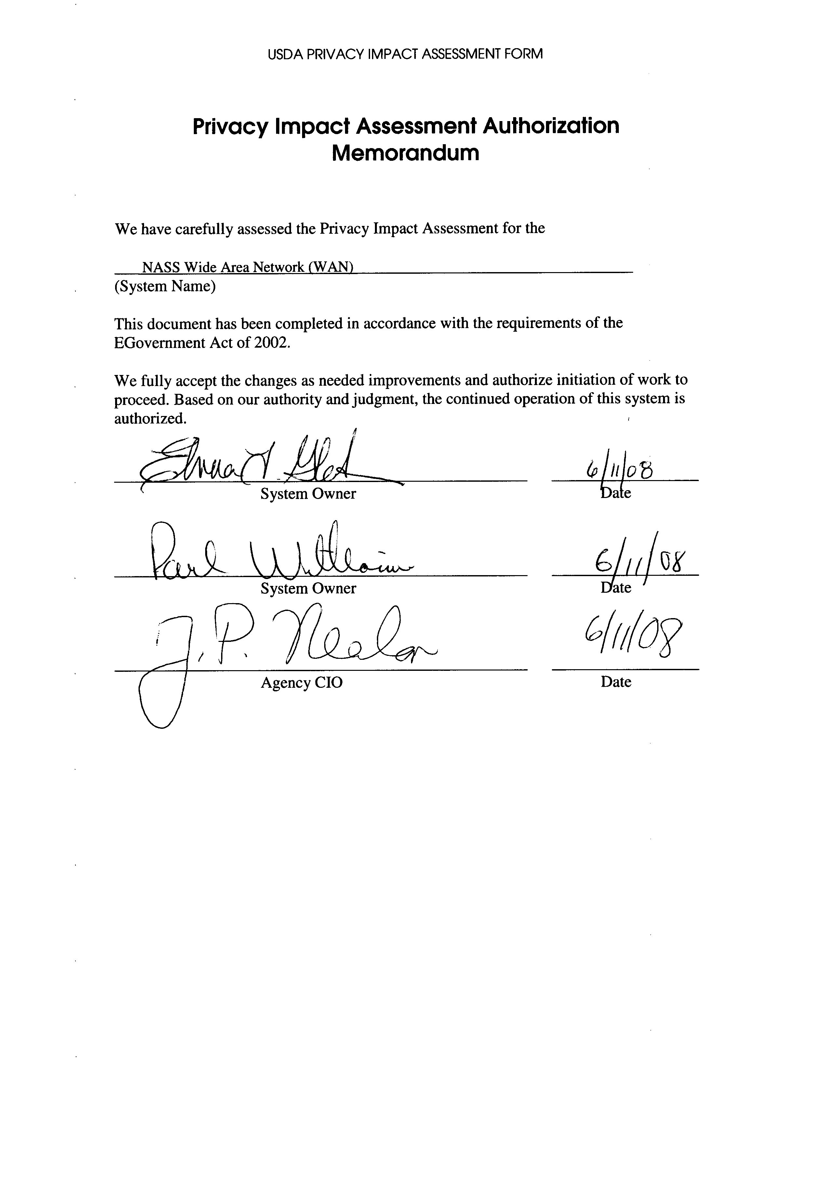

Comments of Latanya Sweeney, Ph.D., Director, Laboratory for International Data Privacy Assistant Professor of Computer Science and of Public Policy Carnegie Mellon University To the Department of Health and Human Services On "Standards of Privacy of Individually Identifiable Health Information". 26 April 2002.

