Bioterrorism and Other Public Health Emergencies
Tools and Models for Planning and Preparedness

Emergency Preparedness Resource Inventory (EPRI)

A Tool for Local, Regional, and State Planners

Part 1. Implementation Report

Prepared for:
U.S. Department of Health and Human Services
Agency for Healthcare Research and Quality
540 Gaither Rd.
Rockville, MD 20850

Contract # 290-00-0003

Prepared by:
Abt-Geisinger Associates

Andrea Hassol
Gary Gaumer
Anthony Turel, MD
Cynthia Thomas, DO

AHRQ Publication No. 05-0077-1
April, 2005

Funding to support the Health Emergency Assistance Line and Triage Hub (HEALTH) Model was provided by the U.S. Department of Health and Human Services, Agency for Healthcare Research and Quality, under Contract No. 290-00-0014.

The authors of this report are responsible for its content. No statement in the report should be construed as an official position of the Agency for Healthcare Research and Quality or the U.S. Department of Health and Human Services.

This document is in the public domain and may be used and reprinted without permission except those copyrighted materials noted, for which further reproduction is prohibited without the specific permission of copyright holders.

Suggested Citation: Hassol A, Gaumer G, Turel A, Thomas C. Emergency Preparedness Resource Inventory (EPRI), A Tool for Local, Regional, and State Planners. Part 1. Implementation Report. Prepared by Abt-Geisinger Associates under contract no. 290-00-0003. AHRQ Pub. No. 05-0077-1. Rockville, MD: Agency for Healthcare Research and Quality. April 2005.

Preface
Abt Associates Inc., serving as prime contractor, the Geisinger Health System, and Relyon Media Inc. collaborated on this project. The contract was funded by the Agency for Healthcare Research and Quality (contract # 290-00-003, task orders 5 and 6).

Abt staff designed the structure for the Web-based inventory tool (called the Emergency Preparedness Resource Inventory—A Tool for Local, Regional, and State Planners) and assisted in the pilot field test.

Geisinger Health System assembled a project Steering Committee in Pennsylvania, created the resource list and list of location types for the data warehouse, and implemented the pilot field test.

Relyon Media, a Web development firm, programmed the Web-based tool based upon input of both the Abt and GHS project staffs.

An accompanying Technical Manual is intended for System Administrators implementing this tool in their own jurisdictions. Instructions for downloading and installing the software appear in that report. The software tool itself is available without cost from the Agency for Healthcare Research and Quality; it is copyrighted and cannot be resold.

For additional information, contact:

Andrea Hassol
Abt Associates Inc.
55 Wheeler St.
Cambridge, MA 02138
617-349-2488
andrea_hassol@abtassoc.com

Carole Dillard
Agency for Healthcare Research and Quality
(301) 594-1358
cdillard@ahrq.gov
Contents

Preface…………………………………………………………………………………………. iii
1. Introduction……………………………………………………………………………………. 1
2. Inventory is Comprehensive………………………………………………………………….. 2
Types of Locations included in the inventory…………………………………………………... 3
Types of Resources included in the inventory………………………………………………….. 4
Specific Resources included in the Inventory…………………………………………………... 5
3. Inventory is Flexible and Customizable……………………………………………………… 5
Configuring locations and resources to tailor the inventory structure to needs/circumstances… 6
Decide which resources to inventory……………………………………………………. 6
Determine what types of locations own/control the resources you want to inventory…... 6
Match resources to location types……………………………………………………….. 6
Periodically Updating Data……………………………………………………………………... 8
4. Inventory Has Automated and Secure Reporting…………………………………………… 8
System Configuration Reports………………………………………………………………… 10
Senior Planner Reports………………………………………………………………………… 10
Emergency Response Reports…………………………………………………………………. 11
Region-wide Reports…………………………………………………………………………... 16
Data and Report Security……………………………………………………………………… 19
5. Software Has Been Fully Tested…………………………………………………………….. 19
Steering Committee……………………………………………………………………………. 19
County-level political support…………………………………………………………………. 20
Selected location types, resource types and resources relevant for pilot test…………………. 21
Outreach to solicit participation……………………………………………………………….. 21
Recruiting Organizations and Collecting Data: Lessons Learned…………………………….. 22
Motivating Participation………………………………………………………………... 22
Test Results……………………………………………………………………………... 22
Lessons Learned About Soliciting Participation……………………………………….. 23

- Introduction
This report, and the accompanying Technical Manual and Appendix, presents a software tool intended for use by local or regional planners to develop an inventory of critical resources that would be useful in responding to a bioterrorist attack. The Emergency Preparedness Resource Inventory (EPRI) is a Web-based software tool for assembling such an inventory.

In 2002, Abt Associates conducted a review of guidance promulgated by the Centers for Disease Control and Prevention (CDC) and other agencies of the Department of Health and Human Services (DHHS) to states and regions concerning preparedness to respond to bioterrorism events. The federal guidance focused on estimating the demand for resources needed in the event of specific bioterrorism events, and assuring that needed resources can be quickly assembled. That is, states and localities were advised to estimate threats and the resources that would be needed to respond to these threats. This focus on demand for resources continues to be the emphasis of federal initiatives. Much less mention was found in the planning and guidance documents related to assessing community or regional supply of resources that could be made available to cope with bioterrorism events.

An exception to this rule was the CDC’s 2001 planning guide covering many aspects of bioterrorism preparedness and response. The planning guide suggested that effective planning includes determining the resource base (the supply) of resources in a community. The CDC advised that members of planning teams should:

- Know what resources they bring to emergency response and recovery
- List available resources and compare against what would be needed to respond to an emergency, and
- Identify shortages (i.e. where potential demand exceeds supply).

In discussions with one regional planning taskforce in Pennsylvania, it became clear that planners had no such inventory or detailed knowledge of available local and regional resources, and that the lack of such an inventory was impairing planning effectiveness. This situation probably exists in many other parts of the country.

An inventory of critical resources could be useful in a number of ways:

Incident Response: A major emergency, whether natural or man-made, could require the rapid location and deployment of equipment, supplies and personnel. First responders need to know where the needed resources are located, how much is available, and whom to contact to get access to those resources. An inventory that lists relevant resources and their quantities and locations, as well as contact information, would meet this need.

Estimating Gaps: An inventory would tell planners “what is”—what exists in their jurisdiction. Planning also requires some measure of “what should be”; with the difference between these being an imbalance, either a surplus or a shortage. Determining “what should be” could rest on the guidance of an expert panel, or a set of standards developed at a federal level, or a model of a ‘well supplied’ community that others are striving to match. Such standards could also revolve around specific threat scenarios. The adequacy of community preparedness would broadly recognize the span of threats, the likelihood of their occurrence, distances from larger urban areas, etc. Standards could be defined for each resource in an inventory, and might best be done on a population basis, for example burn beds per capita or respirators per capita.

Investment Decisions: Having identified shortage where a community does not meet agreed-upon standards, an inventory could have dollars associated with each resource to guide investment decisions. If a state or locality has a fixed budget, and a list of needed resources (possibly prioritized based on local decisions or perceived threat likelihoods), trade-offs among investments become more obvious.

The goals of this project were to:

- Create a software tool for assembling a regional inventory of resources that would permit better bioterrorism readiness planning and better response in the event of an incident, and

- Pilot test the software tool in an eight-county region of Pennsylvania.

This report presents the features and contents of the inventory software (EPRI) and describes a pilot test conducted during the summer of 2003. This report discusses the contents of the inventory, how state or local authorities can customize the inventory structure to meet their needs, security and confidentiality protections, and an extensive test of the inventory tool.

EPRI is a software tool that can be customized to create an inventory appropriate for any region, state or locality. It is Web-based so that all selected organizations in an area can log in to enter information about their resources. It creates automated reports for use in preparedness and planning as well as incident response. EPRI also has extensive security protections. Please see the accompanying Technical Manual for detailed instructions for installing and using the tool.

- Inventory is Comprehensive
The list of resources to be itemized in EPRI is comprehensive and covers resources that might be available in major urban settings, as well as in rural areas like central Pennsylvania. Included in the tool are virtually every type of organization, agency and location that might have resources to contribute in the case of a major emergency, and the specific resources each might be expected to control. Not only health care providers and first responder agencies were included, but also public schools, mortuaries, animal control facilities, community pharmacies, and others. The tool’s flexibility makes it possible to add to, or subtract from, the resources currently included. A state or region wishing to use the tool to create their own inventory might want to restrict themselves to a smaller set of organizations, or might wish to restrict the list of resources to those relevant only to immediate incident response. EPRI offers full flexibility so that the inventory structure can be tailored to the needs and circumstances unique to any given setting or purpose.

Three terms are used in this report to explain the inventory structure and contents:

- Location Types are places (hospitals, fire stations, public schools) that might be expected to control useful resources.

- Resource Types are categories of resources (antibiotics, physicians, emergency vehicles) that help to organize the inventory.

- Resources are the specific sorts of equipment, personnel and supplies that might be needed to respond to a natural or man-made disaster.

Types of Locations included in the inventory
EPRI currently contains thirty-three location types, encompassing a large array of services (see box, where location types are listed alphabetically).
Box 1. Location Types in EPRI Inventory

Adult Day Care Centers  Airports  Animal Care & Kennels  Arenas & Stadiums  Blood Banks/Blood Centers  Child Care Centers  Colleges & Universities  Community Pharmacies  Emergency Management  Agencies  Emergency Medical Services/Ambulance  Fire Stations  Free-standing 911 Centers  Free-standing Clinics  & Surgical Centers  Gyms, Clubs &  Community Centers  Home Health Agencies  Hospitals | Law Enforcement  Major Utilities & Industry  Mass Media  Medical Equipment/DME Suppliers  Mortuaries  National Guard  Nursing Homes  Outpatient Dialysis Centers  Parks & Resorts  Prisons & Jails  Private Physician Offices  Public Schools  Psychiatric Hospitals  Public Health Departments  Red Cross  Rehabilitation Facilities  & Hospitals  Warehouses

Healthcare locations include hospitals, home health nursing agencies, nursing homes, freestanding medical and surgical centers, private physician offices, rehabilitation and psychiatric hospitals, blood banks, and public health departments. Each of these location types was chosen for inclusion based on its capacity to provide medical services, to contribute medical supplies or patient beds, or to house or shelter patients.

Emergency response locations include emergency management agencies, emergency medical services, fire departments, law enforcement agencies, the American Red Cross, and the National Guard. Each of these location types provides unique services during any emergency situation or disaster response. Each can contribute specially trained personnel and equipment during an emergency and should be included in planning and incident response efforts.

Miscellaneous other types of locations have been included as well, although we normally do not think of these as bioterrorism response locations. Keeping in mind that any disaster, in particular one prompted by biological agents of terrorism, may affect the animal population as well as the human population, animal care facilities and animal containment facilities have also been included in the inventory. Due to the fact that a large-scale disaster may create mass fatalities, funeral homes have also been included. Location types such as arenas, stadiums, warehouses, gymnasiums, and community centers were included because they have extensive space that could be used for housing or sheltering individuals in need, creating a vaccination or antibiotic distribution site, housing animals, or serving as a storage location for imported equipment, supplies, or medication and have also been included in the inventory. Due to the ever-changing nature of planning needs, the tool was designed to be readily customizable to any region and/or any planning and incident response need.

Types of Resources included in the inventory
A resource class designates the way data are collected. For example, Personnel is a resource class and collects information about full time and part time personnel. Facilities Capabilities is another resource class and contains yes/no questions about the sorts of capabilities a facility might have (e.g. back-up water supply, food preparation). All types of resources are assigned a resource class so that data collection is correctly formatted.

Resource type is a category of personnel or equipment resources. Some examples of resource types include physicians, antibiotics, and communication equipment.

Within each resource type are specific resources; examples include pediatricians (within physicians), azithromycin (within antibiotics), and mobile radios (within communications equipment). Each resource type, and the resources specific to it, represent personnel or equipment critical in planning and responding to large-scale emergencies. An Internet search was undertaken to identify any list previously compiled for the wide range of location types in our inventory, but none was located. Emergency response directors on the project steering committee indicated that no such list exists. As a result, project staff developed what is believed to be the first comprehensive list of this type. Resources were initially identified through an extensive review of the literature, expert consultation, interviews with emergency response and healthcare providers, and meetings of a project Steering Committee.
Box 2. Resource Types in EPRI Inventory

Antibiotics  Antidotes/Antitoxins  Beds  Blood Products  Communications Capability  Communications Equipment  CRNPs  Emergency Response Capability  Emergency Response  Equipment  EMS Personnel  Emergency Transportation Equipment  Facility Size  Facility/Utilities Capabilities | IV Fluids  LPNs  Major Medical Equipment  Medical Supplies  Medical Therapists  Non-Medical  Personnel  Other Medical  Equipment  Other Medical  Personnel  PAs  Pharmacists  Physicians  RNs  Technicians  Transportation  Vaccines

Rather than asking every type of location to go through the entire list within the inventory and fill in information where applicable, each resource has been assigned to specific location types where that resource is likely to be found. Fire stations are not asked about hospital beds, for example, and home health agencies are not asked about fire trucks.

To facilitate data entry for the end user and effective use of the data by planners and responders, resource nomenclature has been standardized when possible. For example, personal protective equipment (PPE) resources have been standardized in accordance with the Occupational Safety and Health Administration (OSHA) guidelines regarding PPE.

Those resources that have been standardized are listed and defined in a Help Guide that is incorporated into EPRI. This allows users to refer to the help guide to ensure that data entry regarding existing resources reflects the intent of the inventory. Due to potential differences in planning needs across the country, resources currently included in the inventory can easily be edited or removed, and additional resources can be added to make the inventory specific to the needs of each community, region, or administrative agency using the tool.

Specific Resources included in the Inventory
For every resource type (see box on previous page) there is a list of specific resources; some resource types have just a few resources, others have many. There are hundreds of specific resources in the inventory, all organized by resource type. (See box for an example of the specific resources included in the resource type: Antibiotics.)
Box 3. Example Resource Type: Antibiotics
Specific Resources
IV Cipro 200MG Doses on hand
IV Levofloxacin 500mg Doses on hand
IV Penicillin Doses on hand
IV Penicillin G - 4 million dose units on hand
Oral Amoxicillin 500mg Doses on hand
Oral Cipro 500MG Doses on hand
Oral Doxycycline 100mh Doses on hand
Oral Levofloxacin 500mg Doses on hand
Oral Ofloxacin 200mg Doses on hand
Oral Rifampin 150mg Doses on hand
Oral Tetracycline 500mg Doses on hand
Streptomycin IM - 1 gram vials on hand

The entire list of resource types, resources and locations types appears in a separate Appendix accompanying this report.

3. Inventory is Flexible and Customizable
EPRI allows a state or local authority to specify precisely which location types, resource types and resources are to be included. The extensive lists can be readily shortened or expanded, and can be changed whenever needed. At present, the inventory is configured for the eight-county area of Pennsylvania where it was pilot tested; this configuration may not be optimal for other regions. Resources or locations currently not included may become necessary in the future and can be added. This section explains how to customize the inventory to meet particular needs and circumstances. Complete instructions for installing and operating EPRI appear in the Technical Manual accompanying this report.

Configuring locations and resources to tailor the inventory structure to needs/circumstances

Decide which resources to inventory
As discussed above, EPRI uses a hierarchy of specific resources within resource types. A resource type might be ‘antibiotics,’ while resources would be each type of antibiotic you wish to include (e.g. those useful in response to a bioterrorism event). A resource type might be ‘physicians,’ while resources would be the types of physicians you want to include (e.g. specialists in burns, trauma, infectious diseases). The inventory is organized with this two-tiered structure as an organizing principle to enable relatively quick and straightforward movement around the data warehouse. Rather than searching for each individual resource, one can drill down to the resource type, of which there are 28, and then to the specific resource.

The Appendix accompanying this report contains the entire matrix of resource types and resources currently included in EPRI. The Technical Manual explains how to create new resource types and resources, to customize the inventory as needed.

Determine what types of locations own/control the resources you want to inventory
EPRI uses the concept of a location type. An organization may have one, and only one, location – a stand-alone nursing home, for example. Or an organization may have several locations – a nursing home chain, or may have both nursing homes and home health agencies – two different location types. The inventory contains fields for entering information about the parent organization, and each of the distinct locations that are a part of that organization. The inventory structure now includes many types of locations, and more can be added. Some searches will be at the level of location type – what resources local hospitals contain, what resources are available at fire stations, etc. Therefore an organizing principle for location type was needed and project staff specified 33 location types ranging from animal control facilities to college campuses to hospitals for inclusion in the inventory.

The appendix accompanying this report contains the location types currently structured in the inventory – any of which can be altered by future users. The Technical Manual explains how to create new location types.

Match resources to location types
EPRI allows the system administrator to specify what resource types and resources the different location types are likely to control. Some location types are likely to only have a few relevant resources, while others have vast resources relevant to any sort of disaster or terrorist event. Initial decisions were made by project staff about exactly which resources are likely to be relevant for which location types. For example, based on recommendations from emergency response providers and other individuals on the project steering committee, the types of emergency transportation vehicles that emergency medical services (EMS) providers often have available, as well as those that might be available through a county emergency management agency, were included in the inventory for those location types..

The appendix accompanying this report shows an example of the location type-resource matrix currently structured in the inventory – any of which can be altered by future EPRI users. The Technical Manual explains how the matrix of resources may be customized.

The following screen shot from EPRI shows a particular type of location (emergency medical service/ambulance), and a particular resource type (communications equipment), and indicates which of the specific communication equipment resources have been activated for EMS/ambulance organizations. Steering committee members advised that five of the six types of communication equipment are likely to be available at EMS/ambulance locations, and EMS/ambulance companies will be asked to report on these five. The sixth resource (specialized communication van) is not a resource that EMS providers are likely to have and these organizations will not be asked to report on it. System administrators can decide which specific resources are relevant for each location type, and can activate or inactivate any of the resources currently assigned to that location type. A system administrator might, for example, decide not to ask EMS/ambulance companies about their communications equipment at all; or might even decide to omit EMS/ambulance companies from the inventory entirely.

Figure 1. Resources activated for specific location types
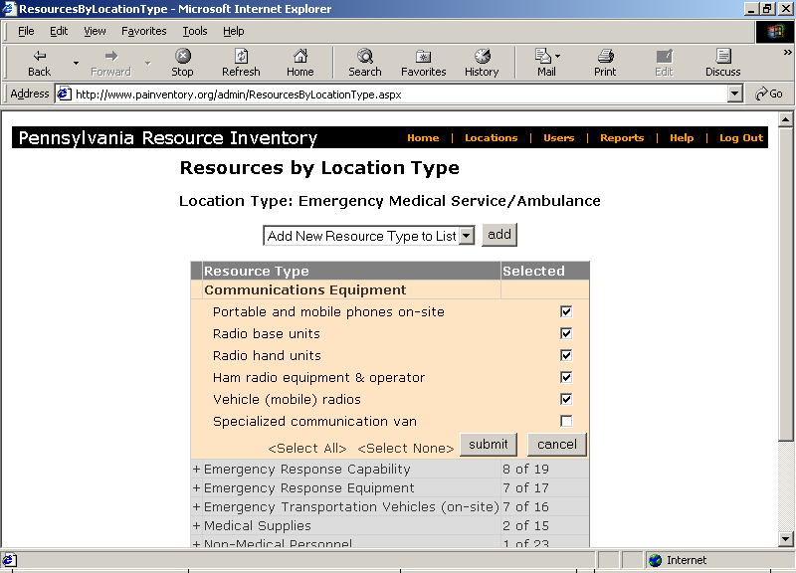

T

On the Web site, the administrator can open each resource type, thereby enabling the entire list of resources within it to appear. Those resources that the administrator wishes to activate for the particular location type (in this case, EMS/ambulance) are checked. The accompanying Technical Manual provides detailed instructions for modifying any of the settings in the inventory, adding or deleting resources or resource types, adding or deleting location types, altering which resources are relevant for each location type, etc.

Periodically Updating Data
EPRI is designed to support periodic updating. An e-mail generated within EPRI can be sent to all participating organizations asking that they update their data. Each participating organization would be asked to review their data and update anything that has changed since the last reporting. Rather than requesting that all data be re-entered, only personnel and equipment resources that have experienced change over the interim need to be reported, thereby minimizing the burden on participants.

Each resource in EPRI can be set to a different periodicity for updating. Some resources change very infrequently (e.g. fire trucks, burn unit beds) while others resources are almost constantly changing (e.g. personnel, drug inventories). A system administrator may decide to seek updated information on resources that change infrequently at a frequency of only once per year, while those resources that change rapidly may need to be updated quarterly. Again, the flexibility designed into the system is intended to allow the system administrator to minimize burden on participating organizations and tailor EPRI to unique settings and circumstances.

The data manager and data entry person designated by each participating location have the ability to generate a report of that site’s specific resource inventory. This site specific report can be printed or downloaded for other mandated reports or the organization’s own planning needs.

4. Inventory Has Automated and Secure Reporting
EPRI will create a number of automated reports. Some may be more useful for planning purposes, and others may be more useful for incident response needs. The Web-based inventory, and the reports it generates, must be secure. If the system were breached, the information contained within it, and the automated reports it produces, could offer abundant information to terrorists. Institutions involved in a competitive market place also need assurance that proprietary information will not be accessible to their competitors. For example, hospitals in a metropolitan area, competing for personnel, would not want to share information about the number of nurses, physicians and technicians they employ.

The need for utmost security necessitates a tool that can be hosted on a secure server by any state or regional agency compiling such an inventory. Access to EPRI is password protected and the data transmitted between the Web server and the user are encrypted. In addition, approved users are granted authorized access only to data at the level of aggregation they each need to accomplish their roles in planning or response. Those without a need to view aggregated data within a region, or detailed data about an institution or organization, do not have such access.

Table 1 provides a list of all automated reports that can be generated from the inventory. Sections that follow describe the reports and who has access to them. In addition to the automated reports, the inventory data can be downloaded into an Access database to build customized reports beyond those listed here.

Table 1. List of Automated Reports
System Configuration
Resource List  Each resource type with its associated resources. |  | Level 1 - Administrator
Resource Location Assignments  Each location type with its associated resource types and resources. Each resource notes whether it is active and/or assigned to the location type. |  | Level 1 - Administrator
Export Access Database  Download a copy of the entire database in Microsoft Access format. |  | Level 1 - Administrator
Senior Planner
Location Inventory  View inventory data for one or more locations. |  | Level 2 - Senior Planner
Emergency Response Director
Resources within Radius  Displays all the locations that report on resources within a certain distance from a certain city or latitude/longitude coordinates. |  | Level 2 - Senior Planner
Region-wide Reports
Aggregate Inventory | Level 4 - External VIP
Aggregate Inventory Per 1,000 People | Level 4 - External VIP
Aggregate Inventory By County | Level 4 - External VIP
Aggregate Inventory Per 1,000 People By County | Level 4 - External VIP
Map Reports
Inventory within Radius |  | Level 2 - Senior Planner
Aggregate Inventory By County |  | Level 4 - External VIP
Aggregate Inventory Per 1,000 People By County |  | Level 4 - External VIP

As shown in the table above, EPRI includes mapping capabilities. In particular, with EPRI you can:
- Create a map showing the location of resources within a certain distance of a town.
- Overlay demographic data on a map of the location of resources, so that you can study the relationship between resource locations and, say, population.
- Obtain a map showing the route between a town and a location housing a particular resource.
- Obtain driving directions between a town and a resource location, including the estimated travel time.
- Create a map showing resource levels by county.

Examples of the maps are shown later in this section. See the Technical Manual for further details on how to set up EPRI’s mapping capability.

System Configuration Reports
The system configuration reports display how the inventory is configured: all of the resource types, location types, resources, and the matrix layout for resources within location types. These reports tell the system administrator exactly how the inventory is configured in case changes are being contemplated. These reports generate a summary list of what is available and can be utilized by moving through all the screens to look at each location type and the resource types and resources that have been activated for it.

The resource list report is intended for use by the system administrator. It lists all of the resource types (antibiotics, beds, etc.) and then all of the specific resources within each resource type. The report lists all 28 different resource types and hundreds of specific resources. It is a display of the structure of the inventory, as customized by a system administrator.

The resource location assignments report is also intended for the system administrator. This list goes through the specific resources that each different type of location may control, and identifies those resources to be included during the data entry process. Specifically it lists each type of location; then within each location type, it lists each resource type; and within each of those resource types, it lists each resource. The report also indicates whether or not a resource has been activated for that type of location. This report provides a view of the entire matrix of location types and resources. An example of this report appears in the Appendix accompanying this report.

The export Access database feature allows for the download of all of the data contained within the inventory into an Access database. This feature allows the system administrator to create new reports that are separate and independent from the automated reports included in EPRI. It could be that the automated reports created within EPRI do not meet all the analytic needs of planners. The system administrator and other planners may wish to work with the database themselves. This feature allows the system administrator to use the data in any way necessary. This is also a way to create an archive by which a copy of the database is stored each time data are reported (annually, semi-annually, or whatever frequency a system administrator selects).

Senior Planner Reports
The location inventory is intended for senior planners and administrators, who may need to see all of the information associated with one or more locations. It will show how many staff are employed, what equipment is available, etc. for each individual participating location/organization. Access to this location-specific information should be tightly controlled. Due to the proprietary nature of the information, only those with a need to know should have access to this level of data. Competing hospitals, for example, should not be allowed to see each other’s detailed information. This is a report that should not be needed frequently, and may never be needed in the course of normal operations of the inventory. The following is an example of the first page of such a report for a home health agency.

Figure 2. Location-specific resources

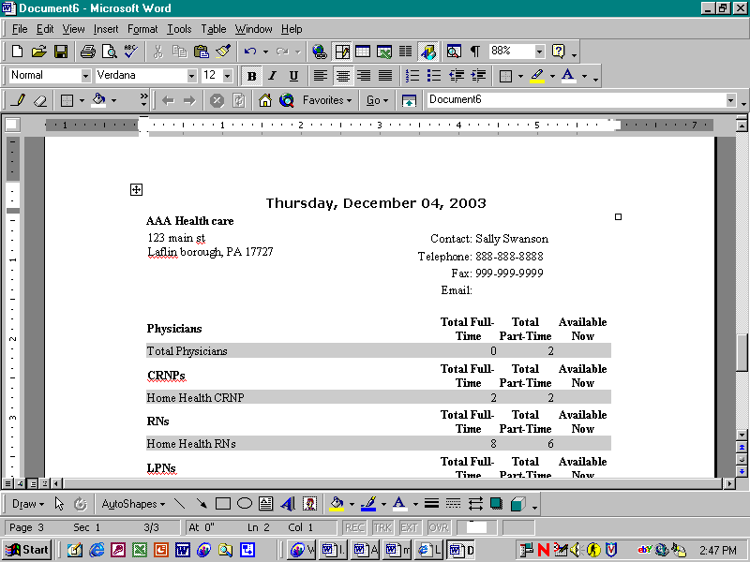

Emergency Response Reports
Resources within radius is an incident response report that would be available to administrators, senior planners, and most importantly to incident response commanders as a real time report. It allows a first response commander in need of a particular resource to specify what is being sought, and the geographic area to be queried (the area around a disaster site). The report will list all organizations that are asked about the resource being sought, and will show the number of personnel or equipment resources of the specific type requested that have been reported by each organization. In addition, the contact person identified by that organization, their contact information, and the distance from the incident site to the organization will be listed. In the following hypothetical example, a first response commander needs to locate personal protective equipment within a radius of 50 miles of a chemical spill. The report obtained lists every location that has reported having personal protective equipment/suits along with a contact name/number, and how many suits are present at the site. In an emergency, a special request could be e-mailed to these locations requesting an update of how many such suits can be made available immediately, in 24 hours, and in 48 hours. The incident commander could also simply telephone the emergency contact person at each organization and ask these questions.

Figure 3. Resources near the site of an emergency

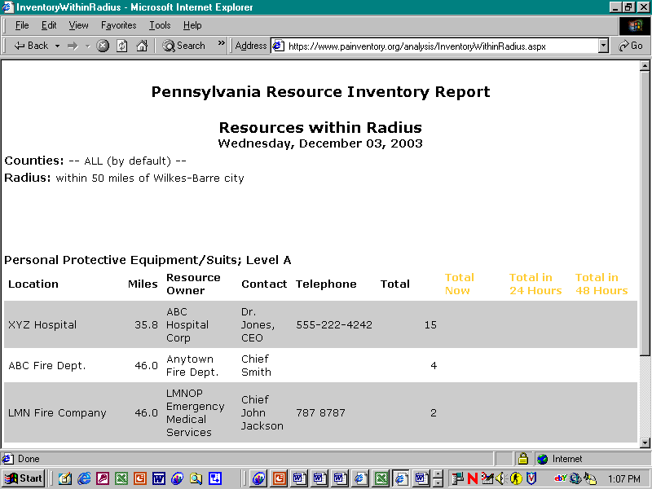

There is currently no report designated for Level 3; for security purposes all reports that show individual facility data are designated 2. A state may, however, decide to permit wider access to various reports and can re-designate the Resources Within Radius, or any other report, as Level 3 if desired.
The location of resources can also be displayed on a map. Map 1 below shows the locations of Oral Cipro within 40 miles of the town of Ashley:

Map 1. Resources within a specific distance of a town
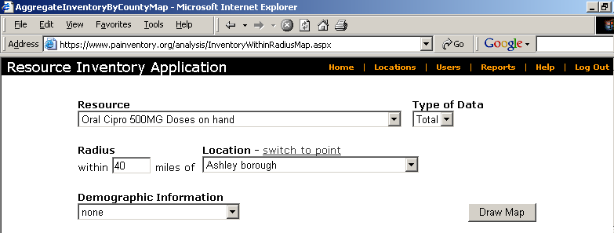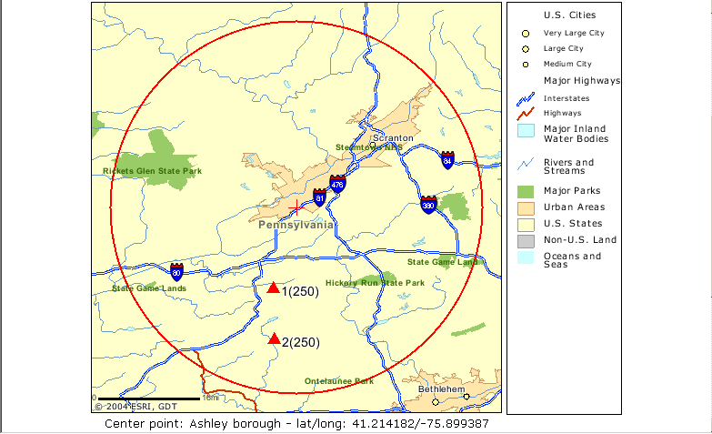
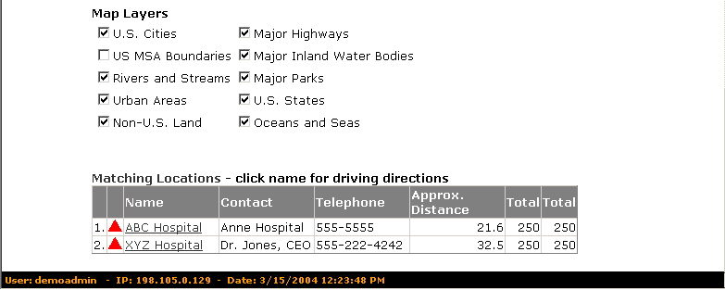
Demographic information can also be overlaid on this map to enable users to study the correlation between, say, population data and resource locations, as shown in Map 2 below.

Map 2. Demographic data overlaid on resource location data
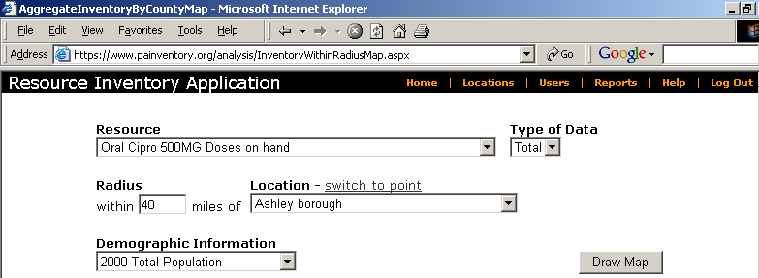
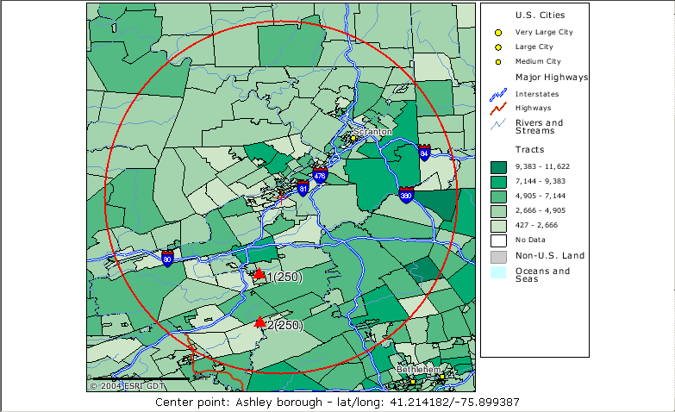
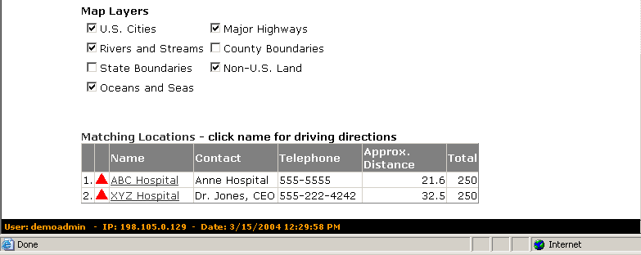

When the user clicks on one of the names of the locations in the Matching Locations table (e.g., ‘ABC Hospital’ in the above screen), a map and driving directions are displayed that guides the user from the specified town to the location with the resource (note the ‘Start’ and ‘End’ label on the map):

Map 3. Driving directions to a resource location
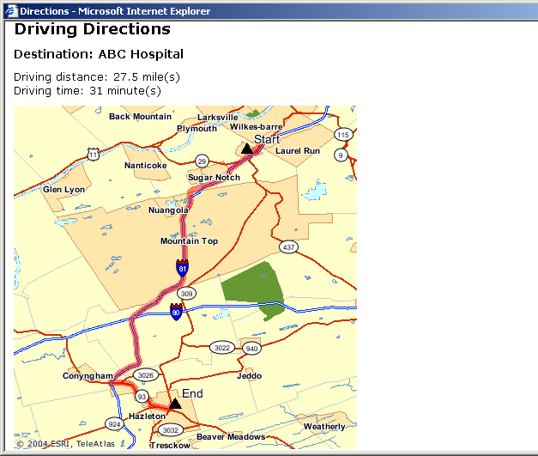
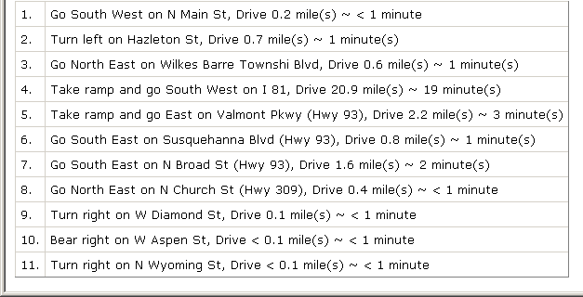

Region-wide Reports
Four region-wide reports, which are intended for planning purposes, aggregate information about an entire state or region.

The aggregate inventory report (see Figure 4) could be useful to planners and could be shared with others external to the state or region (a bordering state for example) to display the information about the entire region.

Figure 4. Aggregate Inventory report, across counties
Top of Form

Aggregate Inventory

Resource type: Major Medical Equipment

Counties: County A, County C, County F inclusive
Radius from City/Town: not defined
Radius from Point: not defined
Major Medical Equipment | Total
X-Ray Machines (stationary) | 31
X-Ray Machines (portable) | 27
CT Scanners | 8
In-house MRIs (not mobile) | 2
Dialysis Stations | 20

Bottom of Form

The aggregate inventory per 1,000 report (not shown) presents exactly the same information, displayed per 1,000 population in the state or region. Such a report regarding decontamination tents, for example, might show that there are only a few tents to cover a million or more people, even though there are many chemical production facilities located in the region. This in turn might prompt regional authorities to invest in increasing the availability of this important resource.

The aggregate inventory by county report (not shown) is the same type of information, arranged by county. In the following example, the physicians (resource type) are displayed for a single county, showing the different types of physicians (resources) in the county. Note that full time and part time physicians are itemized.

The aggregate inventory by county per 1,000 (see Figure 5) combines the previous two reports, and breaks down resources available in the county per 1,000 population. This report allows a proportionate comparison across counties in a region or state, so that planners can compare one county with another. The following is a hypothetical report comparing the emergency response equipment in two nearby counties; one county is larger and equipment per 1,000 more abundant while the other has a nuclear power plant.

Figure 5. Inventory by county, per 1,000 population
Top of Form
Aggregate Inventory Per 1000 People By County

Total Population: 62,547 21,003
Top of Form
Emergency Response Equipment - Total by county | County A | County B
Decontamination Rooms
Decontamination Tents | 0.008 | 0.000
Decontamination Showers | 0.017 | 0.004
Personal Protective Equipment/Suits; Level A | 0.167 | 0.040
Personal Protective Equipment/Suits; Level B | 0.000 | 0.002
Personal Protective Equipment/Suits; Level C | 0.000 | 0.000
Personal Protective Equipment/Suits; Level D | 0.125 | 0.000
Negative Pressure Purifying Respirators | 0.000 | 0.000
Self-Contained Breathing Apparatus | 0.125 | 0.050
Supplied Air Respirators | 0.000 | 0.000
Emergency Showers | 0.000 | 0.000
Eye/Face Wash units | 0.004 | 0.000
Eyewash/Shower combined units | 0.000 | 0.000
Portal Radiation Monitors | 0.000 | 0.000
Radiological Survey Meters (portable) | 0.000 | 0.400
Radiologic Dosimeters | 0.125 | 0.800
Biological Weapon Detectors | 0.000 | 0.000

Bottom of Form

Bottom of Form

County-level resource levels can also be mapped. The map below provides a visual display of the number of EMTs by county:

Map 4. Resources by County

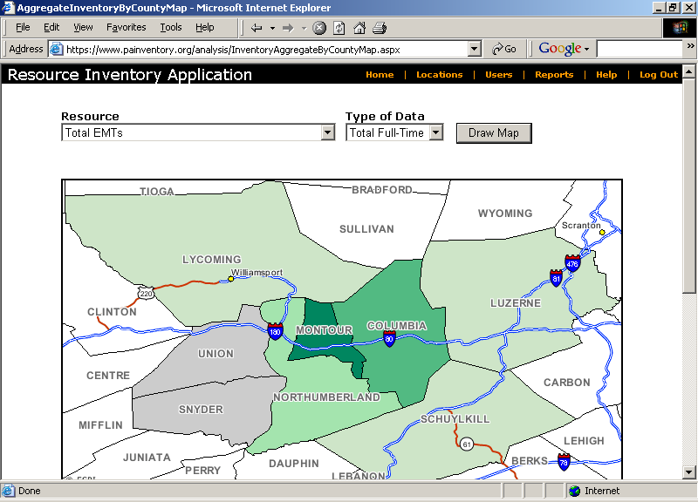
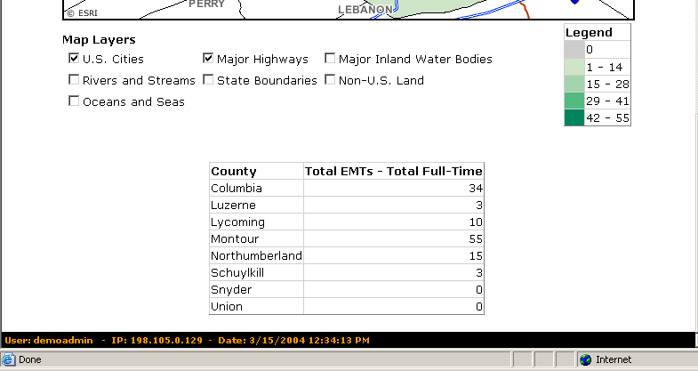

Data and Report Security
In addition to encryption and password protection, security/access levels were built into EPRI. Each person entering data for an organization, or using reports/data from the inventory, must first be an authorized user with an individual UserID and password. When the system administrator is setting up a new user’s account, s/he must assign an “input role” (entering data for one organization or not entering data at all) as well as an “output role” (organization staff, planners, external planners and VIPs, or emergency response commanders). These security levels control what can be entered, and more importantly, what data and reports can be generated and viewed. A system administrator can alter these security levels for any individual user. Those security levels currently designed in EPRI may not quite match the requirements of all states or regions creating an inventory. The accompanying Technical Manual describes how to create new user accounts and how to set the security access level (input and output roles).

Software Has Been Fully Tested
This chapter explains how the pilot test was implemented in an eight-county region of rural Pennsylvania. This test included soliciting political support, configuring EPRI for the location types and resources relevant to the pilot test, outreach to organizations to solicit their participation, and remote data entry by participating organizations.

Steering Committee
The Steering Committee provided input on the design of the inventory (what resources, location types, etc. should be included). Most importantly, they also provided recommendations on the types of reports they, as end users, would find most helpful in planning and response activities. Other potential users creating their own regional inventory of resources may also find a Steering Committee helpful.

Members of the project steering committee were helpful in terms of obtaining the guidance and feedback necessary to make the project successful. It was important that the steering committee have representation from emergency management, public health, healthcare providers, hospital administration, first responders, and other sectors involved in emergency planning. Individuals living and working in the pilot region who were identified as having considerable expertise and experience in these fields were invited to serve on the committee. Steering committee members included:
- Representatives of the Department of Health from district, regional and state levels;
- Healthcare providers practicing emergency medicine and representing the research community;
- Hospital administration officials;
- Emergency management agency coordinators from several pilot counties as well as regional representatives;
- Regional counterterrorism task force representatives; and
- A home health nursing director.

In addition, severalmembers volunteered to sit on the committee following presentations of the project goals and objectives at local and regional emergency management committee meetings.

Following commitment to serve on the committee, the members were assembled and an overview and explanation of the goals of the project were given. Early in the project, management of the committee members’ expectations played a large role in properly directing the focus of the group. Misconceptions concerning the design and eventual purpose of EPRI were addressed and questions answered. It was useful to describe EPRI as a tool for assembling a “data warehouse” that would hold the data inventoried. It was very important to point out that the utility of EPRI was primarily for planning, although the benefits as an incident response tool were also recognized. Indeed, steering committee members felt that cooperation would be enhanced (especially among first responder agencies) if the data could become useful in their missions of emergency response. Throughout the course of the pilot project, the steering committee provided valuable feedback regarding the structure, functionality, and use of EPRI.

County-level political support
In addition to creating the project steering committee, which included representatives from key agencies and organizations in the eight-county area, it was felt necessary to secure acceptance and cooperation from local authorities. County government plays a strong role in Pennsylvania and our efforts were therefore directed first at County Commissioners, the elected county managers in Pennsylvania.

To familiarize officials in the pilot region with the goals and objectives of the project and obtain endorsement from county officials, a series of meetings and presentations were arranged. The county commissioners of each county were sent a letter of introduction and a request for the opportunity to present an overview of the project. Follow–up calls were made to each office for which no response was received within two weeks after the initial letter was sent. A presentation was subsequently made to each of the county commissioners of six of the eight counties in the pilot region. Of the two counties for which presentations were not given, the emergency management coordinators of each county served on the project steering committee and provided updates to the officials of those counties. All six counties agreed to support the pilot test, and one county contribued its director of Public Safety to serve on the steering committee. Throughout the course of the project, the emergency management coordinators of each county provided considerable support through provision of listings of organizations and call lists, coordinating meetings, and communicating with providers in their respective counties. In addition, project staff participated in a variety of local and regional emergency management and planning groups and attended meetings of the regional counter terrorism task force, which included all but one of the pilot counties. This facilitated working relationships with the individuals responsible for planning in the communities targeted for the pilot.

Selected location types, resource types and resources relevant for pilot test
Box 4. Identifying 11 Location Types for
the Pilot Test - where did lists come from?
Location Type Lists Obtained From:
Hospitals Local hospital staff
Nursing Homes Medicare, State health depart. Web site
Home Health Agencies State health department Web site
Fire Stations/depts. County Emergency Mgmt.Directors
Law Enforcement County Emergency Mgmt.Directors;
state police Web site
EMS/ambulance County Emergency Mgmt.Directors;
Regional EMS council
Emergency management State Emergency Management Web
site
Public Health Departments State health department Web site
Red Cross American Red Cross Web site; phone
Books for each county
Animal Care & Kennels Internet searches; county phone books
Funeral Homes National Funeral Directors Association
Web site; searches by county

There are 33 types of locations in the inventory and over 2500 specific locations in the eight-county area that could have been included in the pilot test. To make the pilot manageable within the timeframe of the project, the location types to be inventoried were reduced to eleven. Those most immediately involved in emergency response, health care providers, and a few others that might not think of themselves as emergency resources (animal control, mortuaries) were selected, to determine what is involved in gaining cooperation from such places. For purposes of the pilot test, EPRI was configured to include only these location types. All the resource types and specific resources assigned to these location types in EPRI were reviewed to select those that should be retained for the pilot test. It was decided to retain all the resource types and nearly all the resources for the 12 types of locations selected for the pilot study.

Having specified location types, it was necessary to identify the specific locations that existed in the pilot region (see box). Project staff enlisted the help of emergency management coordinators of each county in obtaining lists of emergency medical service providers, fire departments, and law enforcement agencies in each county. Geisinger Medical Center administrative staff provided names and addresses for all hospitals in the pilot region. Various professional societies, such as the state home health nursing association, also provided lists of locations/organizations within the region. Identification of several location types, such as nursing homes and funeral homes, required use of national databases, some of which were available through online listings. A complete listing of approximately 1100 specific locations was compiled to be included in the pilot data collection effort.

Outreach to solicit participation
To reach each of the specific organizations and agencies identified, a letter of introduction was mailed inviting representatives to attend a presentation to be made in their county. Each letter also contained a brief overview of the project goals and objectives, the counties included in the pilot test, and contact information for project staff. These letters were mailed to each location at least two weeks prior to their planned county meeting. One individual meeting was held in each of four of the pilot counties; a combined meeting was held for two small counties, which are geographically adjacent; and two individual meetings were held in each of the two largest counties in the pilot region. In addition, two evening meetings were held to facilitate attendance by individuals unable to attend a meeting during regular working hours. For example, volunteer firefighters often work day jobs and cannot take time away to attend a meeting but may be more available in the evening to attend a meeting.

To publicize the meetings, local radio and newspaper interviews were granted and meeting dates were published. Each organization was provided with an overview of the project and, if requested, written materials regarding the project. Following provision of this information, participation was requested from each organization.

During each meeting, sign-in sheets listing each of the organizations in the county were used to track attendance. Following each meeting, those organizations that sent a representative, and those that did not, were catalogued for the purpose of followup. At the completion of all meetings, each organization not in attendance was contacted by telephone, again offering information and requesting participation.

Recruiting Organizations and Collecting Data: Lessons Learned
Having mailed letters to all selected organizations in the eight-county region, and having held meetings in each county, the next task was to contact organizations to solicit cooperation and to set them up as EPRI users so that they could submit data.

Motivating Participation
Since there was no mandated governmental or organizational directive sent to any of the contacted organizations, the pilot test was dependent upon the goodwill and trust of the various contacted organizations to participate in the project and the inventory. The pilot test enjoyed no formal support from state agencies, although there was direct contact with several levels of leadership of the Pennsylvania Department of Health, Pennsylvania Emergency Management and Pennsylvania Office of Homeland Security. Information regarding the project and EPRI were presented in several meetings to keep these organizations updated on the progress of the project. None of the state agencies was able to guarantee the necessary financial and personnel commitment to manage and maintain this inventory beyond the current year, because their resources are based on annual funding (largely grants) coming mainly from the federal government. This may be a barrier in other states as well, until more stable funding streams become available for homeland defense. The project team had no incentives to offer other than that of community preparedness and no leverage to compel cooperation.

Test Results
The project staff was able to recruit and collect data from all 12 types of locations chosen for the pilot, from animal control facilities to hospitals. All types of organizations were able to log onto the system, bring up their organization’s data entry pages, and enter data. Queries and email were sent between participating organizations and the system administrators. Reports were generated with the contributed data. EPRI was successfully tested, all functions worked as expected, and no redesigns were required.

Although EPRI met with great enthusiasm from many organizations, cooperation (and data) were not forthcoming from the majority of organizations selected for the pilot test. During the three summer months of 2003, approximately 15% of the 1100 organizations targeted in the eight-county area were recruited and provided data. Much of the difficulty in eliciting cooperation from the organizations in the pilot region had to do with the fact that the test was conducted during the summer months when many organizations were short staffed and had competing priorities. In addition, there was neither a mandate nor any incentive to participate. Inventories organized by states or regions that do have official sponsorship or mandates will perhaps be more successful in securing cooperation.

Lessons Learned About Soliciting Participation
If a state or region decides to assemble an inventory of resources, it will need to reach out to organizations throughout the area. Direct telephone contact may be necessary to those organizations that do not respond to a mailing or an e-mail solicitation. The following guidance may be useful in making telephone contacts to solitict participation, set up user accounts, and collect data.

Preparing materials: In addition to re-mailing and faxing the letter previously sent (which many contacts did not recall receiving), printouts were created of the data entry forms so that individuals at organizations in the pilot area could see exactly what information was being sought. These printouts were faxed or mailed, along with a form requesting contact information that would allow the creation of new user accounts (contact name, address, e-mail, and phone). Being flexible in using email, fax, mail and phone was important due to the diverse array of organizations being contacted.

Creating a database for record-keeping: It was necessary to track which organizations had been contacted, which had agreed to participate, which had not yet agreed, which needed calls backs etc. With 1100 organizations to recruit during the summer months, such a tracking system was extremely useful. A Microsoft Access database was created and included identifying information for each organization and location, and notes about the status of each organization’s recruitment. A report of pending cases helped staff to prioritize their daily work. A weekly status report was generated with each organization and its status (e.g. pending, recruited/agreed to participate, refused).

Efficiently Contacting Organizations: For this pilot test, 1100 organizations had to be contacted in a limited time. We arranged to have project staff make outreach calls at different times of day, including evening shifts. We found that most volunteer fire departments do not have an employee who answers the phone (or picks up the mail) and it was nearly impossible to reach anyone at these small fire stations who could provide information. This will be a challenge in any rural area where firefighting is a largely volunteer effort.

Getting past Gatekeepers: Gatekeepers include receptionists, operators, secretaries, and answering services. Some are extremely helpful in reaching the organization’s executive; some are not. System administrators must be able to quickly describe the project and its relevance, obtain the name of the individual empowered to make decisions for the organization, and try to get through to that person. System administrators must make it immediately clear that this is not a sales effort and there are no costs to participate, and to give the name of the sponsoring agency to establish legitimacy. A set of Frequently Asked Questions was created so that our system administrators would be prepared to handle common questions in a consistent manner.

Explaining the usefulness of the inventory: The objection heard most often from location directors was that there is no need for this resource, or that the location’s participation was not valuable. In the pilot area of rural central Pennsylvania, many people felt that the local community would not be a target of bioterrorism. It is important to reinforce the idea that this inventory can be used for any major disaster in the area, as well as serving as a resource during any evacuation of people from metropolitan areas.

Addressing concerns of validity, security, and confidentiality: Some organizations, especially those in law enforcement, were concerned about security. System administrators need to explain who will have access to data and reports and how data is secured.

Discussing the burden of participation: Once organizations understood the need for such a resource, they wanted to know what they would be required to do and how much time and effort would be involved. A few organizations had an aversion to the Web or technology, or did not have the technology available to enter data. For these few organizations, information was collected over the phone, and project staff entered the data into EPRI.

It is important that anyone implementing such inventory be familiar with similar projects that may be taking place in the same locality. Early in our outreach efforts, we learned that nursing homes and home health agencies were in the process of putting together local and county emergency preparedness programs and contact lists. It is important to be able to explain how this inventory is different and why participation in both activities is important. It may also be possible to combine efforts with others engaged in such projects, to reduce the burden on participating organizations.

Convincing organizations to enter data: Recruitment is only as valuable as the ability to capture a location’s inventory data. Even when outreach was successful and organizations agreed to participate, a location did not always follow through and log in to enter data. Reminder calls, emails and faxes were often necessary.

Technical assistance to participating organizations was often necessary. System administrators usually had to use the telephone to walk each location’s data entry staff through the login and entry steps. Advice regarding how to locate, count and aggregate information was occasionally necessary, and we provided a toll-free number people could call for assistance. In some cases, data entry staff did not have adequate Internet access at work, but were willing to enter data from their homes after hours. We therefore staffed our toll-free helpline during the evening as well as daytime hours.

This project did not develop standards against which to measure the resources available in the test area. Cost data were not included for specific resources.
The accompanying Technical Manual contains detailed instructions for hosting the inventory tool, customizing the structure of the data warehouse to meet local needs, granting access to users, and other technical functions.
During the course of the pilot, the funeral home/mortuary location type was deactivated because in this region there is a central crematory and no corpse processing or storage in a mass fatality event is handled by individual funeral homes. The same might be true in other regions of the country.
The reports were not tested in a ‘real life’ emergency or in a drill.
The inventory tool has a built-in capability for sending emails.

