Report of 2005 Riparian Condition Monitoring

Karen Zamudio

Ecologist, Fremont-Winema National Forest

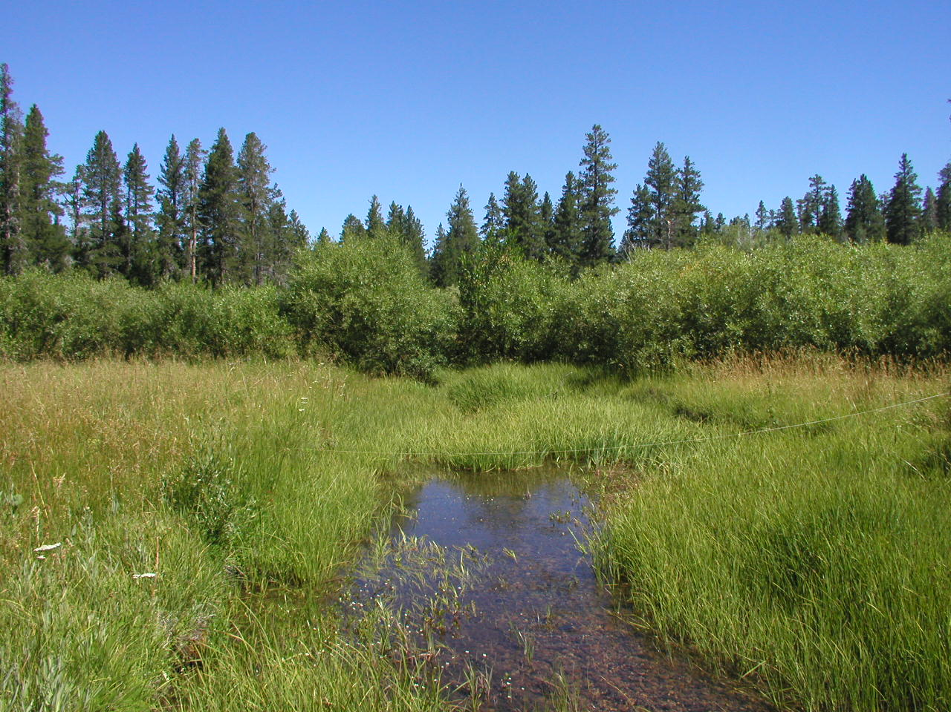

January 25, 2006
Riparian monitoring to assess trends in grazed watersheds focused efforts this year on reassessing Proper Functioning Condition on 43 stream reaches, rephotographing cross-sections on 14 reaches, and collecting macroinvertebrate samples from 8 reaches. Results showed stable to improving trends in most of the reaches visited.

Proper Functioning Condition Assessments:
A team comprised of rangeland management specialist, hydrologist and fisheries biologist reassessed 43 stream reaches. Stream reaches which had previously been rated as Non-functional or Functional-at-risk were the highest priority for reassessment because they have the greatest risk of damage to water quality and aquatic habitat and are most likely to show change over the 8 or 9 years since initial assessment. All but four reaches showed stable to upward trend ratings.

Thirty-five reaches were rated as Functional-at-risk in 1996 or 1997. Of these, eleven have improved to proper functioning condition. The majority, twenty-three, have remained in Functional-at-risk status, but many show signs of improving trend. One reach has declined in condition and is rated as Non-functional. Of three reaches that were rated as Non-functional in 1996, two were rated as Proper Functioning Condition in 2005, while one remains in Non-functional condition. Five reaches previously rated in Properly Functioning Condition retained that rating of resiliency. Two new reaches, not previously assessed, were rated as having Properly Functioning Conditions in 2005.

Table 1. Comparison of Proper Functioning Condition (PFC) ratings between 1996 and 2005 for selected stream reaches.

Initial PFC rating in 1996 or 1997 | PFC rating from 2005 for the same reaches
Non-functional – 3 went to… | Proper functioning condition – 2, Non-functional - 1
Functional at risk – 35 went to… | Functional at risk – 23, Proper functioning condition – 11, Non-functional - 1
Proper functioning condition – 5 stayed | Proper functioning condition - 5

High flows in May of 2005 assisted specialists in the assessment of hydrologic and riparian function. Effects of the recent high water were evident and the channel and riparian vegetation’s degree of resiliency was noticeable. Those sites showing the most improvement were on perennial streams. Ephemeral and intermittent channels are the ones that recover their functionality the slowest. Bank-building requires adequate moisture to maintain riparian dependent plant species in good vigor and runoff to carry and deposit sediments. In some cases flow regulation and diversion hamper efforts to improve riparian condition. Grazing standards and protections will need to be strengthened in a few pastures in accordance with the Biological Opinion issued by US Fish and Wildlife Service with respect to grazing effects on Suckers.

Photo monitoring:
Photo retakes of monumented cross-sections on 14 reaches in 2005 permitted the development of time series with three or four dates (1996, 2000, 2002 and 2005 generally). The time series also show stable to slightly improving trend. Again effects of the 1997 and 2005 flood events are evident; however, the ability of the channels to respond appropriately to these events is also evident. Scour and deposition are both evident in some reaches. Plant growth and utilization levels vary between years due to effects of drought, the permitted grazing for the year, as well as the dates of the photo relative to the growing/grazing season. For those reaches with willows increased height and fuller structure are evident (sometimes even making rephotographing the transect difficult). An exception is on the North Fork of the Sprague River where willows remain in a hedged condition and only a few willows show signs of release. Cattle only graze this reach for two weeks, mid season, while elk use the area on migration both in the spring and the fall. Protection of willows from grazing by both species needs to be considered if hedged willows are to regain their form. Photo monitoring on Swamp Creek, Burnt Creek and Coyote Creek show increased size and density of lodgepole pine on the floodplain. Photo monitoring will be useful to track changes related to streambank revetment work with whole junipers in Wild Horse, North Fork Willow and Horse Canyon Creeks.

Figure 1. An example of time series monitoring of an individual transect showing growth in willows and lodgepole pine near a gravelbar with recent deposits.

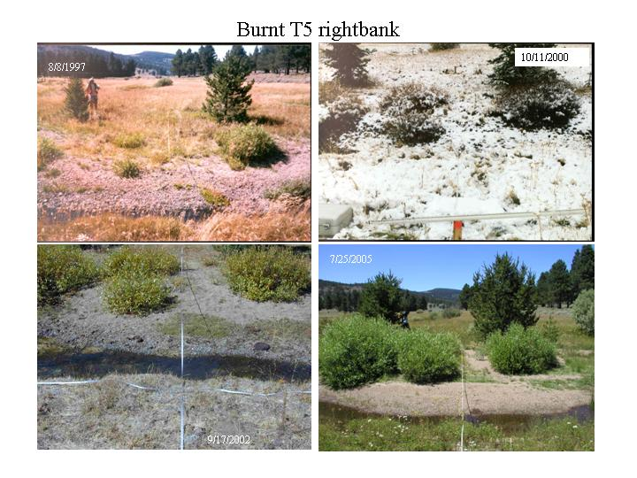

Macroinvertebrate Sampling:
Samples of macroinvertebrates taken from eight reaches in early July were sent to the National Bug Lab for identification and calculation of the Biological Condition Index (BCI). Results are expected in April of 2006, at which time they can be compared with previous samples taken from the same locations. The BCI looks at the relative species composition of the samples. High frequency of sediment tolerant taxa results in a lower BCI, while higher frequency of clean, cold water dependent taxa results in a higher BCI.

