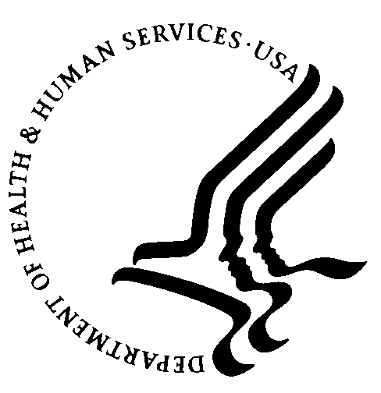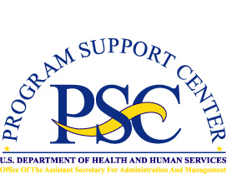Enterprise Human Resources and Payroll (EHRP) Instructional Letter

Number: EHRP05-14
Date: April 17, 2005
Subject: Using SPID Codes Whose Salary Exceeds the Title 5 CAP
___________________________________________________________________

Purpose
The conversion of the HHS payroll system to the Defense Finance and Accounting Service (DFAS) on April 17, 2005 will require changes in procedures for handling salary capping issues for employees hired under Title 42 or Title 38, and for those few employees under Title 5 who are entitled to an exception from the limitation. This letter provides information on the process for handling those actions.
_ _ _ _

Using SPID Codes

The maximum payable salary for Title V employees is Executive Level IV. When processing an action for an employee who is not subject to this limit it will be necessary to use the appropriate SPID code found on Employment Page 1 of Administer Workforce. Employees who do not have a SPID will be capped by DFAS.

For further assistance or for questions regarding the information in this letter, please contact Marie King ( MKing@psc.gov) or Theresa Lewis ( TLewis@psc.gov ).

