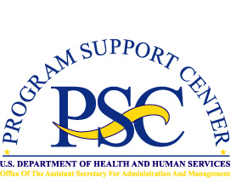Enterprise Human Resources and Payroll (EHRP) Instructional Letter

Number: EHRP05-05
Date: April 17, 2005
Subject: Addresses
___________________________________________________________________

Purpose
The conversion of the HHS payroll system to the Defense Finance and Accounting Service (DFAS) on April 17, 2005 will require some changes in the processing of addresses. This letter provides information on these changes.
_ _ _ _

Users will no longer be able to key a 999-8 address separation. DFAS will only be accepting a 999-5 address change. When processing an address for an employee who is separating the address change must be processed first so that it will be applied to DFAS database first. DFAS will not accept an address change for a separated employee.

For further assistance or for questions regarding the information in this letter, please contact Marie King ( MKing@psc.gov ) or Theresa Lewis ( TLewis@psc.gov ).

