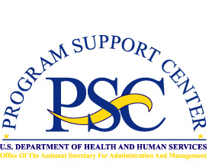Enterprise Human Resources and Payroll (EHRP) Instructional Letter

Number: EHRP05-04
Date: April 17, 2005
Subject: Multiple Awards
___________________________________________________________________

Purpose
The conversion of the HHS payroll system to the Defense Finance and Accounting Service (DFAS) on April 17, 2005 will require some changes in the processing of multiple awards. This letter provides information on these changes.
_ _ _ _

Regular Awards

Each award must have a different effective date.

Time-Off Awards

If two or more time-off awards are submitted within the same pay period, the last time-off award processed will overlay any others processed within that pay period and will be the only one to update DFAS.

All such overlaid time-off awards will need to be tracked manually.

For further assistance or for questions regarding the information in this letter, please contact Marie King ( MKing@psc.gov ) or Theresa Lewis ( TLewis@psc.gov ).

