U.S. Census Bureau
U.S. Bureau of Economic Analysis

NEWS

U.S. Department of Commerce • Washington, DC 20230

For Immediate Release
8:30 A.M. EDT tHURSDAY, sEPTEMBER 11, 2008

For information on goods contact: |  | For information on services contact:
U.S. Census Bureau: |  | U.S. Bureau of Economic Analysis:
Nick Orsini | 301-763-6959 | Technical: Christopher Bach | 202-606-9545
Maria Iseman | 301-763-2311 | Media: Ralph Stewart | 202-606-2649
 |  | CB08-137, BEA08-40, FT-900 (08-07)

U.S. INTERNATIONAL TRADE IN GOODS AND SERVICES

July 2008

Goods and Services

The U.S. Census Bureau and the U.S. Bureau of Economic Analysis, through the Department of Commerce, announced today that total July exports of $168.1 billion and imports of $230.3 billion resulted in a goods and services deficit of $62.2 billion, up from $58.8 billion in June, revised. July exports were $5.4 billion more than June exports of $162.8 billion. July imports were $8.7 billion more than June imports of $221.6 billion.

In July, the goods deficit increased $3.6 billion from June to $74.9 billion, and the services surplus increased $0.2 billion to $12.7 billion. Exports of goods increased $4.5 billion to $120.8 billion, and imports of goods increased $8.1 billion to $195.7 billion. Exports of services increased $0.8 billion to $47.4 billion, and imports of services increased $0.6 billion to $34.7 billion.

In July 2008, the goods and services deficit increased $4.9 billion from July 2007. Exports were up $28.2 billion, or 20.1 percent, and imports were up $33.0 billion, or 16.8 percent.

Goods

The June to July change in exports of goods reflected increases in industrial supplies and materials ($1.6 billion);

automotive vehicles, parts, and engines ($1.4 billion); capital goods ($0.9 billion); and consumer goods ($0.8 billion). A decrease occurred in foods, feeds, and beverages ($0.1 billion). Other goods were virtually unchanged.

The June to July change in imports of goods reflected increases in industrial supplies and materials ($7.0 billion); capital goods ($0.6 billion); other goods ($0.3 billion); and foods, feeds, and beverages ($0.1 billion). Decreases occurred in automotive vehicles, parts, and engines ($0.1 billion) and consumer goods ($0.1 billion).
The July 2007 to July 2008 change in exports of goods reflected increases in industrial supplies and materials ($11.9 billion); foods, feeds, and beverages ($3.4 billion); capital goods ($3.3 billion); consumer goods ($2.5 billion); automotive vehicles, parts, and engines ($1.3 billion); and other goods ($0.5 billion).
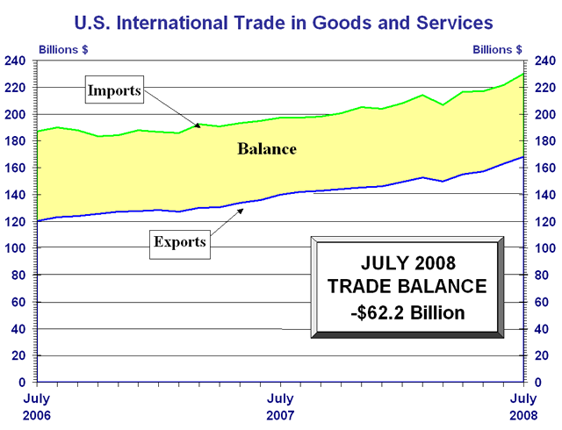

The July 2007 to July 2008 change in imports of goods reflected increases in industrial supplies and materials ($26.8 billion); consumer goods ($2.2 billion); capital goods ($1.8 billion); foods, feeds, and beverages ($0.7 billion); and other goods ($0.7 billion). A decrease occurred in automotive vehicles, parts, and engines ($1.8 billion).

Services

Services exports increased $0.8 billion from June to July. The increase was mostly accounted for by increases in other private services (which includes items such as business, professional, and technical services, insurance services, and financial services), travel, and other transportation (which includes freight and port services). Changes in other categories of services exports were small.

Services imports increased $0.6 billion from June to July. The increase was mostly accounted for by increases in other transportation, other private services, and travel. Changes in other categories of services imports were small.

From July 2007 to July 2008, services exports increased $4.9 billion. The largest increases were in travel ($1.6 billion), other private services ($1.3 billion), and other transportation ($1.1 billion). Within other private services, the largest increases were in financial services and business, professional, and technical services.

From July 2007 to July 2008, services imports increased $2.7 billion. The largest increases were in travel ($0.6 billion), other transportation ($0.6 billion), and other private services ($0.5 billion). Within other private services, the largest increases were in business, professional, and technical services and insurance services.

Goods and Services Moving Average

For the three months ending in July, exports of goods and services averaged $162.6 billion, while imports of goods and services averaged $223.0 billion, resulting in an average trade deficit of $60.4 billion. For the three months ending in June, the average trade deficit was $60.2 billion, reflecting average exports of $158.3 billion and average imports of $218.5 billion.
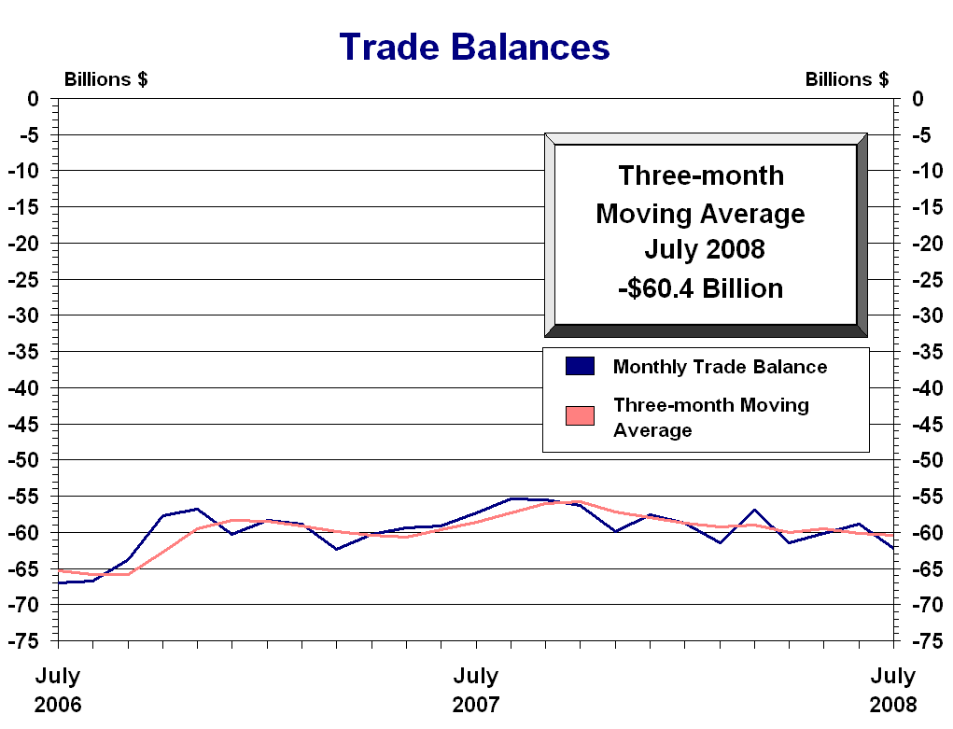

Selected Not Seasonally Adjusted Goods Details

The July figures showed surpluses, in billions of dollars, with Australia $1.2 ($1.0 for June), Hong Kong $1.1 ($1.8), Singapore $0.9 ($1.5), and Egypt $0.5 ($0.4). Deficits were recorded, in billions of dollars, with China $24.9 ($21.4), OPEC $24.2 ($18.1), the European Union $11.0 ($8.2), Canada $8.3 ($7.2), Japan $6.3 ($6.1), Mexico $5.5 ($5.7), Venezuela $5.4 ($4.6), Nigeria $3.8 ($3.3), Korea $1.3 ($0.5), and Taiwan $0.5 ($0.6).

Advanced technology products (ATP) exports were $23.3 billion in July and imports were $30.4 billion, resulting in a deficit of $7.1 billion. July exports were $1.7 billion less than the $25.0 billion in June, while imports were $1.5 billion more than the $28.9 billion in June.

Revisions

Goods carry-over in July was $0.4 billion (0.3 percent) for exports and $2.2 billion (1.1 percent) for imports. For June, revised export carry-over was $0.2 billion (0.2 percent), revised down from $0.8 billion (0.7 percent). For June, revised import carry-over was $0.2 billion (0.1 percent), revised down from $1.4 billion (0.7 percent).

Services exports and imports for January through June 2008 reflect the incorporation of more comprehensive and revised quarterly and monthly data. For services exports, the largest revisions over the entire period were in other private services and royalties and license fees. For services imports, the largest revisions over the entire period were also in other private services and royalties and license fees.

Services exports for June were revised down $1.2 billion to $46.5 billion. The revision was more than accounted for by downward revisions in other private services and royalties and license fees. An upward revision in travel was partly offsetting. Services imports for June were revised down $0.4 billion to $34.1 billion. The revision was more than accounted for by a downward revision in other private services. Upward revisions in royalties and license fees and other transportation were partly offsetting.

Table of Contents

Seasonally Adjusted

Exhibit 1 | U.S. International Trade in Goods and Services . . . . . . . . . . . . . . . . . . . . . . . . . . . . . . . . | 1
Exhibit 2 | U.S. International Trade in Goods and Services Three-month Moving Averages. . . . . . . | 2
Exhibit 3 | U.S. Services by Major Category – Exports . . . . . . . . . . . . . . . . . . . . . . . . . . . . . . . . . . . | 3
Exhibit 4 | U.S. Services by Major Category – Imports . . . . . . . . . . . . . . . . . . . . . . . . . . . . . . . . . . . | 4
Exhibit 5 | U.S. Trade in Goods. . . . . . . . . . . . . . . . . . . . . . . . . . . . . . . . . . . . . . . . . . . . . . . . . . . . . . | 5
Exhibit 6 | Exports and Imports of Goods by Principal End-Use Category . . . . . . . . . . . . . . . . . . . . | 6
Exhibit 7 | Exports of Goods by End-Use Category and Commodity. . . . . . . . . . . . . . . . . . . . . . . . . | 7
Exhibit 8 | Imports of Goods by End-Use Category and Commodity. . . . . . . . . . . . . . . . . . . . . . . . . | 9
Exhibit 9 | Exports, Imports, and Balance of Goods, Petroleum and Non-Petroleum End-Use Category Totals . . . . . . . . . . . . . . . . . . . . . . . . . . . . . . . . . . . . . . . . . . . . . . . . . . . . . . . . . | 11
Exhibit 10 | Real Exports and Imports of Goods by Principal End-Use Category (2000 Chain-weighted dollars) . . . . . . . . . . . . . . . . . . . . . . . . . . . . . . . . . . . . . . . . . . . . . . . . . . . . . . . . | 12
Exhibit 11 | Real Exports, Imports, and Balance of Goods, Petroleum and Non-Petroleum End-Use Commodity Category Totals (2000 Chain-weighted dollars) . . . . . . . . . . . . . . . . . . . . . . | 13

Not Seasonally Adjusted

Exhibit 12 | U.S. Trade in Goods. . . . . . . . . . . . . . . . . . . . . . . . . . . . . . . . . . . . . . . . . . . . . . . . . . . . . . | 14
Exhibit 13 | Exports and Imports of Goods by Principal End-Use Category . . . . . . . . . . . . . . . . . . . . | 15
Exhibit 14 | Exports, Imports, and Balance of Goods by Selected Countries and Areas. . . . . . . . . . . . | 16
Exhibit 15 | Exports and Imports of Goods by Principal SITC Commodities. . . . . . . . . . . . . . . . . . . . | 18
Exhibit 16 | Exports, Imports, and Balance of Advanced Technology Products. . . . . . . . . . . . . . . . . . | 20
Exhibit 16a | Exports, Imports, and Balance of Advanced Technology Products by Technology  Group and Selected Countries and Areas. . . . . . . . . . . . . . . . . . . . . . . . . . . . . . . . . . . . . . | 21
Exhibit 17 | Imports of Energy-Related Petroleum Products, Including Crude Oil . . . . . . . . . . . . . . . | 22
Exhibit 18 | Exports and Imports of Motor Vehicles and Parts by Selected Countries. . . . . . . . . . . . . | 23
Information on Goods and Services.. . . . . . . . . . . . . . . . . . . . . . . . . . . . . . . . . . . . . . . . . . . . . . . . . . . . . . |  | A-1

