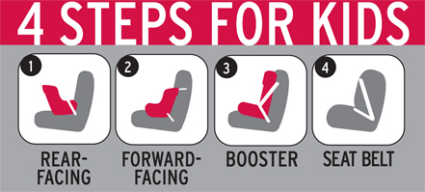
CPS Week Planner

SAMPLE NEWS RELEASE

[486] WORDS
Please Note: Prior to filling in the names of an organization or its spokespeople in the release below, you MUST contact them to obtain their permission. In addition, you must get their approval for the language of their quotations, and any changes they may require. Only after all of these steps have been taken should the release be distributed.

FOR IMMEDIATE RELEASE: [Date]

CONTACT: [Name, Phone Number, E-mail]

[Local Organization] Urges Parents and Caregivers to
Get Their Child Safety Seats Inspected

City, State – Three out of four child safety seats are improperly installed in vehicles according to research by the National Highway Traffic Safety Administration. That’s why [Local Organization] is urging all parents and caregivers to attend the Second Annual “National Seat Check Saturday,” on Saturday September 20. As part of National Child Passenger Safety Week (September 21-27) [Community name] will have English- and Spanish-speaking certified technicians available to provide free on-site child safety seat inspections from [time] at [location].

“It’s the responsibility of every parent and caregiver out there to make sure their children are safely restrained – every trip, every time,” said [Local Leader]. “We are urging everyone to get their child safety seats inspected. When it comes to the safety of a child, there is no room for mistakes.”

According to National Highway Traffic Safety Administration research, 8,325 lives of children under age 5 have been saved by the proper use of child restraints during the past 30 years. In 2006, among children under 5, an estimated 425 lives were saved by child restraint use. Research shows that child restraints provide the best protection for all children up to age 8; after age 8 seat belts provide the best protection.

For maximum child passenger safety, [Local Leader] said parents and caregivers should refer to the following 4 Steps for Kids guidelines for determining which restraint system is best suited to protect children based on age and size:
- For the best possible protection keep infants in the back seat, in rear-facing child safety seats, as long as possible up to the height or weight limit of the particular seat. At a minimum, keep infants rear-facing until at least age 1 and at least 20 pounds.
- When children outgrow their rear-facing seats (at least age 1 and at least 20 pounds) they should ride in forward-facing child safety seats, in the back seat, until they reach the upper weight or height limit of the particular seat (usually around age 4 and 40 pounds).
- Once children outgrow their forward-facing seats (usually around age 4 and 40 pounds), they should ride in booster seats, in the back seat, until the vehicle seat belts fit properly. Seat belts fit properly when the lap belt lays across the upper thighs and the shoulder belt fits across the chest (usually at age 8 or when they are 4’9” tall).
- When children outgrow their booster seats, (usually at age 8 or when they are 4’9” tall) they can use the adult seat belts in the back seat, if they fit properly (lap belt lays across the upper thighs and the shoulder belt fits across the chest).

For more information on Child Passenger Safety Week, a national effort to remind parents and caregivers of the lifesaving effect child safety seats have in protecting young children, please visit www.nhtsa.gov.

###

