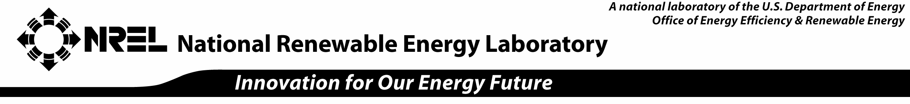

Licensing Candidate Information – Small Business

Date:

Company Name:

Address:

Contact Information

Name:

Title:

Phone:

Fax:

E-mail:

Address:

Basic Information

1. What NREL technology are you interested in? Why?

2. Indicate the type of license you are interested in: □ Nonexclusive □ Exclusive □ Research

3. Have you worked with the U.S. Department of Energy before? □ Yes □ No
If yes, when and in what capacity?

4. Is the company a subsidiary or a joint venture? □ Yes □ No
If yes, please attach the parent company’s or each joint venture participant’s legal name, legal form, and headquarters location.

If headquarters are not in the United States, does the company have business units in the United States? □ Yes □ No If yes, please provide:

Address(es):

Approximate number of units:

Number of employees at the units:

5. Please indicate the company’s legal status: LLC □ Corporation □ Public □ Private
□ Other (if so, explain):

6. Please provide your investment requirements and sources of capital for the next three years.

7. In a paragraph, please describe the business model of your company.

8. Summarize your company’s experience in commercializing an early-stage technology.

9. Describe your exit strategy for shareholders.

Attachments

Please attach the following to this form:

- Table of the company capitalization, including ownership and percentage owned

- Resumes of the founder(s) and the top management team. Be sure to highlight their relevant experience.

Submit this form and attachments to:
Rich Bolin
NREL Technology Transfer Office
1617 Cole Blvd. MS 1635
Golden, CO 80401
303-275-3028
richard_bolin@nrel.gov

