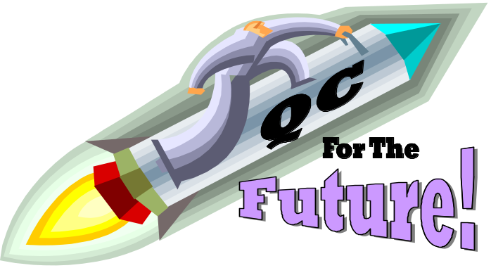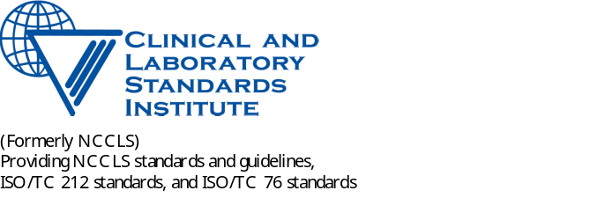

Equivalent Quality Control Workshop

Baltimore, Maryland

March 18, 2005

What is quality control?

QC consists of procedures used to detect testing errors and monitor test performance over time. Advances in laboratory technology have led to internal, built-in monitoring systems that may fulfill the functions of traditional QC procedures. These advances present opportunities for alternative QC options for the future.

Be a part of the future!

WHY? The CLIA regulations provide for non- regulatory “equivalent procedures” for QC provided they ensure equivalent quality testing. This meeting is intended to solicit input from all affected constituencies and ongoing participation in the development of protocols for QC and a QC Plan for the Future. We recognize the importance of having broad input to ensure sound scientific and statistical basis for QC policies and procedures that reflect state-of-the art technology and promote quality testing.

WHAT? Development of a proposed voluntary consensus document will be discussed as the basis for an alternative QC option for CLIA purposes. Attendees should be prepared to present data, scientific and technical information, experiential considerations and other documentation that will facilitate the discussions and determinations about additional QC options during the breakouts.
Following the workshop, participants will receive a conference report. The manuscripts from each of the speakers will be published in a laboratory professional journal at a later date.

WHO? This workshop is intended for subject matter experts from the IVD industry, clinical laboratories, government agencies and other oversight organizations.
Individuals wishing to share or to augment their knowledge of current and future testing technology and Quality Control and to provide input into a plan for QC for the future are invited to participate.

WHERE? Renaissance Harborplace Hotel in Baltimore, Maryland.

WHEN? The 2005 NCCLS Leadership Conference convenes March 16 through March 19. The Equivalent Quality Control Workshop is on March 18.

Speakers

Nationally recognized laboratory, industry and government experts: Joe Boone, Robert Habig, Thomas Hearn, Fred Lasky, Valerie Ng, Luann Ochs, Elissa Passiment, Donald Powers, James Westgard and Judy Yost.

Organizers
The American Association for Clinical Chemistry
The American Society for Clinical Laboratory Science
The Advanced Medical Technology Association (AdvaMed)
The Centers for Disease Control and Prevention
The Centers for Medicare & Medicaid Services
The US Food and Drug Administration
The American Society for Microbiology
The American Medical Technologists
The American Society for Clinical Pathologists
The American Clinical Laboratory Association
The College of American Pathologists
The Clinical Laboratory Management Association
The Clinical and Laboratory Standards Institute, formerly NCCLS, who will also serve as the convener of the Workshop.

Registration
Hotel Reservations: Renaissance Harborplace Hotel
202 East Pratt Street
Baltimore, Maryland 21202
Phone: 1-888-511-7809
Fax: 1-410-539-5780

For Meeting or Workshop Reservations:

Call CLSI/NCCLS at 610-688-0100 or go online at http://nccls.org
The Workshop on 3/18 is $150. (includes lunch and break snacks).
The CLSI/NCCLS President’s Reception on the evening of 3/17 is only $75.

To register online, or for more information, http://nccls.org

This program has been supported in part by the generous contributions of IVD sector of AdvaMed.

